2019 IC US Poverty Housing Briefing Packet
Section 1: The Link Between Housing and Poverty

Importance of Housing to Anti-Poverty Advocacy

Why Housing?
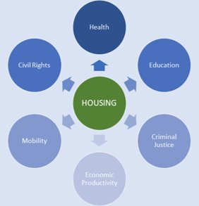
Housing affects everyone — whether they’re in a stable home or facing housing instability. Housing impacts multiple aspects of people’s lives, their health care, education, nutrition, and economic mobility. Families tend to spend their funds on rent before other expenses, and often housing cost is the single largest expense in a household budget. As author Matthew Desmond says, “the rent eats first”. -- Access to affordable, safe, and decent housing is an anti-poverty tool. When households pay a reasonable amount for housing (paying 30 percent of one’s income or less is considered affordable), they are able to use the remaining funds for other things like food, health care, bills, education, investments, or improvements in quality of life. But for too many families, affordable housing is out of reach. Rents have increased by 61 percent since 1960, while wages have only gone up by 5 percent. And while the high cost of housing impacts nearly one-third of all U.S. households, renters are hardest hit; close to 50 percent of renters are forced to pay unaffordable housing costs as opposed to 23 percent of homeowners.
Fortunately, public support around housing affordability is building. RESULTS sits on the Opportunity Starts at Home Campaign’s Roundtable, and their recent polling found that nine in ten people believe that stable affordable housing is very important or one of the most important things that effect people’s security and wellbeing. The poll also found that the concern for affordable housing has increased by 21 points in just three years, with the vast majority of people feeling the effects of the affordable housing crisis in their own community.
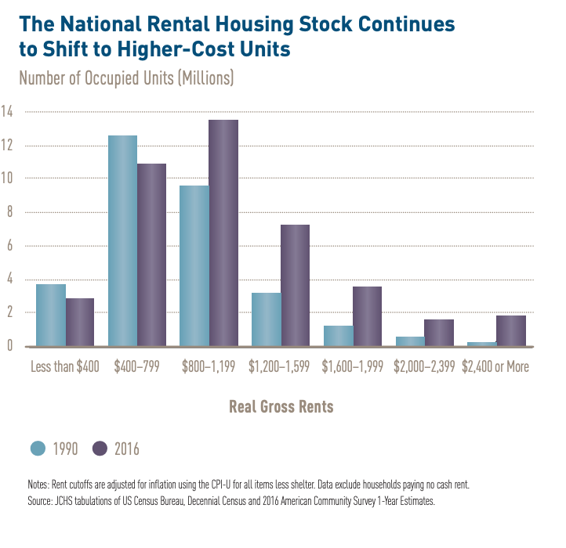
What is the Affordable Housing Crisis?
Lack of affordable housing stock coupled with stagnant wages and limited housing assistance are contributing factors to the affordable housing crisis. For instance, the Joint Center on Housing Studies at Harvard notes that between 1987 and 2015, there has been an increase of 6 million very low-income renters while the number of households getting assistance has only grown by 950,000. Consequently, the share of those getting federal housing assistance has decreased by 4 percent within that period, with only one in four eligible households getting assistance today.
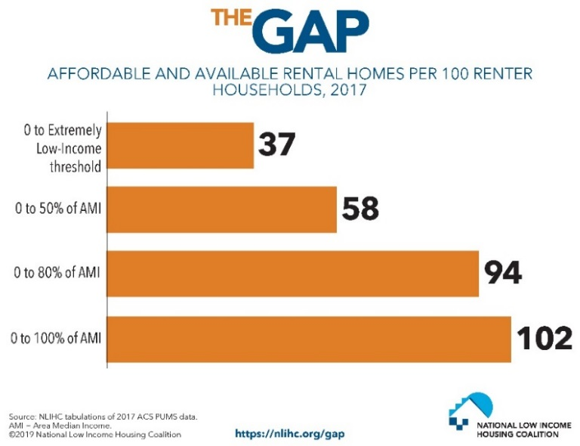
Nationwide, the supply of higher cost rental homes is increasing while the number of housing units for low-income households is going down (see figure 1). The National Low Income Housing Coalition estimates that there is an overall shortage of seven million affordable and available rental homes for extremely low-income households. This means that there are only 37 affordable and available rental units (see figure 2) per 100 households. Extremely low-income households are those with incomes at or below the federal poverty level or earn only 30 percent of the area median income (AMI), whichever is higher. Currently, no state in the nation offers enough affordable housing for extremely low-income renters. See figure 3 to understand how your state fares.
Figure 2⁶
Figure 1⁵
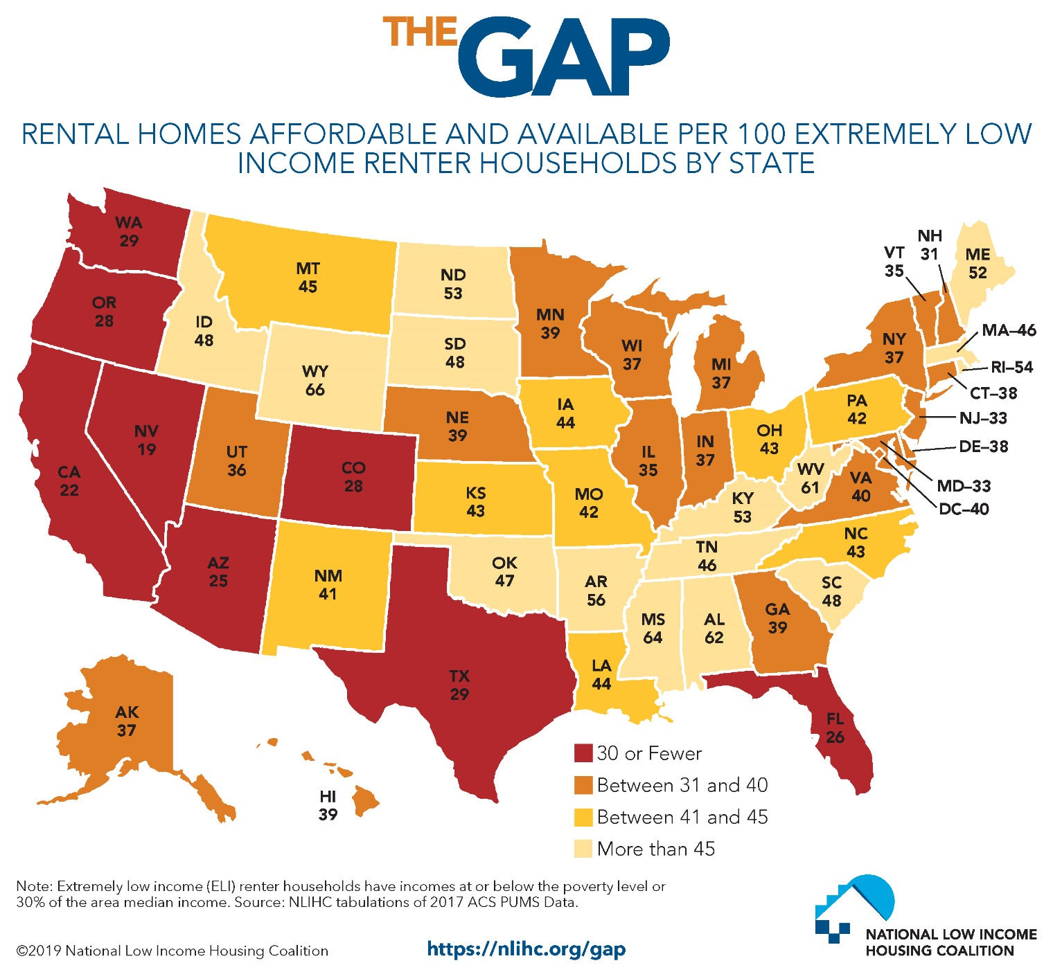
Figure 3⁶

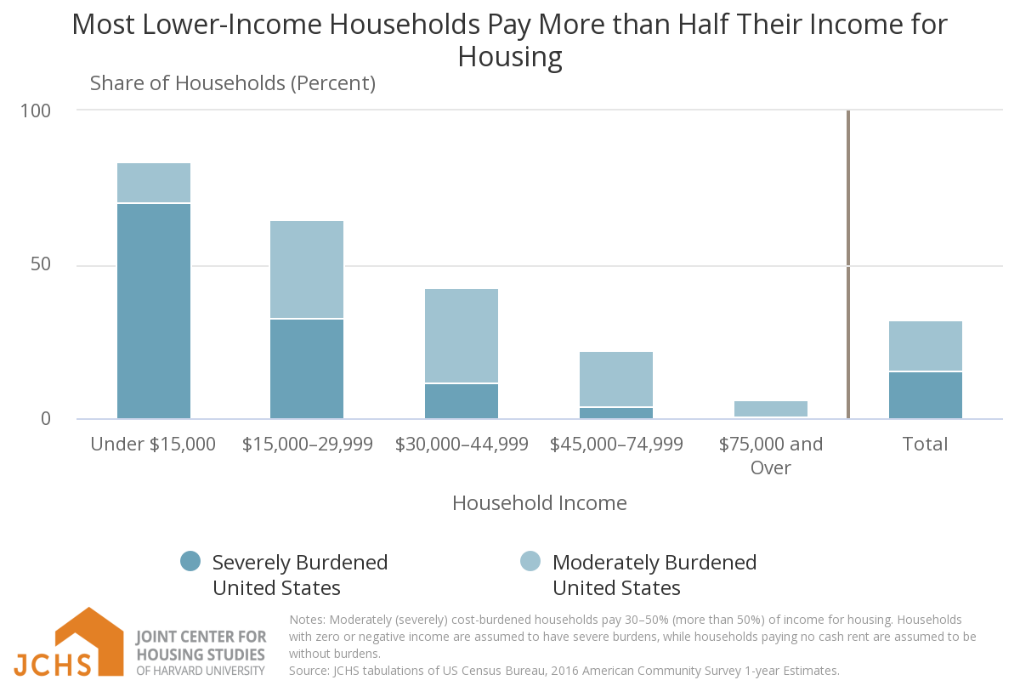
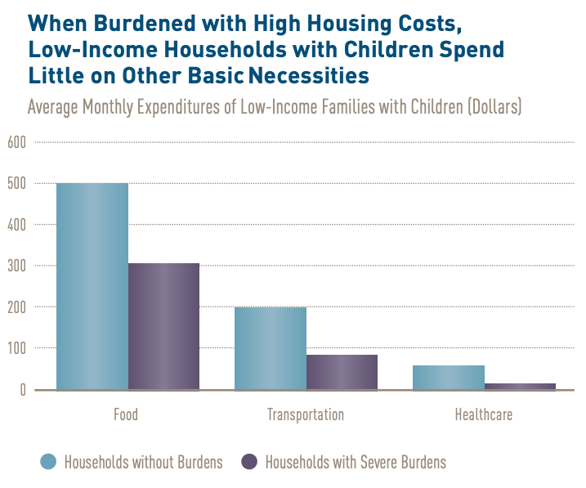
The shortage of affordable housing creates an unacceptable reality where extremely low-income renters are cost burdened, i.e. they pay more than 30 percent of their income for housing. For too many families, their monthly housing bill far outpaces this affordability mark. Seventy-one percent of all extremely low-income households pay more than 50 percent of their income towards rent. Not only are a majority of extremely low-income renters paying most of their income towards housing, they also make up the largest percentage of cost-burdened households (see figure 4). Unaffordable housing not only jeopardizes financial security, but also has long lasting effects on a range of other outcomes. Because households that are rental cost-burdened spend large portion of their income on housing and thus have less funds to spend on basic needs, are more likely to have poorer health, a higher risk of food insecurity, worse mental health outcomes, poor childhood performance on cognitive tests, and a higher risk of low weight and premature births.&
Figure 4⁹
When households are forced to pay more for rent it causes larger societal ripple effects. For example, unstable housing is projected to cost $111 billion over the next 10 years in health care costs for families with children. These costs are avoidable when families have access to safe, decent, affordable housing.
Figure 5⁹

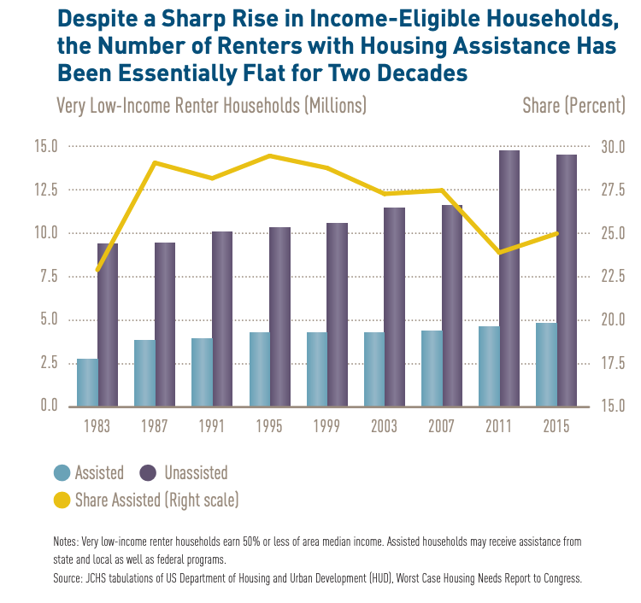
After accounting for inflation, the federal minimum wage ($7.25) has actually decreased in recent years, while the cost of living has not. In 2018, the “national housing wage” or the minimum wage needed for a full-time worker to afford a modest two-bedroom apartment was $22.10. Many Americans need help to fill the gap between rising housing costs and wage stagnation, but the need far outpaces what is provided. Currently, over four million households sit on the waiting list for housing assistance, and with many waitlists closed around the country, this number underestimates need.& With an average wait time of over two years, the need for affordable housing truly tips this issue to crisis levels. Research from the Joint Center for Housing Studies at Harvard University demonstrates that the number of assisted households have remained stagnant while the number of people qualifying for housing assistance has increased (figure 6). Due to this disinvestment, too many households face housing instability.
Figure 6¹⁵

The Disproportionate Impact of the Housing Crisis
As we have learned in other briefs, inequality is not shared equally. People of color, the elderly, and people with disabilities are disproportionately affected by the housing crisis:
- Seventy-eight percent of families with children, 66 percent of the elderly without children, and 56 percent of households that are disabled without children go without the rental assistance that they need.
- Forty-eight percent of extremely low-income renter households are seniors or disabled.
- People of color are more likely to have extremely low-incomes than Whites (see figure 7, below).
- Over 71 percent of Hispanics, more than 70 percent of Black, and slightly above 69 percent of White extremely low-income renters are severely cost burdened.
- White renters are more likely than Black, Hispanic, and American Indian or Alaska Native renters to have household incomes above 80 percent of the area median.
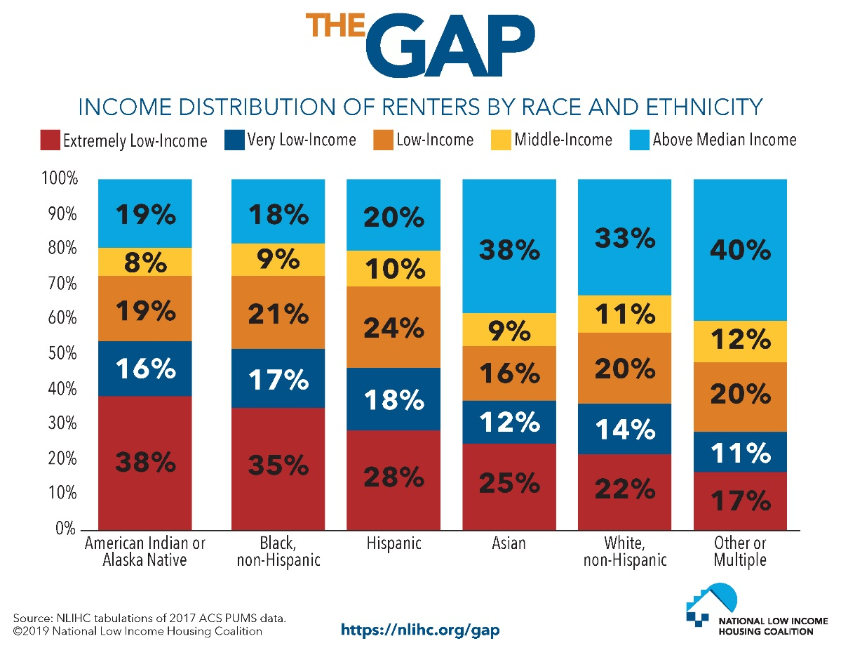

Figure 7¹⁸
Location is another central aspect of the housing crisis. Research shows that those who live in areas of concentrated poverty have worse life outcomes than folks who live in low-poverty areas. As noted in the US Poverty Creation of Wealth and Inequality Briefing, low-income families of color are more highly concentrated in areas of high poverty. From the most recent data, in 2014 seven percent of poor Whites, 15 percent of poor Latinos, and 23 percent of African Americans lived in high poverty neighborhoods. More recent data (2013-2017) show even higher rates for children: 28 percent of Black, 19 percent of Hispanic/Latino, 28 percent of Native American, and 4 percent of White children lived in areas of concentrated poverty. Research shows that living in under-resourced areas can cause negative impacts on children’s development, school achievement, and long term health. Yet, when families with low-incomes move to low-poverty neighborhoods, these child outcomes improve, in part because low-poverty areas are better resourced, giving children access to the needed services and amenities. Sadly, the lasting impact of structural racism, including segregationist housing policies are evident in these neighborhood outcomes, which impact a higher percent of people of color than Whites.

Housing and the Racial Wealth Divide
“Racial Wealth Inequality Conference Brief Section 1” outlined that wealth is an essential anti-poverty tool because it shields families from unexpected costs and allows them to invest in things that spur economic mobility. Yet, Black households own a dime for every dollar of White wealth. Discrepancies in homeownership account for 27 percent of the racial wealth gap, the highest of any factor. Consistently low rates of homeownership for Black households are due to our nation’s history of racial discrimination, especially as it relates to mortgage lending, predatory lending, segregation, blockbusting, and devaluation (see “The Creation of Wealth Inequality” briefing for more information). These historical policies have multi-generational effects as research shows that homeownership begets homeownership. Children from families that are wealthy, homeowners, or both have higher rates of homeownership as young adults (18-34 years old) than young adults from families that are not homeowners or have low-incomes. Coming from a homeowning household increases the likelihood of homeownership for 18-35 year old’s by 7-8 percent.

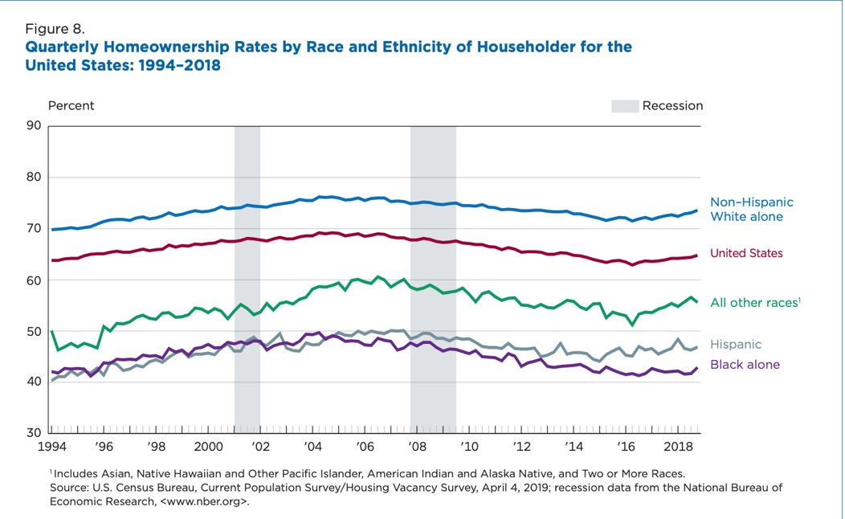
Figure 8

Since 1994, the gap between Black and White homeownership rates has widened, causing a rift of over 29 percent; 72 percent of White households own homes as opposed to 43 percent of Black households. For most Americans the bulk of their assets lie in the value of their home. This is especially true for Black homeowners, with 56 percent of their wealth coming from their homes, whereas home values only account for 38 percent of White household wealth. Homeowners also have drastically more in net wealth than renters. Renters have about $5,000 in median wealth as opposed to the $231,400 in wealth for homeowners, a 98 percent gap.
While homeownership is a main source of wealth, it is not a silver bullet solution. Black homeowners living in Black majority neighborhoods are kept from accessing the full value of their home. A 2018 report from the Brookings Institution showed that among comparable quality neighborhoods, homes were devalued by 23 percent in areas where more than half the residents were Black compared to neighborhoods with nearly zero Black residents. In total, those Black households lose the equivalent of $156 billion in assets. Since structural racism is embedded in every facet of our society, it will take a multi-pronged approach to end racial wealth inequality. However, through housing and tax policy, RESULTS advocates can make positive changes to one of the largest contributors to racial wealth inequality.
In addition to the lost wealth because of home devaluation, Black and Latino households receive disproportionately low tax benefits from the mortgage interest deduction (MID). The Mortgage Interest Deduction (MID), allows homeowners to deduct the interest paid on loans used to purchase, build, or improve their home from their federal taxes. In 2017, Black and Latino households each accounted for about 13 percent of the total population but only received six and seven percent of the total benefits of the MID, respectively. A fairer distribution of benefits would provide $4.8 billion for Black households and $4.1 billion for Latino households from the MID that each of these groups is not currently receiving.
The cost of current racial wealth inequality is large, but the cost of inaction will be even greater. Figure 9 illustrates what the future of racial wealth inequality would look like, before the TCJA was enacted. Since the TCJA gave large tax cuts to corporations and households who already had wealth, the wealth gap in figure 10 could be wider than projected.
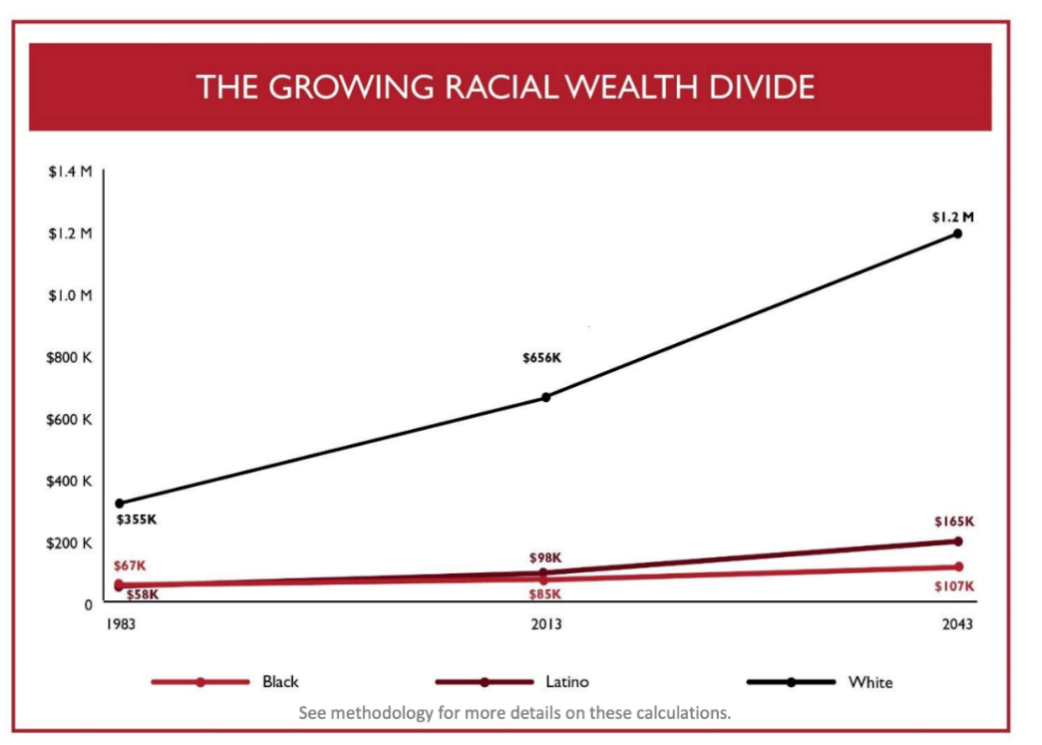
Figure 9³⁶

Knowledge Check
Since 1960, renters incomes have gone up by five percent while rental costs have gone up by 61 percent over this same period. As a result what is the overall shortage of affordable and available homes for extremely low-income renters?
A: 7 million units
What does “housing cost burdened” and “severely housing cost burdened” mean?
A: A household is considered housing cost burdened if they pay more than 30 percent of their income towards housing. Extremely housing cost burdened households are those that pay more than 50 percent of their income on housing.
What percentage of extremely low-income renters are extremely housing cost burdened?
A: Seventy-one percent
True or false: People of color are more likely to have extremely low-incomes than Whites and are overburdened by housing costs at higher rates?
A: True, 28 percent of Black households, 18 percent of American Indian or Alaska Native, and 16 percent of Hispanic households have extremely low-incomes as opposed to six percent of White households. Of these extremely low-income households, 70.9 percent of Black, 63 percent of American Indian or Alaska Native, 71.5 percent of Hispanic, and 69.6 percent of Whites are housing cost burdened.
What proportion of people receive the housing assistance that they need?
A: Only one in four people receive the assistance they need, leaving 75 percent of all eligible households without housing assistance.
Why is housing policy an important component of racial wealth inequality?
A: Homeownership is the largest contributing factor of racial wealth inequality (accounts for 27 percent of the wealth disparity). For most Americans, the majority of their wealth comes from the value of their home. Black households, in particular, have 56 percent of their assets from homeownership. Homeowners have $231,400 in median wealth compared to the $5,000 in median wealth for renters. Additionally, homeowners are able to claim the Mortgage Interest Deduction on their taxes, whereas renters receive no such tax benefit. Since households of color own homes at smaller rate than White households, the not only lose out on wealth from homeownership, but also do not see rewards for paying their housing costs in the way that homeowners do.

Harvard Joint Center on Housing Studies, “State of the Nation’s Housing, 2018.” https://www.jchs.harvard.edu/sites/default/files/Harvard_JCHS_State_of_the_Nations_Housing_2018.pdf. 2018.
Ibid.
Opportunity Starts at Home Campaign, “The Need for Action on Affordable Housing Affordability: Key findings from an online national survey of 1,201 adults conducted on behalf of Opportunity Starts at Home.”https://www.opportunityhome.org/wp-content/uploads/2019/03/Full-Report-PPT-NoEM.pdf. 2019.
Ibid.
Harvard Joint Center on Housing Studies, “State of the Nation’s Housing, 2018.” https://www.jchs.harvard.edu/sites/default/files/Harvard_JCHS_State_of_the_Nations_Housing_2018.pdf. 2018.
National Low Income Housing Coalition, “The Gap: A Shortage of Affordable Homes.” https://reports.nlihc.org/sites/default/files/gap/Gap-Report_2019.pdf. 2019.
Ibid.
Ibid.
Harvard Joint Center on Housing Studies, “State of the Nation’s Housing, 2018.” https://www.jchs.harvard.edu/sites/default/files/Harvard_JCHS_State_of_the_Nations_Housing_2018.pdf.
Opportunity Starts at Home Campaign, “The Need for Action on Affordable Housing Affordability: Key findings from an online national survey of 1,201 adults conducted on behalf of Opportunity Starts at Home.”https://www.opportunityhome.org/wp-content/uploads/2019/03/Full-Report-PPT-NoEM.pdf. 2019.
Children’s Health Watch, “Stable Homes Make Healthy Families.” https://childrenshealthwatch.org/wp-content/uploads/CHW-Stable-Homes-2-pager-web.pdf. 2018.
Kurtz, A., Yellin, T., Houp, W., “The US Minimum Wage Through the Years.” https://www.cnn.com/interactive/2019/business/us-minimum-wage-by-year/index.html. 2019.
National Low Income Housing Coalition, “Out of Reach: The High Cost of Housing.” https://reports.nlihc.org/sites/default/files/oor/OOR_2018.pdf. 2018.
Public and Affordable Housing Research Corporation, “Housing Agency Waiting Lists and the Demand for Housing Assistance.” https://www.housingcenter.com/wp-content/uploads/2017/11/waiting-list-spotlight.pdf. 2017.
National Low Income Housing Coalition, “The Long Wait For a Home: Volume 6, Issue 1.” https://nlihc.org/sites/default/files/HousingSpotlight_6-1_int.pdf. 2016.
Harvard Joint Center on Housing Studies, “State of the Nation’s Housing, 2018.” https://www.jchs.harvard.edu/sites/default/files/Harvard_JCHS_State_of_the_Nations_Housing_2018.pdf. 2018.
Ibid.
Ibid.
National Low Income Housing Coalition, “The Gap: A Shortage of Affordable Homes.” https://reports.nlihc.org/sites/default/files/gap/Gap-Report_2019.pdf. 2019.
Ibid.
Ibid.
Ibid.
Economic Policy Institute, “Modern Segregation” https://www.epi.org/publication/modern-segregation/
Annie E. Casey Foundation, “Concentration of Child Poverty by Race.“ https://datacenter.kidscount.org/data/tables/7753-children-living-in-areas-of-concentrated-poverty-by-race-and-ethnicity#detailed/1/any/false/1691,1607,1572,1485,1376,1201,1074,880/10,11,9,12,1,185,13/14943,14942
Ibid.
Ibid.
Oliver, M., Shapiro, T., “Disrupting the Racial Wealth Divide.” https://journals.sagepub.com/doi/full/10.1177/1536504219830672. 2019.
Shapiro, T., “The Roots of the Widening Racial Wealth Gap: Explaining the Black-White Economic Divide.” https://iasp.brandeis.edu/pdfs/Author/shapiro-thomas-m/racialwealthgapbrief.pdf
Choi, J., Zhu, J., Goodman, L., Ganesh, B., Strochak, S., “Millenial Homeownership: Why Is It So Low, and How Can We Increase It?” https://www.urban.org/research/publication/millennial-homeownership. 2018.
Harvard Joint Center on Housing Studies, “State of the Nation’s Housing, 2018.” https://www.jchs.harvard.edu/sites/default/files/Harvard_JCHS_State_of_the_Nations_Housing_2018.pdf. 2018.
Ibid.
Harvard Joint Center on Housing Studies, “State of the Nation’s Housing, 2018.” https://www.jchs.harvard.edu/sites/default/files/Harvard_JCHS_State_of_the_Nations_Housing_2018.pdf. 2018.
Brookings Institution, “The Devaluation of Assets in Black Neighborhoods.” https://www.brookings.edu/research/devaluation-of-assets-in-black-neighborhoods/. 2018.
Fernandex,E., McCaffrey,E., Rubens, K., Whitelemons, C., “Fall 2018 Journal: Mortgage Interest Deduction and the Racial Wealth Gap.” https://bppj.berkeley.edu/2018/08/23/mortgage-interest-deduction-and-the-racial-wealth-gap/. 2018.
Institute on Assets and Social Policy (IASP) and National Low Income Housing Coalition, “Misdirected Investments: How the Mortgage Interest Dedication Drives Inequality and the Racial Wealth Gap.” https://heller.brandeis.edu/iasp/pdfs/racial-wealth-equity/racial-wealth-gap/misdirected-investments.pdf. 2017.
Institute on Assets and Social Policy (IASP) and National Low Income Housing Coalition, “Misdirected Investments: How the Mortgage Interest Dedication Drives Inequality and the Racial Wealth Gap.” https://heller.brandeis.edu/iasp/pdfs/racial-wealth-equity/racial-wealth-gap/misdirected-investments.pdf. 2017.
Asante-Muhammad, D., Collins, C., Hoxie, J., Nieves, E., “The Ever Growing Gap: Without Change, African-American and Latino Families Won’t Match White Wealth for Centuries.” Prosperity Now, Racial Wealth Divide Initiative, and Institute for Policy Studies. https://prosperitynow.org/sites/default/files/resources/The_Ever_Growing_Gap-CFED_IPS-Final.pdf. 2016.

