2019 IC US Poverty Housing Policy Background: The Housing Crisis and Housing Assistance Policies
Section 1: The Link Between Housing and Poverty

Importance of Housing to Anti-Poverty Advocacy

Why Housing?
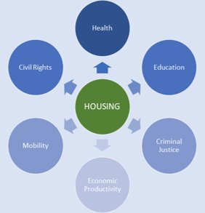
Housing affects everyone — whether they’re in a stable home or facing housing instability. Housing impacts multiple aspects of people’s lives, their health care, education, nutrition, and economic mobility. Families tend to spend their funds on rent before other expenses, and often housing cost is the single largest expense in a household budget. As author Matthew Desmond says, “the rent eats first”. -- Access to affordable, safe, and decent housing is an anti-poverty tool. When households pay a reasonable amount for housing (paying 30 percent of one’s income or less is considered affordable), they are able to use the remaining funds for other things like food, health care, bills, education, investments, or improvements in quality of life. But for too many families, affordable housing is out of reach. Rents have increased by 61 percent since 1960, while wages have only gone up by 5 percent. And while the high cost of housing impacts nearly one-third of all U.S. households, renters are hardest hit; close to 50 percent of renters are forced to pay unaffordable housing costs as opposed to 23 percent of homeowners.
Fortunately, public support around housing affordability is building. RESULTS sits on the Opportunity Starts at Home Campaign’s Roundtable, and their recent polling found that nine in ten people believe that stable affordable housing is very important or one of the most important things that effect people’s security and wellbeing. The poll also found that the concern for affordable housing has increased by 21 points in just three years, with the vast majority of people feeling the effects of the affordable housing crisis in their own community.
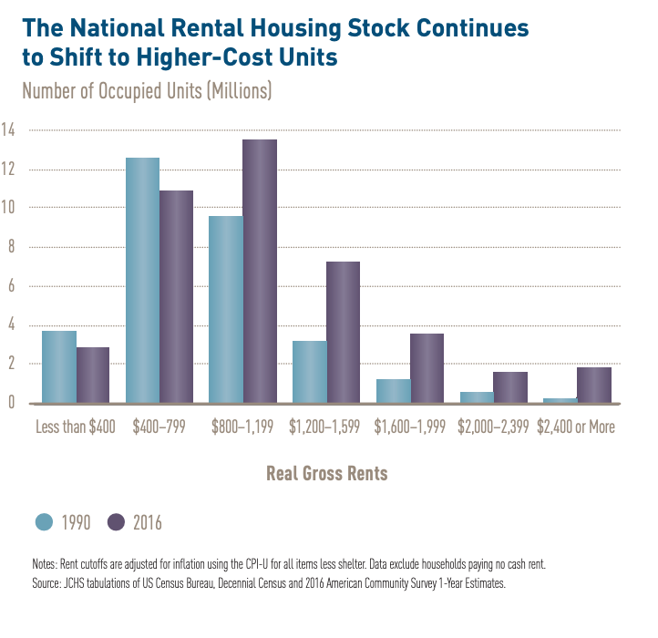
What is the Affordable Housing Crisis?
Lack of affordable housing stock coupled with stagnant wages and limited housing assistance are contributing factors to the affordable housing crisis. For instance, the Joint Center on Housing Studies at Harvard notes that between 1987 and 2015, there has been an increase of 6 million very low-income renters while the number of households getting assistance has only grown by 950,000. Consequently, the share of those getting federal housing assistance has decreased by 4 percent within that period, with only one in four eligible households getting assistance today.
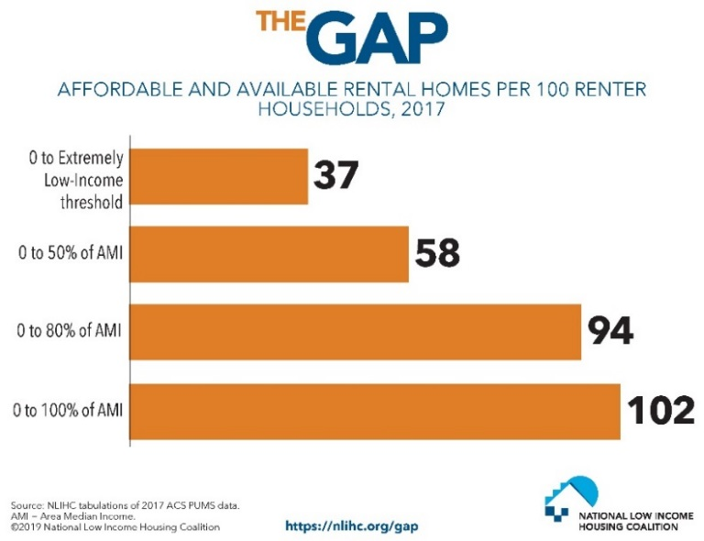
Nationwide, the supply of higher cost rental homes is increasing while the number of housing units for low-income households is going down (see figure 1). The National Low Income Housing Coalition estimates that there is an overall shortage of seven million affordable and available rental homes for extremely low-income households. This means that there are only 37 affordable and available rental units (see figure 2) per 100 households. Extremely low-income households are those with incomes at or below the federal poverty level or earn only 30 percent of the area median income (AMI), whichever is higher. Currently, no state in the nation offers enough affordable housing for extremely low-income renters. See figure 3 to understand how your state fares.
Figure 2⁶
Figure 1⁵
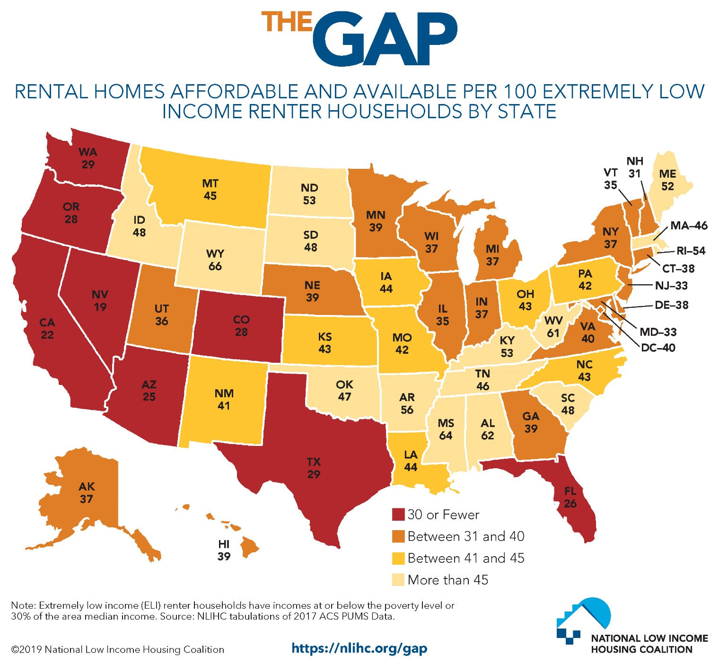
Figure 3⁶

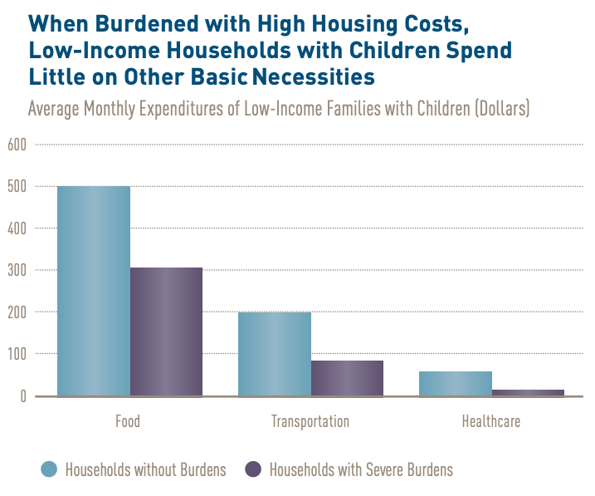
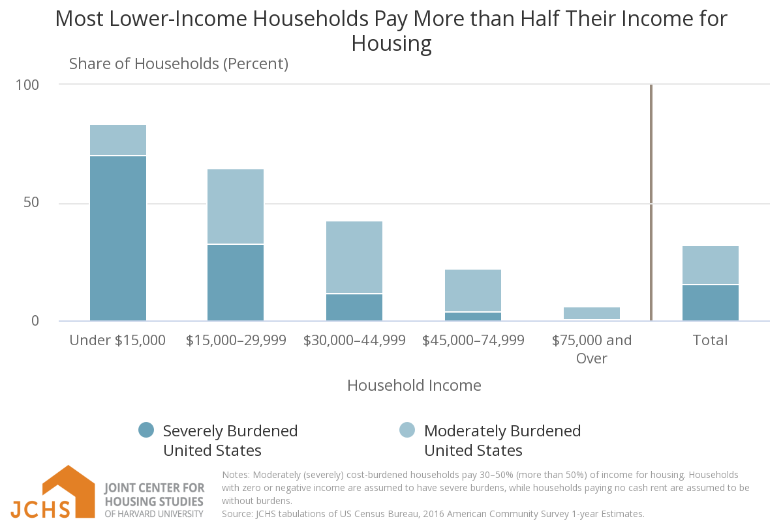
The shortage of affordable housing creates an unacceptable reality where extremely low-income renters are cost burdened, i.e. they pay more than 30 percent of their income for housing. For too many families, their monthly housing bill far outpaces this affordability mark. Seventy-one percent of all extremely low-income households pay more than 50 percent of their income towards rent. Not only are a majority of extremely low-income renters paying most of their income towards housing, they also make up the largest percentage of cost-burdened households (see figure 4). Unaffordable housing not only jeopardizes financial security, but also has long lasting effects on a range of other outcomes. Because households that are rental cost-burdened spend large portion of their income on housing and thus have less funds to spend on basic needs, are more likely to have poorer health, a higher risk of food insecurity, worse mental health outcomes, poor childhood performance on cognitive tests, and a higher risk of low weight and premature births.&
Figure 4⁹
When households are forced to pay more for rent it causes larger societal ripple effects. For example, unstable housing is projected to cost $111 billion over the next 10 years in health care costs for families with children. These costs are avoidable when families have access to safe, decent, affordable housing.
Figure 5⁹
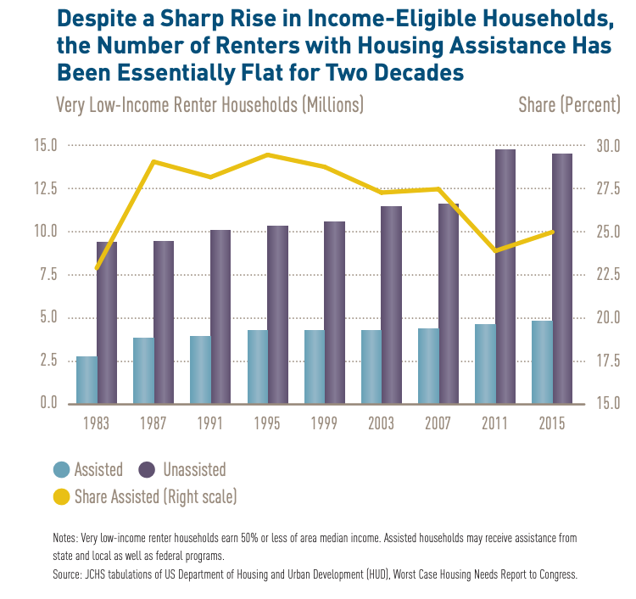
After accounting for inflation, the federal minimum wage ($7.25) has actually decreased in recent years, while the cost of living has not. In 2018, the “national housing wage” or the minimum wage needed for a full-time worker to afford a modest two-bedroom apartment was $22.10. Many Americans need help to fill the gap between rising housing costs and wage stagnation, but the need far outpaces what is provided. Currently, over four million households sit on the waiting list for housing assistance, and with many waitlists closed around the country, this number underestimates need.& With an average wait time of over two years, the need for affordable housing truly tips this issue to crisis levels. Research from the Joint Center for Housing Studies at Harvard University demonstrates that the number of assisted households have remained stagnant while the number of people qualifying for housing assistance has increased (figure 6). Due to this disinvestment, too many households face housing instability.
Figure 6¹⁵

The Disproportionate Impact of the Housing Crisis
As we have learned in other briefs, inequality is not shared equally. People of color, the elderly, and people with disabilities are disproportionately affected by the housing crisis:
- Seventy-eight percent of families with children, 66 percent of the elderly without children, and 56 percent of households with a disability without children go without the rental assistance that they need.
- Forty-eight percent of extremely low-income renter households are seniors or people with a disability.
- People of color are more likely to have extremely low-incomes than Whites (see figure 7, below).
- Over 71 percent of Hispanics, more than 70 percent of Black, and slightly above 69 percent of White extremely low-income renters are severely cost burdened.
- White renters are more likely than Black, Hispanic, and American Indian or Alaska Native renters to have household incomes above 80 percent of the area median.
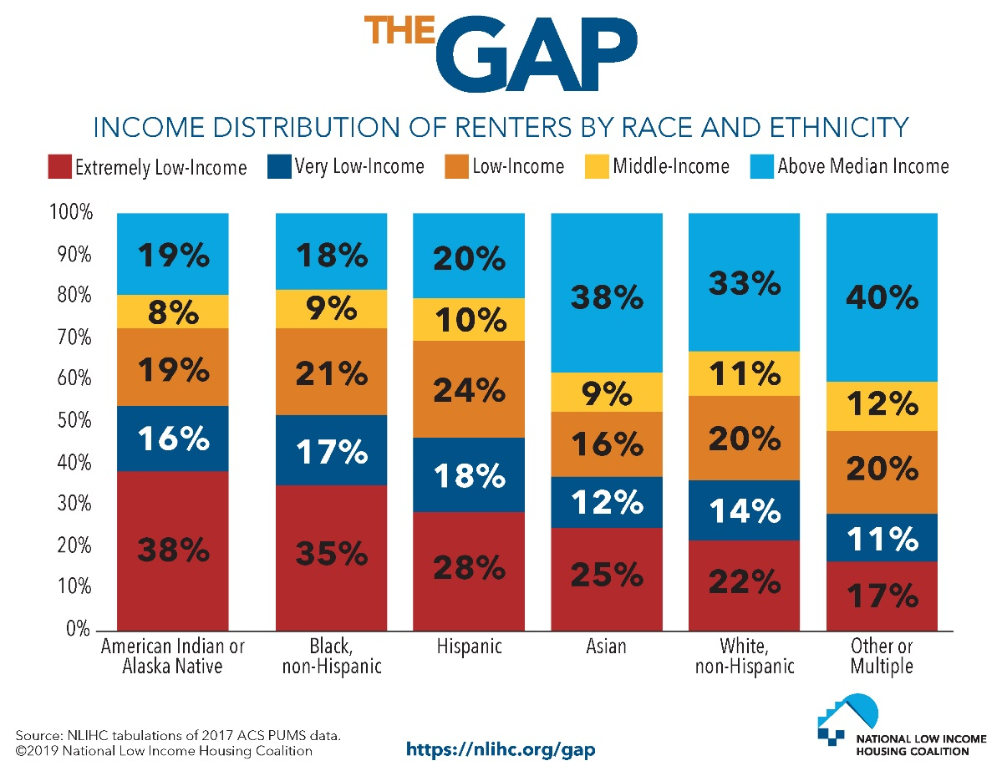

Figure 7¹⁸
Location is another central aspect of the housing crisis. Research shows that those who live in areas of concentrated poverty have worse life outcomes than folks who live in low-poverty areas. As noted in the US Poverty Creation of Wealth and Inequality Briefing, low-income families of color are more highly concentrated in areas of high poverty. From the most recent data, in 2014 seven percent of poor Whites, 15 percent of poor Latinos, and 23 percent of African Americans lived in high poverty neighborhoods. More recent data (2013-2017) show even higher rates for children: 28 percent of Black, 19 percent of Hispanic/Latino, 28 percent of Native American, and 4 percent of White children lived in areas of concentrated poverty. Research shows that living in under-resourced areas can cause negative impacts on children’s development, school achievement, and long term health. Yet, when families with low-incomes move to low-poverty neighborhoods, these child outcomes improve, in part because low-poverty areas are better resourced, giving children access to the needed services and amenities. Sadly, the lasting impact of structural racism, including segregationist housing policies are evident in these neighborhood outcomes, which impact a higher percent of people of color than Whites.

Housing and the Racial Wealth Divide
“Racial Wealth Inequality Conference Brief Section 1” outlined that wealth is an essential anti-poverty tool because it shields families from unexpected costs and allows them to invest in things that spur economic mobility. Yet, Black households own a dime for every dollar of White wealth. Discrepancies in homeownership account for 27 percent of the racial wealth gap, the highest of any factor. Consistently low rates of homeownership for Black households are due to our nation’s history of racial discrimination, especially as it relates to mortgage lending, predatory lending, segregation, blockbusting, and devaluation (see “The Creation of Wealth Inequality” briefing for more information). These historical policies have multi-generational effects as research shows that homeownership begets homeownership. Children from families that are wealthy, homeowners, or both have higher rates of homeownership as young adults (18-34 years old) than young adults from families that are not homeowners or have low-incomes. Coming from a homeowning household increases the likelihood of homeownership for 18-35 year old’s by 7-8 percent.

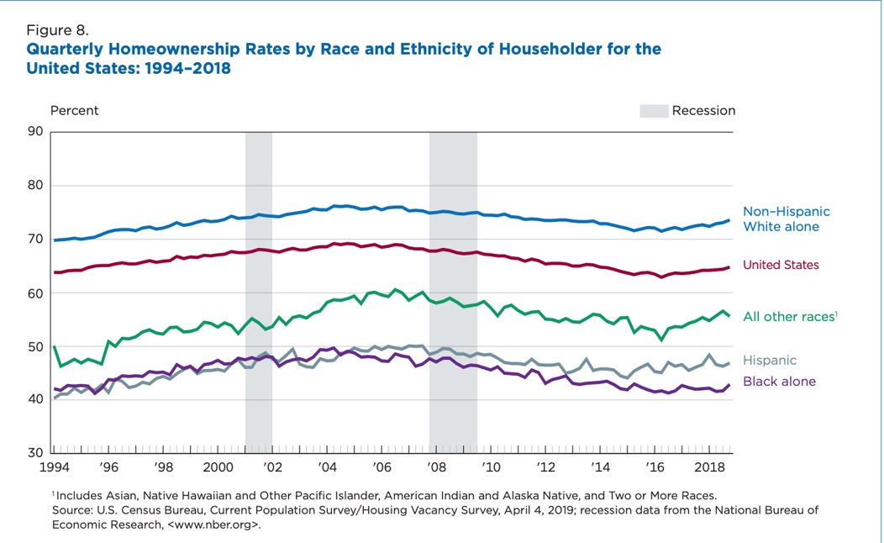
Figure 8

Since 1994, the gap between Black and White homeownership rates has widened, causing a rift of over 29 percent; 72 percent of White households own homes as opposed to 43 percent of Black households. For most Americans the bulk of their assets lie in the value of their home. This is especially true for Black homeowners, with 56 percent of their wealth coming from their homes, whereas home values only account for 38 percent of White household wealth. Homeowners also have drastically more in net wealth than renters. Renters have about $5,000 in median wealth as opposed to the $231,400 in wealth for homeowners, a 98 percent gap.
While homeownership is a main source of wealth, it is not a silver bullet solution. Black homeowners living in Black majority neighborhoods are kept from accessing the full value of their home. A 2018 report from the Brookings Institution showed that among comparable quality neighborhoods, homes were devalued by 23 percent in areas where more than half the residents were Black compared to neighborhoods with nearly zero Black residents. In total, those Black households lose the equivalent of $156 billion in assets. Since structural racism is embedded in every facet of our society, it will take a multi-pronged approach to end racial wealth inequality. However, through housing and tax policy, RESULTS advocates can make positive changes to one of the largest contributors to racial wealth inequality.
In addition to the lost wealth because of home devaluation, Black and Latino households receive disproportionately low tax benefits from the mortgage interest deduction (MID). The Mortgage Interest Deduction (MID), allows homeowners to deduct the interest paid on loans used to purchase, build, or improve their home from their federal taxes. In 2017, Black and Latino households each accounted for about 13 percent of the total population but only received six and seven percent of the total benefits of the MID, respectively. A fairer distribution of benefits would provide $4.8 billion for Black households and $4.1 billion for Latino households from the MID that each of these groups is not currently receiving.
The cost of current racial wealth inequality is large, but the cost of inaction will be even greater. Figure 9 illustrates what the future of racial wealth inequality would look like, before the TCJA was enacted. Since the TCJA gave large tax cuts to corporations and households who already had wealth, the wealth gap in figure 10 could be wider than projected.
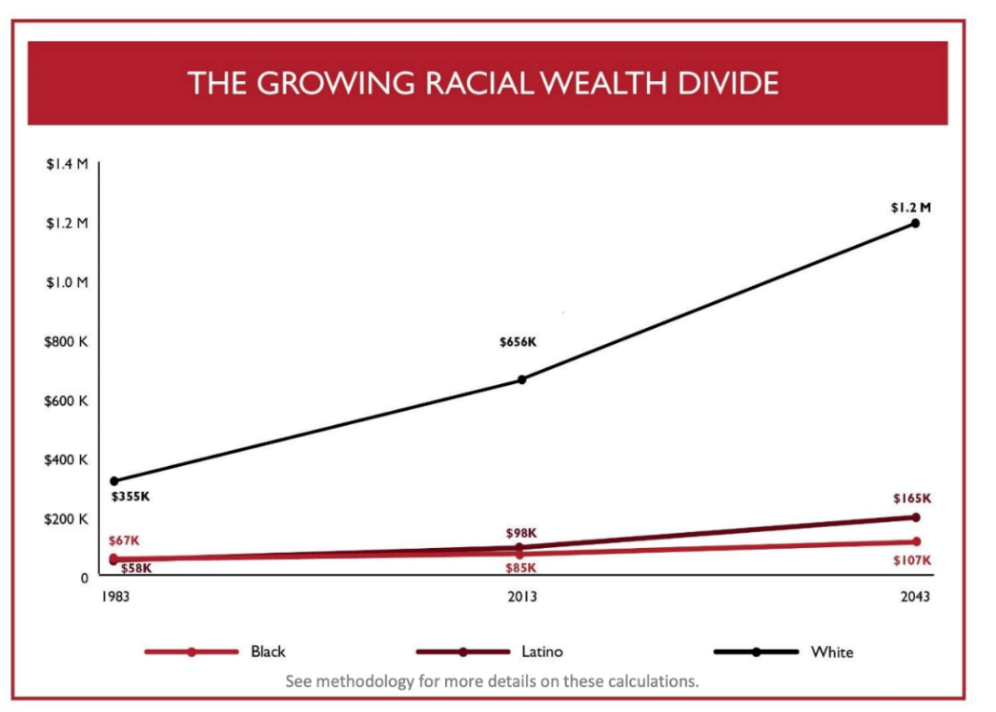
Figure 9³⁶

Section 2: Housing Assistance Policies

Housing Programs Currently in Effect

Affordable Housing Programs Overview
As outlined in the Racial Wealth Inequality Backgrounders the U.S. has a long history of policies that directly or indirectly blocked or built wealth via housing policy. The programs in effect today that address the housing needs for households with low-incomes arose in the 1930’s to counter the effects of the Great Depression.& Although public housing was the first form of federal housing assistance, a variety of new models are administered today. Currently, the Department of Housing and Urban Development, Department of Agriculture, and Department of Treasury administer housing assistance programs, like tax incentives and public housing. The next section will outline the various forms of housing assistance and how each impact households receiving assistance.

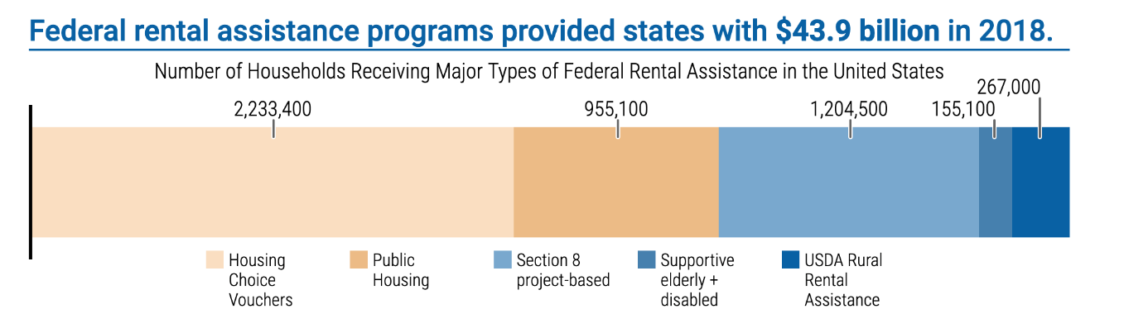
Currently housing assistance is provided for 10 million people in over 5 million households. In 2017, housing assistance alone lifted 2.9 million people out of poverty. The largest programs that support residents with low-incomes are Section 8 housing choice vouchers, Section 8 project based rental assistance, and public housing (see Figure 1).
Figure 10⁴¹
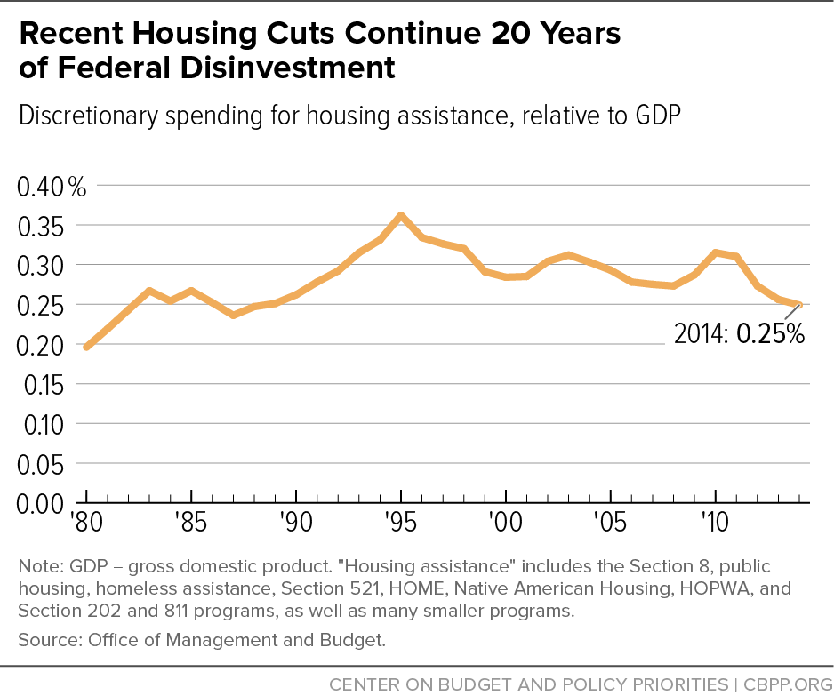
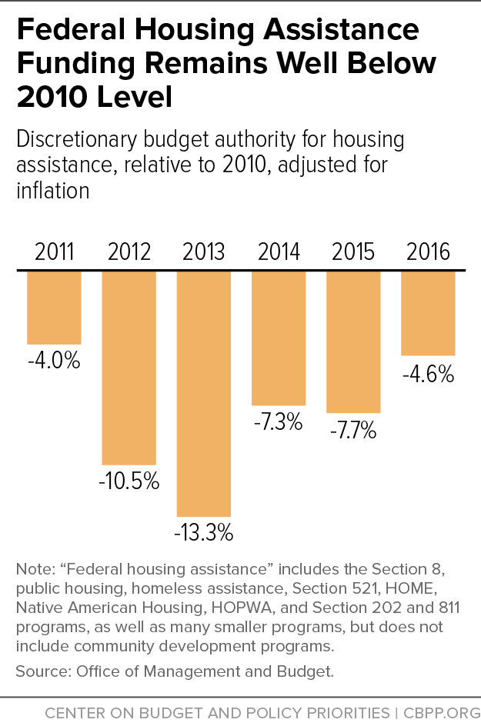
Funding for these incredibly necessary programs does not keep up with increasing need. According to the Center on Budget and Policy Priorities (see Figure 11 and 12), recent spending in housing assistance programs represents a similar proportion of the overall size of the economy to spending in the 1980s. As result, 75 percent of eligible households do not receive the housing assistance they need.

Figure 11⁴²
Figure 12⁴²

RESULTS members have the unique oppotunity to advocate for bolder solutions to affordable housing. Understanding current housing programs and how they support those with low-incomes across the U.S. better positions advocates to understand the ways new policy proposals can create positive impact. This background section will focus on current housing policies. However, one proposal that would ensure all those in need of rental assistance receive it is a renter’s tax credit. While there are tax credits, like the mortgage interest deduction, that benefit high income homeowners no such credit exists for renter households with low-incomes. See the Housing Policy Brief for more information on renters tax credit.
Section 8
The section 8 program provides two types of rental assistance: tenant-based rental assistance and project-based rental assistance. Tenant-based housing choice vouchers assist 2.2 million low-income households (or 5.3 million people),& making it the largest rental assistance program in the nation.& Project-based rental assistance currently supports 1.2 million households (or two million people). These two programs both utilize private market housing stock to meet the needs of residents with low-incomes.
Housing Choice Vouchers
Tenant-based housing choice vouchers (HCVs) which are popularly referred to as “Section 8” or “housing choice vouchers” (even though project-based rental assistance is also a type of section 8 housing assistance), provide families with vouchers that they can use on the private market to help pay housing costs. The programs started in the 1970s to shift responsibility to build and maintain housing away from the government to the private market. The program is run by thousands of public housing administrators (PHAs) across the U.S. At least 75 percent of vouchers go to households with incomes less than 30 percent of Area Median Income (AMI). The other 25 percent of vouchers can go to families that earn up to 80 percent of the area median income.
To make these income limits more tangible, see below for an example. Nevada has the greatest shortage of affordable and available rental units of any state, with just 19 for every 100 extremely low-income residents. Below is a chart that outlines the income limits for households using housing choice vouchers. Income limits are localized to reflect the cost of living differences around the country.
Carson City, NV | 1-Person Household | 2-person Household | 3-Person Household | 4-Person Household
Area Median Income (AMI) | $65,600 | $76,153 est. | $95,833 est. | $115,513 est.
30% AMI | $13,800 | $16,020 | $20,160 | $24,300
80% AMI | $36,750 | $42,000 | $47,250 | $52,500
Poverty Guideline | $12,490 | $16,910 | $21,330 | $25,750

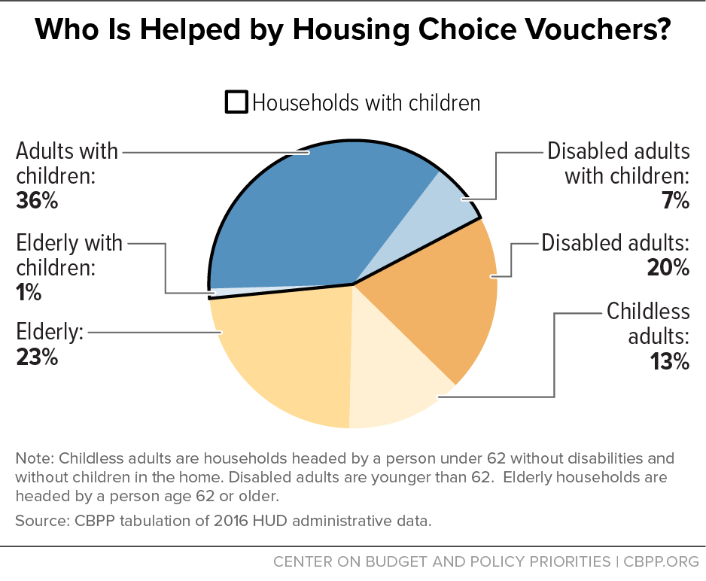
Obtaining a housing choice voucher is often a long process. After a household applies for a voucher they are often put on a waiting list. Currently, over four million households sit on waiting lists for HCVs, with an average wait time of over two years.,& In some areas, waitlists are closed because of such high demand. Those that receive vouchers have at least 60 days to find housing. Once a housing unit is found, a federal housing authority must verify that the unit meets safety and quality standards. Then, families can move into their new homes using the housing choice voucher to help cover rental costs. These vouchers are transferable with a family, meaning they are tenant-based. If a family moves they are still able to use their voucher in a different unit. Of the two million households that receive housing choice vouchers, the largest population of recipients are families with children (see figure 13).
Figure 13⁴⁷

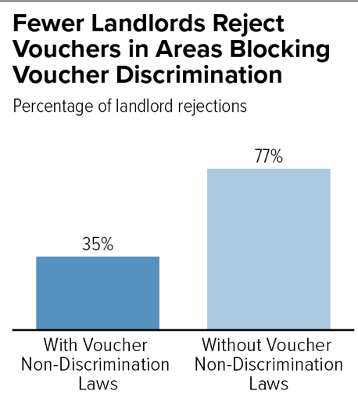
Households with HCVs pay what is nationally deemed affordable, 30 percent of their income or a minimum $50 per household towards rent. The housing voucher covers the rest of the rent up to a reasonable amount. This allows families with low-incomes to afford decent homes without being overburdened by rental costs. Housing choice vouchers differ from public housing because low-income residents can choose their own home on the private market.
Figure 14⁶²
Due to the small stock of affordable rental units, choice does not mean that all markets are open to those using housing choice vouchers. In fact, Center on Budget and Policy Priorities published a report detailing the struggle many low-income households face when trying to locate housing on the private market due, in part, to shortage of affordable housing, competition with higher income households, and discrimination based on the use of housing choice vouchers.& Although nearly all issued vouchers are used, some families are not able to find housing in the time allotted and must forfeit their voucher to the next household on the waiting list.
Currently, there are no federal protections to stop landlords from discriminating against renters based on their source of income. Eleven states, including Washington DC, and 50 localities have laws against source of income discrimination for voucher holders (see figure 15). Still, 2 in 3 voucher holders are not protected against discrimination. Source of income protections have been shown to reduce discrimination, allowing families to gain access to housing. In areas where source of income protections exist, studies show that there is a decrease in discrimination cases (Figure 14).
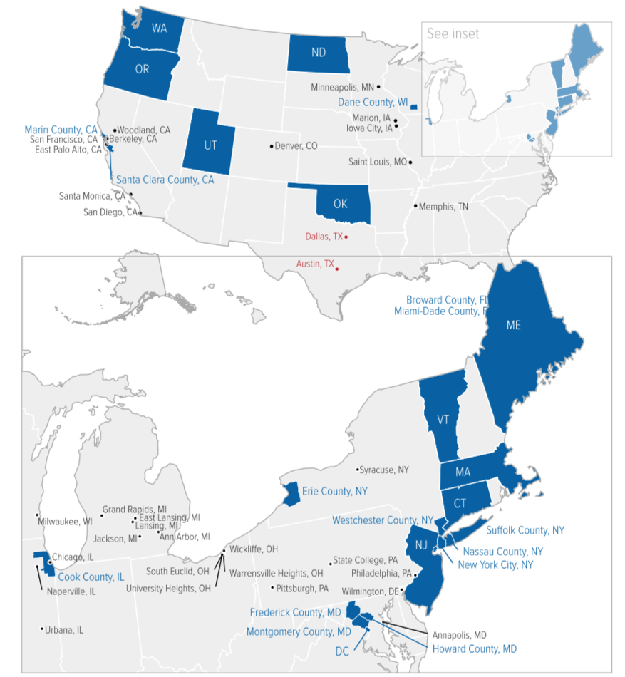
Figure 15⁶²

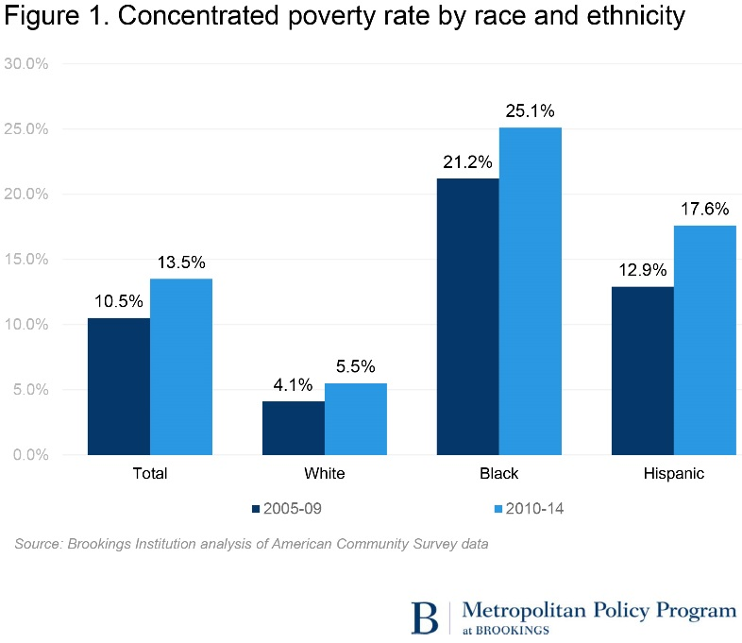
Housing choice vouchers lift families out of poverty and improve well-being because they keep rent burdens low, allowing households to put more money towards meeting basic needs and improving quality of life. However, the neighborhoods were some families are able to secure housing have high concentrations of poverty, meaning that more than 40 percent of resident live with incomes at or below the federal poverty line. These areas are often subject to disinvestment which creates conditions like lack of jobs, poorly funded schools, and nascent public transit. Of all low-income households, Black households were five times more likely and Hispanic households were three times more likely than Whites to live in areas of concentrated poverty according to the most recent 2010-2014 data (see Figure 16). Neighborhoods of concentrated poverty can have negative effects on the long-term wellbeing of residents. Low-income residents face several barriers to economic mobility, health, and educational attainment that are exacerbated in areas of concentrated poverty. In contrast, neighborhoods with “high opportunity” magnify the positive effects of housing choice vouchers. High opportunity areas are marked by low poverty, which means that ten percent of the population or less have incomes at or below poverty lines, have good schools, quality jobs, and accessible transportation. Often these high opportunity neighborhoods are out of reach for many low-income residents either due to income segregation, racial segregation, voucher discrimination, or other barriers.
Figure 16⁶⁶
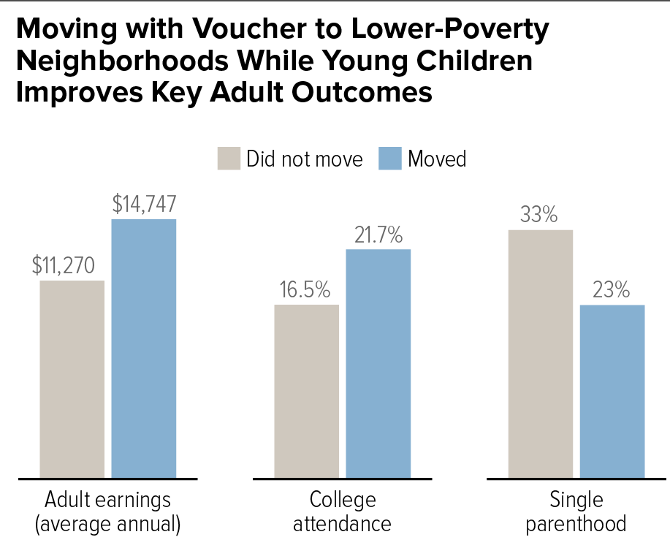
Low-income children who move to high opportunity neighborhoods are more likely to: attend college, earn higher salaries, have better educational outcomes, among other well-being and behavioral indicators (see figure 17). When they move to high opportunity areas, parents are less likely to experience poor mental and physical health outcomes, which benefits children living in their households. One of the goals of the housing choice voucher program is to shift away from the model of concentrated poverty created by large public housing complexes. To work toward decreasing concentrated poverty, Congress began appropriating funds for a Mobility Voucher Demonstration project this year.& Mobility vouchers now devote resources to support families moving to areas of high opportunity.
Figure 17⁶⁹
Project Based Rental Assistance
Although rarely referred to as such, project-based rental assistance is also part of the section 8 housing assistance program. Established in 2001, this program is referred to as project-based because housing units are based at a certain property. Project-based assistance allows public housing authorities to allocate some of their housing choice vouchers to a specific location. For renters that have difficulty finding homes, project-based rental assistance provides stable, guaranteed affordable housing that renters do not have to actively seek out.
This program is also part of the private market, meaning property owners contract their housing units with a PHA to be used for project-based rental assistance. The PHA can have a multi-year contract with the owner, which creates a reliable source of income for the private owner while ensuring a stable affordable housing stock. Although this model does not allow for much resident choice at first, after their first year living in a project-based location, residents are eligible to receive the next open tenant-based voucher to move to a home of their choice.
The eligibility criteria for project-based rental assistance is somewhat different from tenant-based. For an entire property, at least 40 percent of assisted units must go to those with incomes either below 30 percent of the area median income or at the poverty line, whichever is higher. Most of the other units must go to families with income at 50 percent of the area median.

Policy Updates
Currently, the Trump Administration and members of Congress have put forth several policy proposals that would either threaten or support Section 8. The most notable of these proposals include:
- On June 4th the full House Appropriations Committee approved the Transportation, Housing, and Urban Development (THUD) appropriations bill moving it to the House floor for amendments and voting. Although the bill did not include the substantial increases RESULTS advocates worked tirelessly for, it does meet current funding levels and provides an increase for HCVs. Housing choice vouchers received a $1.2 billion dollar increase (5.4 percent) over current funding levels and $1.6 billion over the President’s budget request. This will allow 9,000 additional families to access affordable housing across the nation, which is a major success. This bill also provided $25 million for the Housing Choice Voucher Mobility Demonstration Project whereas the President’s Budget provided no funding for this program. Although the $25 million is the same funding amount from last year, this program supports an additional 500 families to move to areas of greater opportunity, providing more resources for upward mobility.
- The Senate has not yet considered their T-HUD bill but is expected to provide the same level of assistance or less than the House.
HUD "Mixed Status” Proposed Rule: An Attack on Immigrant Families
At the beginning of May, the Department of Housing and Urban Development (HUD) proposed a rule to prevent “mixed status” households from receiving housing assistance. Mixed status households include individuals who are eligible and ineligible for housing assistance based on their immigration status. This rule not only targets undocumented individuals but other legal residents as well, under the guise of putting U.S. citizens first. Currently, mixed status households are able to live together but received prorated rental subsidies where the household members with eligible documentation status receive assistance, but ineligible members do not. For example, if there were four people living in a house, two U.S. citizens and two ineligible immigrants, HUD would only provide assistance for the two eligible family members but allow all members to live together. The administration has falsely asserted that this proposal prioritizes citizen households. Yet, HUD’s own research found that this proposal would evict 108,000 people including 75,600 citizens, of which 70 percent are children. Additionally, HUD’s analysis showed that this rule would reduce the number of subsidies provided to families because Congress would be unlikely to appropriate the $227 million a year the proposed rule would cost. Instead, the HUD study predicts that the rule would reduce the quality and quantity of rental assistance to families which could lead to further deterioration and vacancy. This proposed rule does not put U.S. citizens first, as it unnecessarily evicts more than 75,000. Instead this rule is part of the administration’s efforts to stoke fear in immigrant households across the U.S. while pretending to protect the needs of low-income families. RESULTS advocates can submit comments until July 9 against this rule by visiting this website.

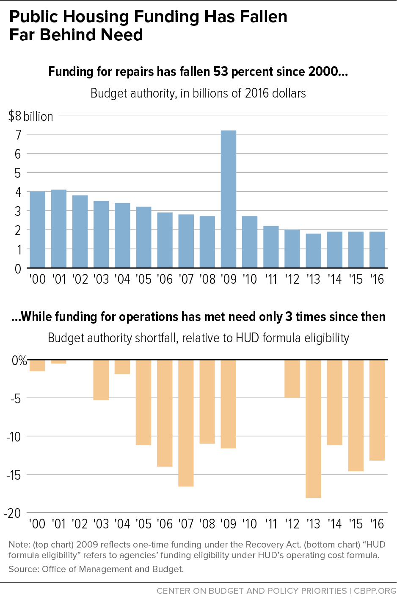
Public Housing
Public housing was the original form of housing assistance. Like housing choice vouchers it is also administered through public housing agencies (PHA). Currently, nearly one million residents utilize public housing. Although many think of public housing as large apartment towers, public housing comes in all shapes in sizes. In 2016, two in five units were in areas of low or moderate poverty.
Renters are eligible if their income is at or below 80 percent or the area median income. Additionally, at least four out of ten new residents each year must have incomes at or below 30 percent of the area median or at the poverty line. The rental cost of public housing is a little more flexible than other programs. Tenants must pay 30 percent of their income or $50 (even if that is above the 30 percent threshold) or pay a steady rate based on the local market instead of fluctuating rent based on income.
The stock of public housing has steadily decreased for the past 20-plus years. After the Nixon administration created the section 8 programs, investment in public housing expansion began to decline. During that time substantial portions of public housing were sold, demolished or converted to the voucher program. HUD officials estimate that about 10,000 units of public housing are lost per year, amounting to a loss of over 250,000 lost units since the 1990s.& Public housing is normally funded through the Public Housing Operating Fund (pays for operational costs) and the Public Housing Capital Fund (pays for updates, renovations, and remodels), yet both programs have been consistently underfunded (see Figure 18). Due, in part, to severe disinvestment the backlog on needed repairs to public housing exceeds $40 billion and has led to dangerous conditions for residents in areas like New York and Illinois. While investments in public housing may seem counterproductive, due to the presence of housing choice vouchers, public housing is the only form of permanent affordable housing that is available to people with low-incomes, seniors and folks with disabilities.
Figure 18⁴²

Policy Updates
Due to the ongoing shortfall in funding for public housing, there are a few legislative proposals that work to narrow the margin between funding and unmet need. The President’s budget proposal eliminated the Public Housing Capital Fund which would leave no funds for updates or renovations to public housing.
- The House THUD bill set funding levels at $2.9 billion for the Public Housing Capital Fund, a full $80 million above last years enacted levels. In addition, the bill provided $4.8 billion for the Public Housing Operating Funds to ensure public housing can continually operate.
- Representative Maxine Waters introduced the Housing is Infrastructure Bill draft which would provide $70 billion of the Public Housing Capital Fund. All necessary fixes could be made with this level of funding.
- Senator Elizabeth Warren introduced a plan (S.787 American Housing and Economic Mobility Act of 2019) for affordable housing that would provide $3.6 billion for the Public Housing Capital Fund for 2020.&
National Housing Trust Fund
While the previous programs focused on the demand side of the affordable housing crisis, the housing trust fund (HTF) attempts to support an increase in supply for low and extremely low-income households. States that are granted National Housing Trust Fund dollars must use at least 80 percent of the funds for rental housing and 10 percent for homeownership. Additionally, the housing must be targeted specifically at low and extremely low-income households, with the majority of resources targeted to extremely low-income households (those with income at or below 30 percent of the area median or less than the poverty line). Congress mandated that the two major federal mortgage backing organizations, Fannie Mae and Freddie Mac set aside nearly .03 percent of new business for the housing trust fund. In 2016 the first round of funds were awarded, and last year the HTF had $267 million total in funds. The National Low Income Housing Coalition found that, in 2018, 42 states had been awarded funding and about 1,500 housing units were in the process of being constructed or rehabilitated for those with low-incomes.
Although small right now, the HTF has significant potential to increase the supply of affordable housing so that those with the lowest incomes can obtain an affordable home.

Policy Updates
Since the National Housing Trust Fund is a key resource for building affordable housing, several members of Congress have made proposals regarding its funding.
- Senator Elizabeth Warren’s American Housing and Economic Mobility Act (S. 787) would provide $445 billion to the Housing Trust Fund over ten years, or over $44 billion per year. An independent analysis forecasted this funding level would create 2.1 million homes for families with low-incomes.
- At the beginning of June, Senator Cory Booker announced an updated version of his renters tax credit bill. This year’s bill would allocate $40 billion per year for the Housing Trust Fund to expand the stock of affordable housing.
- Representative Maxine Waters’ Housing is Infrastructure bill draft provides $5 billion to the Housing Trust Fund for 2020, prioritizing properties built for families experiencing or at risk of experiencing homelessness. Although talks disintegrated, Republican and Democratic leadership did propose a $2 trillion infrastructure package that could have included funding for the National Housing Trust Fund using Representative Waters’ proposal as guidance.

Tax Code
Tax incentives are one of the most widely hidden subsidies in the U.S. There are three different provisions in the tax code related to housing. Most existing credits benefit wealthy homeowners instead of cost burdened renters. Seeing the opportunity that the tax code provides, several policymakers have proposed tax credits for households that are renters with low-income. See the housing brief for more information about renter tax credits.
Mortgage Interest Deduction
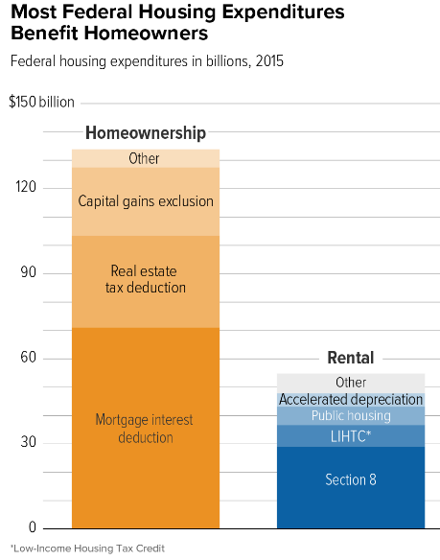
The mortgage interest deduction (MID) allows tax payers to deduct the interest paid on loans to purchase, build, or improve their homes from their annual taxes. This deduction can also be used on second homes. Since White families are more likely to be homeowners, this tax predominately goes to White households. The Tax Cuts and Jobs Act of 2017 (TCJA) made some minor provisions to the MID, but the bulk of the beneficiaries are still the highest income households (see figure 20).& Although the MID benefits homeownership, and as detailed in previous briefing packets homeownership is a major source of wealth building, it does not incentivize renters to become homeowners. Instead, the MID supports existing homeowners and home remodels while providing no support for renters to access the same level of benefits. By not supporting renters to homeownership, the MID serves as another driver of racial wealth inequality as it predominately benefits the 72 percent of White folks that own their homes as opposed to folks of color who own homes at much lower rates from 42-60 percent.
Figure 19¹⁰²

Figure 20⁹⁹

Low-Income Housing Tax Credit (LIHTC)
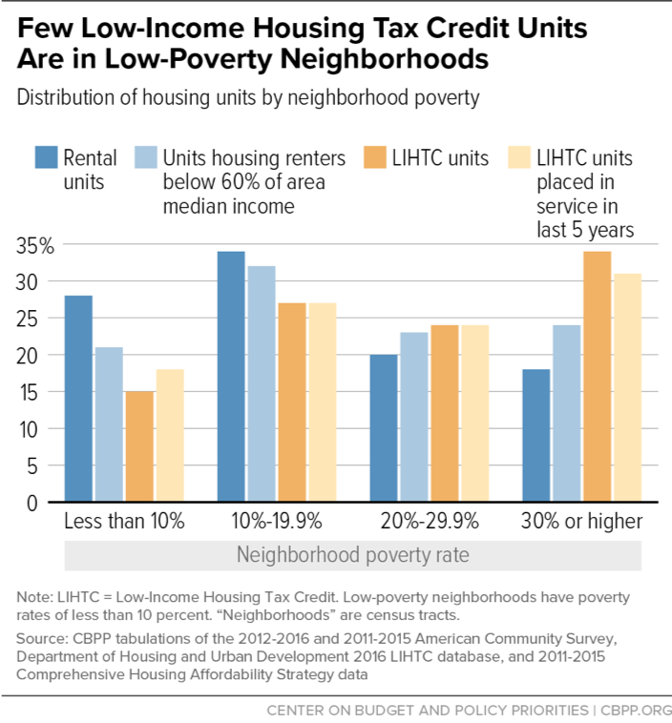
Out of all the tax incentives discussed in this brief, the low-income housing tax credit is the only one that incentivizes home building specifically for low-income populations. Created in 1986, HUD describes LIHTC as the “most important resource for creating affordable housing”, and LIHTC has a history of bipartisan support in Congress. The credit is provided to housing developers that will set aside a certain portion of a housing development for affordable rental units, defined as units that rent for no more than 30 percent of a tenant’s income. Renters in these units can make no more than 60 percent of the area median income.& Developers must maintain the affordability of these units for at least 15 years and often this requirement is extended to 30 years. Three major drawbacks of this tax credit are 1) affordability is often difficult to maintain after the required 15-30 year compliance period ends 2) units tend to be concentrated in high poverty areas and 3) the credit is seen as more of a benefit to developers than low income renters. Scholars, like Dr. Algernon Austin (who will be speaking at this year’s International Conference), have supported shifting the funds from the Low Income Housing Tax Credit to housing choice vouchers because of these drawbacks.
Figure 21¹⁰⁶

Estate Tax
The TCJA doubled estate tax exemptions. Now, individuals who inherit estates worth up to $11 million will pay no taxes on that inheritance. This change expires in 2025 and is projected to decrease revenue by over $5 billion just in its first year, while benefitting less than 2,000 Americans.& Prior to drastic tax cuts since 2001, the estate tax has generated as much as $24.6 billion in revenue, annually (see figure 22, below). This is another example of how the tax system currently benefits wealthy homeowners while providing no offsets for low-income renters.
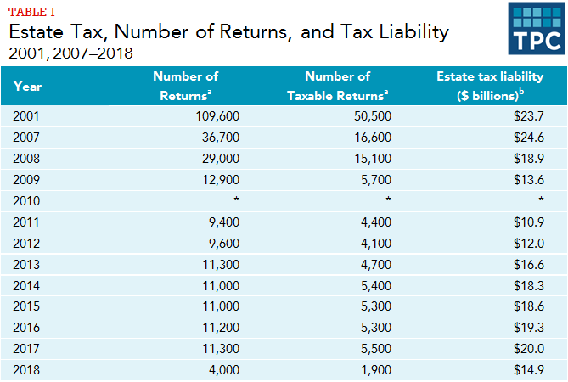
Figure 22¹¹⁰

Knowledge Check
Since 1960, renters incomes have gone up by 5 percent while rental costs have gone up by 61 percent over this same period. As a result, what is the overall shortage of affordable and available homes for extremely low-income renters?
A: 7 million units
What does “housing cost burdened” and “severely housing cost burdened” mean?
A: A household is considered housing cost burdened if they pay more than 30 percent of their income towards housing. Extremely housing cost burdened households are those that pay more than 50 percent of their income on housing.
What percentage of extremely low-income renters are extremely housing cost burdened?
A: Seventy-one percent
How many households are supported by housing assistance program in the United States? And what percentage of eligible households are not provided with the housing assistance they need?
A: Over five million households receive housing assistance. Seventy-five percent of households that are eligible for assistance do not receive it.
Why is housing policy an important component of racial wealth inequality?
A: Homeownership is one the largest contributing factor of racial wealth inequality (accounts for 27 percent of the wealth disparity). For most Americans, the majority of their wealth comes from the value of their home. Black households, in particular, have 56 percent of their assets from homeownership. Homeowners have $231,400 in median wealth compared to the $5,000 in median wealth for renters. Additionally, homeowners are able to claim the Mortgage Interest Deduction on their taxes, whereas renters receive no such tax benefit. Since households of color own homes at smaller rate than White households, the not only lose out on wealth from homeownership, but also do not see rewards for paying their housing costs in the way that homeowners do.
Which program supports the largest number of households needing rental assistance?
A: Tenant-based housing choice vouchers support over two million households and over five million people, making it the largest housing assistance program.
Why is the National Housing Trust Fund important?
A: The National Housing Trust Fund provide funding to build affordable housing for households with the lowest incomes. It is the only funding stream that encourages the creation of permanently affordable housing for people with low incomes.

Harvard Joint Center on Housing Studies, “State of the Nation’s Housing, 2018.” https://www.jchs.harvard.edu/sites/default/files/Harvard_JCHS_State_of_the_Nations_Housing_2018.pdf. 2018.
Ibid.
Opportunity Starts at Home Campaign, “The Need for Action on Affordable Housing Affordability: Key findings from an online national survey of 1,201 adults conducted on behalf of Opportunity Starts at Home.”https://www.opportunityhome.org/wp-content/uploads/2019/03/Full-Report-PPT-NoEM.pdf. 2019.
Ibid.
Harvard Joint Center on Housing Studies, “State of the Nation’s Housing, 2018.” https://www.jchs.harvard.edu/sites/default/files/Harvard_JCHS_State_of_the_Nations_Housing_2018.pdf. 2018.
National Low Income Housing Coalition, “The Gap: A Shortage of Affordable Homes.” https://reports.nlihc.org/sites/default/files/gap/Gap-Report_2019.pdf. 2019.
Ibid.
Ibid.
Harvard Joint Center on Housing Studies, “State of the Nation’s Housing, 2018.” https://www.jchs.harvard.edu/sites/default/files/Harvard_JCHS_State_of_the_Nations_Housing_2018.pdf.2018.
Opportunity Starts at Home Campaign, “The Need for Action on Affordable Housing Affordability: Key findings from an online national survey of 1,201 adults conducted on behalf of Opportunity Starts at Home.”https://www.opportunityhome.org/wp-content/uploads/2019/03/Full-Report-PPT-NoEM.pdf. 2019.
Children’s Health Watch, “Stable Homes Make Healthy Families.” https://childrenshealthwatch.org/wp-content/uploads/CHW-Stable-Homes-2-pager-web.pdf. 2018.
Kurtz, A., Yellin, T., Houp, W., “The US Minimum Wage Through the Years.” https://www.cnn.com/interactive/2019/business/us-minimum-wage-by-year/index.html. 2019.
National Low Income Housing Coalition, “Out of Reach: The High Cost of Housing.” https://reports.nlihc.org/sites/default/files/oor/OOR_2018.pdf. 2018.
Public and Affordable Housing Research Corporation, “Housing Agency Waiting Lists and the Demand for Housing Assistance.” https://www.housingcenter.com/wp-content/uploads/2017/11/waiting-list-spotlight.pdf. 2017.
National Low Income Housing Coalition, “The Long Wait For a Home: Volume 6, Issue 1.” https://nlihc.org/sites/default/files/HousingSpotlight_6-1_int.pdf. 2016.
Harvard Joint Center on Housing Studies, “State of the Nation’s Housing, 2018.” https://www.jchs.harvard.edu/sites/default/files/Harvard_JCHS_State_of_the_Nations_Housing_2018.pdf. 2018.
Ibid.
Ibid.
National Low Income Housing Coalition, “The Gap: A Shortage of Affordable Homes.” https://reports.nlihc.org/sites/default/files/gap/Gap-Report_2019.pdf. 2019.
Ibid.
Ibid.
Ibid.
Economic Policy Institute, “Modern Segregation” https://www.epi.org/publication/modern-segregation/
Annie E. Casey Foundation, “Concentration of Child Poverty by Race.“ https://datacenter.kidscount.org/data/tables/7753-children-living-in-areas-of-concentrated-poverty-by-race-and-ethnicity#detailed/1/any/false/1691,1607,1572,1485,1376,1201,1074,880/10,11,9,12,1,185,13/14943,14942
Ibid.
Ibid.
Oliver, M., Shapiro, T., “Disrupting the Racial Wealth Divide.” https://journals.sagepub.com/doi/full/10.1177/1536504219830672. 2019.
Shapiro, T., “The Roots of the Widening Racial Wealth Gap: Explaining the Black-White Economic Divide.” https://iasp.brandeis.edu/pdfs/Author/shapiro-thomas-m/racialwealthgapbrief.pdf
Choi, J., Zhu, J., Goodman, L., Ganesh, B., Strochak, S., “Millenial Homeownership: Why Is It So Low, and How Can We Increase It?” https://www.urban.org/research/publication/millennial-homeownership. 2018.
Harvard Joint Center on Housing Studies, “State of the Nation’s Housing, 2018.” https://www.jchs.harvard.edu/sites/default/files/Harvard_JCHS_State_of_the_Nations_Housing_2018.pdf. 2018.
Ibid.
Harvard Joint Center on Housing Studies, “State of the Nation’s Housing, 2018.” https://www.jchs.harvard.edu/sites/default/files/Harvard_JCHS_State_of_the_Nations_Housing_2018.pdf. 2018.
Perry, A., Rothwell, J., Harshbarger, D., Brookings Institution, “The Devaluation of Assets in Black Neighborhoods.” https://www.brookings.edu/research/devaluation-of-assets-in-black-neighborhoods/. 2018.
Fernandex,E., McCaffrey,E., Rubens, K., Whitelemons, C., “Fall 2018 Journal: Mortgage Interest Deduction and the Racial Wealth Gap.” https://bppj.berkeley.edu/2018/08/23/mortgage-interest-deduction-and-the-racial-wealth-gap/. 2018.
Institute on Assets and Social Policy (IASP) and National Low Income Housing Coalition, “Misdirected Investments: How the Mortgage Interest Dedication Drives Inequality and the Racial Wealth Gap.” https://heller.brandeis.edu/iasp/pdfs/racial-wealth-equity/racial-wealth-gap/misdirected-investments.pdf. 2017.
Institute on Assets and Social Policy (IASP) and National Low Income Housing Coalition, “Misdirected Investments: How the Mortgage Interest Dedication Drives Inequality and the Racial Wealth Gap.” https://heller.brandeis.edu/iasp/pdfs/racial-wealth-equity/racial-wealth-gap/misdirected-investments.pdf. 2017.
Asante-Muhammad, D., Collins, C., Hoxie, J., Nieves, E., “The Ever Growing Gap: Without Change, African-American and Latino Families Won’t Match White Wealth for Centuries.” Prosperity Now, Racial Wealth Divide Initiative, and Institute for Policy Studies. https://prosperitynow.org/sites/default/files/resources/The_Ever_Growing_Gap-CFED_IPS-Final.pdf. 2016.
National Low Income Housing Coalition, “2019 Advocate Guide.” https://nlihc.org/explore-issues/publications-research/advocates-guide. 2019.
The Nation, “151 Years of America’s Housing History.” https://www.thenation.com/article/americas-housing-history/. 2018.
Fox, L., “The Supplemental Poverty Measure: 2017.” U.S. Census Bureau. https://www.census.gov/library/publications/2018/demo/p60-265.html. 2018.
Center on Budget and Policy Priorities, “Federal Rental Assistance Fact Sheets.” https://www.cbpp.org/research/housing/federal-rental-assistance-fact-sheets#US. 2019.
Rice, D. Center on Budget and Policy Priorities, “Chart Book: Cuts in Federal Assistance Have Exacerbated Families’ Struggle to Afford Housing.” https://www.cbpp.org/research/housing/chart-book-cuts-in-federal-assistance-have-exacerbated-families-struggles-to-afford. 2016.
Center on Budget and Policy Priorities, “Three Out of Four Low-Income At-Risk Renters Do Not Receive Federal Rental Assistance.” https://www.cbpp.org/three-out-of-four-low-income-at-risk-renters-do-not-receive-federal-rental-assistance. 2017.
Center on Budget and Policy Priorities, “Federal Rental Assistance Fact Sheets.” https://www.cbpp.org/research/housing/federal-rental-assistance-fact-sheets#US. 2019.
Center on Budget and Policy Priorities, “Policy Basics: The Housing Choice Voucher Program.” https://www.cbpp.org/research/housing/policy-basics-the-housing-choice-voucher-program. 2017.
Center on Budget and Policy Priorities, “Federal Rental Assistance Fact Sheets.” https://www.cbpp.org/research/housing/federal-rental-assistance-fact-sheets#US. 2019.
Center on Budget and Policy Priorities, “Housing Choice Voucher Fact Sheet.” https://www.cbpp.org/housing-choice-voucher-fact-sheets. 2017.
Center on Budget and Policy Priorities, “Policy Basics: Section 8 Project- Based Rental Assistance.” https://www.cbpp.org/research/housing/policy-basics-section-8-project-based-rental-assistance. 2017.
National Low Income Housing Coalition, “The GAP: A Shortage of Affordable and Available Rental Homes.” https://reports.nlihc.org/sites/default/files/gap/Gap-Report_2019.pdf. 2019.
Department of Housing and Urban Development, “FY FMR and IL Summary System.” https://www.huduser.gov/portal/datasets/fmr/fmr_il_history/data_summary.odn.
Ibid.
U.S. Department of Health and Human Services, “2019 Poverty Guidelines.” https://aspe.hhs.gov/2019-poverty-guidelines. 2019.
Public and Affordable Housing Research Corporation, “Housing Agency Waiting Lists and the Demand for Housing Assistance.” https://www.housingcenter.com/wp-content/uploads/2017/11/waiting-list-spotlight.pdf. 2017.
National Low Income Housing Coalition, “The Long Wait For a Home: Volume 6, Issue 1.” https://nlihc.org/sites/default/files/HousingSpotlight_6-1_int.pdf. 2016.
Harvard Joint Center on Housing Studies, “State of the Nation’s Housing, 2018.” https://www.jchs.harvard.edu/sites/default/files/Harvard_JCHS_State_of_the_Nations_Housing_2018.pdf. 2018.
National Low Income Housing Coalition, “The Long Wait For a Home: Volume 6, Issue 1.” https://nlihc.org/sites/default/files/HousingSpotlight_6-1_int.pdf. 2016.
National Low Income Housing Coalition, “2019 Advocates’ Guide” https://nlihc.org/explore-issues/publications-research/advocates-guide. 2019
Rice, D., Center on Budget and Policy Priorities, “Agencies Generally Use All Available Voucher Funding to Help Families Afford Housing.” https://www.cbpp.org/research/housing/agencies-generally-use-all-available-voucher-funding-to-help-families-afford. 2019.
Sullivan, L., National Public Radio, “Section 8 Vouchers Help The Poor—But Only Is Housing Is Available.” https://www.npr.org/2017/05/10/527660512/section-8-vouchers-help-the-poor-but-only-if-housing-is-available. 2017.
Rice, D., Center on Budget and Policy Priorities, “Agencies Generally Use All Available Voucher Funding to Help Families Afford Housing.” https://www.cbpp.org/research/housing/agencies-generally-use-all-available-voucher-funding-to-help-families-afford. 2019.
Poverty and Race Research Action Council, “Expanding Choice: Practical Strategies for Building a Successful Housing Mobility Program.” https://www.prrac.org/pdf/AppendixB.pdf. 2019.
Bell, A., Sard, B., Koepnich, B., “Prohibiting Discrimination Against Renters Using Housing Vouchers Improved Results.” https://www.cbpp.org/research/housing/prohibiting-discrimination-against-renters-using-housing-vouchers-improves-results. 2018.
Ibid.
Fischer, W., Center on Budget and Policy Priorities, “Research Shows Housing Vouchers Reduce Hardship and Provide Platform for Long-Term Gains Among Children.” https://www.cbpp.org/research/housing/research-shows-housing-vouchers-reduce-hardship-and-provide-platform-for-long-term. 2015.
Center on Budget and Policy Priorities, “Housing Mobility Demonstration Will Improve Families’ Access to High Opportunity Areas.” https://www.cbpp.org/research/housing/housing-mobility-demonstration-will-improve-families-access-to-high-opportunity. 2019.
Kneebone, E. and Home, N., Brookings Institution, “U.S. Concentrated Poverty in the Wake of the Great Recession.” https://www.brookings.edu/research/u-s-concentrated-poverty-in-the-wake-of-the-great-recession/. 2016.
Ibid.
Center on Budget and Policy Priorities, “Housing Mobility Demonstration Will Improve Families’ Access to High Opportunity Areas.” https://www.cbpp.org/research/housing/housing-mobility-demonstration-will-improve-families-access-to-high-opportunity. 2019.
Sard, B., Rice, D., “Realizing the Housing Voucher Program’s Potential to Enable Families to Move to Better Neighborhoods.” https://www.cbpp.org/research/housing/realizing-the-housing-voucher-programs-potential-to-enable-families-to-move-to. 2016.
Ludwig, Jens, et al. "Long-term neighborhood effects on low-income families: Evidence from Moving to Opportunity." American Economic Review 103.3 (2013): 226-31.
Congressional Research Service, “Choice and Mobility in the Housing Choice Voucher Program: Review of Research Findings and Considerations for Policymakers.” https://www.everycrsreport.com/reports/R42832.html. 2012.
H.R. 5793- Housing Choice Voucher Mobility Demonstration Act of 2018. https://www.congress.gov/bill/115th-congress/house-bill/5793.
S. 2945- Housing Choice Voucher Mobility Demonstration Act of 2018. https://www.congress.gov/bill/115th-congress/senate-bill/2945/text?r=77.
National Low Income Housing Coalition, “Advocate Guide: 2019.” file:///C:/Users/maime/Downloads/Advocates-Guide_2019%20(2).pdf. 2019.
Center on Budget and Policy Priorities, “Policy Basics: Section 8 Project-Based Rental Assistance.” https://www.cbpp.org/research/housing/policy-basics-section-8-project-based-rental-assistance. 2017.
House Committee on Appropriations, “Appropriations Committee Releases Fiscal Year 202 Transportation-Housing and Urban Development Funding Bill.” https://appropriations.house.gov/news/press-releases/appropriations-committee-releases-fiscal-year-2020-transportation-housing-and. 2019.
Ibid.
Bell, Alison, Center on Budget and Policy Priorities, “House Bill Would Expand Housing Voucher Mobility Demonstration.” https://www.cbpp.org/blog/house-bill-would-expand-housing-voucher-mobility-demonstration. 2019.
Bell, Alison, Center on Budget and Policy Priorities, “House Bill Would Expand Housing Voucher Mobility Demonstration.” https://www.cbpp.org/blog/house-bill-would-expand-housing-voucher-mobility-demonstration. 2019.
Center on Budget and Policy Priorities, “Federal Rental Assistance Fact Sheets.” https://www.cbpp.org/research/housing/federal-rental-assistance-fact-sheets#US. 2019.
Center on Budget and Policy Priorities, “Policy Basics: Public Housing.” https://www.cbpp.org/research/policy-basics-public-housing. 2017.
National Low Income Housing Coalition, “Advocates Guide: 2019.” file:///C:/Users/maime/Downloads/Advocates-Guide_2019%20(2).pdf. 2019
Ibid.
Center on Budget and Policy Priorities, “Policy Basics: Public Housing.” https://www.cbpp.org/research/policy-basics-public-housing. 2017.
Popkin, S., Levy, D., Scally, C., “America’s public housing program faces an uncertain future.” https://www.urban.org/urban-wire/americas-public-housing-program-faces-uncertain-future. 2018.
House Committee on Appropriations, ”Appropriations Committee Releases Fiscal Year 2020 Transportation-Housing and Urban Development Funding Bill.” https://appropriations.house.gov/news/press-releases/appropriations-committee-releases-fiscal-year-2020-transportation-housing-and. 2019.
Water, M., “Housing is Infrastructure Act of 2019.” https://financialservices.house.gov/uploadedfiles/bills-116pih-housinginfrastructure.pdf. 2019.
Kimura, D., “Waters Releases Draft of Housing is Infrastructure.” https://www.housingfinance.com/policy-legislation/waters-releases-draft-of-housing-is-infrastructure-bill_o. 2019.
Harrison, P., “An Update on Elizabeth Warren’s Housing Plan.” https://www.dataforprogress.org/blog/2019/3/15/an-update-on-elizabeth-warrens-housing-plan. 2019.
“American Housing and Economic Mobility Act – 116th Congress.” https://www.warren.senate.gov/imo/media/doc/American%20Housing%20and%20Economic%20Mobility%20Act%20Summary%20116th%20Congress%20(003).pdf. 2019.
Housing and Urban Development, “About Housing Trust Fund.” https://www.hudexchange.info/programs/htf/about/.
National Low Income Housing Coalition, “Getting Started: First Homes Being Built with 2016 National Housing Trust Fund Dollars.” https://nlihc.org/sites/default/files/NHTF_Getting-Started_2018.pdf. 2018.
“American Housing and Economic Mobility Act – 116th Congress.” https://www.warren.senate.gov/imo/media/doc/American%20Housing%20and%20Economic%20Mobility%20Act%20Summary%20116th%20Congress%20(003).pdf. 2019.
O’Donnel, K., “How Cory Booker’s Bill Plans to Tackle Housing Affordability.” https://www.politico.com/story/2019/06/05/cory-booker-housing-affordability-1354841. 2019.
Water, M., “Housing is Infrastructure Act of 2019.” https://financialservices.house.gov/uploadedfiles/bills-116pih-housinginfrastructure.pdf. 2019.
Freking, K and Marscaro, L., The Hill, “Dems Say Trump Agrees to $2 Trillion Infrastructure Tab.” https://www.apnews.com/811a378287564265b92d9a937d4624f7. 2019.
Fernandez, E., McCaffrey, E., Rubens, K., Whitelemons, C., “Fall 2018 Journal: Mortgage Interest Deduction and the Racial Wealth Gap.” https://bppj.berkeley.edu/2018/08/23/mortgage-interest-deduction-and-the-racial-wealth-gap/. 2018.
Ibid.
Tax Policy Center, “Tax Policy Center Briefing Book: Key Elements of the U.S. Tax System.” https://www.taxpolicycenter.org/briefing-book/how-did-tcja-change-standard-deduction-and-itemized-deductions. Gleckman, H., Tax Policy Center, “The TCJA Shifted the Benefits of Tax Expenditures to Higher-Income Households.” https://www.taxpolicycenter.org/taxvox/tcja-shifted-benefits-tax-expenditures-higher-income-households. 2018.
Tax Policy Center, “Tax Policy Center Briefing Book: Key Elements of the U.S. Tax System.” https://www.taxpolicycenter.org/briefing-book/how-did-tcja-change-standard-deduction-and-itemized-deductions.
Tax Alliance for Economic Mobility, “Principles for Reform: Housing and Homeownership Tax Expenditures.” https://www.taxallianceforeconomicmobility.org/wp-content/uploads/2019/01/Tax_Alliance_Housing_and_Homeownership_Principles_2019-FINAL.pdf. 2019.
Fischer, W and Sand, B., Center on Budget and Policy Priorities, “Chart Book: Federal Housing Spending is Poorly Matched to Need.” https://www.cbpp.org/research/housing/chart-book-federal-housing-spending-is-poorly-matched-to-need. 2017.
Prosperity Now, “Scorecard: Homeownership.” https://scorecard.prosperitynow.org/data/issue#housing/outcome/homeownership-rate. 2017.
Department of Housing and Urban Development, “Low-Income Housing Tax Credits.” https://www.huduser.gov/portal/datasets/lihtc.html. 2018.
Scally, C.P., Gold, A., DuBois, N., Urban Institute, “The Low-Income Housing Tax Credit.” https://www.urban.org/sites/default/files/publication/98758/lithc_how_it_works_and_who_it_serves_final_2.pdf. 2018.
Fischer, W., Center on Budget and Policy Prorities, “Low-Income Housing Tax Credit Could Do More to Expand Opportunity for Poor Families.” https://www.cbpp.org/research/housing/low-income-housing-tax-credit-could-do-more-to-expand-opportunity-for-poor-families. 2018.
Tax Policy Center, “Tax Policy Center Briefing Book: Key Elements of the U.S. Tax System.” https://www.taxpolicycenter.org/briefing-book/what-low-income-housing-tax-credit-and-how-does-it-work.
Scally, C.P., Gold, A., DuBois, N., Urban Institute, “The Low-Income Housing Tax Credit.” https://www.urban.org/sites/default/files/publication/98758/lithc_how_it_works_and_who_it_serves_final_2.pdf. 2018.
Austin, A., Demos, “Affordable Housing for All.” https://www.demos.org/policy-briefs/affordable-housing-all. 2019.
Tax Policy Center, “Tax Policy Center Briefing Book: Key Elements of the U.S. Tax System.” https://www.taxpolicycenter.org/briefing-book/how-many-people-pay-estate-tax.
Tax Policy Center, “Fixing the TCJA: Restoring the Estate Tax’s Exemption Levels..” https://www.taxpolicycenter.org/taxvox/fixing-tcja-restoring-estate-taxs-exemption-levels. 2019.
Ibid.

