Media Action: Support global education
COVID-19 has wreaked havoc on even the strongest education systems. And countries already facing the consequences of decades of colonialism, resource extraction, and unjust global lending policies now face even greater challenges. At the peak of the pandemic, 1.6 billion of the world’s children were out of school — and many are at risk of never returning. Urgent action is needed now to ensure the COVID-19 education crisis does not turn into a permanent catastrophe for an entire generation.
As the only international fund of its kind, the Global Partnership for Education (GPE) has spent nearly 20 years helping governments invest in innovative solutions to get all girls and boys in school and learning. GPE now has an ambitious five-year plan to transform education systems in lower-income countries, helping build back better from the pandemic and ensure no child is left behind.
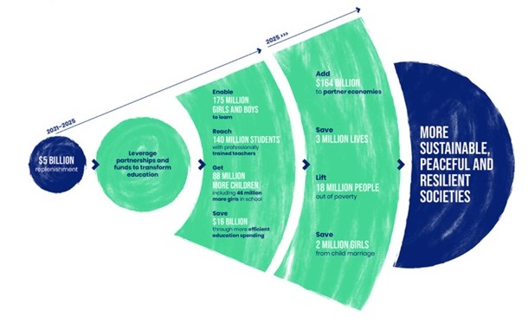
Look for local stories about education, the pandemic, or poverty to use as a hook for a letter to the editor. Then personalize and submit your own letter urging Congress to support a bold billion-dollar pledge in support of GPE (use the sample below to get started). Once published, leverage your media by forwarding it to your members of Congress.

Sample LTE: Support the Global Partnership for Education
For families around the globe, the school day routine ground to halt as COVID-19 surged. For many, this marked a transition to online learning. But for children facing poverty or pushed to the margins, it has often meant no school at all.
Urgent action is needed so the COVID-19 education crisis does not become a catastrophe for an entire generation.
As the only international fund of its kind, the Global Partnership for Education (GPE) marshals global resources for national education plans. Now, GPE and its partners have a five-year plan to support learning for 175 million more children in lower-income countries, helping build back better from the pandemic.
The Biden Administration should do its part with a $1 billion five-year commitment to GPE. This will show that the U.S. is committed to working with the global community to help every child reach their potential.
For tips on writing and submitting letters to the editor, see our Media Basics. Also, consider making your letter-writing a group activity. Invite local RESULTS group members and people in your action network to join together online to discuss why education matters to each of you and to write and share your letters with each other.

