RENTER’S TAX CREDIT BACKGROUNDER
LAST UPDATED: 08/18/2022

Background & Context
The federal tax system is a powerful, effective financial tool for supporting struggling renters and preventing housing instability. Financial resources that flowed through the tax code, such as multiple rounds of economic stimulus payments and temporary expansions of the Child Tax Credit (CTC) and Earned Income Tax Credit (EITC), proved effective in lifting people, especially children, out of poverty. These critical investments enabled the United States to prevent – even temporarily - an eviction tsunami, and improve the food security, mental health, and overall financial security of millions of households.
Realizing the human right to housing entails guaranteeing the availability of affordable, accessible housing to all who require it. Housing affordability often leads to housing stability, and individual safety and security.
Inequities remain in our federal tax system, but we can change this system to do a better job of addressing the affordable housing and homelessness crisis. For decades, policymakers have used tax policy to concentrate wealth mostly among those who already have it. This has created, maintained, and even increased disparities in income and wealth. Lawmakers have done little to address these disparities or create opportunities for low- and middle-income people to build wealth. While there are progressive elements of the tax code, it often benefits wealthy people and corporations, leaving everyone else behind.
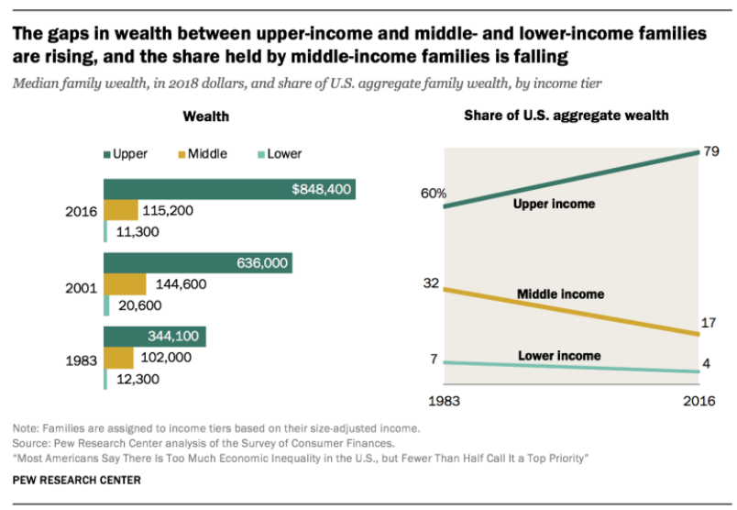
Source: https://www.pewresearch.org/social-trends/2020/01/09/trends-in-income-and-wealth-inequality/
At RESULTS, we are dedicated to creating a progressive tax code that serves as a tool for addressing poverty and inequality in the United States. RESULTS has a long history of building bipartisan support for anti-poverty policies, including targeted tax credits for low-income Americans. Now, we are hoping to reach a group that is often forgotten by tax policymakers: renters.
This document explains what a renter’s tax credit is, why it is needed, and how it could work to benefit struggling tenants across the country.

Why Renters?
Renters are often left behind by the existing tax code. Despite their contributions to the economy, many tax breaks, such as the mortgage interest deduction, the first-time homebuyer credit, and state and local deductions, only benefit homeowners. This contributes to widening wealth disparities. Prioritizing no- and low-income renters is an important step in creating a progressive tax code.
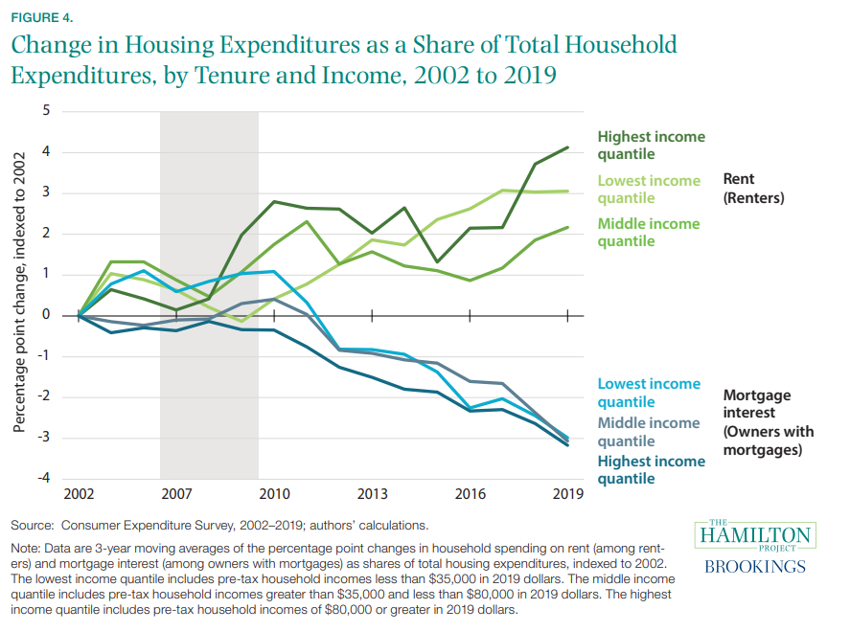
Source: https://www.hamiltonproject.org/assets/files/A_Comparison_of_Renters_and_Homeowners.pdf
High rent costs are a severe burden on low-income renter households. Even before the COVID-19 pandemic, millions of people in the United States struggled to afford housing. Now, rents are skyrocketing, and people are struggling even more to keep up. To make matters worse, wages are not increasing with rents. Right now, a minimum-wage worker cannot afford a two-bedroom apartment in any state in the United States. A recent report found that nearly half of all renter households are spending more than 30 percent of their incomes on rent and utilities each month, forcing people to make an impossible choice between housing and other necessities like food or healthcare. And when tax benefits are given to homeowners, landlords, and developers, they are not necessarily passed down to renters.
Tax credits and other tax benefits would immediately and directly help people afford their rent, providing housing stability and preventing evictions and homelessness. It would also give people the freedom to spend their incomes on other necessities, such as food, clothing, healthcare, and childcare. The tax code, if designed to benefit and prioritize renters, could also help lift households further away from poverty and give them more freedom and financial security. We would all benefit from a healthier, happier population that thrives and promotes economic growth.

What is a Renter’s Tax Credit?
A renters’ tax credit would cap out-of-pocket rent and utilities expenses, so that low-income families can afford a safe place to live without sacrificing other basic needs. It would provide direct, immediate relief to struggling renters. With a renter’s tax credit, households who are considered “rent-burdened" would receive a tax benefit based on their income and/or how much they spend on rent. A renter’s tax credit uses the tax code to deliver targeted relief to struggling renter households, similar to the Child Tax Credit and Earned Income Tax Credit.
A renter’s tax credit could be calculated in different ways. One method is based on the relationship between a household’s income and the amount of rent they pay. A household is considered rent-burdened if they pay more than 30 percent of their income toward rent. This means that we could base a renter’s tax credit on this percentage. The basic formula for this could be as follows:
credit amount = rent paid – 30 percent of income
For example, if someone makes $1,000 per month, technically they should only spend $300 per month (30 percent) on rent. If they spend $500 per month on rent, this is $200 more than they should be forced to spend. To make up for this, they would receive a $200 per month renter’s tax credit.
Although a federal renter’s tax credit has not yet been enacted, several members of Congress have introduced refundable renter’s tax credit legislation. One was by then Sen. Kamala Harris (S1106, https://bit.ly/3bNA2i0), with a companion bill from Rep. Danny Davis (HR2169, https://bit.ly/3bNA2i0); and the other was by Sen. Cory Booker (S2684, https://bit.ly/3nu6xnZ) with a companion bill from Rep. Jim Clyburn (HR4808, https://bit.ly/3OZE19w). These proposals seek to provide relief to a broader population of struggling renters uniformly across the nation. The Terner Center for Housing Innovation at the University of California, Berkeley drafted a seminal paper that formed the basis for these various policy proposals in Congress. What distinguishes these federal proposals from their state counterparts (more below) is that the refundable tax credit will be paid out on a monthly basis, just like rent.
Many states already have some variation of a tax credit or deduction for renters in place, providing a lifeline to those who are eligible to receive them. But these benefits are not sufficient to address the housing affordability crises that many households experience. And none of them meet the criteria of being a fully refundable, monthly credit.
States such as Arizona, Colorado, Connecticut, Iowa, Missouri, Montana, New Mexico, North Dakota, Pennsylvania, Rhode Island, and Utah have renter’s tax credits but limit eligibility to the elderly and/or people with disabilities.
Some states, like Arizona, California, Hawaii, Maryland, Michigan, Missouri, Rhode Island, and Utah have renter’s tax credits that are not refundable and only reduce a household’s tax liability without providing any cash refund.
Similarly, Indiana, Massachusetts, and New Jersey have deductions for renters that only reduce taxable income and do not benefit lower-income households. In other states where the cost of living is very high, like California and Hawaii, the renter’s tax credit is less than $100, which does not provide any tangible benefit to reduce rent hardships.
Additional states, such as Kentucky and Nebraska, have introduced legislation for a state-level renter’s tax credit.

What kind of Renter’s Tax Credit do we need?
In order for a renter’s tax credit to truly help struggling renters, the credit must be a fully refundable tax credit. There are several states who offer a refundable tax credit, including Maine, Minnesota, New York, Vermont, Washington, D.C., and Wisconsin. But what does a fully refundable tax credit mean?
Refundable v. Non-Refundable
A refundable tax credit simply works like this – if your tax credit is larger than the amount of taxes you owe, you receive a refund for the difference. For example, if you owe $300 in taxes and receive a $500 refundable tax credit, you would receive the remaining $200 as a tax refund. This is a great way to get money into people's hands, and it gives them the flexibility and freedom to make family financial decisions. This is how the EITC works, as well as the 2021 expanded CTC.
However, if the credit was not refundable, the remaining $200 of your credit would disappear. Non-refundable tax credits, which most are, typically only benefit people with higher incomes.
Credit v. Deduction
As noted above, a credit is a reduction in the amount of taxes you owe. A deduction, on the other hand, is a reduction in the amount of your taxable income. For example, if you make $1,000 of taxable income and receive a $600 tax deduction, you would only have $400 of taxable income. Lower taxable income means lower taxes owed. Like a non-refundable tax credit, deductions typically benefit people with higher incomes. Because of the progressive nature of our tax code, lower-income Americans already have little or no taxable income, thus a tax deduction has minimal or no impact on their tax liability. The most common federal tax deduction is the standard deduction, used by about 90 percent of tax filers.

Why do we need a Renter’s Tax Credit?
The tax code reflects the priorities of the country. Policymakers use the tax code to collect revenue for the country and benefit various groups. Unfortunately, the tax code currently works to benefit wealthier individuals and corporations, often at the expense of those with lower incomes or without large amounts of wealth. At RESULTS, we recognize that a more progressive tax code can help shrink wealth and income disparities, reduce poverty, and expand opportunity.
As we saw with the 2021 expansions of the Child Tax Credit (CTC) and Earned Income Tax Credit (EITC), fully refundable tax credits are powerful tools in addressing poverty. These credits helped offset the cost of raising kids (CTC) and provided a boost for workers’ incomes (EITC). The CTC alone reached over 61 million children in December of 2021, cutting child poverty by almost 30 percent. Families used this extra income to pay for food, healthcare, childcare, and other necessary expenses. They also used it to replenish or grow their savings for long-term stability. The CTC not only decreased child poverty in the short term, but it also increased family social mobility in the long term. Sadly, Congress let both of these expansions expire at the end of 2021.
Note that the expanded EITC was not a monthly payment. It was received as a tax refund when workers filed their 2021 federal tax returns in early 2022, As such, data on how much the expanded EITC reduced poverty for these workers is not yet available.
The tax code is a key tool for making structural change. Our advocacy on tax policy is not only about one-time payments for emergencies. It is about long-term policies that address historic underinvestment in renters, assist those who are struggling, and give people the resources to get ahead. The renter’s tax credit would provide targeted and increased support for those who have low or very low incomes and higher levels of rent burden.
Delivering new benefits through the tax code is possible. Using the existing mechanisms for the advanced CTC, the EITC, and the Economic Impact Payments (stimulus checks during the first year of the COVID-19 pandemic), we know we can put money directly in the pockets of people who need it – even on a monthly basis. Using the tax code this way cuts administrative costs and burdens.
The tax code is an important tool in our advocacy toolbox for addressing the needs of people who are struggling in this country. While there are many important programs, like Housing Choice Vouchers, Public Housing, and other programs through the Department of Housing and Urban Development (HUD), these are not accessible or available for many people. Right now, only one in four eligible renters receives federal housing assistance due to inadequate funding. With a renter's tax credit, we can address many of the gaps we see with these programs, such as the long waitlists to receive benefits, refusal of landlords to take part in programs, and limited housing choice. One study found that a renter’s credit would assist two and half times as many poor renters and nearly three times as many severely cost-burdened renters as existing housing subsidy programs.
A refundable renter’s tax credit would broadly benefit households that existing housing and homelessness programs are unable to serve.
There is no one-size-fits-all solution to addressing the affordable housing and homelessness crises. Congress provides modest funding for conventional housing assistance and homelessness programs. But these programs are provided only to a small segment of the population who need assistance and meet certain eligibility requirements. Efforts to expand them quickly through the congressional appropriations process is just not feasible given the incremental and discretionary nature of that process. Instead, a renter’s tax credit would be a more immediate and complementary way of addressing the problems with current aid programs.
Many states and local communities are also taking additional steps to address the affordable housing crisis. But these actions, along with the patchwork of state-level renter‘s tax credits, are not enough to ensure everyone who needs housing assistance receives it. Many households do not qualify for these programs because of narrow eligibility guidelines that limit who gets assistance. And those who are eligible endure extremely long wait lists or face discrimination in the housing market. A recent audit of the U.S. Department of Housing and Urban Development (HUD) showed low use of housing vouchers. These low rates are not due to absence of need nor demand, but rather the chronic underfunding of the program. In addition, long-term plans to increase the supply of affordable housing will provide only minimal relief (if any) for currently suffering and struggling families.
As the Terner Center suggests, effective housing policy should be a ladder of opportunity. Each rung on the ladder should help people reach their goals, whether that is homeownership, escaping poverty, affording necessities, or moving to a preferred area. However, the ladder of housing policy today is neither complete nor accessible. The renter’s tax credit would be another important rung on that ladder to supplement and complement existing housing programs - it is an additional and critical tool to solve remaining issues with affordable housing, poverty, and homelessness. A renter’s tax credit that reaches a broader segment of the population would provide much needed housing stability that would likely keep adults in the workforce, off public benefits, and prevent households from entering the homeless system of care.
A renter’s tax credit is urgently needed to address the worsening affordable housing and homelessness crises as pandemic assistance ends.
The COVID-19 pandemic exacerbated the housing affordability, eviction, and homelessness crises that have existed for decades. Local, state, and federal governments intervened to prevent the imminent threat of further economic fallout from the pandemic by enacting eviction moratoria, spending bills, and tax reforms to provide immediate cash relief to struggling renters and families.
Many of these interventions enacted and passed during the height of the pandemic have already ended. Yet increased housing demand together with the ongoing shortage of affordable housing in the United States (which existed before the pandemic) are causing home and rental prices to soar. Economists predict that rising rents and home prices are unlikely to slow down anytime soon, putting more pressure on already struggling families.
A renter’s tax credit for lower-income individuals and families would help defray the cost of rent, particularly at a time when rent increases have outpaced inflation and wage growth. By providing housing stability to households, a renter’s tax credit would prevent many more Americans from experiencing homelessness.
A refundable renter’s tax credit creates a more equitable tax code.
Pursuing a renter’s credit is also a matter of equity. The tax code has long given benefits to homeowners (primarily through residential mortgage interest and property tax deductions) as well as builders, developers, and landlords (through the Low-Income Housing Tax Credit), but not to renters, who are basically entering a lottery for federal rental assistance. Also, many tax breaks, such as the mortgage interest deduction, the first-time homebuyer’s credit, and state and local property tax deductions, mostly favor white, wealthy homeowners. This disparity exacerbates already enormous racial income and wealth gaps. Similarly, the current lack of affordable rental housing across the United States provides evidence that these white wealthy landlords are not passing the economic benefits they receive from the tax code on to renters.
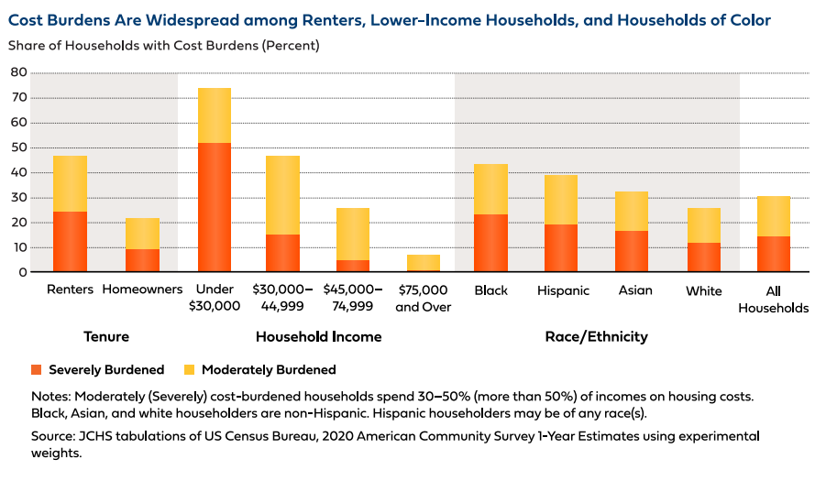
Source: https://www.jchs.harvard.edu/sites/default/files/reports/files/Harvard_JCHS_State_Nations_Housing_2022.pdf
A refundable tax credit for renters would be one more effective tool in addressing housing affordability and lifting households out of poverty.
“Refundable” tax credits can be effective in lifting vulnerable individuals out of poverty, especially those in households with very low or no income. A refundable tax credit can be designed so that it provides immediate cash benefits even to families who are not required to file a tax return (because their income is too low). If a household‘s refundable tax credit is larger than the amount of income taxes they owe, they receive a refund for the difference. This approach returns money into people's hands, giving them the choice and flexibility to make pressing fiscal decisions efficiently. By comparison, if the tax credit is not refundable, it provides no benefit to households that have little or no tax liability. As with deductions, non-refundable tax credits are generally only beneficial to people with higher incomes.
The CTC and EITC boost household resources to pay for basic needs like housing, utilities, and food. Temporary enhancements to the CTC enacted in 2020 and 2021 cut child poverty in half in the United States. While most families with children qualified for the 2021 enhanced advanced monthly payments, full refundability of the CTC particularly benefitted marginalized low-income households and households of color who might not be required to file income tax returns. When those provisions expired at the end of 2021, child poverty rose by 41 percent.
As mentioned above, the federal government’s robust and rapid fiscal response to the pandemic demonstrated the enormous potential of tax policy to lift people out of poverty. And this response did so with little-to-no administrative overhead or burdensome compliance requirements. Given the ability to target tax subsidies directly to renters, landlords would not be able to discriminate the same way they do with tenants who use Housing Choice Vouchers or other similar types of housing subsidies.
A renter’s tax credit helps achieve economic and housing justice for all.
Households of color are more likely than white households to be renters; and renters of color faced the greatest financial hardship during the pandemic, with over one in seven falling behind in their rent payments. The lack of fair and affordable housing in urban, suburban, and rural communities contributes to housing instability, evictions, and even homelessness, all of which disproportionately impact communities of color. The COVID-19 pandemic exacerbated these conditions, putting vulnerable communities at even greater risk of losing their homes when everyone was sheltering in place to prevent the spread of the virus.
Black and Latinx renters in general, and women in particular, are more likely to face eviction threats, actual evictions, and exposure to the negative consequences of eviction like bad credit, homelessness, job loss, and depression. From 2012 to 2016, Black individuals made up 19.9 percent of all adult renters but 32.7 percent of all defendants in eviction filings. Black people are also more likely to experience homelessness and to access shelters; they make up 13 percent of the general population, but more than 40 percent of the homeless population. These disparities extend to other communities in the United States as well – Native Hawaiians and Pacific Islanders currently have the highest rate of homelessness.
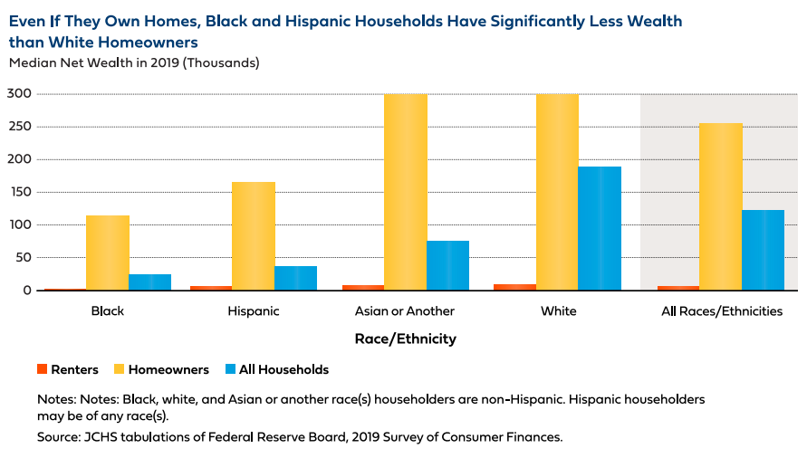
Source: https://www.jchs.harvard.edu/sites/default/files/reports/files/Harvard_JCHS_State_Nations_Housing_2022.pdf
Further compounding this housing injustice is economic injustice. Federal, state and local tax policies have systemic designs that were intentionally constructed to benefit white households and undermine wealth accumulation for households of color. Federal tax housing subsidies are heavily skewed to high-income households and wealthy homeowners. But homeownership remains out of reach for many people of color. A refundable renter’s tax credit could provide renter households, many of whom are renters of color, with much needed housing stability, reducing their likelihood of getting evicted and experiencing homelessness - all without sacrificing other basic needs.
The renter’s tax credit also addresses the existing urban and rural divide. A renter’s tax credit would apply to urban and rural renters regardless of location, ensuring that everyone receives the benefits they need.
By alleviating rent-cost burdens, this credit can help people obtain stable, accessible, and affordable housing. Additionally, the credit allows people to access housing in the areas they choose, whether that’s close to family, community, jobs, public transportation, and/or crucial services. Such flexibility will also allow people with disabilities to find housing that is more accommodating, thereby fostering yet another layer of equity.

Further Readings
Center for Law and Social Policy - Principals for Federal Tax Policy
Prosperity Now - Guide to Using the Tax Code for Economic and Racial Equality
Roosevelt Institute – How the Tax Code Can Create a More Equal Economy
National Women’s Law Center – A Tax Code for the Rest of Us
Brookings - Funding our nation’s priorities: Reforming the tax code’s advantageous treatment of the wealthy

University of California, Berkeley, Fall 2018 Journal: Mortgage Interest Deduction and the Racial Wealth Gap(August 2018), available at https://bppj.berkeley.edu/2018/08/23/mortgage-interest-deduction-and-the-racial-wealth-gap/
The Effects of the Rent Burden on Low Income Families (March 2018), available at https://www.bls.gov/opub/mlr/2018/beyond-bls/the-effects-of-the-rent-burden-on-low-income-families.htm.
See generally, National Low Income Housing Coalition, Out of Reach, https://nlihc.org/oor.
Harvard University, Joint Center for Housing Studies, “The Rent Eats First: Rental Housing Unaffordability in the United States” (February 2022) https://www.jchs.harvard.edu/research-areas/journal-article/rent-eats-first-rental-housing-unaffordability-united-states.
See also, Bold Proposals for Renters’ Tax Credits, National Low Income Housing Coalition, https://nlihc.org/sites/default/files/Factsheet_08022018.pdf (comparison chart for more information about the differences between the two bills). (comparison chart for more information about the differences between the two bills).
The FAIR Tax Credit, Terner Center for Housing Innovation at UC Berkeley, https://ternercenter.berkeley.edu/wp-content/uploads/pdfs/FAIR_Credit.pdf.
See e.g., Protecting and strengthening Minnesota’s Renters’ Credit, Minnesota Budget Project, https://www.mnbudgetproject.org/issues/current-agenda/renters'-credit
ARS § 43-1072. https://www.azleg.gov/ars/43/01072.htm#:~:text=43%2D1072%20%2D%20Earned%20credit%20for,of%20age%20or%20older%3B%20definitions.
CO Rev Stat § 39-31-101. https://leg.colorado.gov/sites/default/files/images/olls/crs2021-title-39.pdf at 917.
CGS Chapter 204a. https://www.cga.ct.gov/current/pub/chap_204a.htm#:~:text=Chapter%20204a%20%2D%20Property%20Tax%20Relief,Persons%20with%20Permanent%20Total%20Disability.
Iowa Code § 425.17. https://www.legis.iowa.gov/docs/code/425.17.pdf.
RSMo §125.030. https://www.revisor.mo.gov/main/OneSection.aspx?section=125.030&bid=39181&hl=.
MCA § 15-30-2337. https://www.leg.mt.gov/bills/mca/title_0150/chapter_0300/part_0230/sections_index.html.
NMSA § 7-2-18. https://nmonesource.com/nmos/nmsa/en/item/4340/index.do#!fragment/zoupio-_Toc100336881/BQCwhgziBcwMYgK4DsDWszIQewE4BUBTADwBdoAvbRABwEtsBaAfX2zgEYAGLgZl4BsADiEcAlABpk2UoQgBFRIVwBPaAHJ1EiITC4Ei5Ws3bd+kAGU8pAEJqASgFEAMo4BqAQQByAYUcTSMAAjaFJ2MTEgA.
N.D. Cent. Code § 57-02-08.1. https://www.ndlegis.gov/cencode/t57c02.pdf.
Pa. Code § 61.401.1. https://www.pacodeandbulletin.gov/Display/pacode?file=/secure/pacode/data/061/chapter401/s401.1.html&searchunitkeywords=rent%2Crebate&origQuery=rent%20rebate&operator=OR&title=null.
R.I. Gen. Laws § 44-33-3. http://webserver.rilin.state.ri.us/Statutes/TITLE44/44-33/44-33-3.HTM.
UT Code § 59-2-12. https://le.utah.gov/xcode/Title59/Chapter2/59-2-P12.html.
ARS § 43-1072. https://www.azleg.gov/ars/43/01072.htm#:~:text=43%2D1072%20%2D%20Earned%20credit%20for,of%20age%20or%20older%3B%20definitions.
California Code, RTC § 17053.5. https://leginfo.legislature.ca.gov/faces/codes_displaySection.xhtml?lawCode=RTC&sectionNum=17053.5.
HI Rev. Stat. § 235.55.7. https://files.hawaii.gov/tax/legal/hrs/hrs_235.pdf at 43.
MD Code, Tax-Property § 9-102. https://mgaleg.maryland.gov/mgawebsite/Laws/StatuteText?article=gtp&section=9-102
MCL § 206.522. http://www.legislature.mi.gov/(S(tlljzh55ivalofcdzynicc1b))/mileg.aspx?page=getobject&objectname=mcl-206-522
RSMo §125.030. https://www.revisor.mo.gov/main/OneSection.aspx?section=125.030&bid=39181&hl=.
R.I. Gen. Laws § 44-33-3. http://webserver.rilin.state.ri.us/Statutes/TITLE44/44-33/44-33-3.HTM.
UT Code § 59-2-12. https://le.utah.gov/xcode/Title59/Chapter2/59-2-P12.html.
IC Taxation § 6-3-2-6. http://iga.in.gov/legislative/laws/2021/ic/titles/006#6-3-2-6.
CMR § 830.62.3.1. https://www.mass.gov/regulations/830-CMR-6231-rent-deduction.
NJ Rev. Stat. § 54:4-6.3. https://www.nj.gov/dca/divisions/dlgs/programs/tenant_docs/trlaw.pdf.
California Code, RTC § 17053.5. https://leginfo.legislature.ca.gov/faces/codes_displaySection.xhtml?lawCode=RTC&sectionNum=17053.5.
HI Rev. Stat. § 235.55.7. https://files.hawaii.gov/tax/legal/hrs/hrs_235.pdf at 43.
An Act relating to a tax credit for renters, H.B. 696, 2022 Kentucky General Assembly, 2022 Reg. Sess. (Ken. 2022). https://apps.legislature.ky.gov/recorddocuments/bill/22RS/hb696/orig_bill.pdf.
A Bill for an Act relating to income taxes, LB740, 107th Legislature, 2022 Reg. Sess. (Neb. 2022). https://nebraskalegislature.gov/FloorDocs/107/PDF/Intro/LB740.pdf.
Brookings, The new child tax credit does more than just cut poverty, September 24, 2021, https://www.brookings.edu/blog/up-front/2021/09/24/the-new-child-tax-credit-does-more-than-just-cut-poverty/.
Sara Kimberlin & Christopher Wimer, A Renter’s Tax Credit to Curtail the Affordable Housing Crisis, available at https://muse.jhu.edu/article/687579.
Sonya Acosta & Brianna Guerrero, Long Waitlists for Housing Vouchers Show Pressing Unmet Need for Assistance, Center on Budget and Policy Priorities, October 6, 2021, https://www.cbpp.org/research/housing/long-waitlists-for-housing-vouchers-show-pressing-unmet-need-for-assistance.
Cunningham, et al., A Pilot Study of Landlord Acceptance of Housing Choice Vouchers, U.S. Department of Housing and Urban Development, September 20, 2018, https://www.huduser.gov/portal/pilot-study-landlord-acceptance-hcv.html.
HUD Remains Challenged to Serve the Maximum Number of Eligible Families Due to Decreasing Utilization in the Housing Choice Voucher Program, Office of Inspector General for the U.S. Department of Housing and Urban Development, September 15,2021, https://www.hudoig.gov/sites/default/files/2021-10/2021-CH-0001_0.pdf.
The Low-Income Housing Tax Credit (LIHTC) is a supply-side solution to the affordable housing crisis. It is a tax benefit to incentivize (but not require) developers and investors to build more affordable housing. LIHTC is out of reach for the poorest households without a deeper housing subsidy like a Housing Choice Voucher. Furthermore, affordable housing built through LIHTC is also temporary - LIHTC properties shift to market rate housing after 30 years and only has a compliance period of 15 years. See National Housing Law Project, LIHTC Preservation and Compliance, available at https://www.nhlp.org/resources/lihtc-preservation-compliance/. LIHTC is a shallow subsidy and in practice, “lower-income renters living in LIHTC units often require additional subsidies to make this housing affordable.” https://www.jchs.harvard.edu/sites/default/files/reports/files/Harvard_JCHS_Americas_Rental_Housing_2022.pd.
Building a Better Ladder of Housing Opportunity in the United States, Terner Center for Housing Innovation at UC Berkeley, February 2021, https://ternercenter.berkeley.edu/wp-content/uploads/2021/02/Federal-Framework-Brief-February-2021.pdf.
Abha Bhattarai, Chris Alcantara & Andrew Van Dam, Rents are rising everywhere. See how much prices are up in your area, The Washington Post, April 21, 2022, https://www.washingtonpost.com/business/interactive/2022/rising-rent-prices/.
U.S. Home Price Insights, CoreLogic, June 7, 2022, https://www.corelogic.com/intelligence/u-s-home-price-insights/.
Fernandez, et al., Mortgage Interest Deduction and the Racial Wealth Gap, Berkeley Public Policy Journal, August 23, 2018, https://bppj.berkeley.edu/2018/08/23/mortgage-interest-deduction-and-the-racial-wealth-gap/.
The Impact of the Federal Income Tax Code on Poverty, Congressional Research Service, October 19, 2020, https://crsreports.congress.gov/product/pdf/R/R45971.
3.7 million more children in poverty in Jan 2022 without monthly Child Tax Credit, Center on Poverty & Social Policy at Columbia University, February 17, 2022, https://www.povertycenter.columbia.edu/news-internal/monthly-poverty-january-2022 .
The FAIR Tax Credit, Terner Center for Housing Innovation at UC Berkeley, https://ternercenter.berkeley.edu/wp-content/uploads/pdfs/FAIR_Credit.pdf.
Housing burden: All residents should have access to quality, affordable homes, National Equity Atlas, https://nationalequityatlas.org/indicators/Housing_burden#/.
Center on Budget Policy and Priorities, https://www.cbpp.org/over-1-in-7-renters-not-caught-up-on-rent-during-pandemic-with-renters-of-color-facing-greatest.
Over 1 in 7 Renters Not Caught Up on Rent During Pandemic, With Renters of Color Facing Greatest Hardship, Center on Budget and Policy Priorities, https://www.cbpp.org/over-1-in-7-renters-not-caught-up-on-rent-during-pandemic-with-renters-of-color-facing-greatest.
Peter Hepburn, Renee Louis & Matthew Desmond, Racial and Gender Disparities among Evicted Americans, Eviction Lab, December 16, 2020, https://evictionlab.org/demographics-of-eviction/.
Id.
Racial Inequalities in Homelessness, by the Numbers, National Alliance to End Homelessness, June 1, 2020, https://endhomelessness.org/resource/racial-inequalities-homelessness-numbers/.
Racial Inequalities in Homelessness, by the Numbers, National Alliance to End Homelessness, June 1, 2020, https://endhomelessness.org/resource/racial-inequalities-homelessness-numbers/.
Dorothy Brown, How the U.S. Tax Code Privileges White Families, March 23, 2021, https://www.theatlantic.com/ideas/archive/2021/03/us-tax-code-race-marriage-penalty/618339/; Francine J. Lipman, How to Design an Antiracist State and Local Tax System, 52 Seton Hall L. Rev. 1531 (2022) Francine J. Lipman, Nicholas A. Mirkay & Palma Joy Strand, U.S. Tax Systems Need Anti-Racist Restructuring, 168 Tax Notes 855 (Aug. 3, 2020).
The FAIR Tax Credit, Terner Center for Housing Innovation at UC Berkeley, Ochttps://ternercenter.berkeley.edu/wp-content/uploads/pdfs/FAIR_Credit.pdf.
Brett Grant, Protecting the Renters Credit is a Racial Justice Issue: Part One, Voices for Racial Justice, https://voicesforracialjustice.org/voices/protecting-the-renters-credit-is-a-racial-justice-issue/

