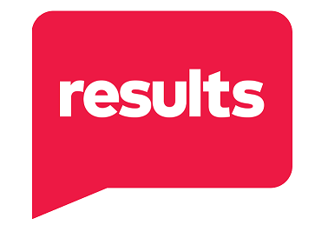
Name: _________________________ Group: ________________________
Instructions: To be champions for the end of poverty, we must consider who you want to be in the movement to end poverty in 2025. Use this form to assess your role and goals in our work, Please bring the completed form to your 2025 planning discussion and use the information when planning with your group.

- Why did I join RESULTS?

- What am I most proud of in my recent advocacy with RESULTS, both individually and as part of our group?

- What skills, talents, and passions do I want to share as part of my advocacy with our group?

- What new skills would I like to develop or actions would I like to accomplish this year?

- What group role(s) would I like to take on in 2025? Learn more about Group Roles here: https://results.org/wp-content/uploads/RESULTS-GR-Roles-2023.pdf
- Group Leader or Co-Leader
- Point Person for Sen. _________________
- Point Person for Rep. _________________
- New Advocate Mentor
- Outreach and Partnership Coordinator
- Action Network Manager
- Media Point Person
- Social Media Manager
- Issue Expert: _____________________
- Fundraising Coordinator
- Other: ____________________________

- What support/training/resources do I need to achieve my advocacy goals?

