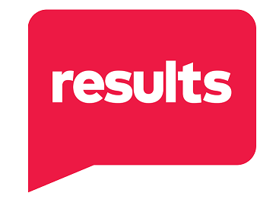
Name: ______________________ Group: ________________________
Instructions: To become effective champions for the end of poverty, we must develop our advocacy skills and become increasingly courageous. Think about who you want to be in the next 6-9 months and map out how to get there.
- What is my motivation for joining RESULTS?

- What am I most proud of in my recent advocacy with RESULTS, both individually and as part of our group?

- What skills, talents, and passions would I like to contribute to the group?

- What new skills would I like to develop or actions would I like to accomplish with RESULTS?

- Circle what ongoing role(s) would I like to have in the group. Learn more about Group Roles here: https://results.org/volunteers/outreach-planning
- Group Leader or Co-Leader
- Point Person for Sen. _________________
- Point Person for Rep. _________________
- New Advocate Mentor
- Partnership and Outreach Coordinator
- Action Network Manager
- Media Point Person
- Social Media Manager
- Issue Expert: _____________________
- Fundraising Coordinator
- Other: ____________________________

- What support/training/resources do I need to achieve my advocacy goals?

