We Must Close the Racial Wealth Divide
Please speak directly to congressional leadership, including tax committee leadership in the House (Ways and Means Committee Leaders Richard Neal and Ranking Member Kevin Brady) or Senate (Finance Committee Leaders Chuck Grassley and Ranking Member Ron Wyden), urging them to prioritize tax and housing policies that reduce racial wealth inequality by helping low-income families access rental housing and homeownership. Some of the policy solutions that will address the affordable housing crisis and help close the racial wealth divide include:
- Pending bipartisan bills to pilot emergency stabilization funds and services for families facing evictions.
- A renters’ credit, which will help address our affordable housing crisis and will have a targeted impact on people of color.
- Increasing the supply of affordable housing via expansions of the National Housing Trust Fund.
- Addressing other barriers to affordable housing and racial equity including restrictive zoning, credit scores, and application fees.
- Targeting homeownership policies for first-time homebuyers impacted by segregation and redlining to reduce racial wealth inequality.
- Passing bipartisan bills to create a Task Force on the Impact of Affordable Housing (S. 1772/H.R. 3211, introduced by Senator Young (R-IN) and Rep. Peters (D-CA)), to better understand the scope of and solutions to the affordable housing crisis.
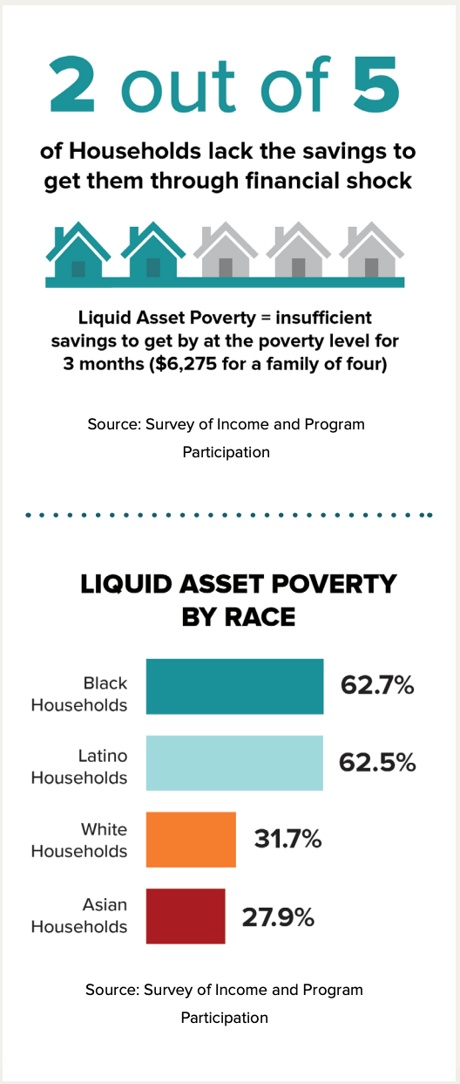
Understanding Wealth and Racial Wealth Inequality
Savings are an essential part of creating economic security. Yet, many American families cannot weather a financial emergency, such as unexpected illness or job loss. According to a Prosperity Now report, the liquid asset poverty rate in the United States is 40 percent (see right) – with startling disparities by race. Over two million households are at risk of eviction each year and in 2016 one million evictions occurred. This forces households to move neighborhoods, change schools, and prohibits many from accessing safe and affordable housing again, due to a record of eviction. Pending bipartisan bills to pilot emergency stabilization funds and services for families facing evictions can help families stay stably housed.
Sadly, because of government policies over our country's history, wealth inequality in the United States has worsened and it has created a staggering racial wealth divide. Median wealth for white families is ten times greater than African American families and eight times greater than Hispanic families. Wealth is not only represented by a savings account. Wealth is the value of all your assets, which include your home, car, and retirement account, minus your debts, such as student loans, credit card debt, and mortgage. Wealth is often the foundation for economic wellbeing as it is a determinant of whether you attend and graduate from college, the kind of neighborhood you live in, the quality of the schools your child attends, the kind of job you have, and your likelihood to own a home.
Invest in Affordable Rental Housing and Homeownership
Housing and wealth inequality are inextricably entwined. Due in part to discriminatory federal housing policies, people of color own their homes at a much lower rate than white households, and there is a greater percentage of low-income renters of color than low-income white renters. According to Harvard researchers, since 1960 renters’ median earnings have gone up 5 percent while rents are up 61 percent. Overall, about half of all renter households are housing cost burdened – paying more than 30 percent of their income towards housing. This contrasts with the 22.5 percent of homeowners that are housing cost burdened.
Alongside the rising cost of living there has been a decrease in the stock of low-cost rental housing. In 2017 alone, 1 million low-cost rental units ($800/month) were lost from the market. When households are forced to pay high housing costs, their spending on other necessities, like food, transportation, and health care are cut. These households also are not able to save for things like homeownership, which is an essential wealth building strategy for many. Renters’ credits and expanding the National Housing Trust Fund to build affordable housing can help address the housing crisis for low-income renters and their families.
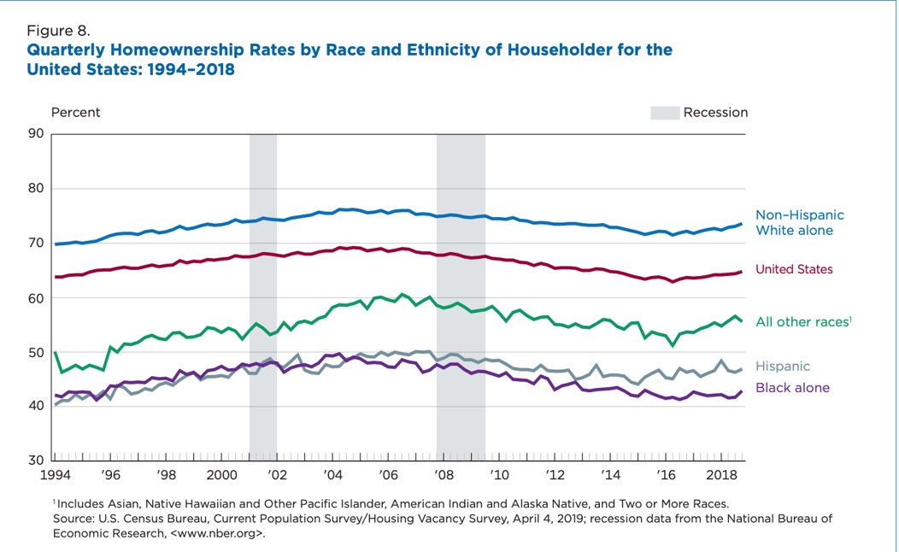
The legacy of segregation and systemic racism continues today and is linked to the affordable housing crisis and homeownership. For most Americans, the bulk of their assets lie in the value of their home. This is especially true for Black homeowners, with 56 percent of their wealth coming from their homes, whereas home values only account for 38 percent of White household wealth. There are stark differences in homeownership, as illustrated below:
Homeowners also have drastically more in net wealth than renters. Renters have about $5,000 in median wealth as opposed to the $231,400 in wealth for homeowners, a 98 percent gap. Targeting homeownership policies to close the homeownership gap and build wealth in communities of color can help reduce racial wealth inequality. Congressional action is necessary to increase access to affordable housing, especially for communities of color.

