Prioritize Tax Policies That Focus on Working Families
Please speak directly to congressional leadership, including House (Ways and Means Committee Leaders Richard Neal and Ranking Member Kevin Brady) or Senate (Finance Committee Leaders Chuck Grassley and Ranking Member Ron Wyden) leaders, urging them to prioritize tax policies that create economic mobility and help families access affordable housing. Specifically, urge them to expand the Earned Income Tax Credit, boosting the Child Tax Credit for low-income families, and supporting tax policies that reduce racial wealth inequality by helping low-income families access rental housing and homeownership.
Refundable Tax Credits Support Working Families
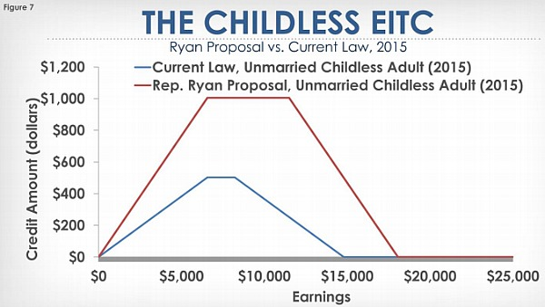
The Earned Income Tax Credit (EITC) and Child Tax Credit (CTC) are pro-work, pro-family financial lifelines for people working in low-wage jobs. Both credits encourage people to work while reducing poverty; together, they lifted 8.3 million Americans above the poverty line in 2017. But updates are needed. Currently, low-income adults without children in the home (including non-custodial parents who pay child support) may only receive a maximum of $500 per year from the EITC. On average, this is less than what they owe in taxes, making these workers the only group that is taxed into or deeper into poverty. Expanding the EITC for childless workers has bipartisan support, but sadly Congress made no changes to the EITC in their 2017 tax bill. In addition, low-income families were largely left out of the CTC increase in that bill. RESULTS supports robust expansions of the EITC and CTC for low-income working families as a strategy to address wage stagnation and ensure Americans can make ends meet.
Investing in Affordable Rental Housing and Homeownership
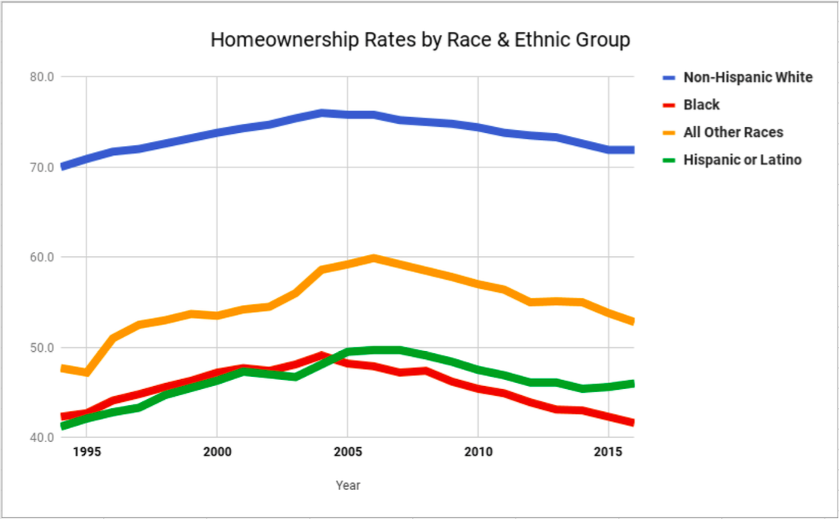
RESULTS is deeply concerned about wealth inequality in the United States. Sadly, government policies over our country's history have worsened inequality and created a staggering racial wealth divide. Median wealth for white families is ten times greater than African American families and eight times greater than Hispanic families. We can remove barriers by increasing access to affordable housing for populations that have suffered the impacts of segregation and discriminatory policies, including increasing federal housing assistance by enacting refundable renters’ credits and first-time homebuyer tax credits, as well as addressing barriers such as credit scores, application fees, past evictions, and discrimination based on income source (e.g. receiving federal housing assistance). We look forward to working with you to increase access to affordable housing, especially for communities of color.

