Prioritize Tax Policies That Focus on Working Families
Please speak directly to congressional leadership, including House (Ways and Means Committee Leaders Richard Neal and Ranking Member Kevin Brady) or Senate (Finance Committee Leaders Chuck Grassley and Ranking Member Ron Wyden) leaders, urging them to prioritize tax policies that create economic mobility by expanding the Earned Income Tax Credit and the Child Tax Credit. We urge you to support the Working Families Tax Relief Act (S. 1138/H.R. 3157) and advocate for expansions of the Earned Income Tax Credit and the Child Tax Credit for low-income families in any tax bills this year.
The Earned Income Tax Credit (EITC) and Child Tax Credit (CTC) are pro-work, pro-family financial lifelines for people working in low-wage jobs. Both credits encourage people to work while reducing poverty; together, they lifted 8.3 million Americans above the poverty line in 2017.
Opportunities to Expand EITC and CTC
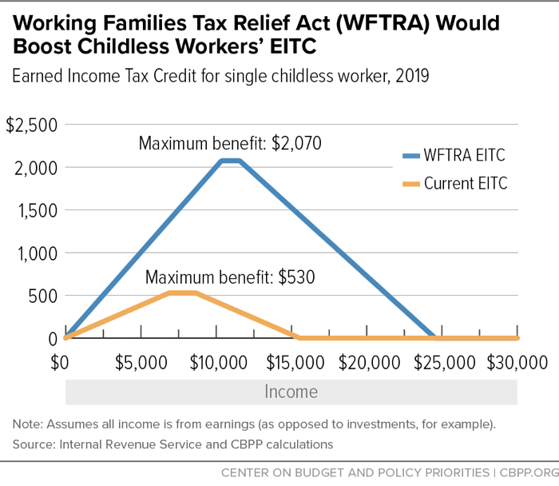
By making improvements to the EITC and CTC, the Working Families Tax Relief Act (S. 1138/H.R. 3157), would boost the financial security of 46 million households, including 8 million Black families, 9 million Latinx families, and 2 million Asian American families. The bill would cut child poverty nationally by 28 percent, lifting 3.1 million children out of poverty and making another 7.7 million children less poor. Specifically, the bill would:
- Increase the EITC for families with children by roughly 25 percent
- Substantially increase the EITC for workers not raising children and lower eligibility to age 19; currently, this is the only group in the tax code that is taxed into poverty
- Make the full $2,000 CTC available to all low- and moderate-income families
- Create a new Young Child Tax Credit for families with young children by providing an extra $1,000 for each child under 6 years old (for a total CTC of $3,000 per child)
- Make the CTC equally accessible to families in Puerto Rico and expand Puerto Rico’s EITC
Overall, expanding the EITC and CTC would help make sure that low-income parents can give their children a good start in life, and help working people afford transportation and other expenses to stay on the job. In June, the House Ways and Means Committee passed temporary expansions of both the EITC and CTC in a broader tax package (H.R. 3300, the business “tax extenders” bill,. Its EITC changes would raise the after-tax incomes of 16 million childless adults and the CTC changes would benefit more than 42 million children under age 17. RESULTS urges Congress to adhere to the 2015 precedent that no business tax breaks should be extended or expanded without also helping low-income workers and families through expansions of the EITC and CTC. We hope you will cosponsor S. 1138/H.R. 3157 if you have not already done so and make expanding the EITC and CTC your top tax priority this year.

