Address the Housing Crisis by Increasing Rental Assistance
Please work to lift the Fiscal Year 2020 caps on federal spending and support a $5 billion increase in Housing Choice Vouchers over the next two years by speaking directly to congressional leadership, along with Senators Collins and Reed or Representatives Price and Diaz-Balart as Chairs and Ranking Members of the Transportation, and Housing and Urban Development, Subcommittees of Appropriations. In addition, support bipartisan efforts to ban housing discrimination based on income source to create more opportunities for families.
The Affordable Housing Crisis
Millions of low-income working families struggle to find affordable housing in the U.S. Over 70 percent of extremely low-income renters spend more than half their income on housing. Consider this:
- A National Low Income Housing Coalition study shows there is no U.S .state where a worker making the prevailing minimum wage can afford a two-bedroom apartment.
- Nationwide, there are only 35 affordable rental homes available for every 100 extremely low-income renter households.
- The supply of rental units available for less than $800/month has dropped by 261,000 since 2005, according to the Joint Center for Housing Studies at Harvard University.
- Only one in four eligible low-income households receives federal housing assistance.
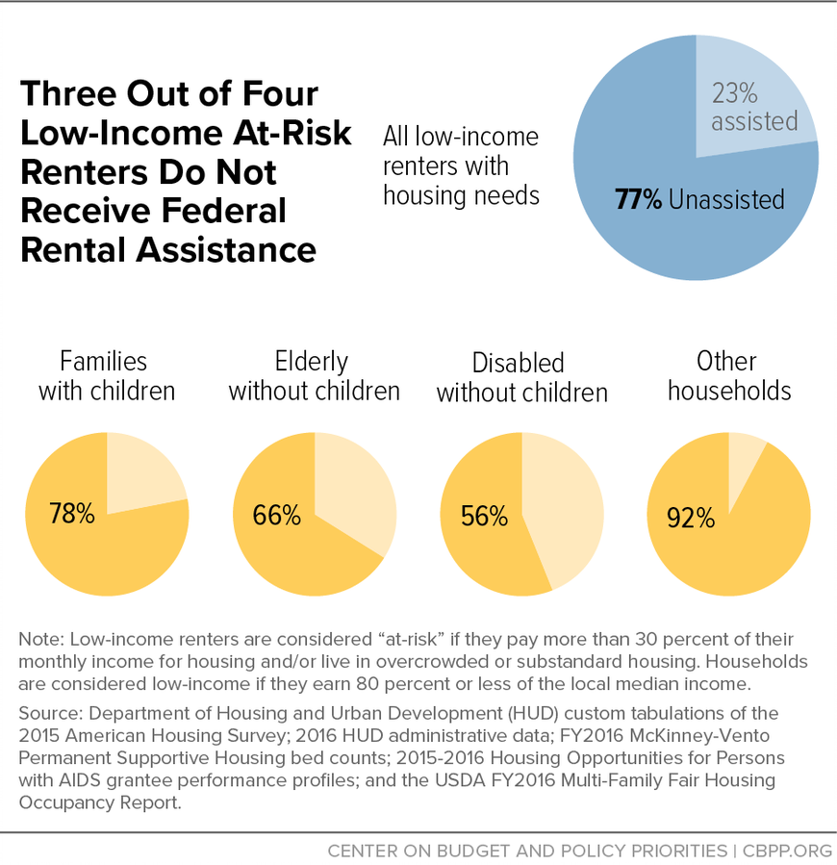
The federal government invests significant resources to support homeownership, largely to the benefit of wealthy, white households. Since families of color are more likely to rent, the rising cost of rent and decline in affordable homes becomes a barrier to building wealth, as more income is spent on rent and less on savings and other wealth-building activities. An increase of $4 billion in Housing Choice Vouchers would help address the housing crisis, funding 340,000 new “Section 8” vouchers over two years.
In addition, families can face discrimination. Two-thirds of families can be denied by landlords simply for getting assistance, creating yet more barriers to economic security. Bipartisan proposals such as the Fair Housing Improvement Act of 2018 introduced in 2018 by Senators Kaine (D-VA) and Hatch (R-UT) seek to address this.
RESULTS requests that you support lifting the spending caps for FY20 and increasing funding for Housing Choice Vouchers by $5 billion over two years by speaking to key negotiators, while endorsing bipartisan efforts to ban housing discrimination based on income source. Longer term, we should increase access to affordable housing and address the legacy of discriminatory policies through policies like refundable renters’ credits and first-time homebuyer tax credits, emergency stabilization funds for families facing evictions, and address barriers such as credit scores, application fees, past evictions, and discriminatory zoning regulations.

