Address the Housing Crisis with a Refundable Renters’ Credit
Please speak directly to congressional leadership, including House (Ways and Means Committee Leaders Richard Neal and Ranking Member Kevin Brady) or Senate (Finance Committee Leaders Chuck Grassley and Ranking Member Ron Wyden) leaders, urging them to support a refundable renters’ credit to help families access affordable housing.
The Affordable Housing Crisis
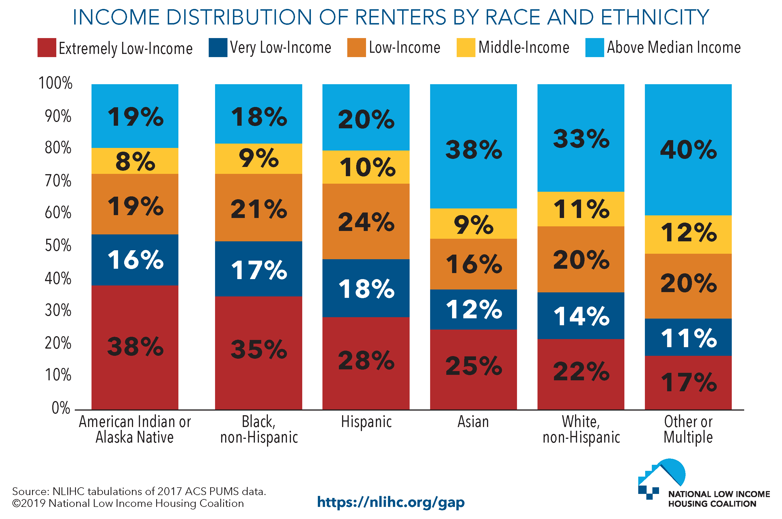
Millions of low-income working families struggle to find affordable housing in the U.S., especially families of color. Over 70 percent of extremely low-income renters spend more than half their income on housing. Consider this:
- According to Harvard researchers, since 1960 renters' median earnings have gone up 5 percent while rents have risen by 61 percent.
- A National Low Income Housing Coalition study shows there is no U.S. state where a worker making the prevailing minimum wage can afford a two-bedroom apartment.
- Nationwide, there are only 37 affordable rental homes available for every 100 extremely low-income renter households.
- Only one in four eligible low-income households receives federal housing assistance.
Meanwhile, we invest significant resources to support homeownership, largely to the benefit of wealthier households, while millions are struggling to afford housing.
Addressing the Crisis Through Federal Policy, including Renters’ Credits
There is no one solution to the housing crisis. As part of a broader effort to address the affordable housing crisis, RESULTS supports tax credits targeted at low- and moderate-income renters, which could help millions of families secure affordable housing. The credit would basically serve as a cap on the amount of out-of-pocket rent and utilities expenses a low-income household would pay (around 30 percent of their income, which is considered the affordability benchmark). A federal tax credit would be provided to make up the gap up to 100 percent of the area’s Small Area Fair Market Rent value. Several policymakers, including Senators Booker (D-NJ) and Harris (D-CA) and former Senator Heller (R-NV), have introduced legislation that does this (H.R. 2169 and S. 1106; S. 3590, H.R. 7050 and S. 3342 in the last Congress). Researchers at Columbia University estimate that a renters’ credit could lift over 9 million Americans above the poverty line. By providing renters some relief from growing rental costs, more families could find safe, affordable places to live.
RESULTS also urges you to prioritize low-income working families and communities of color in your economic policies, especially related to housing and tax issues. We urge Congress to support efforts aimed at housing stability, the legacy of racial segregation, homeownership, and increasing the supply of affordable housing. We urge you to support renters’ credit proposals and voice support for renters’ credit proposals with colleagues in Congressional leadership and on the tax writing committees.

