2019 RESULTS US Poverty Housing Brief
Addressing the Affordable Housing Crisis
As discussed in the 2019 RESULTS U.S. Poverty Campaigns background packets, the U.S. government has a long history of policies that directly or indirectly blocked or built wealth via housing and beyond. Today, the Department of Housing and Urban Development, Department of Agriculture, and Department of Treasury administer housing assistance programs from tax incentives to public housing.
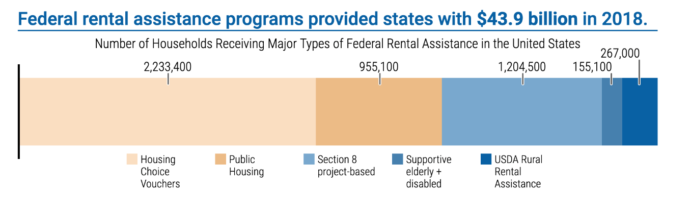
Currently housing assistance is provided for 10 million people in over 5 million households. In 2017, housing assistance alone lifted 2.9 million people out of poverty.0F The largest programs that support residents with low-incomes are Section 8 housing choice vouchers, Section 8 project based rental assistance, and public housing (see Figure 1).1F Funding for these incredibly necessary programs does not keep up with increasing need. As a result, 75 percent of eligible households do not receive the housing assistance they need.2F
Figure 1²
Since 1960 renters’ median earnings have gone up 5 percent while rent payment are up 61 percent.3F This leaves 18 million lower-income renters paying more than 30 percent of their income on rental cost, qualifying them as housing cost burdened (see figure 2). Yet, some households pay half or more of their income on rent, qualifying them as severely housing cost burdened. Severely-cost burdened renters are more likely to have a household income at the poverty line or below 30 percent of the area median income (these households are identified as extremely low-income). Seventy-one percent of extremely low-income households pay more than half their income on rental costs and households of color are more likely to qualify as extremely low-income – see Figure 2 for a further breakdown by race and ethnicity.4F
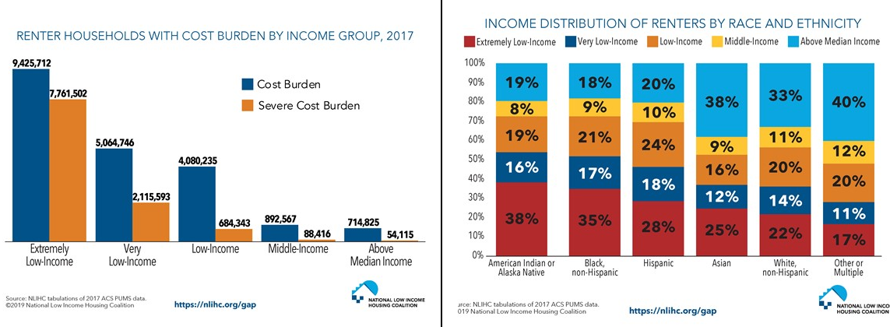
Figure 2
One proposal that would ensure all those in need of rental assistance receive it is a renters’ tax credit. While there are tax credits, like the mortgage interest deduction, that benefit high income homeowners, no such credit exists for renter households with low-incomes.
Renters’ Tax Credit
Tax incentives are one of the most widely hidden subsidies in the U.S. There are three different provisions in the tax code related to housing. Most existing credits benefit wealthy homeowners instead of cost-burdened renters. Seeing the opportunity to leverage tax policy to address the affordable housing crisis, several policymakers have proposed tax credits for households that are renters with low-income.
A renters’ credit could help millions of families secure affordable housing and, over the long-term, help reduce racial wealth inequality. While there are several proposals in Congress, they are similar: the credit would basically serve as a cap on the amount of out of pocket rent and utilities expenses a low-income household would pay (around 30 percent of their income, which is considered the affordability benchmark). A federal tax credit would be provided for renters up to 100 percent of the area’s Fair Market Rent value. By providing renters some relief from growing rental costs, more families could find safe, affordable places to live.
For example, in Carson City, NV the Fair Market Rent value is $1,226 for a three- bedroom home. A family living in a three-bedroom home would pay $14,712 in rental costs per year at the Fair Market Rate.5F If this family earned $49,040, their rental costs would comprise 30 percent of their income, making this an affordable rental cost. However, for many families the $14,712 cost would make up more than 30 percent of their income, creating a housing cost burden. For this example, let’s say the family makes $23,000 per year. In this example, 30 percent of the family’s income is $6,900 which significantly below the $14,712 fair market cost. A renters’ tax credit would refund the difference between the 30 percent of their income and the Fair Market Rate, a credit of $7,812.
According to Columbia University’s Center on Poverty and Social Policy, the renters’ credit bills proposed by Cory Booker and Kamala Harris in the 115thCongress could cut poverty by 2.9 and 2.4 percent, respectively.6F Booker’s HOME Act (S.33427F from 115th Congress) would lift 9.4 million people out of poverty and Harris’ Rent Relief Act (S. 11068F in the current 116th Congress) would lift 7.8 million people out of poverty (see figure 2). Because these bills are administered through the tax code, they reach all households that file taxes. This type of proposal will be discussed at length at this year’s RESULTS International Conference. Please see Appendix A for a comparison of different renters’ tax proposals.
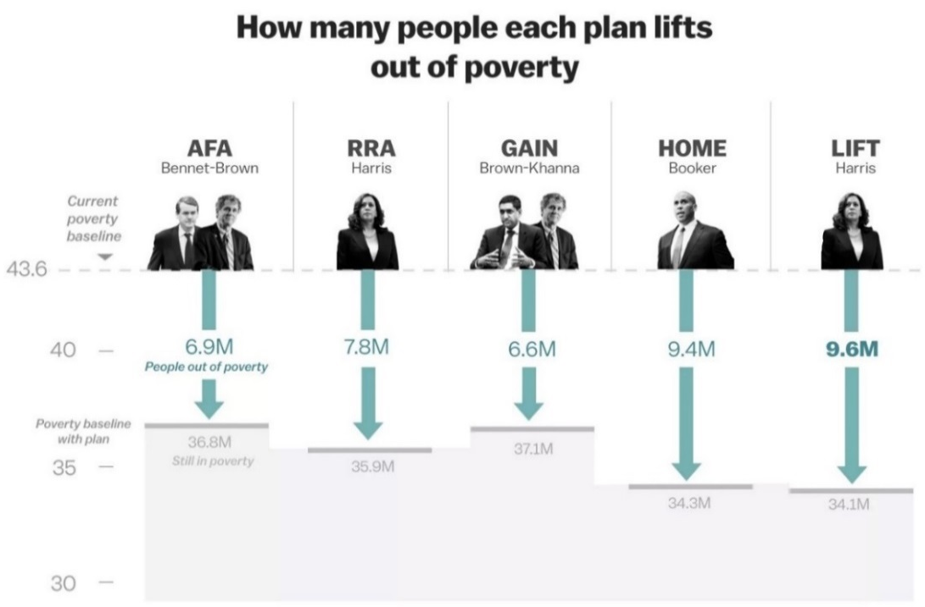
Figure 2⁴

Renters’ tax credits provide low-income renter households protection against high housing costs. While this credit is a promising strategy for affordable housing, there are some conflicting considerations regarding this legislation.
- If this credit is provided monthly, as some proposals put forward, it would require substantial updates to the IRS.9F However, this is preferable to yearly credits because it stops the cycle of borrowing and paying off debt. By providing monthly credits, households could cover additional monthly expenses or emergency costs when they occur instead of taking on costly loans that accrue interest by the end of the year.
- Some project that a renters’ tax credit could drive up the cost of living because it would decrease the competition for landlords to keep rents low and allow some households to choose more expensive apartments which could further the construction of high cost units.10F&11F
Supporters of the renters’ credit argue that the benefits of a renters’ credit outweigh the cost, noting that:
- Tax credits have a higher rate of uptake by eligible households, since all eligible tax filers receive the credit.12F
- The credit would be guaranteed13F because it would be part of the tax code and not considered in annual appropriations (spending) bills the way that other programs like housing choice vouchers are.
As with any new federal program, renters’ tax credits have both benefits and drawbacks. Knowing the critiques and the praise can lead to more productive conversations around this proposal. However, the drawbacks should not dissuade advocates from the potential of this credit. We have the opportunity to educate policymakers about renters’ credits as a tool to more effectively shift tax policies to address the affordable housing crisis and reduce racial wealth inequality.14F
Additional Housing Policy Options
Current affordable housing programs, like housing choice vouchers, public housing, and the National Housing Trust Fund, are effective in addressing some aspects of the affordable housing crisis. However, there are other policy options:
- Creating an Emergency Stabilization Fund is another tool that could reduce housing instability and homelessness. Over two million households are at risk of eviction each year and in 2016 one million evictions occurred.15F&16Fforcing households to move neighborhoods, change schools, and barring many from accessing safe and affordable housing again, due to a record of eviction.17F,18F&19F These evictions occur at the highest levels in the South, particularly in communities where 30 percent or more of the population identify as Black.20F This matches other evidence that evictions disproportionately effect people of color and women living in poverty.21F,22F,23F &24F An Emergency Stabilization fund would assist households in covering their housing costs after unexpected expenses (like a broke-down car) or financial downturns (like losing a job).25F By providing funds to stabilize households during unexpected hardship, stabilization funds keep families from experiencing homelessness and ensure housing stability. This is an idea included in the Opportunity Starts at Home policy agenda.26F
- Expanding the National Housing Trust Fund, a key resource for building affordable housing. States that are granted National Housing Trust Fund dollars must use at least 80 percent of the funds for rental housing and 10 percent for homeownership.27F Additionally, the housing must be targeted specifically at low and extremely low-income households, with the majority of resources targeted to extremely low-income households (those with income at or below 30 percent of the area median or less than the poverty line). Although small right now, the HTF has significant potential to increase the supply of affordable housing so that those with the lowest incomes can obtain an affordable home. Senator Elizabeth Warren’s American Housing and Economic Mobility Act (S. 787) would provide $445 billion to the Housing Trust Fund over ten years, or over $44 billion per year. This increase could create 2.1 million homes for families with low-incomes and lower rent costs by 10 percent.28F
- Providing down payment assistance for first-time homebuyers is another way to expand homeownership to those that can make mortgage payments but struggle to make a large initial down payment. Racist federal policies kept families of color, and particularly Black families from accessing homeownership (see The Creation of Wealth Inequality Backgrounder). Since homeownership is integral to wealth building29F, first-time homebuyer assistance programs are seen as one avenue to address and repair these unequal outcomes resulting from discrimination, where 72 percent of White households own homes as opposed to just 43 percent of Black households30F Elizabeth Warren’s American and Economic Mobility Act (S. 78731F) works to target these disparities by providing grants for first-time home buyers in formerly redlined or officially segregated areas32F In 2018, Senate Finance Ranking Member Ron Wyden also introduced legislation (S. 336433F) to help first-time homebuyers as well, although his bill was less targeted and administered through the tax code.34F
- Currently, there is no federal law against source of income discrimination. As a result, two-thirds of households that use housing choice vouchers can be denied housing simply for using a voucher.35F Creating a federal ban on source of income discrimination is one way to ensure voucher holders are not denied housing because of their form of rental payment.36F There is bipartisan interest in reintroducing legislation to ban discrimination by income source, similar to the Fair Housing Improvement Act of 2018.37F
- Inclusive zoning policies prohibit the use of restrictive zoning ordinances like banning multi-family housing or requiring minimum parking lot sizes which often block developers from building affordable housing units by restricting neighborhoods to single home building only. These are often the legacy of local efforts to codify segregation.38F Senator Cory Booker’s housing proposal seeks to address this issue by both withholding block grants (worth a total of $16 billion) from localities that maintain restrictive zoning and providing additional funds to areas that foster more inclusive zoning practices. His proposal leverages funds beyond the Department of Housing and Urban Development to increase the stock of affordable housing39F
- A bipartisan group of legislators introduced legislation to create a Task Force on the Impact of Affordable Housing in June (S. 177240F and H.R. 321141F) to better understand the scope of and solutions to the affordable housing crisis. Specifically, experts on the Task Force will evaluate the cross-sector impact of the lack of affordable housing (i.e. understand the impact on health, education, income etc.), evaluate the cost of the crisis to government programs, and make recommendations to Congress on how to use federal programs to address the affordable housing crisis.42F
- Credit scores and application fees have also been identified as a barrier to accessing housing. Many landlords or apartment management companies require tenants to meet a certain credit score and provide a deposit on their unit before moving in. This system disproportionately harms people of color and those with low-incomes because they are less likely to have mortgages or credit card payments, which are both used to calculate credit scores43F &44 Alternately, credit scores do not take into account regular payments on rent, utilities, or phone bills which both people of color and those with low-incomes are likely to make payments on45F In 2018, the House passed Representative Keith Ellison’s Credit Access and Inclusion Act,46F but the Senate did not take up Senator Tim Scott’s companion legislation in the Senate47F&48F This year, Senators Tim Scott and Joe Manchin49F re-introduced the Credit Access and Inclusion Act (S. 1828)50F putting forth a model for how to start creating a more inclusive credit scoring system.
- As noted in previous backgrounders, racial disparities exist in the affordable housing crisis. One way in which to alleviate these disparities is through reparations for the legacy of slavery in the U.S. For many years, policymakers have introduced H.R. 4051F to create a commission of experts to study and recommend to Congress the best path for instituting reparations. This year, the House Judiciary Committee held a hearing on reparations to continue the conversation.52F
- Last year, Senator Booker introduced the American Opportunity Accounts Act (S. 376653F) for what is now popularly called “Baby Bonds.” This proposal establishes a savings account for children at birth, depositing money into the account per year based on the child’s household income which low-income households receiving up to $2,000 per year.54F At 18, children can use the funds for a variety of things, including purchasing a home. While this legislation could help many children growing up in low-income families, studies also project that it would nearly close the racial wealth gap.55F
Eliminating Poverty and Reducing Racial Wealth Inequality through Advocacy
Essential to RESULTS efforts to creating a world without poverty is racial equity. As demonstrated in the racial wealth inequality backgrounds, people of color are disproportionately represented among those living in poverty and have not been giving the same advantage as White folks to move up economically. This can be seen through the vast disparities in wealth, where White folks have more than nine times the wealth of Black folks and nearly eight times the wealth of Hispanic folks.56F Meanwhile, homeownership rate for Black households is nearly the same as is was 40 years ago and homes are devalued by 23 percent in majority-Black neighborhoods.57F58F&
RESULTS anti-oppression statement outlines the important of prioritizing legislation that works to end the history of racist federal policies that helped create contemporary disparities in economic mobility. The statement explicitly acknowledges: “Poverty cannot end as long as oppression exists.59F This statement and the deep understanding of the interconnection between poverty and racial wealth inequality grounds the focus of all U.S. poverty campaigns.
There is no single policy that can close the racial wealth divide. Rather it will take a suite of policies and interventions to address the various disparities in income, assets, and opportunity that contribute to racial wealth inequality. Ultimately, closing the racial wealth divide will require an assessment of how current federal policies continue to perpetuate racial wealth inequality and enacting new polices that ensure households of color receive adequate support to build wealth. Due to the enduring efforts of activists, there are renewed efforts to discuss the enduring history of racial inequality and the role of policy. This was manifested through a historic hearing held on June 19th to discuss the creation of a commission to study reparations. While no single public policy can unilaterally close the racial wealth divide on its own, housing stability and homeownership policies are proven to have large effects on closing the racial wealth divide60F As a result, the conversations at RESULTS International Conference will focus on the intersection of housing and racial wealth inequality.
One way to build momentum for the broader goal of ensuring all families have access to affordable housing is to shift tax dollars so that low-income families receive tax benefit for their housing costs in similar ways to homeowners. The key way in which to do this is through a renters’ tax credit. As noted above, renters’ credits provide credits to families that are housing cost burdened, paying more than 30 percent of their income (this is considered the affordability bench mark) towards housing. Capping the amount households with low incomes pay towards rental costs could allow households to pay additional bills, invest in the future, and take steps to increase their quality of life and move out of poverty.

Appendix A
61F

Fox, L., “The Supplemental Poverty Measure: 2017.” U.S. Census Bureau. https://www.census.gov/library/publications/2018/demo/p60-265.html. 2018.
Center on Budget and Policy Priorities, “Federal Rental Assistance Fact Sheets.” https://www.cbpp.org/research/housing/federal-rental-assistance-fact-sheets#US. 2019.
Center on Budget and Policy Priorities, “Three Out of Four Low-Income At-Risk Renters Do Not Receive Federal Rental Assistance.” https://www.cbpp.org/three-out-of-four-low-income-at-risk-renters-do-not-receive-federal-rental-assistance. 2017.
Harvard Joint Center on Housing Studies, “State of the Nation’s Housing, 2018.” https://www.jchs.harvard.edu/sites/default/files/Harvard_JCHS_State_of_the_Nations_Housing_2018.pdf.2018.
National Low Income Housing Coalition, “The GAP: A Shortage of Affordable Homes.” https://reports.nlihc.org/sites/default/files/gap/Gap-Report_2019.pdf. 2019.
Department of Transportation Housing and Urban Development, “FY2016 FMR and IL Summary System.” https://www.huduser.gov/portal/datasets/fmr/fmr_il_history/data_summary.odn. 2016.
Matthews, D., Vox, “Five Anti-Poverty Plans from 2020 Democratic Presidential Contenders, Explained.” https://www.vox.com/future-perfect/2019/1/30/18183769/democrat-poverty-plans-2020-presidential-kamala-harris-booker-gillibrand. 2019.
Booker, C., “S. 3342- Housing, Opportunity, Mobility, and Equity Act of 2018.” https://www.congress.gov/bill/115th-congress/senate-bill/3342. 2018.
Harris, K., “S. 1106- Rent Relief Act of 2019.” https://www.congress.gov/bill/116th-congress/senate-bill/1106?q=%7B%22search%22%3A%5B%22s+1106%22%5D%7D&s=6&r=1. 2019.
Capps, K., City Lab, “Cory Booker and Kamala Harris Want a Monthly IRS Tax Credit for Rent.” https://www.citylab.com/equity/2019/03/tax-refund-rent-payment-affordable-housing-assistance/584065/. 2019
Tyger, A. and Eastman, S., “The Unintended Consequences of Senator Booker’s ‘Renters Credit.’” https://taxfoundation.org/cory-booker-rent-credit/. 2019.
Grabar, H., Slate, “These Senators Want to Lower Your Rent.” https://slate.com/business/2018/08/kamala-harris-rent-relief-bill-good-idea-flawed-execution.html. 2018.
Capps, K., City Lab, “Cory Booker and Kamala Harris Want a Monthly IRS Tax Credit for Rent.” https://www.citylab.com/equity/2019/03/tax-refund-rent-payment-affordable-housing-assistance/584065/. 2019
Ibid.
Tax Alliance for Economic Mobility, “Principles for Reform: Housing and Homeownership Tax Expenditures.” https://www.taxallianceforeconomicmobility.org/wp-content/uploads/2019/01/Tax_Alliance_Housing_and_Homeownership_Principles_2019-FINAL.pdf. 2019.
Eviction Lab, Princeton University, “National Estimates: Eviction in America.” https://evictionlab.org/national-estimates/
Collinson, R. and Reed, D., “The Effects of Evictions on Low-Income Households.” https://www.law.nyu.edu/sites/default/files/upload_documents/evictions_collinson_reed.pdf. 2018.
Eviction Lab, Princeton University, “National Estimates: Eviction in America.” https://evictionlab.org/national-estimates/
Causey, J., “’Evicted’ author says Milwaukee’s housing crisis remains unchanged.” https://www.jsonline.com/story/news/special-reports/50-year/2018/05/09/eviction-crisis-remains-unchanged/574579002/
Gross, T., “First-Ever Evictions Database Shows: ‘We’re In the Middle of a Housing Crisis.’” https://www.npr.org/2018/04/12/601783346/first-ever-evictions-database-shows-were-in-the-middle-of-a-housing-crisis. 2018.
Blau, M., Pew Research. “Black Southerners Are Bearing the Brunt of America’s Eviction Epidemic.” https://www.pewtrusts.org/en/research-and-analysis/blogs/stateline/2019/01/18/black-southerners-are-bearing-the-brunt-of-americas-eviction-epidemic. 2019.
Greenburg, D. et al., “Discrimination in Evictions: Empirical Evidence and Legal Challenges.” https://scholar.harvard.edu/files/mdesmond/files/greenberg_et_al._.pdf?m=1462385261.
Hartman, C and Robinson, D., Housing Policy Debate. “Evictions: The Hidden Housing Problem.” https://www.innovations.harvard.edu/sites/default/files/10950.pdf. 2003.
Desmond, D., MacArthur Foundation, “Poor Black Women Are Evicted at Alarming Rates, Setting Off a Chain of Hardship.” https://www.macfound.org/media/files/HHM_-_Poor_Black_Women_Are_Evicted_at_Alarming_Rates.pdf. 2014.
Thomas, Timothy A. 2017. "Forced Out: Race, Market, and Neighborhood Dynamics of Evictions." PhD Dissertation. Department of Sociology, University of Washington. https://soc.washington.edu/research/graduate/forced-out-race-market-and-neighborhood-dynamics-evictions
Opportunity Starts at Home Campaign, “Within Reach: Ambitious Federal Solutions to Meet the Housing Needs of the Most Vulnerable People.” https://nlihc.org/sites/default/files/OSAH_Policy-Agenda.pdf.
Opportunity Starts at Home Campaign, “Within Reach: Ambitious Federal Solutions to Meet the Housing Needs of the Most Vulnerable People.” https://nlihc.org/sites/default/files/OSAH_Policy-Agenda.pdf.
Housing and Urban Development, “About Housing Trust Fund.” https://www.hudexchange.info/programs/htf/about/.
“American Housing and Economic Mobility Act – 116th Congress.” https://www.warren.senate.gov/imo/media/doc/American%20Housing%20and%20Economic%20Mobility%20Act%20Summary%20116th%20Congress%20(003).pdf. 2019.
Tax Alliance for Economic Mobility, “Principles for Reform: Housing and Homeownership Tax Expenditures.” https://www.taxallianceforeconomicmobility.org/wp-content/uploads/2019/01/Tax_Alliance_Housing_and_Homeownership_Principles_2019-FINAL.pdf. 2019.
Harvard Joint Center on Housing Studies, “State of the Nation’s Housing, 2018.” https://www.jchs.harvard.edu/sites/default/files/Harvard_JCHS_State_of_the_Nations_Housing_2018.pdf. 2018.
Warren, E., “S. 787- American Housing and Economic Mobility Act of 2019.” https://www.congress.gov/bill/116th-congress/house-bill/3211?q=%7B%22search%22%3A%5B%22hr+3211%22%5D%7D&s=2&r=1. 2019.
Warren, E. “American Housing and Economic Mobility Act – 116th Congress.” https://www.warren.senate.gov/imo/media/doc/American%20Housing%20and%20Economic%20Mobility%20Act%20Summary%20116th%20Congress%20(003).pdf. 2019.
Wyden, R., “S. 3364- First-Time Homebuyer Credit Act of 2018.” https://www.congress.gov/bill/115th-congress/senate-bill/3364. 2018.
Affordable Housing Finance, “Wyden Introduces Middle-Income Housing Tax Credit Bill.” https://www.housingfinance.com/policy-legislation/wyden-introduces-middle-income-housing-tax-credit-bill_o. 2018.
Bell, A., Sard, B, and Koepnich, B., Center on Budget and Policy Priorities, “Prohibiting Discrimination Against Renters Using Housing Vouchers Improves Results.” https://www.cbpp.org/research/housing/prohibiting-discrimination-against-renters-using-housing-vouchers-improves-results. 2018.
Ibid.
Kaine. “Kaine, Hatch Introduce Bipartisan Bill To Protect Veterans & Low-Income Families From Housing Discrimination” https://www.kaine.senate.gov/press-releases/kaine-hatch-introduce-bipartisan-bill-to-protect-veterans-and-low-income-families-from-housing-discrimination.
Rothstein, Richard. The color of law: A forgotten history of how our government segregated America. Liveright Publishing, 2017.
Capps, K., City Lab, “Will Housing Swing the 2020 Elections?” https://www.citylab.com/equity/2019/06/democratic-candidates-housing-election-2020-trump-campaign/591604/??utm_source=twb. 2019.
Young, T. “S. 1772- Task Force on the Impact of the Affordable Housing Crisis Act of 2019.” https://www.congress.gov/bill/116th-congress/senate-bill/1772?q=%7B%22search%22%3A%5B%22s+1772%22%5D%7D&s=1&r=1. 2019.
Peters, S., “H.R. 3211- Task Force on the Impact of the Affordable Housing Crisis Act of 2019.” https://www.congress.gov/bill/116th-congress/house-bill/3211?q=%7B%22search%22%3A%5B%22hr+3211%22%5D%7D&s=2&r=1. 2019
Senator Young, “Young, King, Cantwell, and Bipartisan Senators Reintroduce Bill to Establish Affordable Housing Task Force.” https://www.young.senate.gov/newsroom/press-releases/young-king-cantwell-and-bipartisan-senators-reintroduce-bill-to-establish-affordable-housing-task-force. 2019
Chopra, A., “A Bill for Inclusive Credit Scores Could Narrow the Racial Wealth Gap and Build Financial Security.” https://prosperitynow.org/blog/bill-inclusive-credit-scores-could-narrow-racial-wealth-gap-and-build-financial-security. 2018.
Streaks, J., “Black Families Have 10 Times Less Wealth than Whites and the Gap is Widening – Here’s Why.” https://www.cnbc.com/2018/05/18/credit-inequality-contributes-to-the-racial-wealth-gap.html. 2018.
Chopra, A., “A Bill for Inclusive Credit Scores Could Narrow the Racial Wealth Gap and Build Financial Security.” https://prosperitynow.org/blog/bill-inclusive-credit-scores-could-narrow-racial-wealth-gap-and-build-financial-security. 2018.
Steinbacher, T., “Proposed Credit Reporting Changes Pass House With Mixed Reviews.” https://www.consumerfinancemonitor.com/2018/08/02/proposed-credit-reporting-changes-pass-house-with-mixed-reviews/. 2018.
Congress, “H.R. 435 The Credit Access and Inclusion Act of 2017.” https://www.congress.gov/bill/115th-congress/house-bill/435/related-bills. 2017.
Congress, “S. 3040 Credit Access and Inclusion Act of 2018.” https://www.congress.gov/bill/115th-congress/senate-bill/3040/related-bills. 2018.
Scott, T., “Scott, Manchin Introduce Legislation to Expand Credit Access.” https://www.scott.senate.gov/media-center/press-releases/scott-manchin-introduce-legislation-to-expand-credit-access. 2019.
Scott, T., “S.1828- Credit Access and Inclusion Act of 2019.” https://www.congress.gov/bill/116th-congress/senate-bill/1828?s=1&r=2. 2019
Lee, J., “H.R. 40- Commission to Study and Develop Reparations Proposals for African-Americans Act.” https://www.congress.gov/bill/116th-congress/house-bill/40?q=%7B%22search%22%3A%5B%22hr+40%22%5D%7D&s=5&r=1
All Things Considered, National Public Radio, “House Panel to Consider Slavery Reparations Proposals.” https://www.npr.org/2019/06/16/733248929/house-panel-to-consider-slavery-reparations-proposals. 2019.
Booker, C. “S. 3766- American Opportunity Accounts Act.” https://www.congress.gov/bill/115th-congress/senate-bill/3766/text. 2018
Matthews, D., “Study: Cory Booker’s Baby Bonds Nearly Close the Racial Wealth Gap for Young Adults”. https://www.vox.com/future-perfect/2019/1/21/18185536/cory-booker-news-today-2020-presidential-election-baby-bonds. 2019.
Zewde, N., “Universal Baby Bonds Reduce Black-White Wealth Inequality, Progressively Raise Net Worth of all Young Adults.” https://static1.squarespace.com/static/5743308460b5e922a25a6dc7/t/5c4339f67ba7fc4a9add58f9/1547909624486/Zewde-Baby-Bonds-WP-10-30-18.pdf. 2018.
Wiehe, M., Nieves, E., Greer, J., Newville, D., Prosperity Now and Institute for Taxation and Economic Policy. “Race, Wealth and Taxes: How the Tax Cuts and Jobs Act Supercharges the Racial Wealth Divide.” https://prosperitynow.org/sites/default/files/resources/ITEP-Prosperity_Now-Race_Wealth_and_Taxes-FULL%20REPORT-FINAL_6.pdf. 2018.
United States Census Bureau, “Quarterly Homeownership Rates by Race and Ethnicity of Households for the United States: 1994-2018.” https://www.census.gov/housing/hvs/data/charts/fig08.pdf. 2018.
Perry, A., Rothwell, J., Harshbarger, D., Brookings Institution, “The Devaluation of Assets in Black Neighborhoods.” https://www.brookings.edu/research/devaluation-of-assets-in-black-neighborhoods/. 2018.
RESULTS, “Our Anti-Oppression Values.” https://results.org/our-anti-oppression-values/.
Sullivan, L, et al., Demos and Institute on Asset and Social Policy. “The Racial Wealth Gap: Why Policy Matters.” https://www.demos.org/sites/default/files/publications/RacialWealthGap_2.pdf. 2016
National Low Income Housing Coalition, “Bold Proposals for Renters’ Tax Credits.” https://nlihc.org/sites/default/files/Renters-Tax-Credit.pdf. 2019.

