2019 RESULTS US Poverty Racial Wealth Inequality Conference Briefing Packet
Section 5: Fixing Our Tax Code for Working Families
While working more broadly to reduce racial wealth inequality, RESULTS focuses on expanding opportunities for low-income individuals and families to move up the economic ladder. Many of America’s low-income working families are struggling to stay afloat as costs have risen faster than their pay over several decades, and too many parents with low incomes struggle to provide for their kids’ basic needs. As discussed in Section 2, the 2017 tax law exacerbated these trends by favoring corporations and mostly wealthy, white households while largely leaving behind low- and moderate-income working families. Tax policy that benefits families in need and people of color can help to close the racial wealth gap and decrease poverty rates.
We support features of the tax code that assist working families, such as the Earned Income Tax Credit (EITC) and the Child Tax Credit (CTC). It is estimated that in 2018 alone, the EITC and CTC lifted 8.3 million people out of poverty, nearly half of them children.
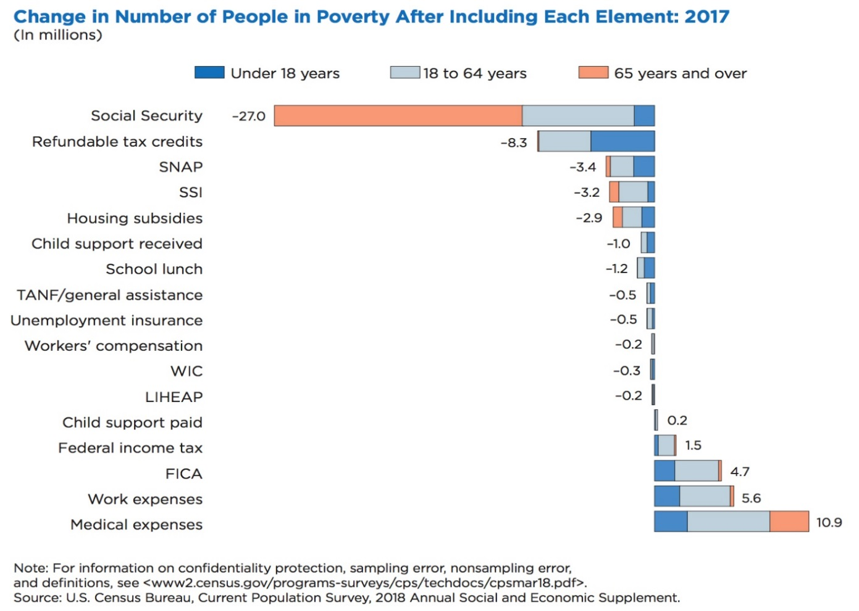
The EITC and CTC are such important anti-poverty tax credits because they’re both fully or partially refundable. For low-to-moderate-income (LMI) families, refundable tax credits can be essential saving tools at tax time. The EITC is fully refundable, meaning that if it exceeds a low-wage worker’s income tax liability (what they owe on taxes), the IRS will refund the balance – for most eligible families with children, this was an average of $3,176 dollars back at tax time in 2016. This successful program is designed to “make work pay;” in addition to supplementing low-wage work with additional income, the higher the income a person earns, the higher the EITC they receive.
The Earned Income Tax Credit (EITC)
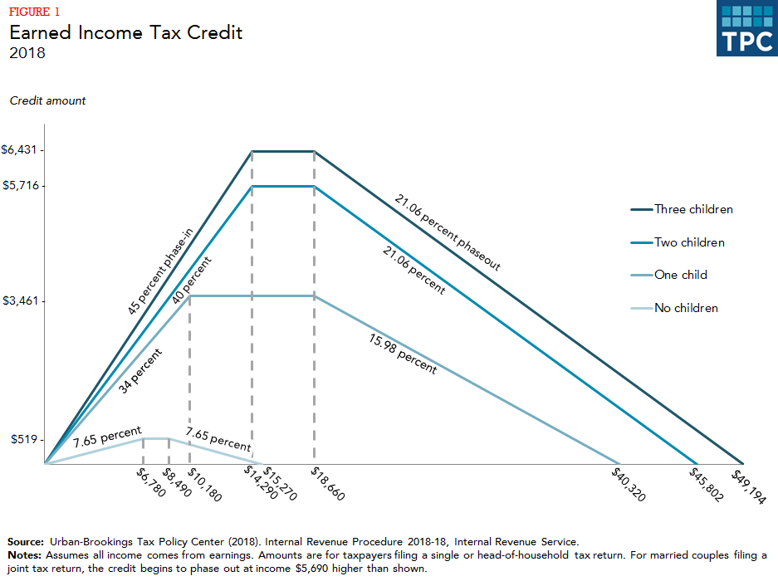
As a credit, the EITC reduces a low-income family’s overall tax liability. It is fully refundable, so if a family’s EITC exceeds the amount of federal taxes owed, the family receives the difference as a refund. The size of the EITC is calculated as a fixed percentage of the worker’s earnings. The credit “phases in,” meaning it increases with additional earnings until the maxiumum credit is reached (at about $14,290 for a family with three children). Once the EITC reaches the maximum, it begins “phasing out” providing a continued but decreasing refund for additional income earned until it disappears completely. This ensures that the EITC is targeted to those who need it. The amount of a person’s EITC depends on family size and marital status (see graph below). First enacted during President Gerald Ford’s administration as part of the Tax Reduction Act of 1975, the EITC was intended “to offset the Social Security taxes of low-income workers with children and to provide those taxpayers with an increased incentive to work.” Since its establishment, the EITC has become the nation’s leading anti-poverty program for working, low-income families. The credit has a long history of bipartisan support, having been expanded under both Republican and Democratic Congresses and presidents. In the Tax Reform Act of 1986, the EITC saw significant expansion, and later the Omnibus Budget Reconciliation Act of 1990 also expanded the credit and added a supplemental credit amount for families with two or more children.
RESULTS volunteers played a critical role in making key EITC and CTC provisions permanent in thhe bipartisan Protecting Americans from Tax Hikes (PATH) Act of 2015, increasing the EITC for larger families and reducing the marriage penalty for joint filers while lowering the income eligibility threshold for the CTC to $3,000. Through 225 meetings with members of Congress and 145 media pieces throughout 2014-2015, RESULTS vounteers played a key role in lifting incomes above or closer for more than 16 million people, including 8 million children, were. This is one of the biggest anti-poverty legislative victories in twenty years, and one that RESULTS volunteers played a critical role in achieving.
Research shows the positive impact of the EITC:
- The EITC has proven to be an effective anti-poverty program. In 2016, the EITC lifted about 5.8 million people above the poverty line, including about 3 million children. The number of poor children would have been more than one-quarter higher without the EITC. The credit reduced the severity of poverty for another 18.7 million people, including 6.9 million children. The EITC (together with the Child Tax Credit) is the largest contributor to preventing poverty for working families. In 2018, the earned income tax credit (EITC) will provide credits ranging from $519 for workers with no children to $6,431 for workers with at least three children. The most recent relevant study found that a $1,000 increase in the EITC led to a 7.3 percentage point increase in employment and a 9.4 percentage point reduction in the share of families with after tax and transfer income in poverty.
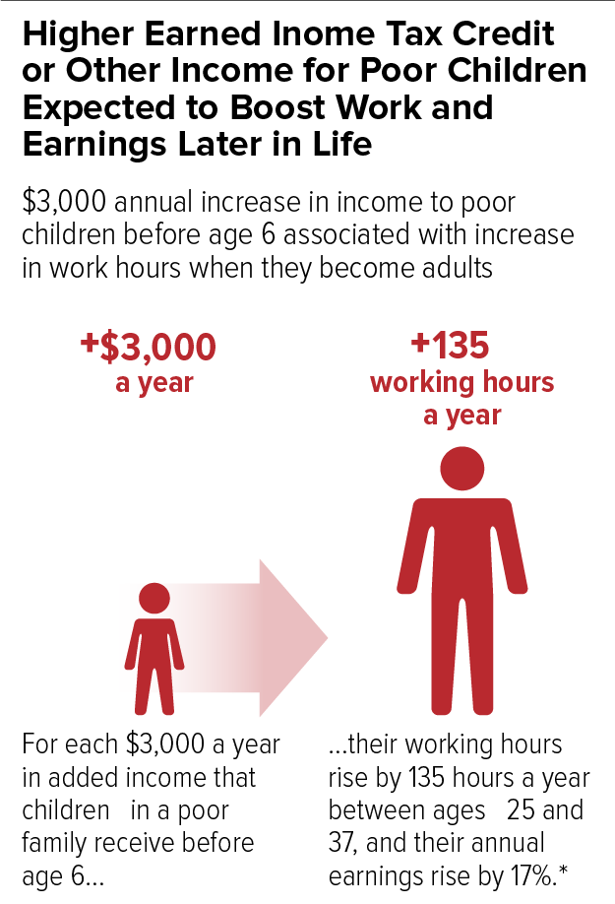
- Infant health is positively linked with increases in the EITC. Research reveals a positive correlation between increased EITCs and infant health markers such as birthweight and premature birth, so that higher EITCs result in healthier birthweights and fewer premature births.
- The EITC strengthens work and earnings in the next generation. Research has found that for children in low-income families, each additional $3,000 per year received before age 6 correlates with an average yearly increase of 135 work hours between the ages of 25 and 37, and their average annual earnings increase by 17 percent. In addition, by boosting the employment and earnings of working-age women, the EITC boosts the size of the Social Security retirement benefits they ultimately will receive.
- EITC children do better in school. Elementary and middle-school students earn higher test scores when their families receive larger refundable tax credits (such as the EITC and CTC). In addition, low-income children are more likely to go to college when their families have benefited from the EITC.
- The EITC strengthens local economies. The EITC refund checks are often spent quickly and locally, resulting in at least $1.50-$2.00 in local economic activity for every $1 claimed.
- The EITC increases promotes work, especially among single mothers. The EITC expansions of the 1990s helped more than a half a million families move from cash welfare assistance to work.
Three Tools Used to Perpetuate Racial Discrimination in Housing

Redlining: “The practice of arbitrarily denying or limiting financial services to specific neighborhoods, generally because its residents are people of color or are poor. While discriminatory practices existed in the banking and insurance industries well before the 1930s, the New Deal's Home Owners' Loan Corporation (HOLC) instituted a redlining policy by developing color-coded maps of American cities that used racial criteria to categorize lending and insurance risks. New, affluent, racially homogeneous housing areas received green lines while black and poor white neighborhoods were often circumscribed by red lines denoting their undesirability.”
Blockbusting: “The efforts of real-estate agents and real-estate speculators to trigger the turnover of white-owned property and homes to African Americans. Often characterized as “panic peddling,” such practices frequently accompanied the expansion of black areas of residence and the entry of African Americans into neighborhoods previously denied to them. In evidence as early as 1900, blockbusting techniques included the repeated—often incessant—urging of white homeowners in areas adjacent to or near black communities to sell before it became “too late” and their property values diminished.”
Zoning Laws: “Municipal or local government laws that dictate how real property can and cannot be used in certain areas. Zoning laws gave localities immense power in determining who could live where, thus the ability to discriminate.”

The Child Tax Credit (CTC)
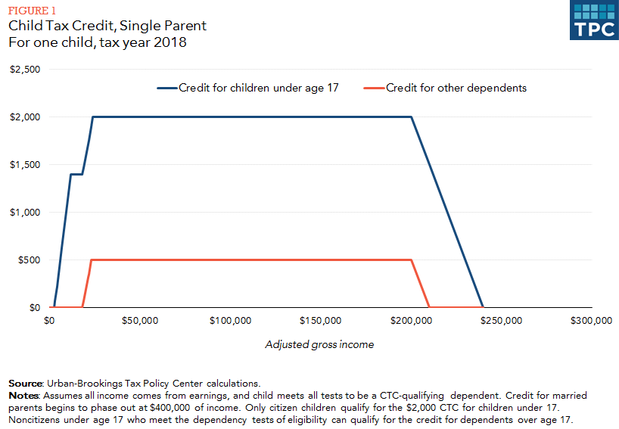
The Child Tax Credit (CTC) is a partially refundable federal tax credit designed to help families offset some of the costs of raising children. When combined with the EITC, the CTC is an effective anti-poverty tool. The Center on Budget and Policy Priorities estimates that in 2017, CTC lifted approximately 2.8 million people out of poverty in 2017, including about 1.6 million children, and lessened poverty for another 13.1 million people, including 6.7 million children.” On Feb. 28, 2019, the non-partisan National Academy of Sciences released a consensus plan to cut child poverty in half. The two policy proposals that had the biggest impact on poverty reduction were both versions of an expanded Child Tax Credit. With the expenses of raising a child continually increasing, the CTC is a critical measure in ensuring that children receive the necessary resources and home stability that they deserve.
The CTC includes a refundable component, the Additional Child Tax Credit, for low-income families. This means that if the value of the CTC exceeds the amount of federal income tax a family owes, the family may receive part or all of the difference in the form of a refund check. As a result, many working families can benefit from the CTC even if their incomes are so low that they owe little or no federal income tax in a given year. This refundable feature is important for low-income working families, who otherwise wouldn’t receive the tax benefits available to higher-income families to help offset the cost of raising children.
First enacted in 1997, the CTC has a similar structure and function to EITC. As with the EITC, only working families are eligible to receive the credit, and the CTC “phases in” as income increases. Unlike the EITC, however, the CTC requires families to earn a minimum income of $3,000 to qualify for the credit and is only partially refundable. That means that if a family’s CTC exceeds its federal tax liability, the family may receive only a portion of the credit rather than the total difference as a refund.
In 2017 the Child Tax Credit was increased but the benefits largely go to high-income households. The credit was doubled to $2,000 per child, but only wealthier families will be able to receive the full benefit. Low-income families can at most get $1,400 per child back as a refund compared to a family earning $400,000, who will get to deduct the full $2,000 credit per child off their taxes.
For many low-income workers, refundable tax credits offer an opportunity to boost emergency savings, purchase necessary items for their household or children, make large purchases (such as a car), or pay down outstanding debts. The Earned Income Tax Credit (EITC) and low-income portion of the Child Tax Credit (CTC) are particularly beneficial policies for communities of color because these communities experience higher rates of poverty.
Expanding the EITC and CTC: The Working Families Tax Relief Act
While tax policy often rewards wealth and exacerbates racial wealth inequality, we can fix our tax laws to give working people and children a fair shot to get ahead. Many of America’s low-income working families are struggling to stay afloat as costs have risen faster than their pay over several decades. Too many parents with low incomes struggle to provide for their kids’ basic needs. Working-class households of all races — those with working-age people without a college degree — have enjoyed only small income gains in recent decades. Many of these working people have low-wage jobs that don’t pay enough to meet basic needs. The problem of low wages affects a broad swath of working people across the country, with the challenges being especially acute in communities of color, where many people face barriers like hiring discrimination.
Meanwhile, Americans have now filed their taxes for 2018 – and this gives us a chance to see first-hand that the 2017 tax law did not make things fairer. The tax code, which was already slanted towards the wealthy and big corporations, was made worse. And some policymakers now want to make up the almost $2 trillion it adds to the federal deficit with cuts to health and nutrition programs, housing, education, and other anti-poverty programs.
An exciting new proposal from Senators Sherrod Brown (OH), Michael Bennet (CO), Dick Durbin (IL), and Ron Wyden (OR) would begin to fix our tax laws to help working people with low-wage jobs keep their heads above water as they work to support themselves and their families. Their proposal, known as the Working Families Tax Relief Act (S. 1138), would improve the EITC and CTC to boost the financial security of 46 million households, benefiting 114 million people, including 8 million Black families, 9 million Latinx families, and 2 million Asian American families. The bill would also cut child poverty nationally by 28 percent, lifting 3.1 million children out of poverty and making another 7.7 million children less poor. Specifically, the bill would:
- Increase the EITC for families with children by roughly 25 percent
- Substantially increase the EITC for workers not raising children and lower the eligibility age to 19
- Make the full $2,000 CTC available to all low- and moderate-income families;
- Create a new Young Child Tax Credit that would provide families with children under 6 years old an extra $1,000 per child (for a total of $3,000 per child)
- Make the CTC equally accessible to families in Puerto Rico while also expanding Puerto Rico’s EITC
Under the bill, a single mom of two earning $20,000 a year would get a $3,700 boost. And, a married couple with two young kids making $45,000 a year would get a $3,500 boost. While there are some other good proposals to expand the EITC and the CTC, the Working Families Tax Relief Act is the only legislation that includes key policy improvements in both the EITC and CTC.
Overall, the Working Families Tax Relief Act would help make sure that low-income parents can give their children a good start in life. This pro-work proposal would help working people afford transportation and other things they need to stay on the job. The 2017 tax law was heavily tilted in favor of large corporations and the wealthy. It is time we fix our tax laws to give working people and children a fair shot to get ahead.
While we don’t expect the Working Families Tax Relief Act to be enacted this year, it is “foundational” legislation that sets the terms of the debate for how we should be focusing our efforts to rewrite the 2017 Trump tax law to promote policies that help millions of Americans struggling to make ends meet. If we can get policymakers and the public to rally around specific proposals to expand the EITC and CTC, we can cement expansions of the EITC and CTC as a top policy priority as part of any legislation moved over the next few years to rewrite the 2017 tax law.
These credits are proven policy successes that help working people with low-wage jobs keep their heads above water, reduce poverty, and improve children’s opportunities. But they can do considerably more. The EITC and CTC expansions in this bill — in combination with legislation to raise the minimum wage, expand access to affordable housing and homeownership, increase funding for child care, provide paid family and medical leave, and more — would help address income inequality that has affected white, Black, and brown working-class households.
Luckily, the Senate Working Families Tax Relief Act has broad support with 45 Senate cosponsors. With similar House legislation just introduced by Representatives Kildee and Evans, we have a chance to build momentum with representatives during advocacy meetings in DC and back home.

U.S. Census Bureau: https://www.census.gov/library/publications/2018/demo/p60-265.html
CBPP: https://www.cbpp.org/research/federal-tax/policy-basics-the-earned-income-tax-credit
Tax Credits for Working Families: http://www.taxcreditsforworkingfamilies.org/earned-income-tax-credit/
Tax Policy Center (TPC): http://www.taxpolicycenter.org/briefing-book/key-elements/family/eitc.cfm
Tax Policy Center (TPC): http://www.taxpolicycenter.org/taxtopics/encyclopedia/EITC.cfm
CBPP: https://www.cbpp.org/research/federal-tax/policy-basics-the-earned-income-tax-credit
Tax Policy Center (TPC): https://www.taxpolicycenter.org/briefing-book/how-does-earned-income-tax-credit-affect-poor-families
Ibid.
CBPP: http://www.cbpp.org/research/policy-basics-the-earned-income-tax-credit
CBPP: http://www.cbpp.org/research/federal-tax/eitc-and-child-tax-credit-promote-work-reduce-poverty-and-support-childrens?fa=view&id=3793
Center for American Progress (CAP): https://www.americanprogress.org/issues/poverty/report/2014/10/07/98452/harnessing-the-eitc-and-other-tax-credits-to-promote-financial-stability-and-economic-mobility/
CBPP: http://www.cbpp.org/research/federal-tax/eitc-and-child-tax-credit-promote-work-reduce-poverty-and-support-childrens?fa=view&id=3793
CBPP: https://www.cbpp.org/research/federal-tax/policy-basics-the-child-tax-credit
ITEP: https://itep.org/the-case-for-extending-state-level-child-tax-credits-to-those-left-out-a-50-state-analysis/
CBPP: http://www.cbpp.org/research/policy-basics-the-child-tax-credit
IBID
CBPP: http://www.cbpp.org/research/policy-basics-the-child-tax-credit
Marr, C., Duke, B., Huang, C., “New Tax Law Is Fundamentally Flawed and Will Require Basic Restructuring.” https://www.cbpp.org/research/federal-tax/new-tax-law-is-fundamentally-flawed-and-will-require-basic-restructuring. 2018.
Tax Credits for Working Families: http://www.taxcreditsforworkingfamilies.org/2016/03/new-survey-sheds-light-workers-use-eitc/

