Strengthen Families and Reduce Poverty by Expanding the Child Tax Credit

Urge colleagues and leadership to expand the Child Tax Credit (CTC) with monthly payments and full refundability for all low-income families

Recently released data from the Census Bureau proved what we already knew: expanding the Child Tax Credit (CTC) dramatically reduces child poverty. Overall, from 2020 to 2021 child poverty fell by 46 percent – primarily because of the CTC. 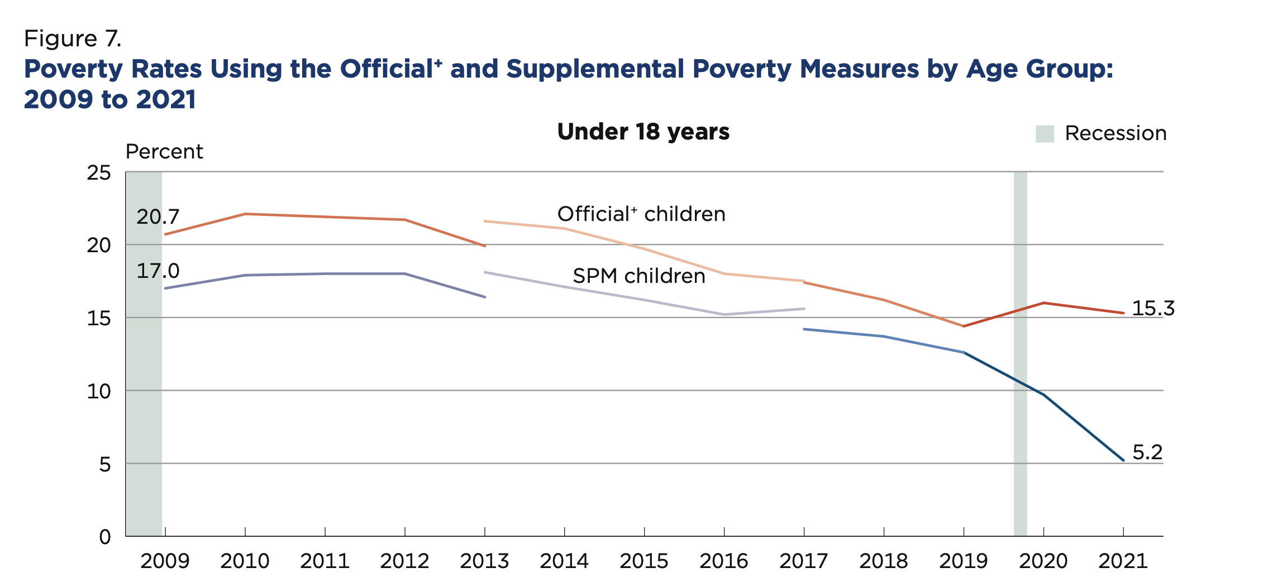
Notes: Census Bureau uses the Federal Poverty Level which does not capture the full cost of meeting basic needs in many communities. The official poverty measure does not include tax credits like the CTC or other anti-poverty programs like SNAP and WIC. The supplemental poverty measure (SPM) includes such programs. Important to note that without the anti-poverty programs RESULTS advocates for, child poverty would be at 15.3 percent instead of 5.2 percent.
The expanded CTC helped families put food on the table, pay the rent, and keep the lights on. It helped families obtain and maintain employment by supporting childcare costs and transportation, but can also support a parent’s decision to focus on caregiving. It provides cash assistance directly to families, allowing them to decide how to navigate the ups and downs of the American economy.
Predictably, Columbia researchers found that there was a 41 percent increase in child poverty as monthly CTC payments stopped in January. Because of congressional inaction, 27 million children in the lowest-income families no longer get the full value of the CTC.
Congress is beginning negotiations on a year-end tax package that will likely provide tax breaks for big businesses. Congress must focus on families struggling to pay rent, put food on the table, and meet other basic needs – and should not pass a tax package providing relief for large corporations unless it also provides relief to families through an expanded Child Tax Credit. RESULTS urges you to enact an extension of an expanded CTC to strengthen families and fight child poverty, prioritizing the needs of families with the lowest or no incomes in a year-end tax package, and communicate that this is a top priority with leadership and colleagues.

