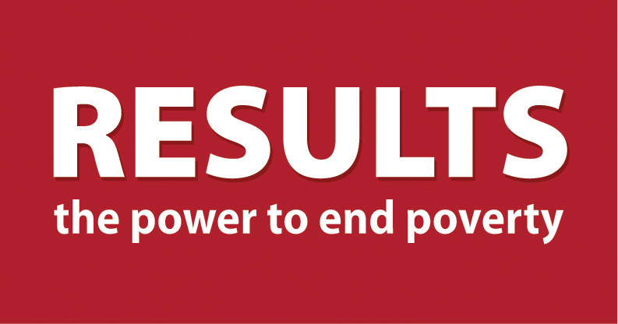
Global Education Outreach Meeting Guide
International Women’s Day
March 8, 2014

We have a great opportunity on March 8 (International Women’s Day) to hear from the CEO of the Global Partnership for Education (GPE), Alice Albright, on an international webinar. Ms. Albright will tell us why investing in GPE is an exceptional investment in global education and outline what is at stake at the June 26 replenishment conference. Our colleagues from RESULTS UK, Canada, and Australia will also join us, as well other global education advocates.

March 8 is a great time to engage people from your community and local action network in RESULTS. Done well, invitees will be given an opportunity to hear why you care about ending poverty, learn about the global education issue, experience international solidarity, take an action, and understand the difference they can make by joining your group. Below is a suggested outline to make the most of this opportunity.

- Find a location. Choose a place where you’ll have access to a computer with speakers and the internet. A home is fine, but you might also check the local library or a school. Some coffee shops and grocery stores also have meeting rooms. Details on how to connect to the webinar are below.
- Invite. Set a goal for how many people you want to come and have everyone in the group commit to getting at least 2 people in the room. Tips:
  - Ask them in person or by phone, follow up with email and/or calls to confirm.
  - Your invitation might sound like this, “I’ve been volunteering with RESULTS for xx months or years and I haven’t found anything that is more effective when it comes to addressing poverty. I’ve seen things improve, I’ve learned so much, and I know my actions make a difference. We are having a special event on Saturday March 8 starting at 1 pm ET and I’d like you to come. Part of the event will be connecting to an international webinar with our colleagues around the world working on global education. We’ll have snacks and good conversation. It will be a great way to honor International Women’s Day. I think you will like this. Would you please come?”
- Prepare. Organize your snacks, beverages, room set up. Make sure you have copies of the GPE Appropriations Sheet and/or copies of an EFA Act and appropriations sign-on letter paper, pens.
- Meet. 2 to 2.5 hours
- Welcome guests and have them sign your sign in sheet. Socialize and snack.
- 30-45 minutes before the webinar starts bring people together and thank them for coming.
  - 8 min: Have everyone briefly introduce himself or herself and share one fun personal fact.
  - 7 min: Have two people from the group briefly explain what RESULTS has contributed to their lives.
  - 11 min: Ask people in the room to share what they would like to get out of the day.
  - 4 min: Let people that that they will be connecting to an international webinar focused on global education and they will have a chance to ask questions. Share why this issue is so critical. Let them know that there will be an opportunity to take action after the webinar as well as join the group and action network.
- 60 min: Webinar.
- 5 min: Get reactions to the webinar
- 15 min: Take action by writing letters on EFA and education appropriations or having everyone sign-on to letters to your representative(s) and senators.
- 10 min: Make a powerful ask for people to join your group that might sound like this, “Members of this group and volunteers around the world feel fortunate to have found RESULTS. RESULTS has given us a opportunity to become the people we want to be in the world—people having big impact on the big problems of poverty. And now we are at a point in time where some amazing things are possible if we ramp up our efforts—all children getting a quality education, the end of AIDS, the end of preventable child deaths, the end of extreme poverty. We want to offer all of you an opportunity to work with us to achieve these amazing goals by becoming members of our group. This would mean meeting twice monthly, taking action regularly, and helping us figure out how to best work with our members of Congress, the media, and our community. Can I see a show of hands of those of you interested in joining us?”
  - Answer questions.
  - Take down contact information of joiners and let them know of next meeting date and time.
  - For those who don’t want to join the group, ask them if they are interested in taking actions and coming back to other outreach meetings.
- Follow Up. Make a plan to follow up with everyone at the outreach event.
- Call people who said they want to join and make confirm their attendance at the next meeting. Encourage them to visit our For New Activists page and go through the Basics at the bottom.
- Call those who did not sign up for the group and confirm that they’d be willing to take important actions you send out. Let them know that those actions will make a difference and that you’ll keep them informed about any results of the group’s actions. Remember: these people are potential future advocates.
- Invite Again. Invite everyone to your next action-taking meeting.

Connecting to the Webinar.
- Test your computer and connection any time before March 8 by going here: http://www.webex.com/test-meeting.html
- On Saturday March 8 at 1:50 pm ET, click on the link below to connect to both audio & visual: https://worldbankgroup.webex.com/worldbankgroup/j.php?MTID=md028b16869d56fe65bc99c9f0c239477. Enter the meeting number (730 725 478) and password: 6265.
- If you are concerned about bandwidth or computer capabilities to join the webinar, you can dial in for the audio at the following numbers: Toll-free number (US/Canada): 1-855-244-8681 Call-in toll number (US/Canada): 1-650-479-3207. Enter the meeting number (730 725 478) and password if they ask for it: 6265.

Use Social Media to Enhance Your Event
- Tweet your meeting and the webinar. Hashtags we will all be using are: #educationforall; #AskAlice; #fundthefuture. Sample tweets for before the meeting are:

This Saturday RESULTS grassroots in the UK, US, Can & Aus are coming together to #AskAlice how to generate global support for #educationforall

This weekend I am joining RESULTS advocates around the world to #AskAlice from @GPforEducation why #educationforall is so important
  - Why is a fully funded @GPforEducation so important? Today RESULTS groups from the #UK to #Japan are coming together to #AskAlice
  - 57 million children are still out of school. Today, I join RESULTS advocates around the world to #AskAlice how to secure #educationforall

