Media Action: Support the Global Fund
At the height of the AIDS crisis, the world came together to fight back, pooling its resources and creating the Global Fund to Fight AIDS, Tuberculosis and Malaria. Now almost two decades later, its success has been nothing less than remarkable. Since 2002, the Global Fund has helped save 27 million lives.
The Global Fund operates on a massive scale and remains effective because it’s structured as an innovative partnership between governments, civil society, the private sector, and people affected by the diseases. Instead of showing up and telling countries what they should do, the Global Fund asks: “What do you need? What is the best way to provide it?” Because the Global Fund partners with local civil society organizations on the frontlines of these epidemics, it is able to reach marginalized people and communities who might otherwise be overlooked.
However, challenges remain. Growing drug resistance, shortfalls in funding, and wavering political commitment are threatening our progress in the fight against AIDS, tuberculosis, and malaria. Science shows that we can end these epidemics, and the Global Fund is the catalyst, but it must have the resources it needs to scale up its work and reach everyone.
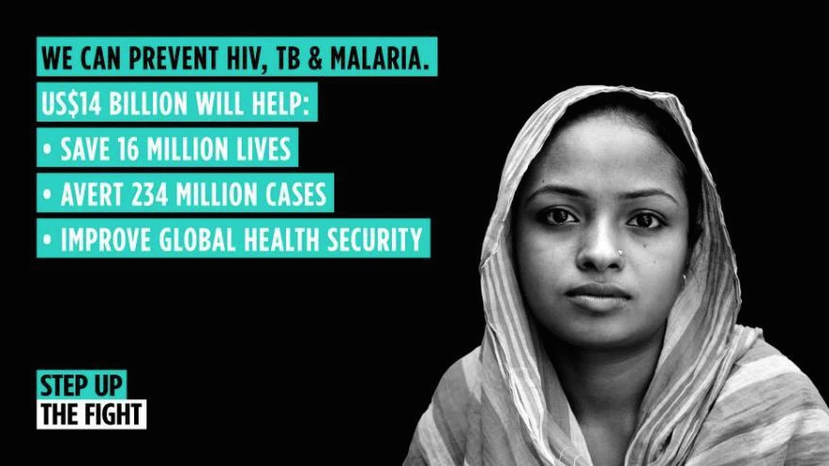
The Global Fund now has a plan to support countries to save 16 million lives over the next three years. It will take at least $14 billion for the Global Fund to do its part.
Since the beginning, the U.S. has played a leading role in the Global Fund, providing a full one-third of its financial resources. That needs to continue, with the U.S. coming to the table with at least $4.6 billion toward the $14 billion minimum target. U.S. support for the Global Fund has also been uniquely bipartisan, crossing party lines when often not much else could. Though the control of Congress and the White House has shifted back and forth between parties over the last 17 years, U.S. support for the Global Fund has remained constant. That support did not magically appear—grassroots advocates made it happen.
So, it’s up to us as advocates again to create the political momentum. It’s up to us to make sure our leaders do their part. It’s up to us to push back against the cynicism that insists we can’t solve big problems. We can. As the Global Fund gears up for a new financing cycle — where countries will be called on to make fresh pledges of support — we must push our own government to lead by example and maintain the U.S.’s robust funding commitment of one-third of the total need.
Why write a letter to the editor?
Writing a letter to the editor is a great way to make sure our government’s commitment to this fight continues. Your senators and representatives read your local paper every day, trying to understand the issues that their constituents care about. They need to hear from you. Even one published letter can make a big difference.
Tips
- Keep your letter short: 150-200 words. Even shorter is better!
- Reference a story that’s already been in the paper as an entry-point for your letter, or “hook” your letter to a story about a local health issue, budget negotiations, the 2020 presidential race, or another local issue. Get creative!
- Make it personal. Customize with your own ideas, examples, and passion.
- Keep a look out for your letter in print and, if you're published, be sure to share it with your members of Congress and repeat your call to action.
- Let RESULTS staff know you've been published!
Sample LTE
To the Editor:
At the height of the AIDS crisis nearly two decades ago, the world came together to fight back, creating the Global Fund to Fight AIDS, Tuberculosis and Malaria. This international partnership has helped save 27 million lives since 2002. This is stunning progress, but we cannot claim victory yet.
HIV and TB treatments aren’t reaching everyone who needs them and progress on tackling malaria has stalled. There are major challenges, but with vigilance we can end these epidemics. Since the beginning, the U.S. has played a leading role in the Global Fund, providing a full one-third of its financial resources. That must continue.
The Global Fund needs at least $14 billion to help save 16 million lives by 2022. I urge our members of Congress and President Trump to continue strong support for the Global Fund by recommitting to provide at least one-third of total need to step up the fight, save more lives, and move us closer to ending these diseases.
[Your name, city, state]

Leading with Action: Letter-Writing Workshop Agenda & Guide
Below is a sample agenda and script that you can use to put people in your community into action. We know that when people take action they are inspired. The agenda below will require roughly 60 minutes. Adapt the elements to fit your style and timeframe.
I. Setting the Stage – 15 Minutes
2 min: Welcome and acknowledge people for being there.
“Thanks to all of you for coming. There are a lot of ways you could be spending the day, and I want to thank all of you for coming out and learning more about how YOU can play a role in the movement to end poverty. Can the RESULTS volunteers briefly say their name and how many years you’ve been involved? Also, can you all be sure to sign our sign in sheet?”
3 min: State the purpose of the meeting.
“Our purpose today is to inspire you all about the difference you can make, working with others, to create the political will to end hunger and poverty. In the next few minutes, we’ll . . .
- Learn a bit about RESULTS, the group organizing this.
- We will learn about an issue of poverty.
- We will take powerful action on the issue: we'll write letters to the editor on replenishing the Global Fund to Fight AIDS, TB, and Malaria.
- Finally, we'll see who is interested in continuing to make a difference with RESULTS.”
10 min: Center the room and do introductions.
“Let’s see who’s in the room tonight and get in touch with why we are here. Please give us your name and tell us briefly why acting on issue of poverty is important to you.” Other possible questions, “What are you committed to in life?” or “Who do you want to be in the world?”
Afterward, “Thank you all for sharing what is important to you. We have a lot in common.”
II. The Basics of RESULTS – 10 Minutes
RESULTS is…
“So, what is RESULTS? RESULTS is movement of passionate, committed, everyday people. Together we use our voices to influence political decisions that will bring an end to poverty. As volunteers, we receive training, support, and inspiration to become skilled advocates. In time, we learn to effectively advise policy makers, guiding them toward decisions that will improve access to health, education, and economic opportunity. Together we realize the incredible power we possess to use our voices to change the world. “
Show one of the videos: Raise Your Voice: https://results.org/ or We Have a Vision: http://www.results.org/blog/we_have_a_vision/
- Share an example of success: “We protected development assistance for FY2018 after the President proposed cutting it by 30%. We worked with Republicans and Democrats to help secure the highest number ever of congressional supporters for AIDS, TB, and malaria; global education; and maternal & child health, sending a message to the President that these programs should be protected and strengthened.”
- A local example of our role in creating change is: “We moved Rep or Senator _______ to sign on to xxx letter as part of this. He/She met with us in ______ (month) of 2018, which was key in getting his/her support.”
A few more details if you have time:
- “RESULTS partners meet twice per month to plan and take action.”
- “During one of our meetings, we connect to a national webinar to learn about an issue, learn to speak powerfully, and take action to influence Congress.” Give an example.
- “We also develop plans for influencing our decision makers through face-to-face meetings, the media, and other community actions.”
III. Issues & Action Component – 30 Minutes
- Introduce the issue of the Global Fund with a story or video:
- Global Fund TB story: https://tinyurl.com/y9o4a99m
- Global Fund HER Project: https://youtu.be/2YhQcYUHHOk
- Global Fund: Keeping Girls in School: https://youtu.be/L3lue3VYGdA
- Read the March Action Sheet together, including sample letter.
- Show people how to find their local media and relevant contact information online.
- Everyone writes their letters to the editor.
- Ask writers to read their letter out loud for feedback and encouragement.
- Debrief on the action-taking—“How did it feel to take action with the media?”
IV. Invitation to Attend the Next Meeting & Closing – 5 Minutes
“Lastly, we are planning to have future meetings like this one to guide people in becoming powerful advocates. We’ll also be visiting our representatives and senators.
- Who is interested in joining us again to take action?
- Who is interested in joining us for a meeting with our representative or senators?
- Who knows other people or groups who might be interested?
- Who is interested in learning more about supporting RESULTS financially?”
Say thank you, capture contact information: name, phone, email, address. Add them to your Action Network list and stay in touch with them. Send contact into to Ken Patterson or Lisa Marchal for the RESULTS national database as part of your group’s Action Network. Your new people will receive actions monthly.

Action Network Managers Action

Here’s a sample message you can send to your Action Network:

Dear (Name), Our voices helped protect millions of dollars for health and education programs in 2018 and 2019 that would have been cut if the President had his way. Great work, but we can’t let down. At a recent pre-replenishment meeting for the Global Fund to Fight AIDS, TB, and Malaria, there was no US government representative! So, we used your work on sign-on letters to demonstrate that the US Congress does care. Take Action: Write a letter to the editor to ensure the US continues to lead on the Global Fund to Fight AIDS, TB, and Malaria.

