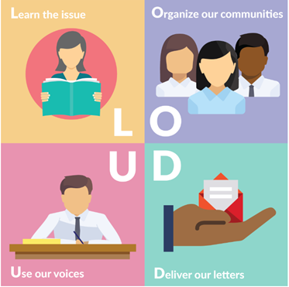

#LettersGetLOUD June Blast
We want all our advocates, allies, and friends to “be in the room” when meetings with representatives and senators happen all during Advocacy Day (July 17) during the 2018 RESULTS International Conference. Well, we’ve made #LettersGetLOUD all year long so far. Why not make sure the #ICGetsLOUD?
Step 1: Determine a point person – it may be you! – for collecting letters for your senators and representatives to be hand-delivered during meetings with members of Congress during Advocacy Day at the IC.
Step 2: Determine a date/time/place for your letter-writing meeting. Make it between June 1 and June 30. It could be in conjunction with a time when your local group is already meeting. It could be a coffeehouse meeting for the community. It’s your choice.
Step 3: Use the June Action Sheet that will help you and others write letters urging cosponsorship for the Reach Every Mother and Child Act. Also use other resources on the #LettersGetLOUD main page to boot your event.
Step 4: Post pictures and videos of the writing and reading of your letters on social media. On Twitter, use the hashtag #LettersGetLOUD.
Step 5: Record your #LettersGetLOUD outreach event via our reporting form.
Step 6: Pack the letters in your suitcase for delivery July 17.
Step 7: Take pictures of letter delivery on July 17 during Advocacy Day meetings and share with your letter writers back home so they see the tangible impact of their advocacy.
The International Conference involves everyone, here and at home. Let’s make sure the #ICGETSLOUD!

