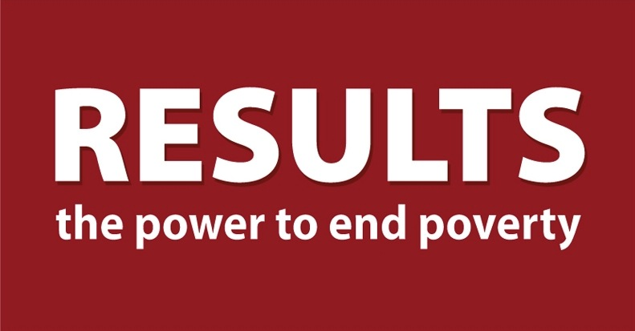
Global Poverty National Webinar

November 11, 2017 | 2:00PM ET
[LOCATION]

Join us for an inspiring, informative call about the power of education featuring Julia Gillard, former PM of Australia. We've invited RESULTS Canada, UK, and Australia to join as well.

FUZE ONLINE: http://fuze.me/30204806
PHONE: dial (201) 479-4595, meeting 30204806

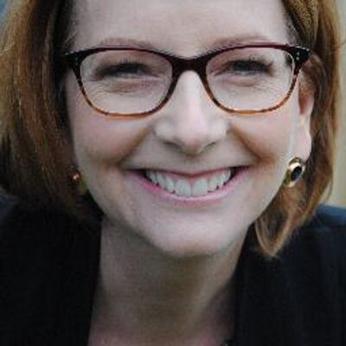
Featuring
JULIA GILLARD
Chair of the Board of Directors for the Global Partnership for Education (GPE), and former Prime Minister of Australia

