RESULTS Expansion Quick Guide

Key Definitions & Principles
The strategy to start and grow RESULTS groups is based in the definition of leadership – enabling others to achieve purpose under conditions of uncertainty. RESULTS organizes in Groups – typically by Congressional District or city – but individuals without a group can operate as “Free Agents” to take regular action or join the “Action Network” for online actions. Groups are expected to meet and act at least twice a month (including to participate in the monthly conference call); set quantifiable goals and develop a plan for each quarter; set norms for how they’ll work together and coach each other; hold at least two outreach events a year and recruit at least one new member per month; fill at least the following interdependent leadership roles: Group Leader, Media Coordinator, House Coordinator, Senate Coordinator, and Outreach Coordinator; and fundraise annually. Groups form and grow through a five-phase development process that escalates individual involvement through a ladder of engagement – increasing commitment, skills, leadership, and impact.

Role of the Organizer/Expansion Agent
- Build a list of prospective volunteers and leadership.
- Present RESULTS to them as a meaningful (and fun) opportunity to act on their values and deepen their advocacy skills.
- Facilitate the group start process, including managing inviting teams and group start meetings.
- Identify, test, confirm, and cultivate group leadership.
- Train new volunteers.
- Transition groups (at least four members with a leadership structure who have taken action) to a Regional Coordinator (RC).
- Data enter all leads and track the group start and development process and report on progress toward goals.

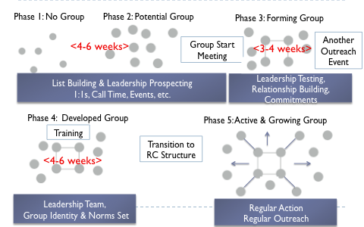
Group Development Process
While not always linear or starting from the same point, this is a framework for the group development process – a 12-16 week process with multiple points of entry – not just the group start workshop.
Dots represent individuals and the box represents the “snowflake” leadership structure. Ideally at least 15 people are committed before group training begins.

Testing and Confirming Leadership
Group leadership is the most important factor in the sustainability and effectiveness of RESULTS groups. While we encourage every RESULTS member to take on leadership, specific leadership roles should be earned – particularly for the Group Leader. Four additional roles are required – Media Coordinator, House Coordinator, Senate Coordinator, and Outreach Coordinator. Each person in a leadership role must have their own responsibility, their own “chunk” of the work, on which the success of the whole depends. In order to ensure that our groups are set up for success, Organizers need to identify, test, and confirm prospective leaders throughout the expansion process, which might not be linear process or necessarily complete before group start meetings.

Testing: This is an opportunity for the Organizer to determine whether a prospective leader has the interest and potential to fulfill a specific role and the potential leader an opportunity to experience leadership. Tests should ideally be specific to the leadership role you think could be the right fit and also a stretch for the volunteer. Be clear about expectations on the front end, check-in mid-way to coach and intervene if necessary, and debrief afterward. The testing process can be explicit but doesn’t have to be.

Confirmation: Confirming people into roles needs to be an explicit process. Ideally there’s a conversation between an Organizer and Group Leader and the Group Leader takes a lead on confirming the rest of the leadership team of the group. These conversations might happen one-on-one or in a bigger group depending on how/when leadership roles can be set. Conversation should clearly lay out expectations of the role, norms to work together, and initial next steps/first priorities. The Organizer should also work with the Group Leader to recognize, celebrate, and publicize leadership as people are confirmed.

List-Building & Relationship Building
Everybody is a prospective RESULTS activist, free agent, and leader. Starting a RESULTS group with a distributed leadership structure requires personal contact with a list of at least 150-200 people (through the organizer, inviting team, etc.) and 20 introductory one-on-one meetings or calls (intentional, exploratory conversations). Tips include:
- Focus on the hottest leads – the people most likely to become activists and leaders.
- Follow-up within 24-48 hours of contact to keep people hot.
- Make and keep it personal. Sometimes you need someone to make an introduction or you need to reference someone in common to give yourself some credibility.
- Use stories and ask questions to solicit stories that get at the “why” – why are YOU involved in RESULTS and why THEY care. Don’t overwhelm people with daunting statistics they won’t remember or inspire them about the difference they can make.

Hot Lead Sources – Start with the people already associated with the RESULTS network – donors, list-serv subscribers, etc. and ask them + their friends, families, and contacts. Find the people who know everybody else within a community. Go to communities of faith with active social justice and political members; existing community groups or affiliates who work on similar issues; participate and hold trainings and talks at local conferences and meetings; put out postings on Idealist and Volunteer Match.
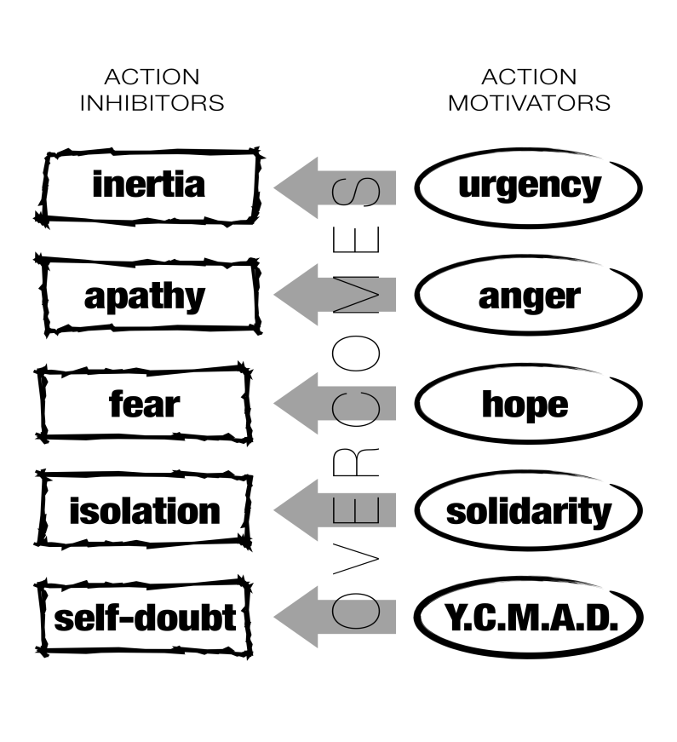
Public Narrative – This is a framework to translate values into stories to motivate action, build relationships, and maintain commitments – to use in 1:1 meetings, call time, and events. People make decisions with the head and their heart so stories with “action motivators” that focus on how individuals or groups overcome a challenge with a specific choice and a clear outcome can inspire people to join and stay involved.

The Story of Self focuses on why individuals are called to RESULTS and to lead and/or what they’ve achieved through RESULTS; the Story of Us communicates values and shared experiences to inspire others to act in concert by identifying with each other – not only with you; and the Story of Now communicates the urgent challenge and choice people face to join RESULTS with the hope we can face it. Organizers should be able to share authentic stories of self about their involvement with RESULTS and the successes of RESULTS groups and be skills in linking their Stories of Self to Stories of Us and Now.

Hard Ask: Everything turns to mush unless people are committing to take concrete actions or roles. The “hard ask” is a tool to solicit those commitments through specific, significant, time-sensitive, and escalating questions. A “no” is better than a “maybe” so make an “ask” that gives them a choice, an opportunity to realize their values – not a favor or a small task that minimizes its significance. Be ready with multiple asks - politely relentless and relentlessly polite. Wind up to the “ask” with the why (its significant), why you (make it specific to the person’s skills, resources, values, experiences), and why now (the urgency).

Group Start Meetings & Inviting Teams
Convening and facilitating inviting teams to recruit for and host group start meetings is a primary strategy for starting a group in a new area. Group start meetings typically last 2-2.5 hours and aim to have at least 20 but ideally closer to 30 participants. The Organizer/Expansion agent works with the hot leads in the area and well-networked, committed supporters to convene an official inviting team who find a place, date, time, and host for the meeting; and convene check-in meetings to discuss the invite-process, logistics, and collaboratively plan the agenda.
Kick-Off:
1st Meeting
Recruitment
2nd Call/Mtg
3rd Call/Mtg
Training, Support
Week 1-2 Week 2-4 Week 4-5 Week 5-6
More Invites, RSVPs, Confirmed
Group Start Planning
Follow-Up

Group Start Meeting

Inviting Teams
- Goals: Build the biggest events possible with diverse, hot leads; test and develop leadership among inviting team; and share the work - prep, execution, follow-up.
- Convene 2-3 times in-person to build their relationships, set goals and strategize on their invitations, practice their asks, check-in on progress, problem-solve challenges, plan the meeting and follow-up, and stay/keep each other inspired.
- Tips for the organizer/host:
  - Be intentional about who you ask to join the inviting team.
  - Focus on facilitating relationships and accountability among the team.
  - Keep the meetings (calls if necessary) focused, inspiring, and engaging.
  - Emphasize and practice personal invitations and confirmations within 48 hours
  - Show exceptional gratitude.

Group Starts Meeting Goals
- Sign-up volunteers to join as Activists or to join the Action Network.
- Sign people up as donors as well.
- Develop and test prospective leadership through the inviting team and other roles at the meeting.
- Generate more leads and prospective leaders.
- Set next meeting dates/times for sign-ups (in advance).

Group Start Meeting Best Practices:
- Start and stay with the WHY – why RESULTS, why these issues, why advocacy/lobbying, why them/this District - keep it local (why their Members matter).
- Keep the meeting engaging and interactive.
- Give people an opportunity to learn about one issue and take a concrete, strategic action to demystify activism and inspire them about the difference they can make.
- Provide a clear, inspired explanation of what it means to join RESULTS.
- Empower inviting team members and other prospective leadership to own the meeting.
- Pick a location and timing that’s convenient for the community, ideally holding two group starts within a short time frame to maximize participation & sign-ups.
- Make a logistics checklist with the inviting team.

Sample Agenda: This is 1.25 hours but doesn’t include time for videos, time for transitions, etc. so will take closer to 2 hours.
0:00-0:03 Welcome, Purpose of Meeting, Overview of Agenda
0:03-0:10 Who is in the room – personal introductions
0:10-0:15 Public Narrative & Introduction to RESULTS
0:15-0:30 Discussion on the RESULTS model – why advocacy and lobbying
0:30-0:33 Another Public Narrative (from an inviting member or host)
0:33-0:65 Quick Action & Skill Building Session
0:72-0:75 Wrap-Up and Close

New Group Orientation
RESULTS provides trainings to individual partners and groups. Completed in (a) separate modules in a 3-4 part series or ideally as (b) one, four-hour session with one follow-up meeting, the orientation provides the group with a baseline of skills and knowledge and a process to develop a three-month plan and goals to become an effective RESULTS group. Ideally the group leader and/or any other confirmed leadership play as much of a role as possible in the logistics and substance of the training. The following goals and sample agendas below assume (a) four separate modules, so should be condensed and reordered if (b) can be scheduled. The website, monthly conference call, and action sheets should be used as a resource/integrated however possible.

 | First Module - Getting Started | Second Module – Our Power
Goals | Build/deepen relationships among group members  Potentially confirm leadership/roles of the group  Set future meeting times  Deepen understanding of one issue and take an action, ideally learning a new skill (building on what was taught/accomplished during previous meetings) | Continue to deepen relationships and acquaint any new members  Learn about lobbying/advocacy and the legislative process  Learn about their elected officials  Test and cultivate leadership within the group
Agenda | Review agenda/goals  Public narrative – why they signed up  Overview of training plan  Overview of legislative & appropriations process and RESULTS theory of change  Review issue from group start meeting & take updated action  Set norms, dates  Homework, next steps | Review agenda/goals  Ice breaker/relationship builder  Debrief any homework  Getting to know our Members of Congress  Complete Power Mapping of MoCs  Take Action & Practice  Homework and next steps – outreach to request MoC meetings

 |  | Third Module – Our Strategy | Four Module – Our Plan
Goals | Continue to deepen relationships and check in on norms  Test, cultivate, and confirm leadership  Map group’s resources and power  Learn about different tactics for lobbying and advocacy |  | Solidify group leadership structure  Set norms and norm corrections  Set goals for group actions  Set calendar for group’s next 2-3 months  Plan for the meeting with the MoC (new skill)
Agenda | Review agenda/goals  Debrief homework  Review current status of all campaigns and priorities  Strategize on next steps for MoC Meetings  Take Action  Homework and Close |  | Review goals/agenda  Revisit why – practice story of self  Develop group plan, goals, and schedule  Review roles  Set norms, including future meetings  Take action  Review decision, next steps, celebrate

Transition to Regional Coordinator Structure
Assuming part-time expansion staff continues to organize in multiple states, the Group Leader’s main point of contact and source of support shifts from the Organizer to the appropriate Regional Coordinator once a group has:

- Their leadership structure set and at least four committed members
- A plan developed
- Orientation complete
- A meeting at least set if not held with an MoC or office.

This structure and intention should be explicit with the group from the beginning and the Organizer should ensure the RC has all of the group’s contact info and plan before the transition and conference call with the Group Leader.

