The global impact of tuberculosis (TB) is staggering
Tuberculosis (TB) is the second leading infectious disease killer in the world after COVID-19 and disproportionately affects impoverished and marginalized communities.
TB is often thought of as a disease of the past, but unfortunately it remains a major global health threat and is a key driver of poverty. With resources diverted to fight the pandemic, TB infections and deaths are on the rise again after a decade of decline. A new report from the World Health Organization (WHO) shows that TB mortality increased in 2020 and again in 2021, up to 1.6 million deaths last year. Additionally, new cases are up for the first time in years, and over 10.5 million people fell ill in 2021. Over 98 percent of TB cases and deaths are in low- and middle-income countries. The vast majority of TB cases are curable, but in resource-poor areas treatment often comes too late.
Estimated TB incidence rates, 2021
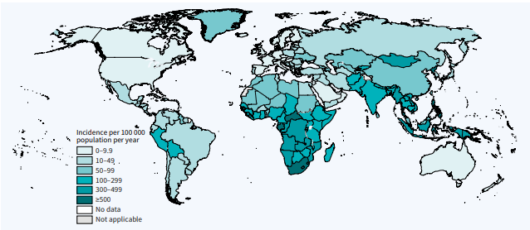
Source: World Health Organization 2022 Global Tuberculosis Report

We need to recover lost progress on TB to save lives
The COVID-19 pandemic damaged the already under-funded TB response in low- and middle-income countries, reversing years of progress. Because of the two diseases’ similarities, TB programs, facilities, and staff were used in the frontline response to COVID. A USAID survey found this rapid mobilization came at the expense of the core TB response and put unprecedented pressure on the health workforce, infrastructure, and resources globally.
In 2021, some countries began to recover, but WHO estimates that around 4 million people are still “missing” from treatment, going undiagnosed and untreated because of lack of access to needed resources. The lack of investment and added stress on health systems during COVID means the United Nations End TB Strategy goals are now off track.
The Stop TB Partnership estimates that delaying or failing to implement the goals will mean 43 million people developing TB, leading to 6.6 million deaths by 2030. This will cost communities and families their loved ones, and upwards of $1 trillion in economic loss by 2030. Humanity would lose a projected 234 million disability-adjusted life years.
Fighting TB in the hardest-hit countries and communities is an issue of health equity and economic justice. To claw back progress and course correct to save more lives, Congress must take action.

The End TB Now Act (H.R.8654 / S.3386)
This bicameral, bipartisan legislation, introduced by Senators Bob Menendez (D-NJ) and Todd Young (R-IN), and Representatives Ami Bera (D-CA) and Maria Salazar (R-FL), directs the U.S. Agency for International Development (USAID) to set bold targets to reach and treat the most vulnerable populations for all forms of TB. The bill also addresses the impact COVID-19 has had on global TB control efforts. Specifically, the bill:
- Requires the U.S. to establish bold goals for reaching the most vulnerable populations to detect, cure and prevent all forms of TB globally
- Strengthens U.S. bilateral coordination with global organizations, including the Global Fund to Fight AIDS, TB, and Malaria, to develop and implement a comprehensive global TB response
- Catalyzes support for research and development (R&D) of new tools to prevent, diagnose, treat, and control TB, including drug-resistant strains of TB worldwide
- Improves the capacity of countries and affected communities with high burdens of TB to implement programs to prevent and control the spread of TB
- Requires annual reporting to Congress on U.S. TB activities and their impact, including progress in recovering from the negative effects of COVID-19 on TB
- Evaluates the performance and the focus on impact of TB programs that are supported by U.S. bilateral assistance funding
The world is not on track to meet global goals on TB—but U.S. leadership can help change that. Will your boss co-sponsor the End TB Now Act (H.R. 8654 / S.3386)?
Please contact Emma.Bruce@mail.house.gov (Bera) or JohnMark.Kolb@mail.house.gov (Salazar) in the House or Heather_Flynn@foreign.senate.gov or Brandt_Anderson@young.senate.gov in the Senate for more information or to sign on.

