Media: Global Fund and the Holidays
The December holidays are a perfect time to celebrate progress made and recommit to ending diseases of poverty.
Since 2002, the Global Fund to Fight AIDS, Tuberculosis, and Malaria has helped save 32 million lives by combatting three preventable and treatable diseases. Because the Global Fund partners with in-country government and civil society organizations on the frontlines of these epidemics, it is able to reach marginalized and often overlooked communities. It also bolsters health systems to address diseases of the future.
Sadly, growing drug resistance, shortfalls in funding, and wavering political commitment threaten progress in the fight against AIDS, tuberculosis, and malaria. Science shows that we can end these epidemics by 2030, but resources and political will are required.
The Global Fund seeks funding commitments from governments, foundations, and the private sector in three-year increments. The most recent replenishment conference on October 10 in France successfully generated $14 billion in pledges over the next three years. The Global Fund will use this money to save an additional 16 million lives, avert 234 million disease cases, and improve global heath security over from 2020-22. But we must ensure that the pledges come in.
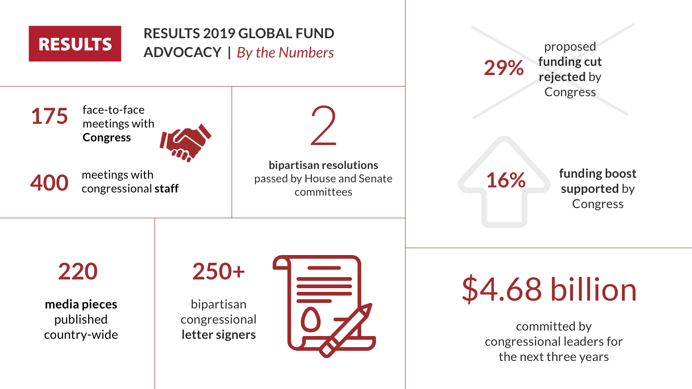
Since the beginning, the U.S. has played a leading role in the Global Fund, providing one-third of its financial resources. In France, a bipartisan delegation from the U.S. Congress made the commitment to again fund one-third of the $14 billion needed ($4.68 billion). The rest of the world stepped up as well, raising $13.92 billion, with promises from France to raise the final $80 million by December.
The U.S. pledge is a direct result of the work of RESULTS advocates and our partners pushing Congress through meetings, calls, letters, and the media throughout the past 18 months. Now we must ensure Congress fulfils the US pledge by thanking them for their support of the passage of Global Fund resolutions H.Res.517 & S.Res.318. Use the media to thank congressional supporters and call for the pledge to be honored during the FY21 appropriations process.
Write a letter to the editor to acknowledge and call for action
Writing a letter to the editor is a great way to ensure our government’s commitment to this fight continues. Your senators and representatives read your local paper every day, trying to understand the issues that their constituents care about. They need to hear from you. Even one published letter can make a big difference. And ask a fellow advocate to write as well. We are transforming the world, and when a person is asked to take a powerful action, that person is often transformed as well.
Tips
- Keep your letter short: 150-200 words. Even shorter is better.
- Reference a story from the paper or an issue everyone is talking about as an entry-point or “hook” for your letter. It could be a local health issue, presidential race, or the weather e.g. “As we wait for the winter blast, it’s malaria season elsewhere.” Be creative!
- Make it personal. Customize with your ideas and passion.
- Look for your letter in print. If you're published, share it with your members of Congress and repeat your call to action.
- Send to the listserve and report your media at: www.tinyurl.com/RESULTSMedia!
Sample LTE (200 words). Personalize it!
To the Editor:
Thanks for your piece on holiday events in the area (cite the article). For many of us, the holidays are a time to take stock of what we’ve achieved and what we have yet do.

One 2019 achievement unknown to many is that Republicans and Democrats in Congress played a key role in assuring that millions of people threatened by AIDS, tuberculosis, and malaria will have access to prevention and treatment they need to survive and live good lives.

On October 9, a bipartisan delegation from Congress went to France and committed one-third of the $14 billion needed by the Global Fund to Fight AIDS, TB, and Malaria to save 16 million lives over the next three years. The next day, world leaders pledged the balance of the funding. This is incredibly good news in a year that has been fraught with division.

But we must ensure the U.S. keeps its promise. Our representative and senators have passed House Resolution 517 and Senate Resolution 318, affirming the U.S. commitment to the Global Fund. Thank you to ________________ for their support of that legislation. Now we must double down on that support and see through on the pledge during FY21 appropriations.

(Name, address, phone)

Letter to the Editor Workshop Agenda
Below is a sample agenda and script that you can use to put people in your community into action. We know that when people take action they are inspired. The agenda below will require roughly 60 minutes. Adapt the elements to fit your style and timeframe.
I. Setting the Stage – 15 Minutes
2 min: Welcome and acknowledge people for being there.
“Thanks to all of you for coming. There are a lot of ways you could be spending the day, and I want to thank all of you for coming out and learning more about how YOU can play a role in the movement to end poverty. Can the RESULTS volunteers briefly say their name and how many years you’ve been involved? Also, can you all be sure to sign our sign in sheet?”
3 min: State the purpose of the meeting.
“Our purpose today is to inspire you all about the difference you can make, working with others, to create the political will to end hunger and poverty. In the next few minutes, we’ll . . .
- Learn a bit about RESULTS, the group organizing this.
- We will learn about an issue of poverty.
- We will take powerful action on the issue: we'll write letters to the editor on the Global Fund to Fight AIDS, TB, and Malaria resolutions.
- Finally, we'll see who is interested in continuing to make a difference with RESULTS.”
10 min: Center the room and do introductions.
“Let’s see who’s in the room tonight and get in touch with why we are here. Please give us your name and tell us briefly why acting on issue of poverty is important to you.” Other possible questions, “What are you committed to in life?” or “Who do you want to be in the world?”
Afterward, “Thank you all for sharing what is important to you. We have a lot in common.”
II. The Basics of RESULTS – 10 Minutes
RESULTS is…
“So, what is RESULTS? RESULTS is movement of passionate, committed, everyday people. Together we use our voices to influence political decisions that will bring an end to poverty. As volunteers, we receive training, support, and inspiration to become skilled advocates. In time, we learn to effectively advise policy makers, guiding them toward decisions that will improve access to health, education, and economic opportunity. Together we realize the incredible power we possess to use our voices to change the world. “
Show one of the videos:
- Raise Your Voice: https://results.org/
- We Have a Vision: http://www.results.org/blog/we_have_a_vision/
- Share an example of success: “We protected development assistance for FY2019 after the President proposed cutting it by 30%. We worked with Republicans and Democrats to help secure the highest number ever of congressional supporters for AIDS, TB, and malaria; global education; and maternal & child health, sending a message to the President that these programs should be protected and strengthened.”
- A local example of our role in creating change is: “We moved Rep or Senator _______ to sign on to xxx letter as part of this. He/She met with us in ______ (month) of 2019, which was key in getting his/her support.”
A few more details if you have time:
- “RESULTS partners meet twice per month to plan and take action.”
- “During one of our meetings, we connect to a national webinar to learn about an issue, learn to speak powerfully, and take action to influence Congress.” Give an example.
- “We also develop plans for influencing our decision makers through face-to-face meetings, the media, and other community actions.”
III. Issues & Action Component – 30 Minutes
- Introduce the issue of the Global Fund with a story or video:
Global Fund TB story: https://tinyurl.com/y9o4a99m
Global Fund HER Project: https://youtu.be/2YhQcYUHHOk
Global Fund: Keeping Girls in School: https://youtu.be/L3lue3VYGdA
- Read the December Action Sheet together, including the sample letter.
- Show people how to find their local media and relevant contact information online.
- Everyone writes their letters to the editor.
- Ask writers to read their letter out loud for feedback and encouragement.
- Debrief on the action-taking—“How did it feel to take action with the media?”
IV. Invitation to Attend the Next Meeting & Closing – 5 Minutes
“Lastly, we are planning to have future meetings like this one to guide people in becoming powerful advocates. We’ll also be visiting our representatives and senators.
- Who is interested in joining us again to take action?
- Who is interested in joining us for a meeting with our representative or senators?
- Who knows other people or groups who might be interested?
- Who is interested in learning more about supporting RESULTS financially?”
Say thank you, capture contact information: name, phone, email, address. Add them to your Action Network list and stay in touch with them. Send contact into to Ken Patterson or Lisa Marchal for the RESULTS national database as part of your group’s Action Network. Your new people will receive actions monthly.

Action Network Managers Action

Here’s a sample message you can send to your Action Network:

Dear (Name), Our voices helped ensure the US stepped up at the Global Fund replenishment conference on October 10—the US pledged one-third of the $14 billion to save an additional 16 million lives over the next 3 years! Thanks for your part in this. But we must ensure the U.S. keeps its promise. Use our online action to thank your members of Congress for passage of the Global Fund resolutions. We must continue to build support.

