Strengthen Families and Reduce Poverty with Bipartisan Support for the Child Tax Credit

Urge colleagues and leadership to permanently expand the Child Tax Credit (CTC) with full refundability for all low-income families.

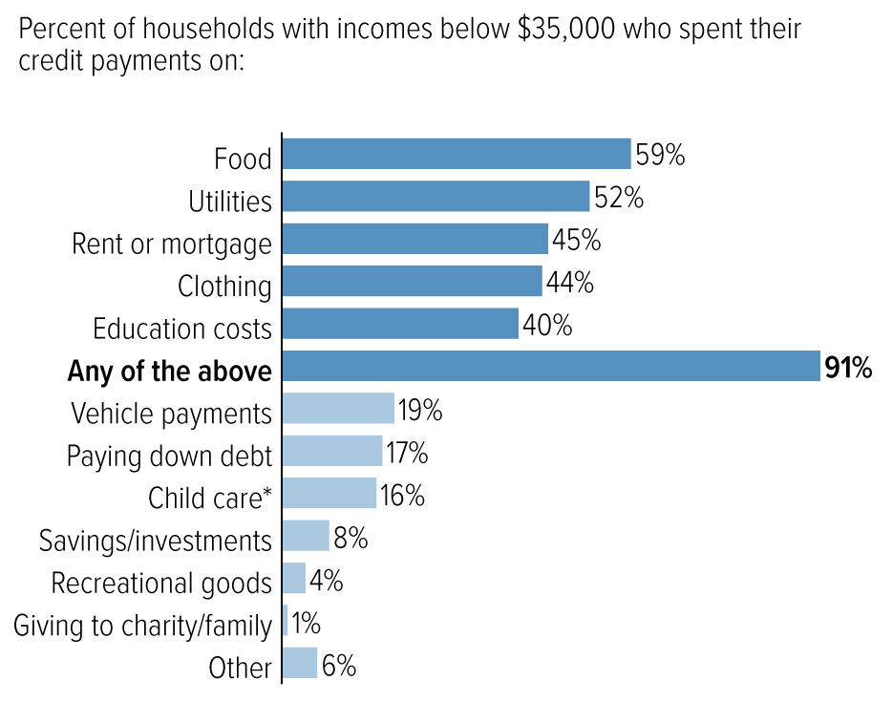
Last year, monthly Child Tax Credit (CTC) payments helped families put food on the table, pay rent, and keep the lights on (visual). The CTC payments meant food insecurity and other material hardships plummeted, according to data from the Census, Columbia University, and JAMA, all while lifting 3-4 million children out of poverty each month. Columbia researchers found that there was a 41 percent increase in child poverty when monthly CTC payments stopped in January.
Studies on the CTC show that it is one of the most effective and efficient ways to strengthen families and reduce child poverty. The CTC helps families obtain and maintain employment, and in some cases the CTC supports child care costs or a family’s decision to focus on caregiving to raise their children. It provides immediate, direct assistance to families as they navigate the ups and downs of the American economy.
Source: CBPP analysis of U.S. Census Bureau’s Household Pulse Survey collected between July and September 2021
A broad array of bipartisan policymakers have supported the CTC since it was first introduced in 1997. Congress expanded and increased the CTC with support from both parties multiple times. Unfortunately, under current law an estimated 27 million children in the lowest-income families do not get the full value of the CTC (except during 2021). Any legislative changes to the CTC must ensure these families get the full benefit.
Congress must work together, as they have so many times in the past, and extend the expanded CTC with permanent full refundability. RESULTS urges you to work with colleagues to find a long-term bipartisan solution to support families and fight child poverty by strengthening the CTC, prioritizing the needs of families with the lowest or no incomes in any tax legislation this year.

