Logging in to Zoom:
- The Zoom link contains the password for one click but on some devices you may have to enter the Meeting ID and password by hand.
- For security purposes, you must either be logged in to Zoom, or if you are not, you may be prompted to enter your name and email address.
- If joining by phone, you will need to enter the Meeting ID and password. Here is a list of international numbers which you can call-in to: https://zoom.us/zoomconference
- If you join prior to the start of the meeting, you may be put in a waiting room. You will be admitted by the host when the meeting starts.

During the meeting:
- As an attendee, you will not be able to speak. However, depending on the meeting host’s preferences, you may be able to raise your hand and they would temporarily allow you to speak.
- Renaming yourself: If you need to change your displayed name within the Zoom meeting, you can do this in two ways. First, in the upper right hand corner of the your video rectangle is a button with 3 dots (). Click that and then select “Rename.” You can also do this by clicking “Participants” in the toolbar at the bottom and then finding your name and clicking “More >”.
- Raising your hand: is also where you go to raise your hand or use other “non-verbal feedback” to indicate things to the host such as “yes,” “no,” “away,” and more.
  - If you’ve joined by phone, you will be limited to raising your hand but you can do so by dialing *9.
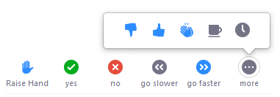

- If you need to share the link to the meeting or send somebody the Meeting ID and Password, you will see a little “i” circle in the upper left hand corner. Click on this to easily copy the meeting link or see the meeting details.
- The green shield icon next to it opens the settings dialog box and will show you which version of Zoom you have.

- Speaker view vs Gallery View: In the upper right hand corner, you will see a button to switch from Speaker View to Gallery View or vice versa. Speaker View shows the person who is speaking. However, anyone that makes a noise may pop up briefly over the speaker if those not speaking are unmuted, which is another reason to be sure you are muted. Gallery view shows everyone at the same time. If many people have their cameras off, you may want to consider selecting “Hide non-video participants” in the Video Settings (little up arrow near the “stop video” icon - we’ll go through these settings in-depth later).
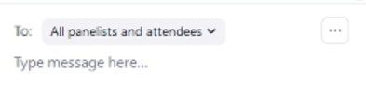
- Utilizing the Chat: In the toolbar at the bottom of Zoom, you will see the chat button. This is a good nondisruptive way to communicate with meeting hosts and other attendees. The default mode for a webinar chat is to “All Panelists,” which means only the people on video can see your chat messages. If you want to chat with other attendees, you must change it to “All Panelists and Attendees.”
  - If you need to message someone privately, click the dropdown menu and select the person you would like to chat with. You can also find their name in the participants list and click “More>” and then “Chat” or click on the three dots in the upper right hand corner of their video window and select “Chat.”
  - NOTE: If someone sends you a private message, the chat will default to you replying privately to them. You will see the word “(Privately)” next to their name but it’s always good to double check who you’re sending your message to.

- Breakout Rooms: The host may put you in breakout rooms. You will automatically be put into this room. If you need to leave the room and go back to the main meeting room, hit “Leave Room.” However, you will be prompted to return to the main meeting room when the breakout session is over, so you likely do not need to use that button.

Zoom Settings
There are a number of ways to get to the settings within Zoom. You can click the up arrows next to the camera icon and select “Video Settings. Similarly, you can do the same with the microphone icon and select “Audio Settings.” You can also click on the little green shield in the upper left corner. Once any of the settings are opened, you can access the other settings in the same dialogue box.
- General Settings:
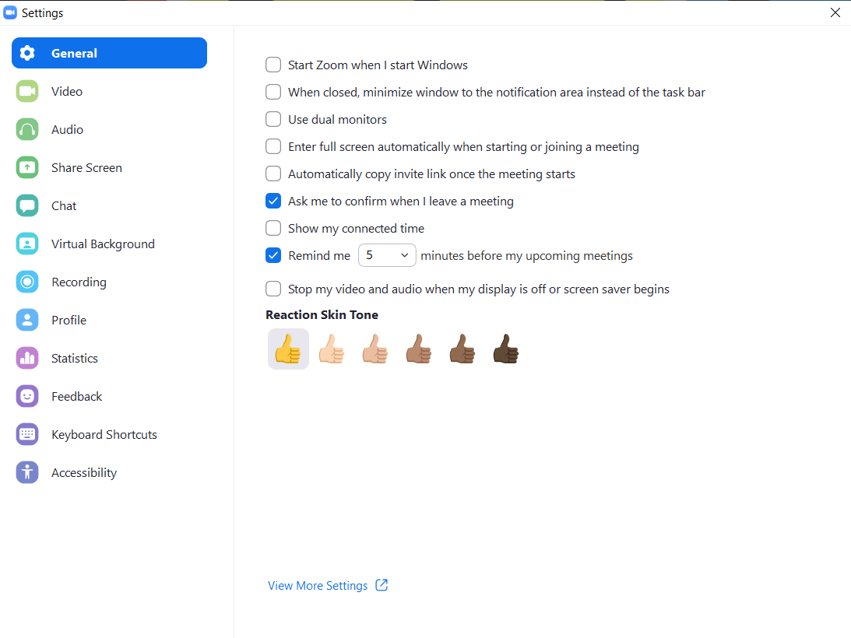

Audio Settings: While you won’t be able to speak, if you need to change you speaker settings, you do so in the audio settings.
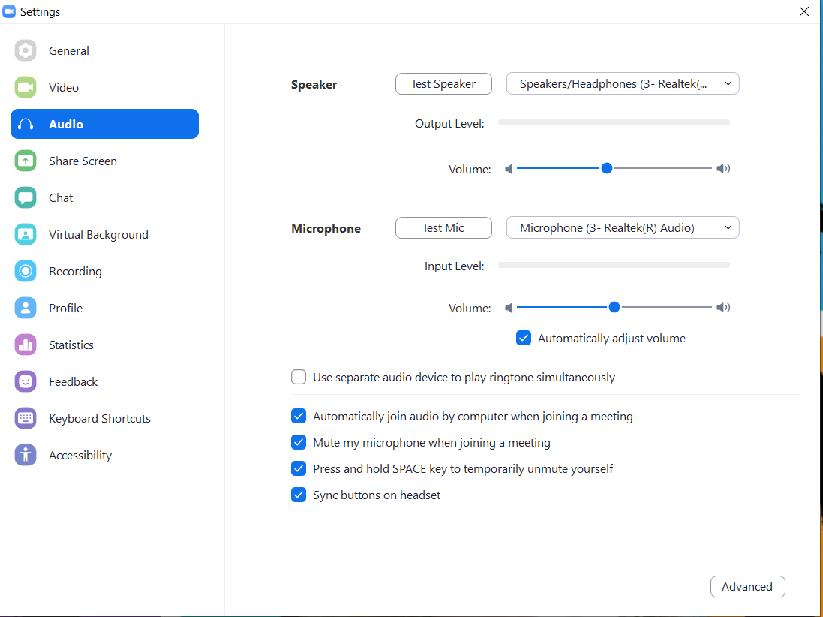

Screen Sharing Settings:
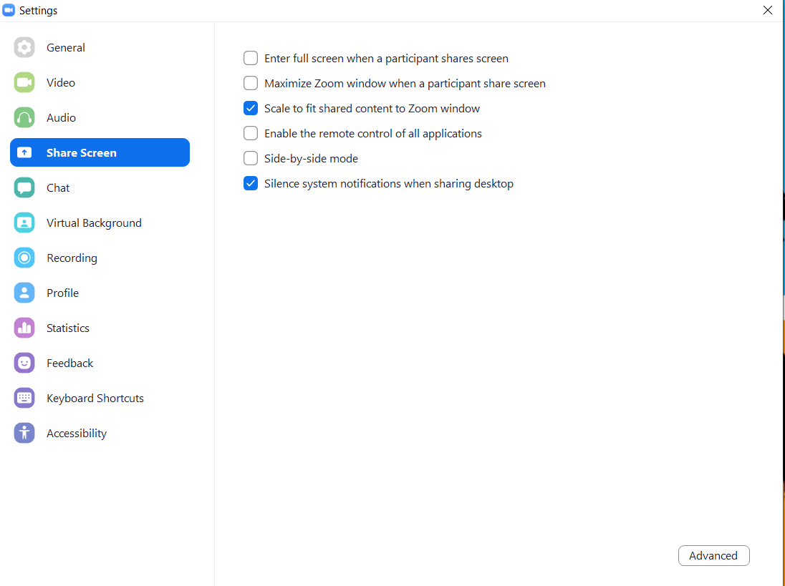

Statistics is where you can see what version of Zoom you have, as well as how the program is using bandwidth and computer resources.
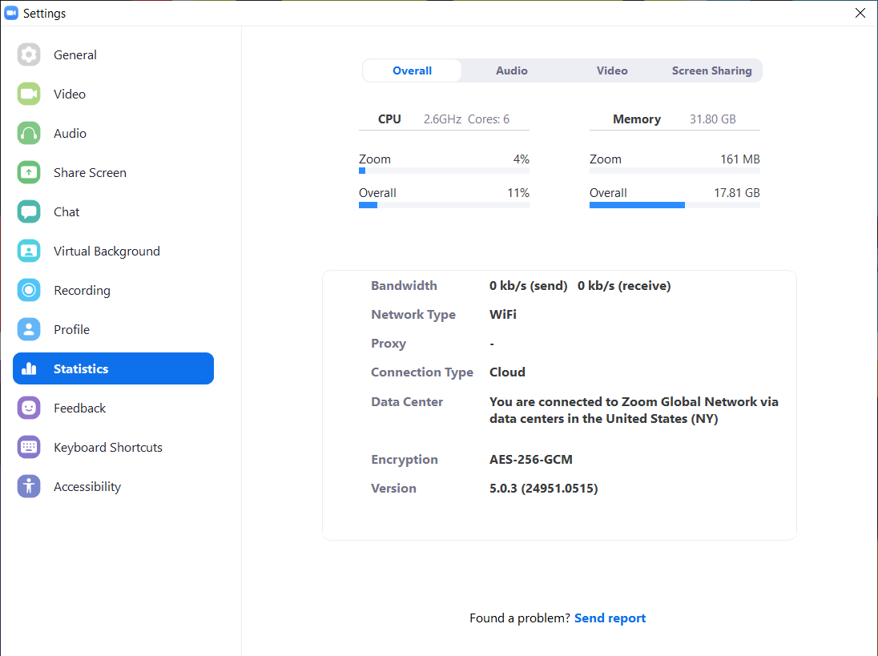

Accessibility is where you can go to adjust the size of closed captioning.
