Join us for the RESULTS September Global National Webinar
Theme: Accessing Education in Difficult Circumstances

Date: Saturday, September 9
Time: 2 pm ET
Location: Ask your local RESULTS Chapter
How to Join Virtually: Login: http://fuze.me/30204806. Or join by phone: (201) 479-4595, meeting ID 30204806
Theme: It is important that all children have access to education, but there are many barriers, particularly in places experiencing conflict or disaster. Education is stability for these children, but how do we ensure that they still have access when times are hard?
Guest speaker:

Lisa Bender
Education Specialist, UNICEF

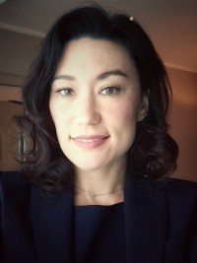
Lisa Bender, an Education Specialist with UNICEF, has a background in humanitarian response, post-crisis transition and social programming for children and youth. At UNICEF’s global headquarters, she provides technical and policy advice in the education sector with a focus on complex emergencies and fragile states.
Prior to UNICEF, Lisa worked with other UN agencies and international NGOs in direct programming, needs assessments, and evaluations in countries such as Yemen, the Democratic Republic of the Congo, and Bangladesh. She has contributed to the Education for All Global Monitoring Report, publications for the Inter-Agency Standing Committee’s Education Cluster, and she authored the Education Chapter of the Post-Disaster Needs Assessment Guidance. Lisa served in the Peace Corps and began her professional career as a social worker and teacher. She holds a Master’s degree from Vanderbilt University's top-ranked Peabody College of Education.

