December 2024 Action Sheet, U.S. Poverty


Protect SNAP in the next Farm Bill
Everyone deserves a healthier life and access to nutritious foods. An integral tool for ensuring that all Americans have access to basic nutrition is the Supplemental Nutrition Assistance Program (SNAP).
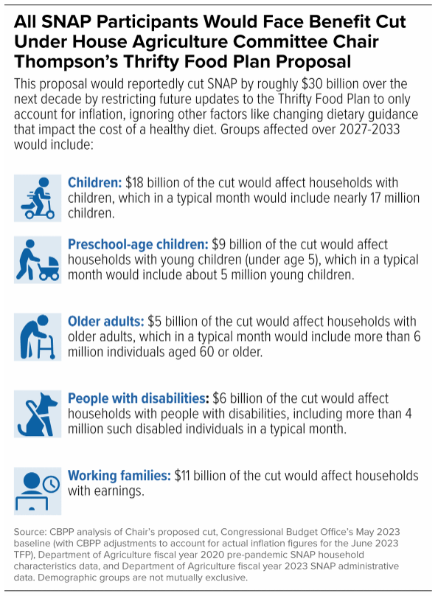
SNAP currently serves over 42 million people each month. New U.S. Census data shows that in 2023, SNAP kept 3.4 million people from falling into poverty. Families with children, older Americans, and persons with disabilities account for nearly 90 percent of SNAP recipients. SNAP reduces poverty, improves community health, and bolsters local economies. It must be protected and strengthened.
As Congress works on a new Farm Bill, some leaders want to cut SNAP benefits by $30 billion over the next decade. This will result in more hunger and hardship for millions.
In particular, the House proposal would undo the 2018 bipartisan improvements to the Thrifty Food Plan (TFP). The TFP calculates the amount of SNAP benefits a family needs to sustain a frugal but healthy diet. In 2021, the TFP was updated to reflect current nutrition science and food costs. It resulted in the first TFP-based increase in SNAP benefits in almost 50 years.
Undoing this change would result in a $30 billion cut in SNAP benefits over the next decade (see chart for more details). This cut impacts every person receiving SNAP and will increase hunger in America.
Congress must protect and strengthen SNAP in a new Farm Bill. They should preserve the 2018 changes to the TFP, expand eligiblity to others susecptible to hunger (e.g., those with felony convictions who have served their time), reduce onerous work reporting requirements, and expand food choice so SNAP recipients can purchase hot, prepared meals at food retailers.

Write letters to Congress about protecting SNAP
Use the talking points below to write letters to your representative and senators today urging them to protect and strengthen SNAP in the new Farm Bill. Consider organizing a group to write letters together. Invite RESULTS group members, Action Network members, and others who care about these issues to write and submit their own letters to members of Congress. You can find a sample meeting agenda here.
Subject: Protect the Supplemental Nutrition Assistance Program (SNAP)
- Tell your representative/senator that Congress is overdue in passing a new Farm Bill which governs farming and food policies in the U.S., including the Supplemental Nutrition Assistance Program (SNAP).
- Share that according to USDA data, last year, 6.8 million households in America experienced “very low food security” at some point.
- Remind them that SNAP helps over 40 million Americans put food on the table each month. Most recipients are working families with children, elderly persons, and people with disabilities.
- Explain that unfortunately, SNAP continues to be under attack by lawmakers who want harmful changes that will cut benefits, limit access, and restrict choice.
- Tell them that, as Congress considers a new Farm Bill, lawmakers must reject efforts to cut or restrict SNAP. Instead, they must work to make it stronger. They must expand access and increase benefits for vulnerable populations.
- Ask your representative/senator to urge House Agriculture Committee Chair Thompson and Ranking Member Scott / Senate Agriculture Committee Chair Stabenow and Ranking Member Boozman to protect and strengthen SNAP in the new Farm Bill.
Tips for your letters:
- For questions, contact RESULTS staff at grassroots@results.org.
- Find your members of Congress at: https://results.org/volunteers/legislator-lookup
- You can hand-write or type letters. Mail them or deliver them in lobby meetings.
- If you get a response, please let RESULTS staff know what they said.

