Tell Congress to take action on housing and homelessness
On June 28, 2024, the United States Supreme Court ruled on Grants Pass v. Johnson. The decision says that the Eighth Amendment to the U.S. Constitution does not extend to laws that criminalize life sustaining acts by people experiencing homelessness.
The Eighth Amendment prohibits cruel and unusual punishment. The city of Grants Pass, Oregon enacted laws criminalizing actions like sleeping or laying down in public spaces. The ruling upheld the city’s decision to criminalize these acts. Effectively, it is now legal to punish people experiencing homelessness for tending to their basic needs in public, even when there is no alternative shelter available.
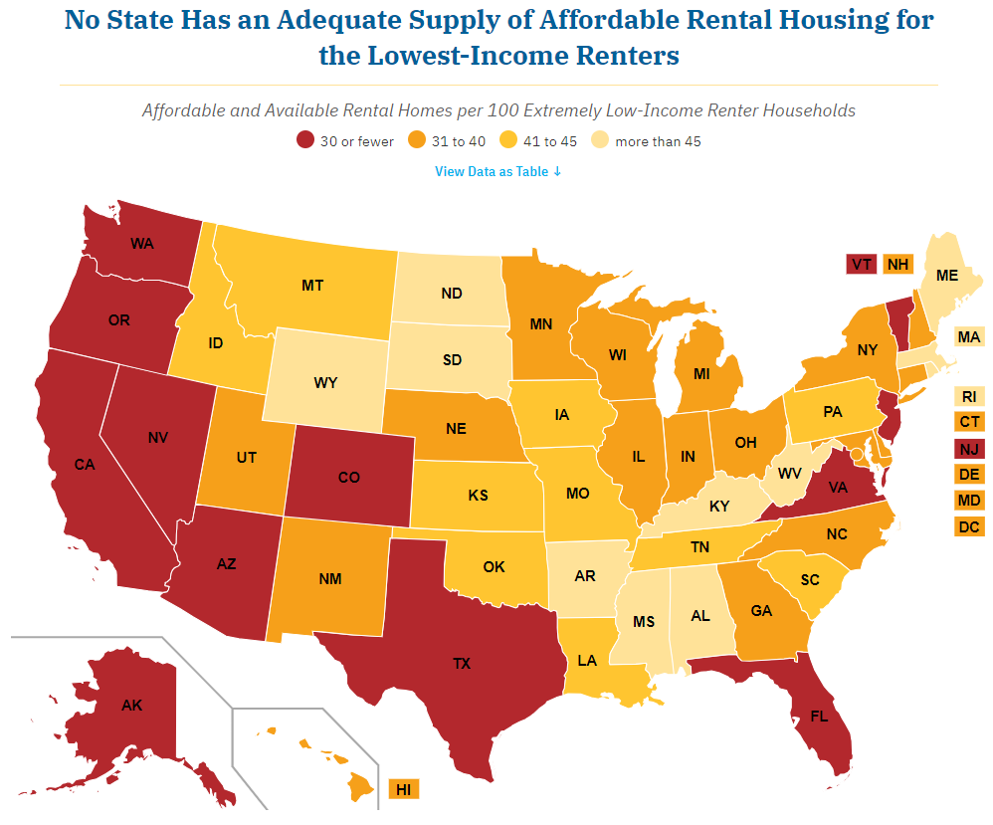
Sadly, cities and local communities across the country can now use this decision to hide poverty and homelessness from the public eye. In July, California Governor Gavin Newsom, based on the Grants Pass ruling, ordered all the homeless encapaments in the state cleared.
These cruel remedies do nothing to solve the root causes of homelessness and poverty. Currently, no state has the necessary affordable housing for renters with low incomes. Plus, there is no consideration for how people will afford the fines and fees, which will make it harder for them to escape poverty. Jail time will create criminal records that make it harder to find work or housing.
We cannot punish our way out of poverty. It is imcumbent on Congress to step in. Congress must take meaningful steps to protect those experiencing homelessness from criminal prosecution and enact policies that will make housing more affordable for people experiencing poverty.
Write your representatives and senators today, urging them to take action to end homelessness and make housing affordable. See the next page for details.
Tell your member of Congress prioritize housing
Write a letter to your representatives and senators today urging them to tell congressional leadership to take action in response to Grants Pass and work to make housing affordable.
- Dear Senator or Representative _______________,
- My name is _______________. I am a constituent of yours from ______________ and a RESULTS volunteer.
- I am writing to in response to the recent U.S. Supreme Court case making it permissible for jurisdictions to criminalize homelessness. I find the ruling appalling.
- Despite false political rhetoric to the contrary, homelessness is not a lifestyle choice. Persons turn to living and sleeping outdoors only as a last resort.
- Much of that is due to the skyrocketing cost of rent in the U.S. According to the National Low-Income Housing Coalition (https://nlihc.org/gap), no state has adequate affordable housing options for people with low incomes.
- And shelters, which are a temporary solution, are often at capacity, unsafe, or unavailable.
- Allowing communities to criminalize homelessness will make this situation worse. People will now be subject to fines they cannot pay and/or jail time that will make it even more difficult to find work or housing.
- We cannot punish our way out of this problem. Congress must step in.
- Will you work with advocates and your congressional colleagues to enact legislation prohibiting state and local governments from criminalizing homelessness?
- Also, will you work with leadership to enact legislation to help make housing more affordable, such as enacting a refundable renter tax credit for people with low incomes to help offset the excessive cost of rent?
- Thank you for your time. I look forward to your response to my request.
Tips for your letters
- For questions, contact RESULTS staff at grassroots@results.org.
- Find your members of Congress at: https://results.org/volunteers/legislator-lookup
- You can hand-write or type letters. Mail them or deliver them in lobby meetings.
- If you get a response, please let RESULTS staff know what they said.

