Protect SNAP in the next Farm Bill
Everyone deserves to live healthier lives and have access to nutritious foods. An integral tool to ensure that all Americans have access to basic nutrition is the Supplemental Nutrition Assistance Program (SNAP).
SNAP currently serves around 40 million people each month. Families with children, older Americans, and persons with disabilities account for nearly 90 percent of SNAP recipients. SNAP reduces poverty, improves community health, and bolsters local economies.
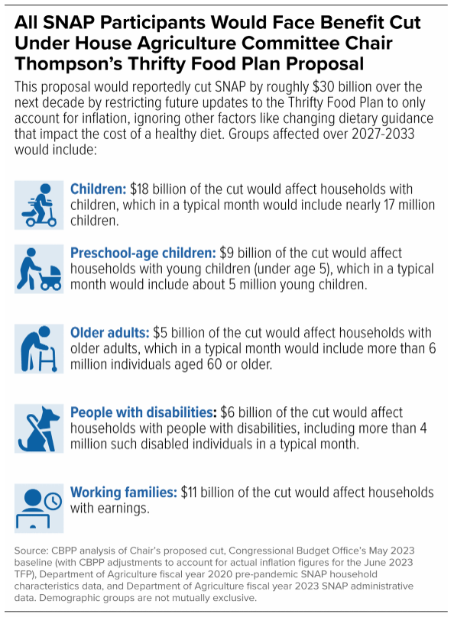
SNAP is reauthorized every five years in the Farm Bill. House and Senate leaders have released plans for a new Farm Bill. The Senate proposal reflects the priorities needed to reduce hunger in America; the House version does not.
In particular, the Senate protects the 2018 bipartisan improvements to the Thrify Food Plan (TFP). The TFP is used to calculate the amount of SNAP benefits a familiy needs to sustain a frugal but healthy diet. In 2021, the TFP was updated to reflect current nutrition science and food costs. It resulted in the first TFP-based increase in SNAP benefits in almost 50 years. The House proposal would undo this improvement, resulting in a $30 billion cut in SNAP benefits over the next decade (see chart). This cut impacts every person receiving SNAP and will increase hunger in America.
On a positive note, both proposals appear to lift the lifetime ban on SNAP benefits for those convicted of a drug offense. This is welcomed, long-overdue change.
RESULTS strongly urges Congress to protect and strengthen SNAP in new Farm Bill. They should preserve the 2018 changes to the TFP, expand SNAP access to those susecptible to hunger but not currently eligible, reduce onoerous work reporting requirements, and expandi food choice so SNAP recipients can purchase hot, prepared meals at food retialers.
Tell member of Congress to protect SNAP in the Farm Bill
Write a letter to your representatives and senators today urging them to tell Agriculture Committee leaders to protect SNAP from reckless cuts and policies in Farm Bill negotiations. Use the talking points below as a guide.
- Dear Senator or Representative _______________,
- My name is _______________. I am a constituent of yours from ______________ and a RESULTS volunteer.
- I am writing to urge you to support of SNAP, the last line of defense against hunger in the United States. In 2022, SNAP helped 3.7 million people lift themselves from poverty.
- Most SNAP recipients who are able to work, do work. Of the approximately 40 million people receiving SNAP each month, nearly 90 percent are families with children, older Americans, and persons with disabilities.
- SNAP benefits are extremely frugal, averaging less than $7 per day per person. Yet the House Farm Bill proposal makes things worse by cutting benefits by $30 billion over the next decade.
- Congress should reject any Farm Bill that increases hunger in America.
- Will you please speak to House and Senate leadership, including Agriculture Committee leaders, and tell them you will not support a Farm Bill that cuts SNAP. Instead, they should:
  - Protect the 2018 bipartisan improvements to the Thrifty Food Plan
  - End the lifetime SNAP ban for those with drug convictions
  - End onerous work reporting requirements
  - Expand grocery food choice to include hot foods
- Thank you for your time and consideration. I look forward to your response.
Tips for your letters
- For questions, contact RESULTS staff at grassroots@results.org.
- Find your members of Congress at: https://results.org/volunteers/legislator-lookup
- You can hand-write or type letters. Mail them or deliver them in lobby meetings.
- If you get a response, please let RESULTS staff know what they said.

