Housing crisis necessitates a new Renter Tax Credit
The U.S. faces multiple housing crises that are worsening, including housing supply and cost problems in both rural and urban areas. The Eviction Lab has found that “eviction rates in some cities are increasing to or surpassing their pre-pandemic levels.”
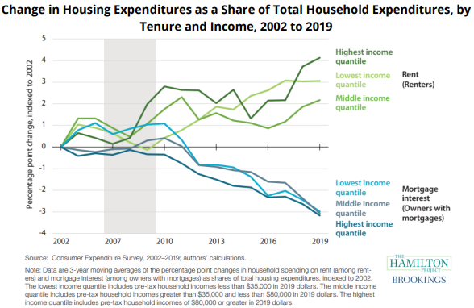
High rent costs are a severe burden on low-income renter households. Rents are skyrocketing and people are struggling even more to keep up. Currently, a minimum-wage worker cannot afford a two-bedroom apartment in any state in the U.S. Moreover, many renters with low and middle incomes are unable to tap into existing housing and homelessness programs.

A Renter Tax Credit (RTC) would help by using the tax code to deliver targeted relief to struggling renter households. While homeowners receive numerous tax breaks, renters are left behind by the existing tax code. A Renter Tax Credit would help correct this imbalance. The RTC would effectively cap out-of-pocket rent and utilities expenses at 30 percent of total household income (above that level, renters are considered “rent-burdened”). These “rent-burdened” households would receive a monthly tax refund they could then afford a safe place to live without sacrificing other basic needs.*
*The credit would cover the rental costs over 30 percent of household income not to exceed the actual rental cost or the fair market rent of the local area, whichever is less. For example, if a family’s monthly income is $2,000 and their rent is $800, their RTC would be $200 ($2,000 x. .30 = $600; $800 - $600 = $200).
Write letters to Congress about the Renter Tax Credit
To build support for creating a Renter Tax Credit, please write letters to your members of Congress urging them to support an RTC as part of any comprehensive tax reform package. Use the talking points below to write your letters.
- Dear Senator _______________ or Dear Congressperson _______________.
- My name is _______________. I am a constituent of yours from ______________ and a RESULTS volunteer.
- The tax code provides billions in tax subsidies to homeowners, developers, businesses, and landlords, but almost nothing for the nearly 44 million Americans who rent.
- Even employed households are having trouble keeping up with skyrocketing rents.
- A renter tax credit would help. The credit would be targeted to rent-burdened, low-income renters and paid out on a monthly basis, capping out-of-pocket rent and utilities expenses at 30 percent of total income.
- This would allow low-income renters to afford a safe place to live without sacrificing other basic needs. [share how a monthly renter tax credit would help you]
- It would also reduce evictions and people experiencing homelessness by providing them with financial stability against high housing costs.
- In any tax legislation this year, would you support targeting relief to renters through a renter tax credit?
- Thank you for your time. I look forward to your response to my request.
Tips for your letters
- Write three letters – one to your representative, one to each of your senators.
- If you don’t know who your members of Congress are, look them up at: https://results.org/volunteers/legislator-lookup.
- You can hand-write or type your letters.
- Plan to deliver letters in upcoming lobby meetings or e-mail them to the tax aides in each office. If you don’t know the aide’s name, contact RESULTS staff for assistance.
- When you get a response, please let RESULTS staff know what they said.
- For any questions you have, contact RESULTS staff at grassroots@results.org.

