Tax time is a good reminder that Congress needs to enact a fair tax code
Americans are filing their federal income taxes this month. Sadly, many families with low-incomes will see a big change in their taxes this year. That’s because the the expanded Child Tax Credit (CTC) is no longer available.
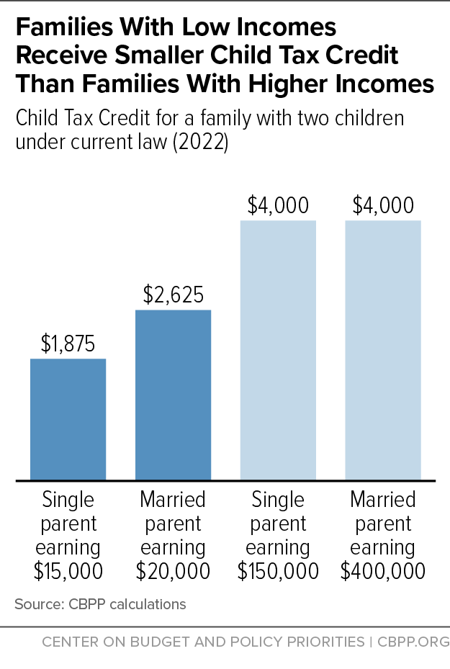
In March 2021, the CTC was increased, expanded to include all-low-income families (approximately 19 million children), and sent to them as a monthly payment for the first time. The result was extraordinary. U.S. Census data shows that the 2021 CTC payments helped cut child poverty by 46 percent. Parents spent their CTC on necessities such as food, rent, utilities, and clothes for their kids. It proved that when you give parents the resources and freedom to provide for their families, they do.
Sadly, just as positively impactful as the CTC payments were in helping lift children from poverty, the cessation of those payments in early January 2022 had an equally negative impact. Child poverty immediately increased and families again struggled to make ends meet. While RESULTS and other advocates fought hard to continue the CTC payments, 51 senators refused to do so. As a result, families making less than $2,500 per year – families with the lowest incomes – will receive no CTC at all this year. Furthermore, millions of working families above that threshold only get a partial credit, while, wealthy families get the full CTC (see chart). This is not what fairness looks like. Congress must expand the CTC again.
Write letters to your members of Congress about the Child Tax Credit
Write letters to them urging them to expand the CTC in any tax legislation this year. Use the guide below to write your letters.
- Dear Senator _______________ or Dear Congressperson _______________.
- My name is _______________. I am a constituent of yours from ______________ and a RESULTS volunteer.
- As Americans prepare to file their taxes this month, I urge you to bring fairness to the tax code by expanding the Child Tax Credit (CTC).
- In 2021, the CTC was increased and expanded to all low-income families. It was also sent as a monthly payment.
- Those payments helped cut child poverty by 46 percent – the largest one-year reduction in history, and gave parents the freedom and flexibility to cover rent, food, and utilities when they needed it most – monthly bill time.
- Because Congress let the 2021 CTC expire, child poverty has gone back up and families are again struggling.
- Under the current CTC, 17 million low-income children from families who are working are excluded from the full CTC. For example, a single mom working full-time at minimum wage gets less than half the CTC than a couple earning $400,000 per year. How is this fair?
- No child deserves to grow up in poverty. The 2021 CTC proved they don’t have to.
- In any tax legislation this year, will you work to make the tax code fair by expanding the Child Tax Credit to cover children in families with low-incomes and reinstate the monthly payments?
- Thank you for your time. I look forward to your response to my request.
Tips for your letters
- For questions, contact RESULTS staff at grassroots@results.org.
- Write three letters – one to your representative, one to each of your senators (find your member of Congress at: https://results.org/volunteers/legislator-lookup).
- You can hand-write or type your letters.
- Plan to deliver letters in upcoming lobby meetings or e-mail them to the tax aides in each office. If you don’t know that person’s name, contact RESULTS staff for assistance.
- When you get a response, please let RESULTS staff know what they said.
- After writing letters to Congress, use these talking points to write a letter to the editor to your local paper calling on your members of Congress by name to act.

