The CTC cut child poverty in half. Why did Congress let it end?
At the start of 2023, millions of American families are facing continued challenges keeping a roof over their heads, putting food on the table, and more without the expanded Child Tax Credit (CTC). In March 2021, the CTC was expanded to all-low-income families and the credit amount was significantly increased from $2,000 per child to $3,000 per child ($3,600 for children under 6). Families received half of their CTC as a monthly payment from July-December 2021 and the other half as a lump sum payment in 2022 when they filed their taxes.
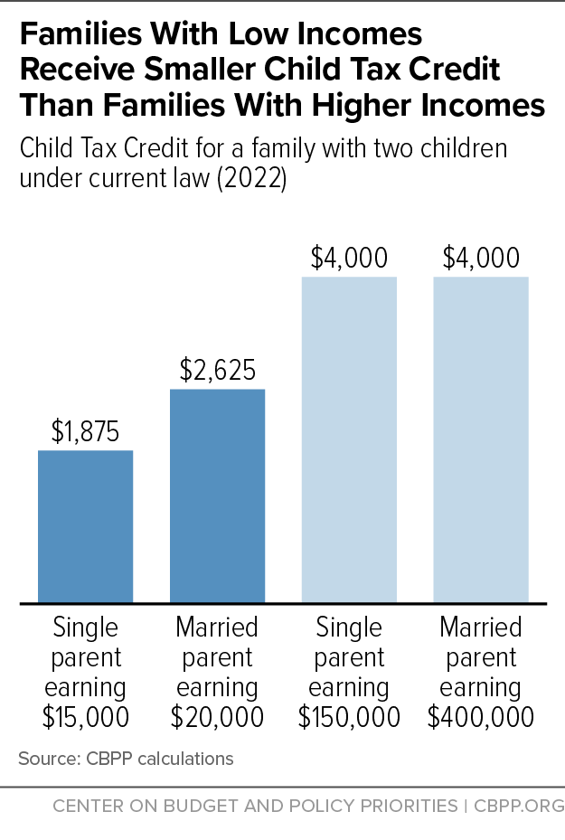
The expanded CTC was nothing short of remarkable. 19 million low-income children who previously qualified for a only a partial CTC – or no CTC at all – were now eligible for the full credit. As a result, U.S. Census data shows that in 2021, child poverty dropped an astounding 46 percent, mainly due to the expanded CTC’s monthly payments. That year, the CTC alone lifted 5.3 million people out of poverty, including 2.9 million children. Parents spent their CTC on necessities such as food, rent, utilities, and clothes for their kids. It proved that when you give parents the resources and freedom to provide for their families, they do.
Sadly, the Senate let the payments expire in December 2021 and Congress did not reinstate the expanded CTC in 2022 (despite relentless advocacy by RESULTS volunteers!). This means that when low-income parents file their 2022 federal taxes this year, they will receive a lower CTC or none at all. Families who receive the credit as a tax refund will get less than half of what they received from the expanded CTC. This amounts to a massive tax increase on struggling families.
For a year, we proved we can end child poverty. That is something we cannot unlearn nor should ever forget. It is unconscionable that a few members of Congress are willfully letting millions of children grow up in poverty when they have the means to stop it.
Write letters to your members of Congress about the Child Tax Credit
The new Congress gives you the opportunity to remind returning lawmakers and educate new ones on the success of the expanded CTC and why they must expand it again as soon as possible. Write letters to them urging them to expand the CTC in any tax legislation they consider this year. Use the talking points below to write your letters.
- Start your letter with “Dear Senator ________” or “Dear Congressperson ________”.
- Introduce yourself with your name, where you live, and that you are a RESULTS volunteer.
- Remind them that in 2021, the expanded Child Tax Credit with monthly payments helped cut child poverty by 46 percent– the largest one-year reduction in history.
- Tell them that the monthly CTC payments gave parents the freedom and flexibility to cover rent, food, and utilities when they needed it most – monthly bill time.
- Explain that when the payments expired in December 2021, child poverty increased, parents couldn’t work because they couldn’t afford childcare, and global inflation made basic necessities more expensive.
- Tell them poverty robs children of their potential. The expanded Child Tax Credit proved we can end child poverty. We must take all steps necessary to make that happen.
- Ask your members of Congress to prioritize tax policies for lower-income Americans. Will they urge congressional leaders to expand the Child Tax Credit to all low-income families with monthly payments in any tax bill this year?
- Thank them for their time and tell them you look forward to their response to your request.
Tips for your letters
- For any questions you have, contact RESULTS staff at grassroots@results.org.
- Write three letters – one to your representative, one to each of your senators.
- If you don’t know who your members of Congress are, look them up at: https://results.org/volunteers/legislator-lookup.
- You can hand-write or type your letters.
- Once finished, plan to deliver letters in lobby meetings for our Set the Agenda campaign (https://results.org/set-the-agenda).
- If you cannot attend a lobby meeting, e-mail the letters to the tax aides in each office. If you don’t know that person’s name, contact RESULTS staff for assistance.
- When you get a response, please let RESULTS staff know what they said.

