Expanding tax credits for low-income workers and families
In 2021 Congress enacted historic legislation that cut child poverty by more than 40 percent. Congress must do more so those gains don’t disappear.
For too long, tax policy has been a driver of inequality – providing benefits and incentives for those who are wealthy while often failing to focus on reducing hardship and creating opportunity for the lowest-income families. At RESULTS, we’re working with Congress to create a tax code to end poverty, address the affordable housing and homelessness crises, and achieve housing and economic justice for all.
The COVID relief package, also known as the American Rescue Plan Act, signed into law in early 2021 was a key step in the right direction. The bill’s temporary tax provisions cut child poverty in half in the United States because of expansions to the Child Tax Credit (CTC), which particularly benefitted marginalized low-income households and households of color (see more below).
The Child Tax Credit helps offset the costs of raising kids and has had bipartisan support for decades. However, the way the CTC is structured leaves out millions of families with the lowest incomes and provides too little relief for millions more.
The 2021 American Rescue Plan fixed key policy gaps, expanded the CTC for millions, and slashed the poverty rate. Unfortunately, despite the great need for these tax credits and ongoing efforts of RESULTS advocates and our allies in Congress, those important provisions expired at the end of 2021. As a result, child poverty rose by 41 percent in January. RESULTS has a long history of building bipartisan support in Congress for refundable tax credits, and we’re not backing down now. We are doing what it takes this year to make large-scale reductions in poverty via lasting changes to our tax code.
Why tax policy?
Are my taxes going up or are they going down? That’s the big question most people have. But there’s a lot more to it. Whose taxes are going up or down? And why? Policymakers in Washington make decisions that affect us all by shifting how taxes are collected and who owes them.
Simply put, the tax code reflects the priorities of our nation. For example, it taxes income from wealth at a lower rate than wages, and rewards homeownership through the mortgage interest deduction while leaving out low-income renters. There are countless examples like these in the tax code. Unfortunately, many of them only benefit wealthier individuals and corporations.
But the tax code can also bring economic justice to all and help people move out of poverty. The Earned Income Tax Credit and Child Tax Credit are two of the best examples we have right now to accomplish these goals. When the EITC and CTC are done correctly and made accessible to those who need them the most, they can provide additional income to those struggling to make ends meet. Our partners at Prosperity Now call these credits the “right-side up” parts of the tax code.
When we talk about structural changes to address inequality and reduce poverty, the tax code is a key place to make it happen. Our advocacy on tax policy isn’t about one-off relief in an emergency: it’s about long-term policies that help people thrive and get ahead.
Key Point: When it's written fairly, the tax code can help achieve economic justice and lift millions above the federal poverty line.

Earned Income Tax Credit and Child Tax Credit: How they work
The Child Tax Credit and Earned Income Tax Credit boost income to pay for basic needs like housing, utilities, and food. These credits have long had bipartisan support as one of the country’s best tools for promoting work and reducing poverty, allowing more people to move out of poverty than any program besides Social Security (5.3 million people in 2020, according to the Census Bureau).
Earned Income Tax Credit (EITC)
To get the Earned Income Tax Credit (EITC), you have to be working. For someone earning money (but not a lot), the EITC provides another boost in income by paying them a small percent on top of what they make at work. Based on what they earned in the previous year, the credit comes as a lump-sum check at tax time. Workers can then use their EITC to keep housing costs affordable, catch up on bills, make household repairs, or pay for other basic needs.
Critically, the EITC is “refundable,” which means workers can get the EITC as a payment, even if they owe little or no federal income tax. This makes it particularly helpful for low-wage earners. As people earn more, the credit grows. Then, once a worker’s income reaches a certain level above the poverty line, the credit holds constant, and then starts to decrease as wages increase. This ensures that the EITC is targeted to those for whom it was intended – low-wage workers.
Child Tax Credit (CTC)
The Child Tax Credit (CTC) helps offset the cost of raising children. Taxpayers can claim a break on their taxes each year based on the number of children in their household and the household’s earnings. Traditionally, it's only available when workers file taxes every year (like the EITC), but COVID relief legislation allowed families to receive half of it as a monthly payment instead in 2021. The 2021 legislation also made the CTC “fully refundable” for even the lowest income families, who previously were left out altogether (more below).
Key Point: The Child Tax Credit and Earned Income Tax Credit boost income to pay for basic needs and reduce poverty. These credits have long had bipartisan support as one of the country’s most effective tools for reducing poverty.

Dramatic reductions in poverty in 2021
The way CTC has been traditionally structured normally leaves out millions of low-income workers and families. Before 2021, 27 million children were excluded from the full Child Tax Credit. The families with the lowest wages received the least help, and in some cases, none at all.
The temporary changes passed in March 2021 resolved these gaps in policy, but only for one year. The American Rescue Plan Act (ARPA) made the full Child Tax Credit available to all low-income families for the first time. This change alone reduced the number of children living below the federal poverty line by almost half. The CTC expansion reduced poverty for children of color even more. This is because Black, Latino and other families of color are more likely to work in low-wage jobs, which is the result of past and existing systemic inequalities that have force them into low-paid work.
ARPA also made a critical change to how the Child Tax Credit works. Rather than one lump sum payment at tax time, low-income families received half their CTC as monthly payments from July to December 2021. This allowed parents to meet their kids’ needs on an ongoing basis (this is why some people are referring to it as a “child allowance”). Also, the maximum CTC amount per child increased to $3,600 for kids under 6, and $3,000 for kids 6-17 (prior to ARPA, the maximum was $2,000 per child). These changes mirror a similar child allowance proposal from Sen. Mitt Romney (R-UT).
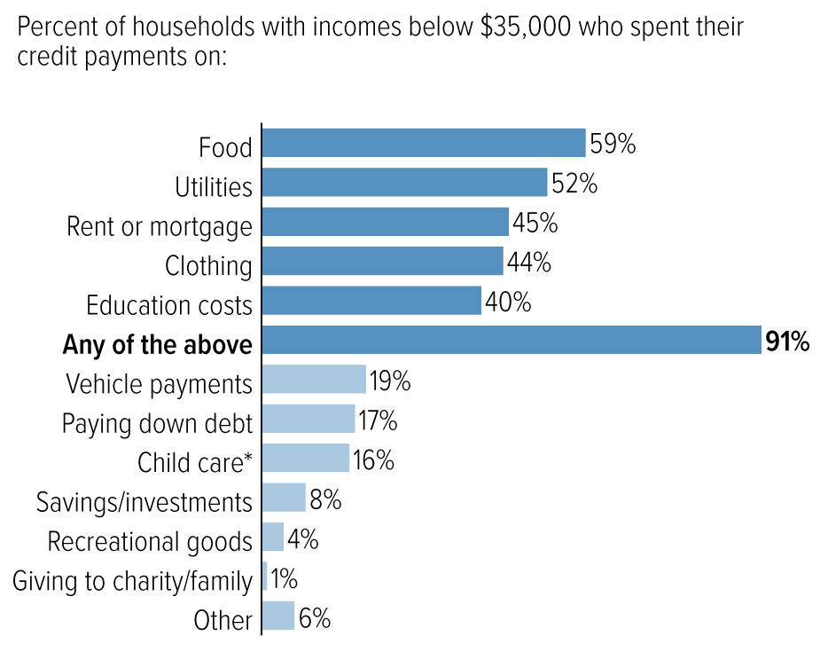
Monthly CTC payments helped families put food on the table, pay the rent, and keep the lights on – as noted in this summary of how families used their CTC payments (visual). Food insecurity and other material hardship dropped after the CTC payments started (see data from the Census, Columbia University, and JAMA). Children’s Health Watch notes that the CTC payments reduced hunger and improved health in families who received them. ARPA showed that investing a modest amount in children and families ($250-$300 per child each month) makes a huge difference. Families caught a break and even thrived. Not only could they pay the bills, they ate healthier, invested in education, and avoided payday loans.
Source: CBPP analysis of U.S. Census Bureau’s Household Pulse Survey collected between July and September 2021
Last year, RESULTS advocates organized hundreds of meetings with members of Congress and their staff. In many of these meetings, you shared personal experiences of how the tax credits helped you. After Congress passed temporary CTC and EITC expansions in ARPA, RESULTS advocates got right to work to make them permanent through hundreds of congressional meetings, a Senate sign on letter, and over 200 pieces of media.
Many policymakers recognized the importance of making the expanded and monthly CTC payments permanent – our long-term goal. To build momentum towards a permanent expanded CTC, last year RESULTS worked with champions in Congress and the Biden Administration to advance legislation that extends the CTC. The House passed its Build Back Better Act on November 19, 2021, which included the following CTC provisions:
- Extend CTC expansions for one year with monthly payments
- Make the CTC permanently and fully refundable for all low-income families,
- Restore CTC eligibility for immigrant families who file tax returns using an ITIN.
This package was broadly based on negotiations over a framework between President Biden and key moderate Democratic Senators (it was clear that congressional Republicans were unanimously opposed to the Build Back Better Act). Suddenly, on December 19, 2021, Senator Manchin (D-WV) publicly withdrew his support for Build Back Better which halted its movement through the Senate. Since the support of all 50 Democratic senators was necessary to pass it given united GOP opposition, the package stalled.
While an extension to these changes wasn’t signed into law in 2021, the White House proposal, House-passed Build Back Better Act, and nearly half the Senate are on record in support of an extension monthly CTC.

Our short-term goal: extend the monthly CTC, especially for families with no or low-incomes
Since the monthly CTC payments stopped in January 2022, families are facing increased hardship. The monthly child poverty rate increased 41 percent from December 2021 to January 2022. Researchers at Children’s Health Watch found that the ending of monthly CTC payments caused family food insufficiency to increase by 12 percent.
Unfortunately, an estimated 27 million children in low-income families have lost all or part of the CTC. This is because the “full refundability” of the CTC, which ensured that children in families with no or low-incomes got the full value of the CTC, has now expired. And without the CTC payments to help, over 3 million children have already fallen back into poverty in 2022.
This loss of monthly CTC payments and full refundability comes at the worst possible time – when families are facing higher costs from inflation. Moody’s Analytics says the average household is spending an extra $327 per month due to inflation, with a steep rise in rents fueling increased costs. The 2021 CTC monthly payments averaged $444 per month per household. The math is simple; if you want to help families with higher costs, extend the CTC.
In April, more than 130 economists wrote that, “the expanded Child Tax Credit is one of the easiest, most effective, and direct tools currently at our disposal to help families deal with the impact of inflation on family budgets.” There is no evidence that the increased CTC in 2021 contributed to rising costs. As noted by CBPP, the expanded CTC would contribute “little or no inflationary pressure”, and two former Treasury Secretaries made a similar point in a May 2 New York Times op-ed. When a politician says that inflation is hurting families, the response should be, “Then why haven’t you extended the Child Tax Credit payments?”
Last year, the CTC payments lifted 3-4 million children out of poverty each month. We can build on that success, as many Americans are facing tighter family budgets. Negotiations on a compromise package that would move via the reconciliation process this summer are happening now. RESULTS Advocacy Month lobby meetings could make a large impact on important conversations, particularly amongst Senate Democrats in Washington. While it will look different from the Build Back Better Act (BBB) passed by the House last year, our job is to make sure that an extension of the Child Tax Credit (CTC) with full permanent refundability is part of any reconciliation package. With families paying more for food, gas, and rent, we must remind senators that the CTC is the perfect tool to help.
Specifically, if Democratic offices say they support the CTC, don’t leave it at that. Push them to tell leadership that the CTC remains a top priority for them in negotiations over a reconciliation package. Ask your senators to keep you updated on what specific actions they are taking to influence the negotiations and push for the CTC extension.
Key Point: The CTC helps millions of families, but millions of the lowest-income families are once again left out. The 2021 changes fixed holes in the policy and expanded the credits for more people as monthly payments, but those expansions have now expired. In the short-term, we’re pushing for Congress to extend the CTC in a reconciliation package this summer.
poverty.

The back story: We’ve done this before, and we’ll do it again

Advocating for broad bipartisan support for the CTC to reduce child poverty long-term
While in the short-term we want Congress to move quickly to extend the CTC, RESULTS will also push to enact permanent structural changes that will reduce poverty and hardship in the long-term. We have to think beyond this current opportunity – Congress may not pass a reconciliation package that extends the CTC, or they may pass a CTC extension for only one year again. With the possibility of another tax and spending package after the November election, policymakers may have other opportunities to reduce child poverty by expanding the CTC. Long-term bipartisan support for the CTC will be key to protect any CTC changes that are made in the coming months make permanent policy change.
This is a extraordinary, perhaps once-in-a-lifetime, opportunity to secure historic breakthroughs against poverty. In addition, RESULTS’ sustained advocacy with a broad range of policymakers can protect against attacks on the CTC and other polices by future Congresses. RESULTS Advocacy Month meetings in Summer 2022 will help lay the groundwork for broader bipartisan support for the CTC.
In previous lobby meetings, some policymakers have pushed back on the legislative process of reconciliation. As we engage with a broad array of Congressional offices, we can emphasize that it is critical that children in families with the lowest incomes get the CTC and that we are focused on this important policy and the impact on child poverty – not the legislative vehicle.
Quite frankly, if politicians want to find a bipartisan solution on the CTC, there is nothing stopping them from beginning work on it right now. Asking policymakers how they can move policies like the CTC to reduce child poverty forward with colleagues and asking them to take a leadership role in pushing the policy regardless of the vehicle is a place to start. In these conversations, it might be helpful to share how the CTC creates a strong return on investment for society along with the state-by-state impact of CTC expansion.
Another effective tool we have in making the case for broad bipartisan support for the CTC is sharing details on how families used the payments, namely to pay rent, buy food, and buy clothes for their kids . A new study from the Brookings Institution shows that the CTC monthly payments dramatically reduced child poverty, fostered healthier eating, and allowed parents to invest in their children’s education. Also, a steady supplement to their monthly income helped families avoid high-interest payday loans for financial help.
Finally, we know some policymakers insist on an earnings requirement or work requirement in order to get the CTC. We urge you to share why you think investing in dramatic reductions in child poverty should be the goal, and that you are focused on reducing hardship for children regardless of their parents’ work history. You could also share that 1.4 million CTC households have left their jobs since the payments stopped, primarily because they can no longer afford childcare. Now, as inflation has increased, families are facing greater obstacles to making ends meet.

A 2015 Redo? RESULTS volunteers made temporary tax credit expansions permanent in a bipartisan package
Back in 2009, in the middle of the Great Recession, RESULTS advocates and others pushed for Congress to expand the EITC and CTC – but Congress made the changes only as a one-time adjustment, set to expire after a year. RESULTS and our partners kept pushing, reminding Congress that poverty was already an emergency before the recession. Returning to the same weaker tax policy that only rewarded the wealthy and made other people vulnerable in the first place didn’t make sense. We successfully worked to get those changes to the tax code extended, and then extended again. Then in 2015, Congress finally made the changes permanent as a part of a larger, end-of-year tax bill, benefiting 50 million people in a package passed with overwhelming bipartisan support.
That lasting victory started – just like we see now – with a short-term emergency response. Then RESULTS advocates kept pushing, with hundreds of meetings with Congress, hundreds of pieces published in their local media, and countless conversations with tax aides on Capitol Hill. Together we made sure that Congress made those expansions permanent, and we’re going to do what it takes to do the same thing again this year.

The takeaway
The Child Tax Credit (CTC) made a historic impact on poverty reduction and supported families to pay for rent, food, utilities, and other necessities.
However, because of 51 senators who have refused to support an extension of these changes, 27 million low-income children are now again excluded from the full CTC.
But it is never too late to turn things around. Congress has a choice. They can be content poverty being on the rise at a time when families face increased costs of putting food on the table and keeping a roof over their heads. Or they can do what’s right and turn 2021’s historic gains into lasting change.
Your advocacy will be the difference-maker in which path they choose.

