Keep up your impressive media advocacy on expanding the CTC
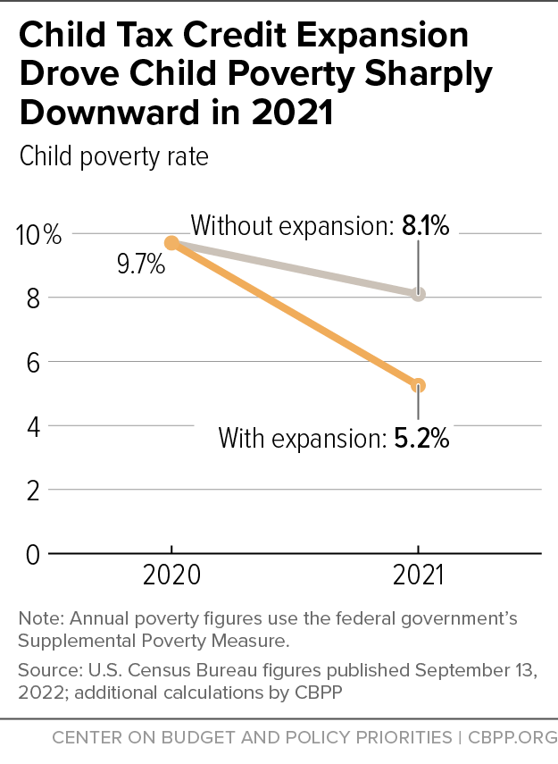
With the November election now over, Congress is back in Washington with a lot of work to complete. The most glaring task for anti-poverty advocates is reinstatement of an expanded Child Tax Credit (CTC). The 2021 CTC was a game-changer. U.S. Census data shows that in 2021, child poverty dropped an astounding 46 percent. A huge source was the expanded Child Tax Credit with monthly payments; the CTC alone lifted 5.3 million people out of poverty, including 2.9 million children.
Sadly, the expansion expired last December. As a result, child poverty has dramatically increased. In addition, Washington University in St. Louis data shows that employment decreased for CTC recipients after the monthly payments stopped, highlighting the importance of the CTC payments in helping families afford childcare, transportation, and stable housing.
But we have a chance to get it back. Some members of Congress want to pass tax breaks to help wealthy corporations before year’s end. It is imperative that Congress also expand the CTC in that legislation.
RESULTS volunteers are leading on the charge to make this happen. In November alone, they got 42 media pieces published on the CTC. The more media attention you generate, the better chance low-income children and families will start receiving the expanded CTC again. Submit a letter to the editor pushing your members of Congress – particularly your senators – to act now.
Write more letters to the editor about the Child Tax Credit
Be sure to check your local paper’s website for the word limit on letters to the editor as well as how to submit them.
- Choose a title for your letter and put it in the subject line of your e-mail or media submission form. Also, start your letter with “Dear Editor”.
- Tell readers Congress has the opportunity to repeat history before the end of the year.
- Remind them that in 2021, the expanded Child Tax Credit with monthly payments helped cut child poverty by 46 percent last year – the largest one-year reduction in history.
- Tell them that the monthly CTC payments gave parents the freedom and flexibility to cover rent, food, and utilities when they needed it most – monthly bill time.
- Explain that since the payments expired last December, child poverty has increased, parents can’t work because they can’t afford childcare, and global inflation has made basic necessities more expensive.
- Inform readers that Congress hopes to pass a tax bill that would extend tax breaks for wealthy corporations this year.
- Say it would be unconscionable for Congress to pass tax cuts for wealthy corporations yet ignore tens of millions of American families struggling to make ends meet.
- Tell readers that the 2021 CTC was an historic achievement in reducing child poverty. We can do it again. Urge both your senators by name to push congressional leaders to expand the CTC to all low-income families with monthly payments in any tax bill this year.
Tips for getting letters published
- If you have personal experience with the CTC, share it in your letter
- Keep your letter short and direct with a clear call to action
- When you get published, forward your letter to the tax aide in your House and Senate offices with a request to pass a CTC extension now
- When you get published, please let RESULTS know by completing our Media Report Form
Also, continue to urge others to write LTEs as well. Use our Action Workshop Agenda (Word version) to host a letter-writing meeting. If you have questions about writing or submitting letters, or hosting an LTE-writing meeting, please contact Jos Linn.
Point persons should also talk to Senate tax aides
We need a full court press these last few weeks of the year. If your RESULTS group has not been in contact with your Senate tax aides in the last few weeks, your group’s Senate point person(s) should contact those aides now to reiterate that they expand the CTC in tax legislation this year. Share published media, local stats, or personal stories of why the expanding the CTC is important to you and to their constituents. For coaching help, please contact Meredith Dodson at mdodson@results.org.

