Media can make the difference on expanding the CTC again
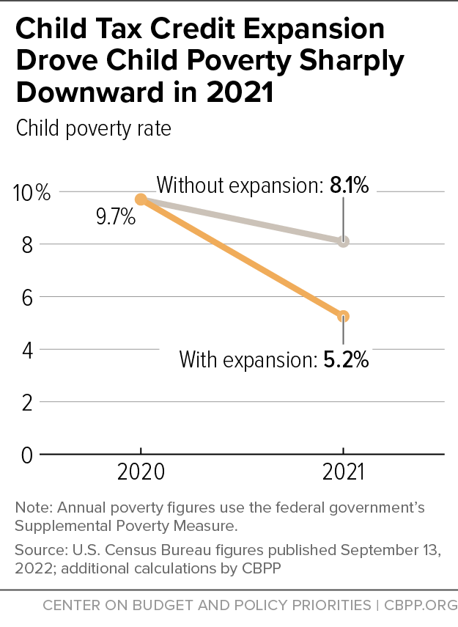
Regardless of what happens in the November election, Congress has much work to complete before a new Congress takes office in January. The most glaring task for anti-poverty advocates is reinstatement of an expanded Child Tax Credit (CTC). The 2021 CTC was a game-changer. U.S. Census data shows that in 2021, child poverty dropped an astounding 46 percent. A huge source was the expanded Child Tax Credit with monthly payments; the CTC alone lifted 5.3 million people out of poverty, including 2.9 million children.
Sadly, the expansion expired last December. As a result, child poverty has dramatically increased. In addition, Washington University in St. Louis data shows that employment decreased for CTC recipients after the monthly payments stopped, highlighting the importance of the CTC payments in helping families afford childcare, transportation, and stable housing.
But we have a chance to get it back. When Congress returns to Washington after the election, part of their agenda will be to pass tax breaks to help wealthy corporations. It is imperative that Congress also expand the CTC to all low-income families in that legislation.
Your local media this month can help pressure Congress to expand the CTC for children and families this year. Your letters to the editor could be the difference in helping families end a tough year on a high note.
Write letters to the editor about the Child Tax Credit
Be sure to check your local paper’s website for the word limit on letters to the editor as well as how to submit them.
- Choose a title for your letter and put it in the subject line of your e-mail or media submission form. Also, start your letter with “Dear Editor”.
- Tell readers that despite all the attention on who will control the next Congress, the current Congress has the opportunity to repeat history before the end of the year.
- Remind them that in 2021, the expanded Child Tax Credit with monthly payments helped cut child poverty by 46 percent last year – the largest one-year reduction in history.
- Tell them that the monthly CTC payments gave parents the freedom and flexibility to cover rent, food, and utilities when they needed it most – monthly bill time.
- Explain that since the payments expire last December, child poverty has increased, parents can’t work because they can’t afford childcare, and global inflation has made basic necessities more expensive.
- Inform readers that Congress hopes to pass a tax bill at the end of the year that would extend tax breaks for wealthy corporations.
- Say that it would be unconscionable for Congress to pass tax cuts for wealthy corporations yet ignore tens of millions of American families struggling to make ends meet.
- Tell readers that last year, we made an historic achievement in reducing child poverty. And we can do it again. Urge your senators and representatives by name not to pass any corporate tax cuts this year unless they also expand the CTC for all low-income families with monthly payments.
Tips for getting letters published
- If you have personal experience with the CTC, share it in your letter
- Helpful resource library containing other published media and studies for use in your writing, as well as our Fall 2022 Campaign Resources
- Keep your letter short and direct with a clear call to action
- Check the word limit for LTEs in your local paper and don’t go over it
- When you get published, forward your letter to the tax aide in your House and Senate offices with a request to pass a CTC extension now
- When you get published, please let RESULTS know by completing our Media Report Form
Also, continue to urge others to write LTEs as well. Use our Action Workshop Agenda (Word version) to host a letter-writing meeting. If you have questions about writing or submitting letters, or hosting an LTE-writing meeting, please contact Jos Linn.

