Help people with rising costs of living
In his March 2022 State of the Union speech, President Biden said “with all the bright spots in our economy, record job growth and higher wages, too many families are struggling to keep up with the bills. Inflation is robbing them of the gains they might otherwise feel.”
Low-income Americans are bearing the brunt of these higher costs. The cost of rent, fuel, and food have all seen significant increases as amidst overall economic uncertainty. It is imperative that Congress continue to push for more investments in helping workers, families, and children thrive.
A recent report from the Center on Budget and Policy Priorities shows that government interventions during the pandemic were amazingly successful. For example, in 2020, the poverty rate actually went down. From the paper: “When government assistance is included, the number of people with annual income below the poverty line fell in 2020 by the largest amount on record: 8 million.”
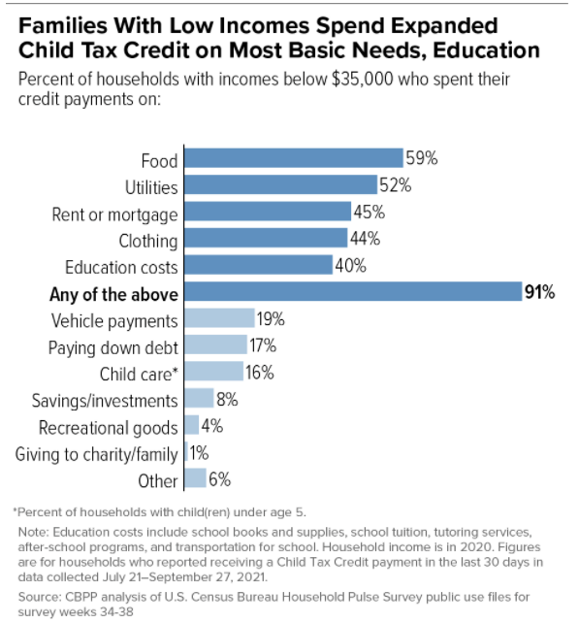
The expanded Child Tax Credit, emergency rental assistance, increased unemployment benefits, and stimulus payments created this success. But the job is far from over.
The increase in inflation – primarily fueled by the rapid re-opening of the economy, supply chain logjams, and corporations hiking prices to increase profits – is forcing millions of Americans into financial dire straits. The answer is NOT to scale back assistance but to build on what has worked to make sure workers and families have the resources they need to make ends meet.
Congress can accomplish this now in two significant ways:
- Continue monthly and expanded Child Tax Credit (CTC) payments. And do it now. In January 2022, 3.7 million children fell into poverty – a 41 percent increase! – because the CTC payments stopped.
- Expand access to rental assistance to keep renters housed.
President Biden closed his speech saying “Now is our moment to meet and overcome the challenges of our time.” It is indeed but we have to make it happen.
Use media to push for investments in housing and child well-being
Get letters to the editor published urging Congress to take action on rising prices extending the CTC and expanding rental assistance. Use the sample letters below to get started.
Child Tax Credit: In his State of the Union speech, President Biden called on Congress to extend the Child Tax Credit (CTC). I wholeheartedly agree.
In 2021, Congress expanded the CTC for millions of American families and sent it to them in monthly payments. Survey shows they spent this money on food, utilities, clothing, and rent.
But 51 U.S. senators let the payments expire in December. As a result, this child poverty rate jumped by 41 percent in January.
Pushing children and families into poverty is unacceptable. And with all of us feeling the pinch at the grocery store, the gas pump, and our utility bills, why is Congress not racing to extend the CTC payments?
I urge our members of Congress to immediately extend the 2021 CTC with permanent full refundability and to resume the monthly payments as soon as possible. And pay for it by making the wealthy and corporations pay their fair share of taxes.
Note: If you qualified for CTC monthly payments last year, go to www.childtaxcredit.gov to learn how to claim the rest of your credit.
Housing: In his State of the Union speech, President Biden talked about the importance of making housing affordable for all Americans. I wholeheartedly agree.
In the U.S. today, a worker must earn three times the prevailing minimum wage to afford a modest one-bedroom apartment. With rent prices skyrocketing, millions of Americans are only one crisis away from eviction and homelessness.
Congress has the power to do something. Federal rental assistance helps millions of low-income families better afford a place to live. But only one in four eligible renters can get assistance because of inadequate funding. Expanding rental assistance to all who are eligible could virtually end homelessness, reduce racial inequality, and save lives. And we can pay for it by making the wealthy and corporations pay their fair share of taxes.
I urge our senators and representatives to prioritize robust funding for rental assistance in upcoming legislative packages.
If you need help submitting your letters, use our CTC media alert or housing media alert to edit and send your letters today. If you have questions, please contact Jos Linn.

