CTC and EITC first steps in addressing racial inequity in tax policy
As tax season begins, Congress is still struggling to extend critical tax supports that not only make major inroads in the fight against poverty, but also start to reduce systemic racial income inequities. The Child Tax Credit (CTC) and Earned Income Tax Credit (EITC) are two of our most effective tools in fighting poverty. Each year, these credits combined lift millions of children, families, and workers above the federal poverty line.
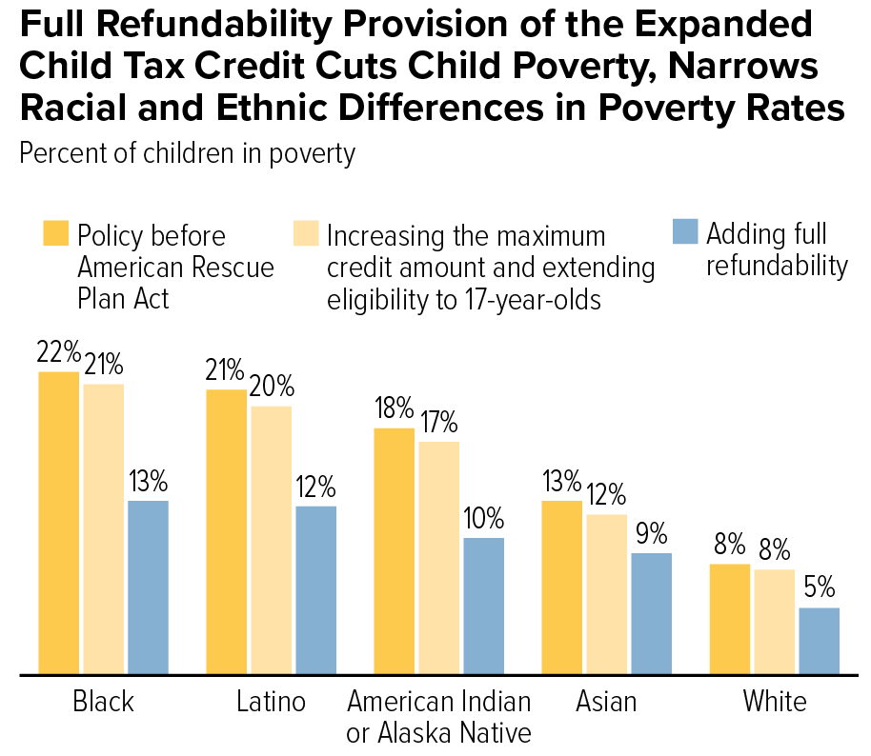
In 2021, significant improvements to the CTC and EITC have strengthened their anti-poverty impact. By allowing all low-income families regardless of income receive the full value of the CTC (“full refundability”), increasing the credit amount, and distributing it as monthly payment, the CTC kept 3-4 million children out of poverty in the latter months of 2021. Also, 17 million low-wage workers not raising children, including young workers just entering the workforce, will be better cushioned from deep poverty when they claim the expanded EITC on their 2021 federal tax return.
These credits are also important tools in addressing system racial inequalities. Because of historic racism in the U.S., Black, Native American, and Hispanic children are 2-3 times as likely to live in poverty compared to White children. By expanding the CTC, and in particular making the credit fully refundable, we dramatically slash the number of these children living in poverty (see chart).
In addition, people of color make up a disproportionate share of low-wage workers. By expanding the Earned Income Tax Credit to younger workers (who are more racially diverse) and others not raising children, the 2021 EITC expansion can help millions of low-wage workers move above the federal poverty line.
Despite these opportunities, Congress has let these vital improvements to the CTC and EITC expire. If not extended, all the progress we make in reducing child poverty, supporting low-wage workers, and narrowing racial inequities will be erased. Take action below to make sure that doesn’t happen.

Use the talking points below to tell your members of Congress to pass legislation now that extends the 2021 CTC and EITC provisions. Here are some ideas:
- If you are the point person for your representative or senator, e-mail or call their tax
- Send a letter to your members of Congress directly (submit your letters via the “Contact” page of your representative’s or senator’s website or e-mail them through the RESULTS website)
- Submit a letter to the editor publicly urging your members of Congress to take action (you can also send an LTE through the RESULTS website)
If you need help with take action, please contact Jos Linn (jlinn@results.org). For additional resources and background, see our 2022 U.S. Poverty Laser Talks and our Action Center.
- Introduce yourself with your name and city. Mention you are a RESULTS volunteer.
- Remind you representative or senator that because of changes to the Child Tax Credit (CTC) in 2021, nearly 4 million were lifted out of poverty last year.
- Also explain to them that changes to the Earned Income Tax Credit (EITC) last year can prevent 5 million low-wage workers, including younger workers just entering the workforce, from being taxed into poverty.
- Tell them that these changes will have a significant impact on systemic racial inequities in the U.S. For example, if continued, the 2021 CTC would cut poverty for Black and Hispanic children nearly in half.
- Share also that because low-wage workers are more likely to be people of color, the EITC expansion is a first step in narrowing America’s historical racial income gaps.
- Share a personal story about your experience with the CTC or EITC, data on the number of children and workers impacted in your state, and/or why you care about this issue.
- Remind them the CTC and EITC provisions expired in December, putting the gains we make in reducing child poverty, supporting workers, and promoting racial justice at risk of disappearing.
- Tell your member of Congress work to pass compromise Build Back Better legislation ASAP that extends the 2021 EITC and CTC provisions, including making full refundability of the CTC permanent.
- If contacting offices directly, ask that they please update you on your request.

