Demand the Senate continue Child Tax Credit expansion
In 2021, Congress took an important step to reduce child poverty by passing a major expansion of the Child Tax Credit (CTC). With these changes, all low-income children – even those in little- or no-income families – were finally made eligible for the full value of the credit, i.e., full refundability.” The credit amount was also increased and made available to families via monthly payments instead of once per year at tax time.
The impact of these changes has been nothing less than extraordinary. After the CTC payments began in July 2021, nearly 4 million children have been kept from poverty. If maintained, Columbia University researchers estimate that the new CTC with the monthly payment could cut child poverty by 45 percent.
Because the CTC changes were limited to 2021 only, RESULTS volunteers, other advocates, and lawmakers pushed to extend them. In November 2021, the House passed the Build Back Better Act (BBB), which extended the CTC changes for another year. It also made permanent full refundability of the CTC, ensuring that all low-income children will always receive the full credit.
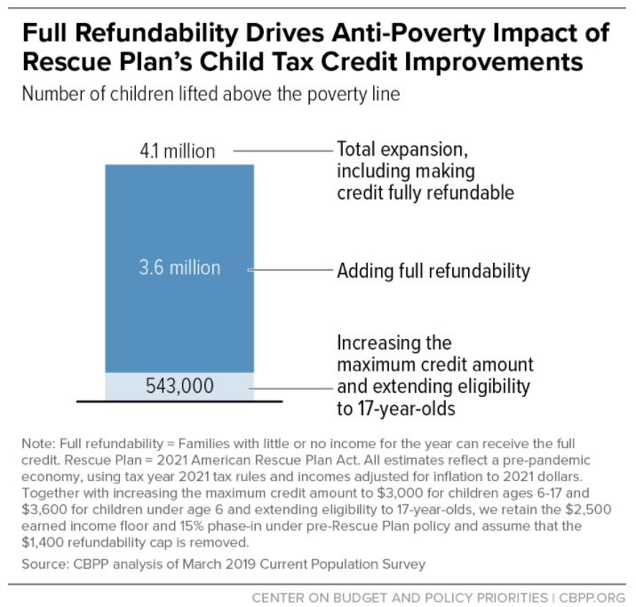
Sadly, the BBB has stalled in the Senate. As result, the new CTC has expired and no monthly payments will go out in January. This puts tens of millions of children and their families at risk of falling into or deeper into poverty in 2022. As the new COVID-19 surge forces more financial hardship on Americans, Congress must act now to prevent another financial crisis for low-income families.
Tell your senators pass BBB now with the CTC extensions, including permanent full refundability of the credit and the monthly payment option. Use the talking points below to write a letter to your senators or a letter to the editor urging them to act.
- Introduce yourself with your name, city, and mention you are a RESULTS volunteer.
- Remind senators that in 2021, Congress passed a major expansion of the Child Tax Credit (or "CTC”), which helped cut child poverty nearly in half last year.
- Explain to them that just as families are facing higher costs and struggling to make ends meet, monthly payments have ended – and 27 million children in the lowest-income families are now losing all or part of their CTC. Share the impact this had had on your family or others in your community if you are able.
- Tell them that the 2021 CTC expansion is the most significant investment in reducing child poverty in a generation. Since the monthly payments started in July 2021, nearly 4 million children have been lifted out of poverty.
- Share with them that researchers at Columbia University estimate that the new CTC could reduce child poverty by a stunning 45 percent.
- Share a personal story about your experience with the CTC, data on the number of children impacted in your state, and/or why you care about this issue.
- Remind them that the Build Back Better Act, which continues the expanded CTC, has stalled in the Senate, putting this critical anti-poverty policy at risk.
- Tell your senator they must extend the expanded CTC, especially permanent full refundability for all low-income families and the monthly payment option.
- Ask them to push their Senate colleagues and leadership to pass a CTC extension in early 2022 (and, if contacting Senate offices directly, request that they update you on this request).
In addition to writing letters and LTEs, if you are the RESULTS point person in your group for a senator, please contact their tax aide to urging support for extending the CTC as soon as possible. Also, please forward any published CTC media to the tax aide to remind them of constituent support for continuing the expanded credit. If you have questions about contacting aides, please contact Jos Linn (jlinn@results.org).
For additional resources and background, see our January 2022 National Webinar resources and our 2022 U.S. Poverty Laser Talks.

