Media Action: Call on Congress and the President for U.S. Leadership on Global Vaccine Access

The development of safe, effective vaccines against a deadly pandemic disease less than a year after it emerged is an extraordinary achievement, made possible by public investment in science and technology.

We know that effective vaccines can end this pandemic, but they’re not being produced fast enough to reach everyone who needs them. Nine out of ten people in low-income countries will not receive a single COVID-19 vaccination dose this year. Across the continent of Africa, just 1% of the population is fully vaccinated. So, it is unconscionable for rich countries to hoard the resources and know-how that could end the misery of COVID-19.
The question driving our campaign is, are we going to leave billions of people behind in this time of crisis, or are we going to step up?

According to a recent poll of likely voters, most Americans want the U.S. to step up. When asked if the U.S. should help other countries struggling with COVID-19, if we should distribute vaccines globally, and if the U.S. lead, the overwhelming majority of Americans, across parties, support all these measures.
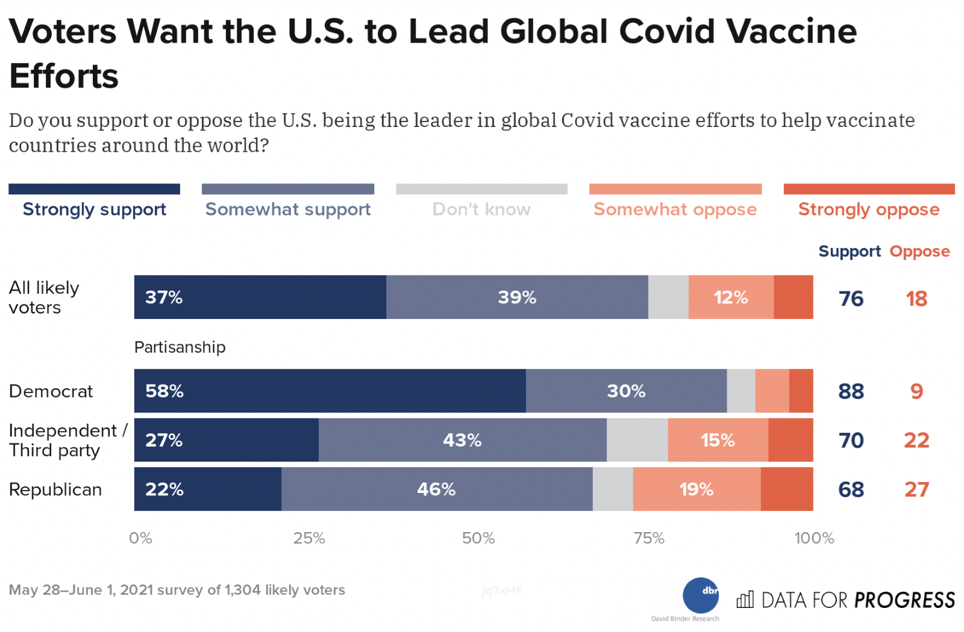
Following a devastating surge in South Asia this spring, many African countries are headed back into lockdown, as the highly infectious Delta variant affects communities that have been denied access to vaccines. As COVID-19 spreads unchecked, dangerous new variants will inevitably emerge and threaten those who are already vaccinated.

President Biden has the opportunity, authority, and obligation to lead a global effort to ensure communities everywhere have access to vaccines. The president must lead a global effort to bring together industry, governments, and global health institutions to urgently increase the supply of vaccines — and if necessary, use his authority to compel companies to share lifesaving, taxpayer-funded innovation with the rest of the world.

Look for local stories about the pandemic to use as a hook for a letter to the editor. Then write and submit your letter to the editor. Consider personalizing your letter with your experience of things opening up due to vaccine access and urge the president and Congress to quickly boost global vaccine manufacturing and ensure vaccines are accessible to all. Once published, leverage your media by forwarding it to your members of Congress.

Sample Letter to the Editor: Lead on Global Vaccines for COVID-19
For tips on writing and submitting letters to the editor, see our Media Basics. Also, consider making your letter-writing a group activity by inviting RESULTS group members and people in your action network to join together online to discuss why a global response to the pandemic matters to each of you and to write and share your letters with each other.

Access to COVID-19 vaccines has allowed our community to reopen schools and businesses and for many like me to see our families for the first time in nearly two years. Meanwhile, many countries globally are imposing new lockdowns to stop a third wave of COVID-19 infections because they’ve been denied access to COVID-19 vaccines.

Vaccination is our pathway out of this pandemic, but there are not enough vaccines being produced so that everyone has access. The unchecked spread of COVID-19 is devastating low-income countries and is generating dangerous variants, which is bad for all of us.

We need U.S. leadership from the president and Congress to urgently boost global manufacturing of vaccines. We have the authority, know-how, and resources to ramp up manufacturing and distribution so that everyone will have access quickly and be able to resume their lives.

Will President Biden and Congress take action?

Letter-writing Workshop Agenda

Below is a sample agenda and script for putting people in your community into action. When people take action, they get inspired. Adapt the 60-minute agenda below. If you need assistance with an online platform, like Zoom, for your meetings, contact Lisa Marchal at lmarchal@results.org.

I. Setting the Stage – 15 Minutes

2 min: Welcome and acknowledge people for being there.
“There are a lot of ways you could be spending your time, and I want to thank all of you for joining us and learning more about how YOU can play a role in the movement to end poverty. Let’s share a bit about why we’re here.”

3 min: State the purpose of the meeting.
“Our purpose today is to inspire you all about the difference you can make, working with others, to create the political will to end hunger, poverty, and inequity. In the next few minutes, we’ll . . .
- Learn a bit about RESULTS, the group organizing this.
- Learn about an issue of poverty.
- Take powerful action on the issue: we'll write letters to Congress
- And, finally, see who is interested in continuing to make a difference with RESULTS.”

10 min: Center the room and do introductions.
“Let’s see who’s here and get in touch with why we are here. Please give us your name and tell us briefly why acting on issue of poverty is important to you.”

“Thank you all for sharing what is important to you. We have a lot in common.”

II. The Basics of RESULTS – 10 Minutes
RESULTS is movement of passionate, committed, everyday people. Together we use our voices to influence political decisions that will bring an end to poverty. As volunteers, we receive training, support, and inspiration to become skilled advocates. In time, we learn to effectively advise policy makers, guiding them toward decisions that will improve access to health, education, and economic opportunity. Together we realize the incredible power we possess to use our voices to change the world. “

- Share the Raise Your Voice video: https://results.org/ via the share-screen function on Zoom.
- Share an example of success: “Prior to the COVID-19 pandemic, we protected development assistance for FY2020 after the President proposed cutting it by 30%. During the pandemic, we helped secure $11 billion in international development funding in the March 2021 COVID relief package, which included $3.5 billion for the Global Fund to Fight AIDS, Tuberculosis and Malaria. We also helped secure $4 billion for Gavi, the Vaccine Alliance in late 2020.
- Share a local example of our role in creating change (perhaps a way in which you moved a legislator to take action).
- A few more details if you have time. Tailor these to reflect what your group does:
- “RESULTS partners meet twice per month to plan and take action.”
- “During one of our meetings, we connect to a national webinar to learn about an issue, learn to speak powerfully, and take action to influence Congress.” Give an example.
- “We also develop plans for influencing our decision makers through face-to-face meetings, the media, and other community actions.”

III. Issues and Action Component - 30 Minutes
- Introduce the issue of global COVID-19 vaccines with a story or video. You can share your screen on Zoom.

Video about the global health impact of COVID-19: https://www.who.int/news-room/spotlight/the-impact-of-covid-19-on-global-health-goals

- Read the August Action Sheet together, including the sample letter.
- Show people how to find the email address of the foreign policy aide for your legislators by using our Legislator Lookup tool: https://results.org/volunteers/legislator-lookup/
- Write, and then ask writers to read their letter out loud for feedback and encouragement.
- Make a plan for sending in the letters and debrief.

IV. Invitation to Attend the Next Meeting & Closing – 5 Minutes
“Lastly, we are planning to have future meetings like this one to guide people in becoming powerful advocates. We’ll also be meeting with our members of Congress and generating media. Who is interested in joining us again to take action?

Say thank you, capture contact information: name, phone, email, address. Add them to your Action Network list in your Group Roadmap and stay in touch with them. Contacts Sarah Leone at sleone@results.org for tips on how to best engage your Action Network, as she can advise on getting Action Network members into the national database and/or starting to receive regular actions from your group on a regular basis.

Action Network Managers Action
Here’s a sample message you can send to your Action Network:

Dear (Name):

The development of safe, effective vaccines against a deadly pandemic disease less than a year after it emerged is an extraordinary achievement, made possible by public investment in science and technology. It is unconscionable for rich countries to hoard the resources and know-how that could end the misery of COVID-19.

Use our online action alert to write a letter to President Biden and raise your voice on this issue, or write a letter to the editor. Report to RESULTS when you get published, and then share your published media with your members of Congress.

