Media Action: Support the Global Partnership for Education

COVID-19 has wreaked havoc on even the strongest education systems. And countries already facing the consequences of decades of colonialism, resource extraction, and unjust global lending policies now face even greater challenges. At the peak of the pandemic, 1.6 billion of the world’s children were out of school — and many are at risk of never returning. Urgent action is needed now to ensure the COVID-19 education crisis does not turn into a permanent catastrophe for an entire generation.
As the only international fund of its kind, the Global Partnership for Education (GPE) has spent nearly 20 years helping governments invest in innovative solutions to get all girls and boys in school and learning. GPE now has an ambitious five-year plan to transform education systems in lower-income countries, helping build back better from the pandemic and ensure no child is left behind.
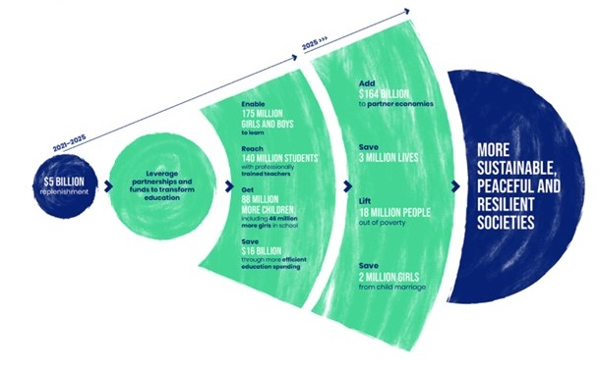
Look for local stories about education, the pandemic, or poverty to use as a hook for a letter to the editor. Then personalize and submit your own letter urging Congress to support a bold billion-dollar pledge in support of GPE (use the sample below to get started). Once published, leverage your media by forwarding it to your members of Congress.

Sample LTE: Support the Global Partnership for Education
For families around the globe, the school day routine ground to halt as COVID-19 surged. For many, this marked a transition to online learning. But for children facing poverty or pushed to the margins, it has often meant no school at all.
Urgent action is needed so the COVID-19 education crisis does not become a catastrophe for an entire generation.
As the only international fund of its kind, the Global Partnership for Education (GPE) marshals global resources for national education plans. Now, GPE and its partners have a five-year plan to support learning for 175 million more children in lower-income countries, helping build back better from the pandemic.
America can and must lead this effort. At this critical moment in global history, a bold pledge of $1 billion for five years will show that the U.S. is committed to working hand-in-hand with the global community to ensure every child can reach their potential.
For tips on writing and submitting letters to the editor, see our Media Basics. Also, consider making your letter-writing a group activity. Invite local RESULTS group members and people in your action network to join together online to discuss why education matters to each of you and to write and share your letters with each other.

Letter-writing Workshop Agenda
Below is a sample agenda and script for putting people in your community into action. When people take action, they get inspired. Adapt the 60-minute agenda below. If you need assistance with an online platform, like Zoom, for your meetings, contact Lisa Marchal at lmarchal@results.org.

I. Setting the Stage – 15 Minutes
2 min: Welcome and acknowledge people for being there.
“There are a lot of ways you could be spending your time, and I want to thank all of you for joining us and learning more about how YOU can play a role in the movement to end poverty. Let’s share a bit about why we’re here.”
3 min: State the purpose of the meeting.
“Our purpose today is to inspire you all about the difference you can make, working with others, to create the political will to end hunger, poverty, and inequity. In the next few minutes, we’ll . . .
- Learn a bit about RESULTS, the group organizing this.
- Learn about an issue of poverty.
- Take powerful action on the issue: we'll write letters to Congress
- And, finally, see who is interested in continuing to make a difference with RESULTS.”
10 min: Center the room and do introductions.
“Let’s see who’s here and get in touch with why we are here. Please give us your name and tell us briefly why acting on issue of poverty is important to you.”
“Thank you all for sharing what is important to you. We have a lot in common.”

II. The Basics of RESULTS – 10 Minutes
RESULTS is movement of passionate, committed, everyday people. Together we use our voices to influence political decisions that will bring an end to poverty. As volunteers, we receive training, support, and inspiration to become skilled advocates. In time, we learn to effectively advise policy makers, guiding them toward decisions that will improve access to health, education, and economic opportunity. Together we realize the incredible power we possess to use our voices to change the world. “
- Share the Raise Your Voice video: https://results.org/ via the share-screen function on Zoom.
- Share an example of success: “Prior to the COVID-19 pandemic, we protected development assistance for FY2020 after the President proposed cutting it by 30%. During the pandemic, we helped secure $11 billion in international development funding in the March 2021 COVID relief package, which included $3.5 billion for the Global Fund to Fight AIDS, Tuberculosis and Malaria. We also helped secure $4 billion for Gavi, the Vaccine Alliance in the December package a few months ago.”
- Share a local example of our role in creating change (perhaps a way in which you moved a legislator to take action).
- A few more details if you have time. Tailor these to reflect what your group does:
- “RESULTS partners meet twice per month to plan and take action.”
- “During one of our meetings, we connect to a national webinar to learn about an issue, learn to speak powerfully, and take action to influence Congress.” Give an example.
- “We also develop plans for influencing our decision makers through face-to-face meetings, the media, and other community actions.”

III. Issues and Action Component - 30 Minutes
- Introduce the issue of global education with a story or video. You can share your screen on Zoom.
Video about the Global Partnership for Education: https://tinyurl.com/VidforEd
- Read the June Action Sheet together, including the sample letter.
- Show people how to find the email address of the foreign policy aide for your legislators by using our Legislator Lookup tool: https://results.org/volunteers/legislator-lookup/
- Write, and then ask writers to read their letter out loud for feedback and encouragement.
- Make a plan for sending in the letters and debrief.
IV. Invitation to Attend the Next Meeting & Closing – 5 Minutes
“Lastly, we are planning to have future meetings like this one to guide people in becoming powerful advocates. We’ll also be meeting with our members of Congress and generating media. Who is interested in joining us again to take action?
Say thank you, capture contact information: name, phone, email, address. Add them to your Action Network list in your Group Roadmap and stay in touch with them. Contacts Sarah Leone at sleone@results.org for tips on how to best engage your Action Network, as she can advise on getting Action Network members into the national database and/or starting to receive regular actions from your group on a regular basis.

Action Network Managers Action

Here’s a sample message you can send to your Action Network:

Dear (Name): COVID-19 has wreaked havoc on even the strongest education systems. And countries already facing the consequences of decades of colonialism, resource extraction, and unjust global lending policies now face even greater challenges. At the peak of the pandemic, 1.6 billion of the world’s children were out of school — and many are at risk of never returning. Urgent action is needed now to ensure the COVID-19 education crisis does not turn into a permanent catastrophe for an entire generation. Use our online action alert to write a letter to the editor and raise your voice on this issue. Report to RESULTS when you get published, and then share your published media with your members of Congress.

