Use media to push for a strong economic recovery focused on reducing poverty
Building on the momentum created by the nearly 300 lobby meetings during the 2021 RESULTS First 100 Days Campaign, use local media to generate letters to the editors (LTEs) pushing Congress to enact bold economic recovery legislation. President Biden has called for new investments in housing and tax credits for low-income workers and children, but his proposals don’t go far enough. Your letters can help create the political will in Congress to dramatically expand rental assistance and ensure workers and children receiving the EITC and CTC stay out of poverty.
For tips on writing and submitting letters to the editor, see our Media Basics. Look for local stories about President Biden’s speech before Congress, economic recovery, the pandemic, or poverty to use as a hook for a letter to the editor. Use the sample letters and links to state data below to personalize and submit your own calling for bold action on housing and tax policies. You can also tailor templates on our website if you don’t submit them directly.
Once published, leverage your media by forwarding it to your members of Congress. Also, consider making your letter-writing a group activity. Invite local RESULTS group members and people in your action network to join together online to discuss why education matters to each of you and to write and share your letters with each other.
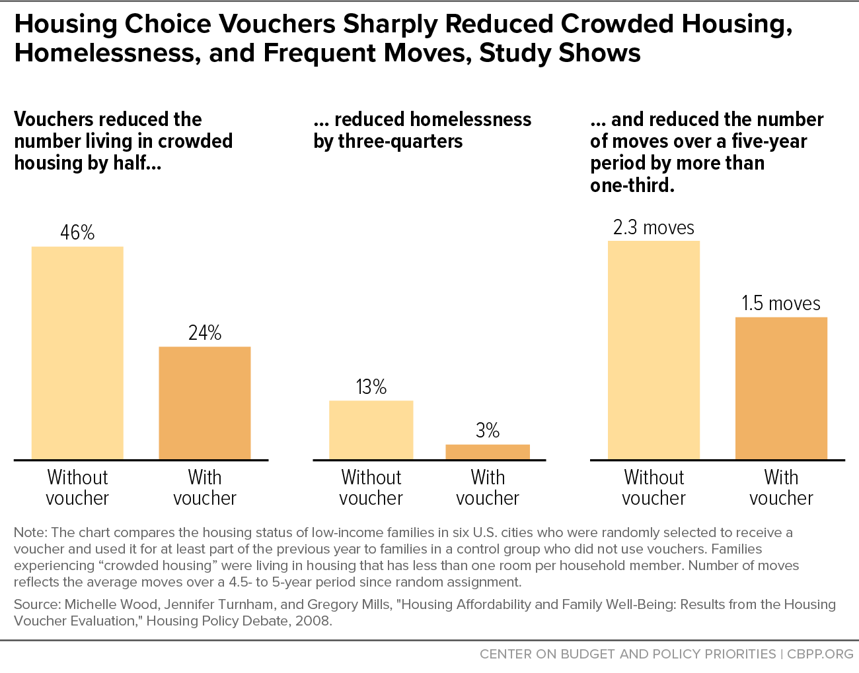
Template LTE: Expand rental assistance
As Americans cautiously return to normal life activities, stable and affordable housing for millions of renters remains out of reach. The pandemic has exacerbated our underlying housing crisis. Thousands of households are getting evicted, and many are at risk of experiencing homelessness because they can’t pay the rent., Yet federal rental assistance only goes to one in four eligible renters due to inadequate funding.
President Biden has proposed building affordable housing in the U.S., but Congress must do more by expanding rental assistance to all eligible renters so millions of families can keep a roof over their head. Housing Choice Vouchers, America’s largest rental assistance program, allow low-income renters to find safe housing they otherwise cannot afford. Studies show that families with stable housing earn higher wages and have better health and education outcomes. I urge our senators and representatives to expand rental assistance to all eligible renters in economic recovery legislation this year.
Template LTE: Make CTC and EITC changes permanent
We can cut child poverty in half – permanently.
The Biden Administration just proposed extending support for workers and families enacted earlier this year, by making permanent both an increase to the Earned Income Tax Credit for younger workers and others not raising children and an expansion of the full Child Tax Credit to all low-income families. He also proposes extending the increased CTC amount ($3,000+ per child) until 2025.
These steps are important, but Congress must make all the CTC changes permanent, including the credit increase. Columbia University estimates this new CTC will cut child poverty by 45 percent! [share how many children will benefit in your state] We can pay for this by asking the wealthy and corporations to finally pay their fair share.
If you could cut child poverty in half, why would you not do it? I urge our representatives and senators to make the new CTC and EITC provisions at 2021 levels permanent in recovery legislation.
Resources:
- RESULTS Blog Post on housing and poverty: https://results.org/blog/recovery-must-focus-on-reducing-poverty-and-systemic-inequities/
- Census Household Pulse data by state: https://www.census.gov/data-tools/demo/hhp/#/?measures=EXR
- Housing data by state (NLIHC): https://nlihc.org/housing-needs-by-state and https://nlihc.org/coronavirus-and-housing-homelessness/eviction-update
- CTC and EITC data by state (CBPP): https://www.cbpp.org/research/federal-tax/american-rescue-plan-act-includes-critical-expansions-of-child-tax-credit-and

