Keep up your First 100 Days lobby meetings
First 100 Days Meeting Map
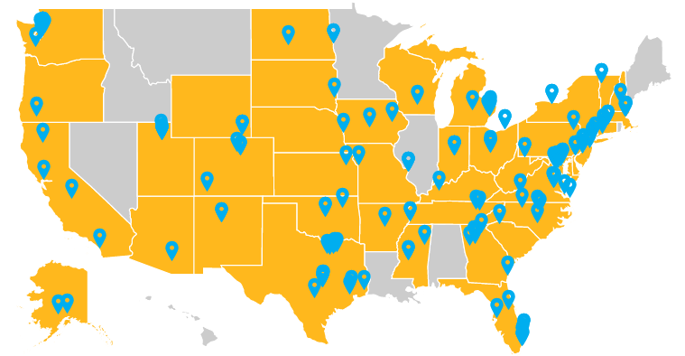
RESULTS volunteers have started 2021 off right. As part of our First 100 Days lobbying campaign, you’ve held over 150 lobby meetings with members of Congress about COVID relief. It has paid off. On March 11, President Biden signed the American Rescue Plan passed by Congress into law. It includes $30 billion to help millions of renters avoid eviction; an increase in the Earned Income Tax Credit benefitting 17 million low-wage workers; and an expansion of the Child Tax Credit to cover all low-income children and distribute it monthly. The CTC changes alone will reduce child poverty in the U.S. by 45 percent over the next year.
The American Rescue Plan is a remarkable achievement in the fight against poverty. Your years of advocacy on housing and tax policy helped make this possible. Celebrate this victory by sharing the success with your local action networks and others you know.
Prioritizing long-term solutions to poverty and addressing the legacy of racist housing policies
The American Rescue Plan is only the first step. The Biden Administration and Congress plan to focus next on economic recovery legislation. This is our opportunity to build on the rescue plan and solidify a generational change in the fight against poverty in America.
There is much work to do. Since 1960 renters' median earnings has gone up 5 percent while rents are up 61 percent. This leaves millions of families paying more than half their earnings for rent. In addition, because of the legacy of segregation, Black households (13% of total) make up 26% of all extremely low-income renters and 40% of people experiencing homelessness.
Right now, only one if four eligible renters can get federal housing assistance. By making the Housing Choice Voucher (HCV) program universal, or enacting a refundable renters’ credit, we can ensure all low-income renters get housing assistance. Along with increasing the supply of affordable housing via the National Housing Trust Fund and promoting homeownership for communities of color, we can stably house millions and undo the impact of years of discriminatory housing practices against people of color.
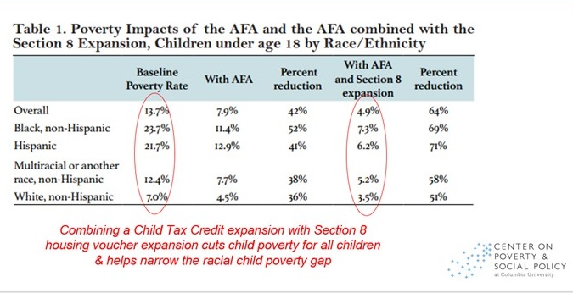
Furthermore, combining an expansion of housing assistance with making the new EITC and CTC provisions permanent (modeled on the American Family Act), Congress can reduce child poverty by more than 60 percent (see chart).
Let’s not waste this opportunity! Continue to meet with members of Congress and their staff urging to make these provisions top priorities in new economic recovery legislation. Please read and use our housing and tax leave behinds and laser talks in your meetings.
Use media to build support for strong recovery bill
Use local media to bolster your message. Use the sample letter below or our online alert to send your letter today. Once published, leverage your media to maximize its impact.
I am relieved that Congress has passed a new COVID relief bill that will provide relief to renters, increase the EITC for low-wage workers, and, astoundingly, cut child poverty by 45 percent by expanding the Child Tax Credit.
It's now time for Congress to build on these successes by fixing vast inequities in housing and lifting more children out of poverty. First, make Housing Choice Vouchers universal to all who qualify; currently, only 1 in 4 eligible renters get federal housing assistance. Next, protect workers and families by making the new EITC and CTC provisions permanent. Columbia University researchers estimate these combined changes could reduce child poverty in America by almost two-thirds.
We have the chance to make a generational leap in reducing poverty in America. I urge our members of Congress to take bold action to permanently and dramatically reduce child poverty and housing instability in recovery legislation this year.

