**Prioritizing Low-Income Americans in a Pandemic, and Building an Equitable Future**

Millions of Americans struggled to keep a roof over their heads, put food on the table, pay bills, and build wealth in an inequitable society before this pandemic, with one in eight Americans living below the federal poverty line. [Pre-pandemic poverty rates were more than two times higher among Black (20.8 percent) and Latinx (17.6 percent) people as among non-Hispanic white people (8.1 percent)](https://www.census.gov/library/publications/2019/demo/p60-266.html).[1]  And at the start of 2020, the United States had an affordable housing crisis – that disproportionately impacted Black, Indigenous, and People of Color (BIPOC). Now millions of low-income working families are struggling to pay rent and put food on the table as layoffs skyrocket due to the COVID-19 outbreak, with the economic downturn anticipated to continue into 2021.

Over the past ten weeks, over 40 million people have filed for unemployment insurance, with an over one in seven workers unemployed.[2] Unemployment is rising faster for women and people of color, and women of color are overrepresented in low-paid jobs such as retail, hospitality, and restaurants. Poverty and inequality were major structural challenges before the pandemic – disproportionately harming BIPOC – and our current crisis is exacerbating these inequities. We must act to prevent millions of low-income renters from losing housing and meet other basic needs – and create a better future. In conversations with policymakers this month, we will push for short-term policies to keep low-income renters stably housed and bold policy solutions to our underlying affordable housing crisis. In addition, in lobby prep calls this month we may suggest you do targeted advocacy during virtual meetings to support food assistance and refundable tax credits for low-income workers and families

This policy overview includes background on:

Background on Our Underlying Affordable Housing Crisis 2

Housing Crisis During a Pandemic 3

Food Assistance During a Pandemic 7

Background on Tax Credits for Low-Income Workers and Families 10

Expanding the EITC and CTC in This Economic Crisis 12

## Background on Federal Housing Programs and Our Underlying Affordable Housing Crisis

The U.S. government has a long history of policies that directly or indirectly blocked or built wealth via housing and beyond (see the [2019 RESULTS U.S. Poverty Campaigns background packets](https://results.org/resources/2019-international-conference-resources/) for a more thorough overview of this history[3]). Currently housing assistance is provided for 10 million people in over 5 million households. **In 2018, housing assistance alone lifted 3 million people out of poverty.**[4]

The largest programs that support residents with low incomes are Section 8 housing choice vouchers, Section 8 project based rental assistance, and public housing. [5]

Meanwhile, Americans’ income levels have not adjusted with the cost of living. **Since 1960, renters’ median earnings have gone up 5 percent while rent payment are up 61 percent.** [6] This leaves 18 million lower-income renters paying more than 30 percent of their income on rental cost, qualifying them as housing cost burdened. When households must pay high housing costs, resources for the other necessities like food, transportation, and health care are cut. These households cannot save for things like a home, which is their best shot at building wealth. Yet, **some households pay half or more of their income on rent** — these households qualify as severely housing cost burdened. Severely-cost burdened renters are more likely to have a household income at the poverty line or below 30 percent of the area median income (these households are identified as extremely low-income). **Seventy-one percent of extremely low-income households pay more than half their income on rental costs and households of color are more likely to qualify as** A screenshot of a cell phone
**extremely low-income**. The figure at the right shows a further breakdown by race and ethnicity, with 54 percent of cost-burdened renters comprising of households of color. [7]

## Housing Crisis During a Pandemic

Housing during the coronavirus pandemic is essential to ensuring the stop of the spread of the disease – and there are obvious challenges for people experiencing homelessness. In addition, many low-income renters work in hourly-wage service sector jobs and have either lost their employment or faced reduced work hours during the pandemic. Keeping these Americans in their homes during this time is crucial for the health and wellbeing of their families and communities.

The pandemic and economic downturn is hitting low-income renters hard. Renters tend to have lower incomes and less assets than their homeowner counterparts and cannot tap into the equity in their homes for a credit line in case of an emergency. And a disproportionate number of renters are Black, Indigenous, and people of color. A history of racism and sexism surrounding policies such as redlining, steering the housing market, and employment discrimination, among many others, have disenfranchised women of color, creating a system that makes it nearly impossible to build significant savings and wealth. And [two-thirds of Black and Latinx women do not have enough savings to live at the poverty line for three months](https://womenswealthgap.org/wp-content/uploads/2020/04/OnTheMargins_April2020_CWWG.pdf) if they lose their jobs.[8]

As the pandemic started, 31 percent of Americans, or 1 in 3, did not think they will be able to keep a roof over their head if the U.S. falls into a recession.[9] In late March, more than one-third of parents reported problems paying for housing, utility, food, or medical costs in the past month, including roughly half of low-income parents and black and Hispanic parents (see figure on next page). [10]

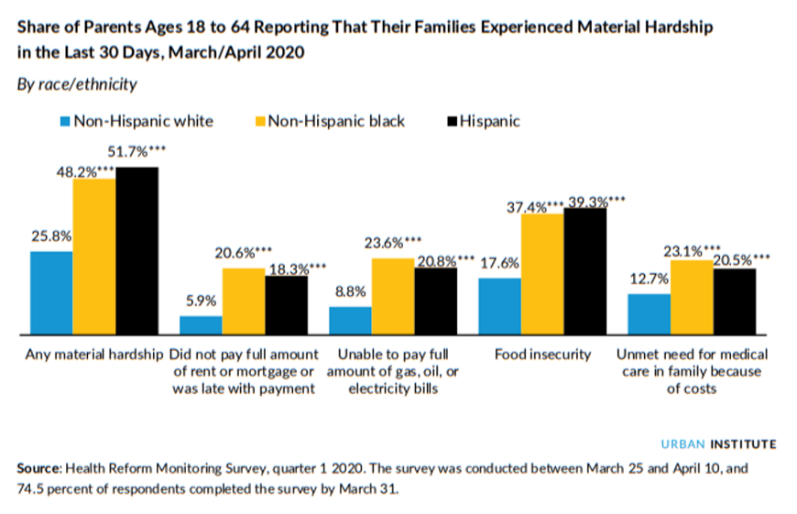

Analyzing Census data, the Urban Institute found [half of Black and Latino renters had slight or no confidence in ability to pay June rent](https://www.urban.org/urban-wire/new-data-suggest-covid-19-widening-housing-disparities-race-and-income) - more than twice the rate for white renters.[11]. And with [the Congressional Budget Office (CBO) forecasting that the unemployment rate will average 10 percent next year](https://www.cbo.gov/publication/56335)[12], millions of low-income renters could see challenges keeping housing for months and years ahead.

Some policymakers are implementing measures to help low-income renters keep their housing. These range from placing a moratorium on all evictions, more limited moratoria for residents who can demonstrate lost wages due to coronavirus, and piloting emergency rental assistance using local funds.

While $12 billion in additional funding in the CARES Act for homelessness and low-income renters is important, [it isn’t enough](https://nlihc.org/sites/default/files/COVID-paper-Culhane-et-al-final-word.pdf) to deal with the immediate needs homeless people are currently facing, or to provide emergency rental assistance to keep millions of low-income renters in their homes. As Congress negotiates additional legislation to respond to the housing crisis, the communities already pushed to the margins still face the greatest risks in this pandemic, and our underlying affordable housing crisis means that millions of families struggle to make rent.

According to the National Low Income Housing Coalition, it is estimated that the cost to extending rental assistance to cover all current and projected housing cost-burdened extremely and very low-income renters would cost approximately $99.5 billion.[13] As policymakers look at emergency rental assistance, the bipartisan [Eviction Crisis Act (S. 3030)](https://results.org/volunteers/action-center/?vvsrc=%2fBills%2fUSA%2f20192020r%2fS.+3030), introduced by Senator Bennet (D-CO) and Portman (R-OH), could be a model – it would establish a federal emergency housing grant program which would provide aid to people experiencing housing insecurity in order to prevent homelessness. The House-passed HEROES Act includes $100 billion in emergency rental assistance – though Senate leaders are moving slowly to enact additional COVID legislation.

A nationwide moratorium on evictions would help renters and homeowners stay housed during the economic crisis. In addition, millions of families face weeks or months where they cannot afford rent due to lost wages, and will not be able to come up with past rent due when an eviction moratorium ends. There is a desperate need for emergency rental assistance combined with a nationwide moratorium on evictions.

These combined measures would help prevent millions of Americans from facing a housing cliff -- losing their homes after the COVID-19 crisis due to an inability to pay back their months of rent that were suspended while ensuring families do not get evicted while they struggle to seek emergency rental assistance. **Increasing funding for emergency rental assistance end eviction prevention would make a tremendous impact on the lives of low-income renters** by allowing them to keep them and their families safe in the homes during this crisis.

We must also look ahead. In future legislation beyond this crisis, Congress may consider a refundable renters’ tax credit for low-income renters would help increase housing affordability by helping families with rising rent costs. Columbia University researchers estimate that a renters’ credit could lift over 9 million Americans above the poverty line. [14] Senators Booker (D-NJ) ([H.R. 4808](https://www.congress.gov/bill/116th-congress/house-bill/4808?q=%7B%22search%22%3A%5B%22Housing%2C+Opportunity%2C+Mobility%2C+and+Equity+Act%22%5D%7D&s=3&r=1)/[S. 2684](https://www.congress.gov/bill/116th-congress/senate-bill/2684?q=%7B%22search%22%3A%5B%22Housing%2C+Opportunity%2C+Mobility%2C+and+Equity+Act%22%5D%7D&s=3&r=2)) and Harris (D-CA) ([H.R. 2169](https://www.congress.gov/bill/116th-congress/house-bill/2169?q=%7B%22search%22%3A%5B%22rent+relief+act%22%5D%7D&s=1&r=1)/[S. 1106](https://www.congress.gov/bill/116th-congress/senate-bill/1106?q=%7B%22search%22%3A%5B%22rent+relief+act%22%5D%7D&s=1&r=2)), and Heller (R-NV) ([S. 3580](https://www.congress.gov/bill/115th-congress/senate-bill/3580?q=%7B%22search%22%3A%5B%22s.3580%22%5D%7D&s=2&r=3)) in the last Congress, have all introduced renters’ credit legislation. **A renter’s credit – paired with measures to reduce evictions and increase the supply of affordable housing via the National Housing Trust Fund – would ensure more families have a safe, affordable place in good times and bad.** A refundable renter’s tax credit and more money in the to build affordable housing will help low-income renter households, particularly households of color, move toward greater economic security.

COVID-19 and Hunger in the United States

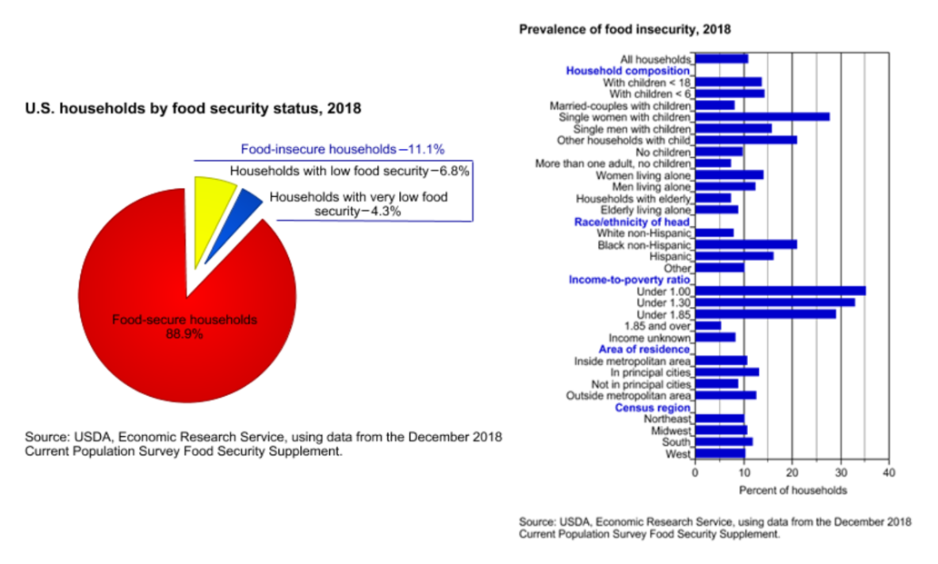Despite the United States being the richest nation on the planet, millions of Americans experience food insecurity every day. The U.S. Department of Agriculture (USDA) defines food insecurity as a lack of consistent access to enough food for an active, healthy life.[15] In 2018, an estimated 1 in 6 Americans lived in food insecure households—37 million Americans including 11 million children.[16] Moreover, counties with the highest rates of food insecurity are overrepresented by counties with a majority African American population. Approximately 21.2 percent of Black households were food insecure versus 11.1 percent overall.[17] Food insecurity affects both physical and mental health, even inhibiting children’s ability to learn in school.

First created in the 1960s under the name Food Stamp Program (FSP), the Supplemental Nutrition Assistance Program (SNAP) supports individuals and families who cannot access food for reasons of financial hardship. Participation in the program has steadily increased since its establishment with a single drop in the early 2000s.[18] In practice, SNAP provides a monthly stipend to eligible low-income families for the purchase of food with either an Electronic Benefit Transfer (EBT) card or voucher. Eligibility for SNAP is based on household income and assets, and, because this is a federal entitlement program, all those who qualify and apply for benefits receive them.

SNAP is the nation’s leading anti-hunger program for low-income working families, seniors, and people with disabilities living on fixed incomes. Nearly 70 percent of SNAP participants are in families with children; a third are in households with seniors or people with disabilities.[19] Overall, SNAP is an impactful and flexible program designed to adapt to large-scale economic downturns. In February of 2020, the program helped over 36 million low-income Americans afford a nutritionally adequate diet,[20] and participation is expected to increase as we continue to feel the effects of the current pandemic. According to the Census' Supplemental Poverty Measure, in 2018 SNAP lifted 3.21 million people above the federal poverty line, making it the third most effective anti-poverty program in the United States.[21]

## Food Assistance During a Pandemic

For the families and individuals already struggling before the pandemic as well as those who lost jobs due to the emergency response, food assistance programs are vital. Per a nationally representative survey of nonelderly adults conducted between March 25th and April 10th, the number of food insecure households has doubled from 11 percent in 2018 to 20 percent. More than one in five Americans experienced food insecurity in the early weeks of the pandemic.[22]

According to researchers at the Center on Budget and Policy Priorities, SNAP participation also sharply increased between March 25th and April 10th.[23] SNAP serves as a frontline defense against food insecurity, poverty, and the long-term detriments that have been exacerbated due to the current pandemic. By providing families with a grocery benefit they can use to purchase food directly, SNAP is a safe, effective way to ensure that low-income children, families, and seniors can get the food they need.

The unemployment rate jumped from 4.4 to 14.7 percent in April[24] with a slight decline to 13.3 percent in May according to the most recent jobs report. However, the black unemployment rate has stayed stagnant at over 16 percent.[25] In response to mass unemployment, 31.0 percent of households reported that their family had to cut back spending on food. An estimated 9.3 percent identified as hungry, or of very low food security, including 10.8 percent of parents with children younger than 6, 17.5 percent of black parents, and 13.0 percent of Hispanic parents.[26] Researchers at Feeding America have predicted that if the unemployment rate remains greater than 11 percent for the duration of 2020, the annual food insecurity rate will reach 16.7 percent, affecting 54.3 million Americans.[27]

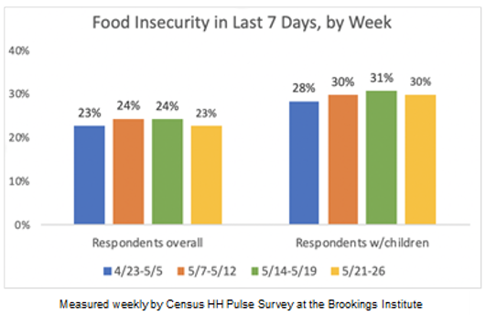The unprecedented disruption to the economy, incomes, and employment triggered by COVID19 means that communities will need every option available to fight hunger and strengthen the economy. We at RESULTS appreciate the investments and economic supports provided for in the CARES Act to help laid-off workers, older Americans, and children, but the legislation did not include provisions to strengthen the Supplemental Nutrition Assistance Program (SNAP). Despite the unemployment rates slight decrease in May, food insecurity has not improved, especially for households with children. We therefore strongly urge Congress and the Administration to increase the SNAP benefit levels in the next federal COVID-19 relief package.

**Given the extraordinary increase in need during this public health pandemic and related economic crisis, we urge Congress to use the next federal relief package to strengthen SNAP by increasing the maximum benefit available to all households by 15% and increasing the minimum benefit from $16 dollars to $30.** Researchers at the University of Kentucky [28] and from Dartmouth and Wellesley Colleges[29] found that an increase in the level of SNAP benefits would reduce food insecurity and increase consumption of more nutritious foods. Boosting the maximum SNAP benefits by 15 percent would provide an extra $100 a month for an average family of four.[30] The Children’s Defense Fund reports that a permanent expansion of SNAP benefits would reduce child poverty by 16 percent, affecting 1.8 million children.[31]  These increases are needed to offset the significant loss in income and soaring unemployment resulting from COVID-19-related closures and disruptions.

Strengthening SNAP will not only feed families, but boost the economy. Economists estimate that every dollar in federally funded SNAP benefits during a recession generates between $1.50 and $1.80 in economic activity because it frees cash for poor households to buy other essential items, like diapers and medication, and provides revenue directly to stores, thus helping maintain local jobs. The U.S. Department of Agriculture’s Economic Research Service estimates that every $1 billion invested in SNAP supports 13,600 jobs and approximately $32 million in farm revenue.[32] As the federal government continues to evaluate effective policies to stimulate the economy, we recommend that the increase to SNAP benefits as outlined above be kept in place until the economy recovers from its current shock.

In addition, [RESULTS supports efforts to suspend all proposed and final administrative rules](https://results.org/blog/results-responds-to-white-house-proposals-that-threaten-low-income-families/) that would terminate or weaken SNAP benefits, expand eligibility to young children enrolled in childcare feeding programs as well as college students, and waive harsh working requirements for the duration of the economic downturn. Placing harsher restrictions on program eligibility would have a negative impact on the participation of low-income families and children in need of financial relief. Furthermore, the overhead cost for implementing these regulations would divert vital state resources away from responding to the impact of COVID-19 on communities across the nation. Congress should act now to make these benefits more robust, which will ensure that everyone is able to put food on the table in the coming months and support the economic recovery.

Background on Tax Credits for Low-Income Workers and Families

While working more broadly to reduce racial wealth inequality, RESULTS focuses on expanding opportunities for low-income individuals and families to move up the economic ladder. Many of America’s low-income working families are struggling to stay afloat as costs have risen faster than their pay over several decades, and too many parents with low incomes struggle to provide for their kids’ basic needs. As colleagues writing about state tax policy at the Center on Budget and Policy Priorities note, “*we know that white supremacy and structural racism created — and perpetuate — disparities in power, resources, and opportunities in ways that systematically disadvantage communities of color and preserve the privilege of an elite, largely white class… As a result of these and other barriers, the wealthiest 10 percent of white households hold nearly two-thirds of the country’s wealth, and other white households about another fifth, leaving only 13 percent for everyone else*.”[33] Tax policy perpetuates inequality but changing tax policy can help to close the racial wealth divide and decrease poverty rates. And, within our current public health and economic crises, tax policies that reduce disparities are critical.

We support features of the tax code that assist working families, such as the Earned Income Tax Credit (EITC) and the Child Tax Credit (CTC). The EITC and CTC work because they’re both refundable, either fully or partially. For low-to-moderate-income (LMI) families, refundable tax credits are critical supplements to income and can also be essential saving tools at tax time. The EITC is fully refundable, meaning that if it exceeds a low-wage worker’s income tax liability (what they owe on taxes), the IRS will refund the balance. The average EITC refund was $2,476 in 2019, though the EITC can be much higher for families with children.[34] This successful program is designed to “make work pay” by increasing the credit as earnings go up.

It is estimated that in 2018 alone, [the EITC and CTC lifted 8.9 million people out of poverty](https://www.census.gov/library/publications/2019/demo/p60-268.html), nearly half of them children (see figure on next page).[35]

[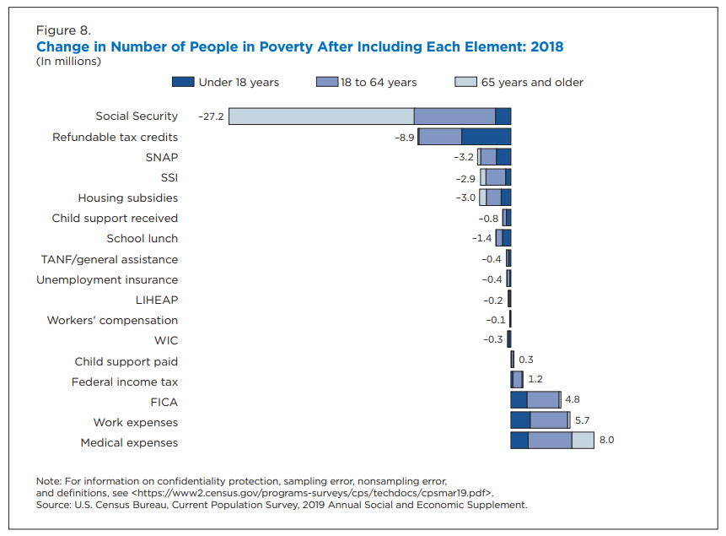](https://www.census.gov/content/dam/Census/library/visualizations/2019/demo/p60-268/figure8.pdf)The Earned Income Tax Credit (EITC)

The amount of a person’s EITC depends on family size and marital status.[36] Since its establishment, the EITC has become the nation’s leading anti-poverty program for working, low-income families:

* **The EITC has proven to be an effective anti-poverty program.** The most recent relevant study found that a $1,000 increase in the EITC led to a 7.3 percentage point increase in employment and a 9.4 percentage point reduction in the share of families below the poverty line.[37]
* **The EITC strengthens local economies.** The EITC refund checks are often spent quickly and locally, resulting in at least $1.50-$2.00 in local economic activity for every $1 claimed.[38]
* **The EITC increases promotes work, especially among single mothers.** The EITC expansions of the 1990s helped more than a half a million families move from cash welfare assistance to work.[39]

**Three Tools Used to Perpetuate Racial Discrimination in Housing**

**Redlining:** “The practice of arbitrarily denying or limiting financial services to specific neighborhoods, generally because its residents are people of color or are poor. While discriminatory practices existed in the banking and insurance industries well before the 1930s, the [New Deal's](http://www.encyclopedia.chicagohistory.org/pages/883.html) Home Owners' Loan Corporation (HOLC) instituted a redlining policy by developing color-coded maps of American cities that used racial criteria to categorize lending and insurance risks. New, affluent, racially homogeneous housing areas received green lines while black and poor white neighborhoods were often circumscribed by red lines denoting their undesirability.”

**Blockbusting:** “The efforts of [real-estate](http://www.encyclopedia.chicagohistory.org/pages/1045.html) agents and real-estate speculators to trigger the turnover of white-owned property and homes to [African Americans](http://www.encyclopedia.chicagohistory.org/pages/27.html). Often characterized as “panic peddling,” such practices frequently accompanied the expansion of black areas of residence and the entry of African Americans into neighborhoods previously denied to them. In evidence as early as 1900, blockbusting techniques included the repeated—often incessant—urging of white homeowners in areas adjacent to or near black communities to sell before it became “too late” and their property values diminished.”

**Zoning Laws:** “Municipal or local government laws that dictate how real property can and cannot be used in certain areas. Zoning laws gave localities immense power in determining who could live where, thus the ability to discriminate.”

The Child Tax Credit (CTC)

The Child Tax Credit (CTC) is a partially refundable federal tax credit designed to help families offset some of the costs of raising children, and like the EITC, is an effective anti-poverty tool. In 2019, the non-partisan [National Academy of Sciences released a consensus plan to cut child poverty in half](https://www.nationalacademies.org/our-work/building-an-agenda-to-reduce-the-number-of-children-in-poverty-by-half-in-10-years#sectionPublications).[40] The two policy proposals that had the biggest impact on poverty reduction were both versions of an expanded Child Tax Credit.[41] With the expenses of raising a child continually increasing, the CTC is a critical measure in ensuring that children receive the necessary resources and home stability they deserve.

Sadly, because the CTC is only partially refundable, it does not reach the families who need it most. Those earning below $2,500 per year may not claim the CTC and those who do qualify may only receive a portion of the full credit as a refund. Meanwhile, families earning up to $400,000 are able to claim the full credit on their taxes.Chuck Marr, Chye-Ching Huang, Arloc Sherman, and Brandon Debot Center on Budget and Policy Priorities

## Expanding the EITC and CTC in This Economic Crisis

For many low-income workers, refundable tax credits offer an opportunity to boost emergency savings, purchase necessary items for their household or children, make large and necessary purchases (such as a car for work), or pay down outstanding debts.[42] The Earned Income Tax Credit (EITC) and low-income portion of the Child Tax Credit (CTC) are particularly beneficial policies for communities of color because these communities experience higher rates of poverty.

While tax policy often rewards wealth and exacerbates racial wealth inequality, we can fix our tax laws to give working people and children a fair shot to get ahead. Many of America’s low-income working families are struggling to stay afloat as costs have risen faster than their pay over several decades, and millions have now lost jobs or income due to COVID-19. The EITC and CTC are proven policy successes that help working people with low-wage jobs keep their heads above water, reduce poverty, and improve child well-being. But they can do considerably more.

There is a lot of attention right now on frontline workers during the pandemic -- grocery store staff, truck drivers, home health aides, etc. [5.8 million low-wage workers](https://www.cbpp.org/research/federal-tax/temporarily-expanding-child-tax-credit-and-earned-income-tax-credit-would), many essential employees, are taxed into poverty or locked out of claiming the EITC altogether since they are under 25, over 64, or don’t claim children.[43]

In addition, with millions of children home away from access to school meals and social supports, it is unconscionable that 27 million children in the lowest-income families are not reached by the full CTC. If the CTC were fully available to these families, it would [lift an additional 3 million people — including 2 million children — above the poverty line](https://www.cbpp.org/research/federal-tax/temporarily-expanding-child-tax-credit-and-earned-income-tax-credit-would).[44] Expanding the CTC and EITC would help low- and moderate-income working families of all races and benefit [17 million Black and Latino households](https://www.cbpp.org/research/federal-tax/how-the-federal-tax-code-can-better-advance-racial-equity).[45]

In the short-term, it is critical that Congress support crucial investments that immediately help low-income Americans get through the current economic crisis such as housing assistance and SNAP (as noted above). Unfortunately, the crisis will continue into next year –[the Congressional Budget Office (CBO) forecasts that unemployment will average 10 percent in 2021](https://www.cbo.gov/publication/56335).[46] Temporary expansions now of the EITC and CTC could help low-income workers and families raising children as the economic crisis continues – servicing as a “back to work” bonus in winter 2021.

Ultimately, RESULTS supports broader expansions of the EITC and CTC and we hope to build support for permanent improvements for a new Congress that — in combination with legislation to raise the minimum wage, expand access to affordable housing and homeownership, increase funding for child care, provide paid family and medical leave, and more — would help address income inequality that has affected Black, Latinx, and other working-class households.

1. U.S. Census Bureau. “Income and Poverty in the United States: 2018”. Available at <https://www.census.gov/library/publications/2019/demo/p60-266.html>
2. U.S. Bureau of Labor Statistics. “June 5 Employment Situation Summary.” Available at <https://www.bls.gov/news.release/empsit.nr0.htm>.
3. RESULTS. “2019 U.S. Poverty Campaigns background packets." <https://results.org/resources/2019-international-conference-resources/>.
4. U.S. Census Bureau. "Figure 8. Change in Number of People in Poverty After Including Each Element: 2018." <https://www.census.gov/content/dam/Census/library/visualizations/2019/demo/p60-268/figure8.pdf>.
5. Center on Budget and Policy Priorities. “Federal Rental Assistance Fact Sheets.” Available at

   <https://www.cbpp.org/research/housing/federal-rental-assistance-fact-sheets#US>
6. Joint Center for Housing Studies of Harvard University. “State of the Nation’s Housing 2018.” Available at <https://www.jchs.harvard.edu/sites/default/files/Harvard_JCHS_State_of_the_Nations_Housing_2018.pdf>
7. Prosperity Now. "Scorecard Key Findings." https://scorecard.prosperitynow.org/main-findings <https://scorecard.prosperitynow.org/main-findingshttps://scorecard.prosperitynow.org/main-findings>
8. CNBC. “On the Margins: Economic Security for Women of Color through the Coronavirus Crisis and Beyond”. Available at <https://womenswealthgap.org/wp-content/uploads/2020/04/OnTheMargins_April2020_CWWG.pdf>
9. Closing the Women's Wealth Gap. “On the Margins: Economic Security for Women of Color through the Coronavirus Crisis and Beyond”. Available at <https://womenswealthgap.org/wp-content/uploads/2020/04/OnTheMargins_April2020_CWWG.pdf>
10. Urban Institute. “Parents Are Struggling to Provide for Their Families during the Pandemic: Material Hardships Greatest among Low-Income, Black, and Hispanic Parents,” *Urban Institute*. 2020. Accessed 3 June 2020. <https://www.urban.org/research/publication/parents-are-struggling-provide-their-families-during-pandemic>
11. Urban Institute. "New Data Suggest COVID-19 is Widening Housing Disparities by Race and Income." <https://www.urban.org/urban-wire/new-data-suggest-covid-19-widening-housing-disparities-race-and-income>
12. Congressional Budget Office. “CBO’s Current Projections of Output, Employment, and Interest Rates and a Preliminary Look at Federal Deficits for 2020 and 2021.” <https://www.cbo.gov/publication/56335https://www.cbo.gov/publication/56335>.
13. National Low-Income Housing Coalition. “NLIHC Research Note: The Need for Emergency Rental Assistance During the COVID-19 and Economic Crisis.” <https://nlihc.org/sites/default/files/Emergency-Rental-Assistance-Needs-for-Workers-Struggling-due-to-COVID-19.pdf>
14. Vox. “5 anti-poverty plans from 2020 Democratic presidential contenders, explained” <https://www.vox.com/future-perfect/2019/1/30/18183769/democrat-poverty-plans-2020-presidential-kamala-harris-booker-gillibrand>
15. The U.S. Department of Agriculture. Definition of food insecurity: https://www.ers.usda.gov/topics/food-nutrition-assistance/food-security-in-the-us/definitions-of-food-security.aspx
16. The U.S. Department of Agriculture. “Household Food Security in the United States in 2018.” <https://www.ers.usda.gov/webdocs/publications/94849/err-270.pdf?v=9183.3>
17. Feeding America. “The Impact of the Coronavirus on Local Food Insecurity.” <https://www.feedingamerica.org/sites/default/files/2020-05/Brief_Local%20Impact_5.19.2020.pdf>
18. US Department of Agriculture. “A Short History of SNAP.” <https://www.fns.usda.gov/snap/short-history-snap>
19. Center on Budget and Policy Priorities. “Policy Basics: The Supplemental Nutrition Assistance Program (SNAP).” <https://www.cbpp.org/research/policy-basics-the-supplemental-nutrition-assistance-program-snap>
20. U.S. Department of Agriculture. “SNAP Data Tables.” <https://www.fns.usda.gov/pd/supplemental-nutrition-assistance-program-snap>
21. U.S. Census Bureau. “The Supplemental Poverty Measure: 2018.” <https://www.census.gov/content/dam/Census/library/publications/2019/demo/p60-268.pdf>
22. Urban Institute. “More Than One in Five US Adults Experienced Food Insecurity in the Early Weeks of the Pandemic.” <https://www.urban.org/urban-wire/more-one-five-us-adults-experienced-food-insecurity-early-weeks-pandemic>
23. Center on Budget and Policy Priorities. “SNAP Is Responding to Increased Need, Early Evidence Shows.” <https://www.cbpp.org/blog/snap-is-responding-to-increased-need-early-evidence-shows>
24. U.S. Bureau of Labor Statistics. “The Employment Situation — April 2020.” <https://www.bls.gov/news.release/pdf/empsit.pdf>
25. U.S. Bureau of Labor Statistics. “The Employment Situation — May 2020.” <https://www.bls.gov/news.release/pdf/empsit.pdf>
26. Urban Institute. “Parents Are Struggling to Provide for Their Families during the Pandemic: Material Hardships Greatest among Low-Income, Black, and Hispanic Parents.” <https://www.urban.org/research/publication/parents-are-struggling-provide-their-families-during-pandemic>
27. Feeding America. “The Impact of the Coronavirus on Local Food Insecurity.” <https://www.feedingamerica.org/sites/default/files/2020-05/Brief_Local%20Impact_5.19.2020.pdf>
28. The Hamilton Project. “Modernizing SNAP Benefits.” <http://www.hamiltonproject.org/papers/modernizing_snap_benefits>
29. Center on Budget and Policy Priorities. “The Relationships Among SNAP Benefits, Grocery Spending, Diet Quality, and the Adequacy of Low-Income Families’ Resources.” <http://www.cbpp.org/research/the-relationships-among-snap-benefits-grocery-spending-diet-quality-and-the-adequacy-of-low>
30. Children’s Defense Fund. “SNAP Must Be Strengthened to Fight Child Hunger During the Pandemic and Beyond,”. 2020. <https://www.childrensdefense.org/wp-content/uploads/2020/05/CDF-SNAP-Brief-May-2020.pdf>
31. Children’s Defense Fund. “Ending Child Poverty Now.” <https://www.childrensdefense.org/wp-content/uploads/2018/06/Ending-Child-Poverty-Now.pdf>
32. United States Department of Agriculture Economic Research Service. “The Supplemental Nutrition Assistance Program (SNAP) and the Economy: New Estimates of the SNAP Multiplier.” <https://www.ers.usda.gov/topics/food-nutrition-assistance/supplemental-nutrition-assistance-program-snap/economic-linkages/>  
    
33. Center on Budget and Policy Priorities. “3 Principles for an Anti-Racist, Equitable State Response to COVID-19 – and a Stronger Recovery.” <https://www.cbpp.org/sites/default/files/atoms/files/5-20-20sfp.pdf>
34. IRS. "EITC Fast Facts." Available at <https://www.eitc.irs.gov/partner-toolkit/basic-marketing-communication-materials/eitc-fast-facts/eitc-fast-facts>
35. U.S. Census Bureau. “The Supplemental Poverty Measure: 2018.” October 7, 2019. Accessed 5 June 2020. <https://www.census.gov/library/publications/2019/demo/p60-268.html>
36. Tax Policy Center (TPC): <http://www.taxpolicycenter.org/briefing-book/key-elements/family/eitc.cfm>
37. Tax Policy Center (TPC). “Tax Policy Center Briefing Book: Key Elements of the U.S. Tax System: Taxes and the Poor.” Accessed 5 June 2020. <https://www.taxpolicycenter.org/briefing-book/how-does-earned-income-tax-credit-affect-poor-families>
38. Center for American Progress (CAP). “Harnessing the EITC and Other Tax Credits o Promote Financial Stability and Economic Mobility.”. <https://www.americanprogress.org/issues/poverty/report/2014/10/07/98452/harnessing-the-eitc-and-other-tax-credits-to-promote-financial-stability-and-economic-mobility/>
39. Center on Budget and Policy Priorities. “EITC and Child Tax Credit Promote Work, Reduce Poverty, and Support Children’s Development, Research Finds.” <http://www.cbpp.org/research/federal-tax/eitc-and-child-tax-credit-promote-work-reduce-poverty-and-support-childrens?fa=view&id=3793>
40. National Academies of Sciences, Engineering, and Medicine. “A Roadmap to Reducing Child Poverty.” <https://doi.org/10.17226/25246>.
41. The Institute on Taxation and Economic Policy. “The Case for Extending State-Level Child Tax Credits to Those Left Out: A 50-State Analysis.” <https://itep.org/the-case-for-extending-state-level-child-tax-credits-to-those-left-out-a-50-state-analysis/>
42. Tax Credits for Workers and Families. “New Survey Sheds Light on How Workers Use the EITC.” <http://www.taxcreditsforworkersandfamilies.org/news/new-survey-sheds-light-on-how-workers-use-the-eitc/>
43. Center on Budget and Policy Priorities. “Temporarily Expanding Child Tax Credit and Earned Income Tax Credit Would Deliver Effective Stimulus, Help Avert Poverty Spike.” <https://www.cbpp.org/research/federal-tax/temporarily-expanding-child-tax-credit-and-earned-income-tax-credit-would>
44. Center on Budget and Policy Priorities. “Temporarily Expanding Child Tax Credit and Earned Income Tax Credit Would Deliver Effective Stimulus, Help Avert Poverty Spike.” <https://www.cbpp.org/research/federal-tax/temporarily-expanding-child-tax-credit-and-earned-income-tax-credit-would>
45. Center on Budget and Policy Priorities. “How the Federal Tax Code Can Better Advance Racial Equity.” <https://www.cbpp.org/research/federal-tax/how-the-federal-tax-code-can-better-advance-racial-equity>
46. Congressional Budget Office. “CBO’s Current Projections of Output, Employment, and Interest Rates and a Preliminary Look at Federal Deficits for 2020 and 2021”. <https://www.cbo.gov/publication/56335>