Millions Face Eviction if Congress Does Not Act
According to the most recent federal jobs report, the U.S. economy added 4.8 million jobs in June, with the majority of gains occurring in the restaurant, tourism, and hospitality industries. Meanwhile, the unemployment rate for Black men actually increased for the second month in a row, to 16.3%, widening the gap between White workers and Black workers by 5.3 percentage points. Now, another round of closures and shutdowns caused by a surge in COVID-19 cases are likely to force the unemployment rate back up in the coming weeks and months.
Let us also not forget that these slight improvements mean little to the approximately 25 percent of families who felt housing insecure in mid-June. The CARES Act’s federal eviction protection ended on July 25 and Senate leaders, at this point, do not plan to renew $600 boost in unemployment benefits, which expired on July 31. This will dramatically increase the number of cost-burdened households (HH paying more than 30 percent of their income in rent).
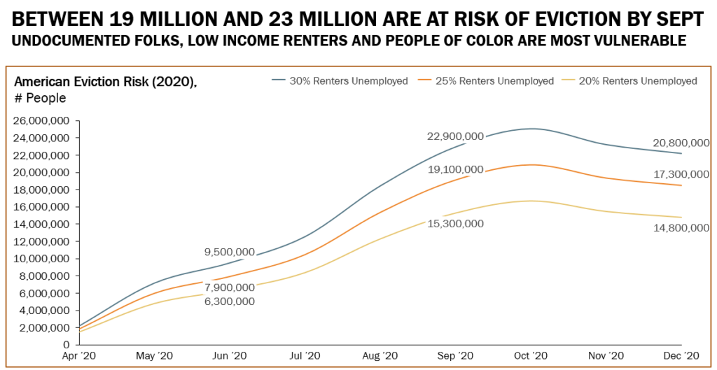
The Aspen Institute estimates that 19-23 million Americans face eviction by the end of September. To prevent that disastrous outcome, Congress must include $100 billion in emergency rental assistance to help both tenants and landlords as well as a national moratorium on evictions in the next COVID-19 bill. The House included these provisions when it passed the HEROES Act in May. The Senate must do the same to prevent a mass displacement that could destabilize communities for years to come.
Talk to Senate and House housing aides now
Members are now back in DC negotiating the next COVID-19 bill. The Senate released its initial plan, the HEALS Act, in late July. The HEALS Act only provides $3.3 billion for emergency rental assistance and no moratorium on evictions (also, no new money for SNAP). We must do all we can to change correct this grievous mistake.
It is vital we convince Senate Republicans to include targeted financial relief for low-income renters in the final COVID bill and remind Senate Democrats to prioritize our housing requests negotiations. The same messages should be used for House members. Here are all our current requests:
- $100 billion in emergency rental assistance and a national eviction moratorium
- Boost the maximum SNAP benefits by 15 percent
- Expand the EITC and CTC for low-income workers and families

Contact Senate and House housing aides to express your disappointment with the Senate proposal and remind them to again tell Sens. Mitch McConnell and Chuck Schumer, and Reps. Nancy Pelosi and Kevin McCarthy, to include $100 billion in emergency rental assistance and a national moratorium on evictions in the final COVID bill. Any new information you come across is reason enough to contact aides, e.g. the release of the Senate proposal, updated state poverty data, NLIHC’s Out of Reach 2020 report on housing costs, recent media you’ve had published (see below), relevant stories in local media, etc.
RESULTS has all the resources you need to take this message to your members of Congress this month, including our housing, SNAP, and EITC/CTC request sheets (if you lobbied on those issues recently) and a sample follow-up e-mail for congressional aide (please be sure to personalize. Find other helpful resources on our Lobbying and Conference Resources pages. As always, contact us a grassroots@results.org if you have questions.
Your advocacy now could be the difference in preventing low-income Americans from falling off a housing “cliff” and deeper into poverty. Thank you for all you do.
Back Up Housing Requests with Published Media
With leaders in Congress busy trying to reach agreement, you can influence those negotiations through local media. Your letters to the editor will put pressure on your members of Congress to tell Senate and House leaders to prioritize housing in the next COVID bill. Amplify your directly lobbying this month with a letter to the editor urging your members of Congress by name to pass emergency rental assistance and a moratorium on evictions now.
Use the sample below to get started in your own letter to the editor:
Millions of low-income renters face the threat of eviction and homelessness unless Congress acts soon.
COVID-19 has cost more 40 million Americans their jobs. When people cannot work, they cannot pay the rent. As local eviction bans expire this summer, low-income renters will owe thousands of dollars in back rent. Without help, these renters will be forced out of their homes in the middle of pandemic.
The House has passed several bills that would enact a national moratorium on evictions and provide $100 billion to help low-income renters pay the rent. This will help millions of renters stay housed, and their landlords get paid, until the economy improves. The Senate must do the same.
I urge our members of Congress to push for quick passage of a COVID-19 bill that includes at least $100 billion for emergency rental assistance and a national moratorium on evictions.
Be sure to personalize the letter before sending it. Send it directly to your local paper or use our online media alert to send your letter today.

