Nearing the Edge of the Housing Cliff
According to the June federal jobs report, the U.S. economy added 4.8 million jobs in June, with the majority of gains occurring in the restaurant, tourism, and hospitality industries. Meanwhile, the unemployment rate for Black men actually increased for the second month in a row, to 16.3%, widening the gap between White workers and Black workers by 5.3 percentage points. Now, another round of closures and shutdowns caused by a surge in COVID-19 cases are likely to force the unemployment rate back up in the coming weeks and months.
Let us also not forget that these slight improvements mean little to the approximately 25 percent of families who felt housing insecure in mid-June. The CARES Act’s federal eviction protection ends on July 25 and Senate leaders, at this point, do not plan to renew $600 boost in unemployment benefits, which also expires in July. Is a slightly lower unemployment rate still a win when we think about the impending eviction and homelessness crisis?
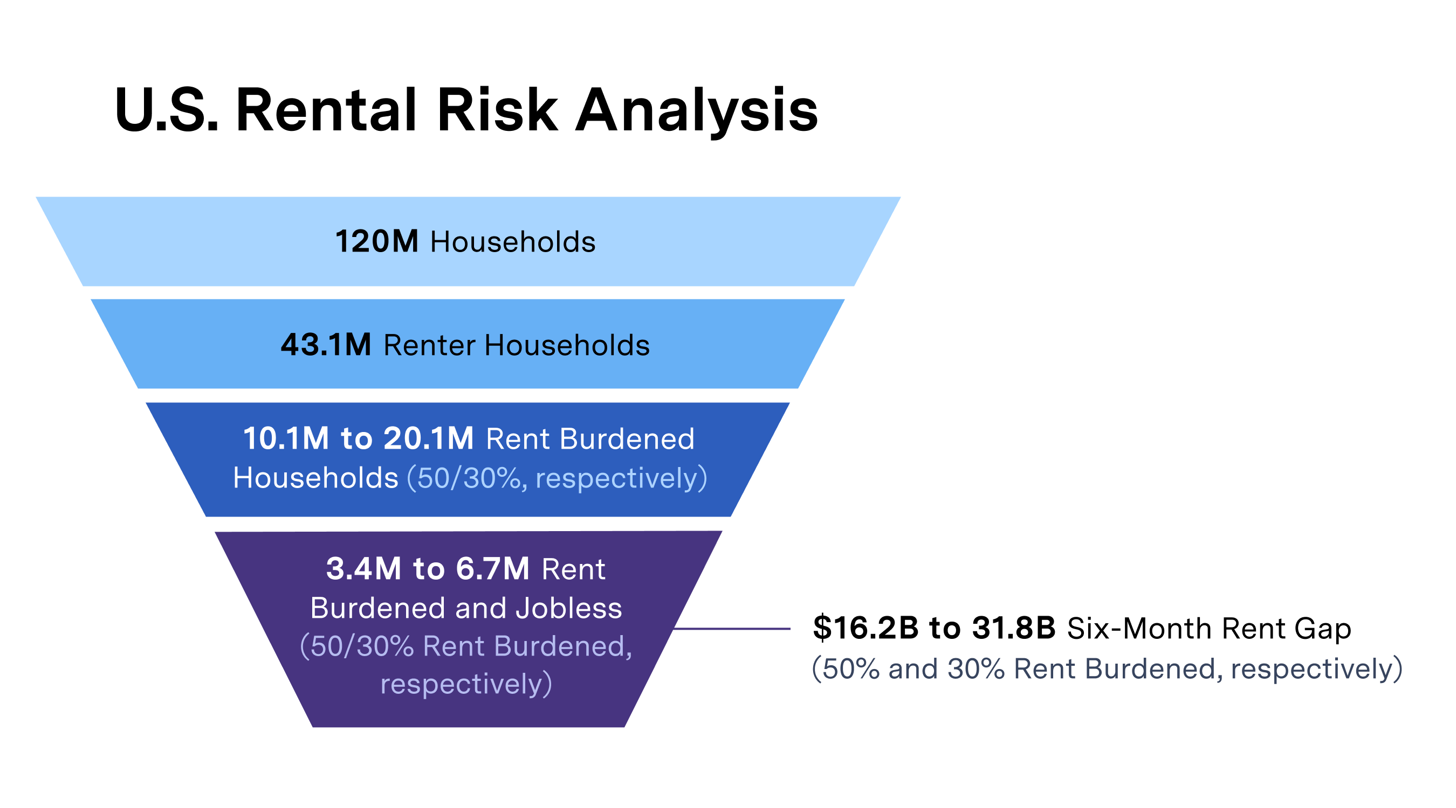
Across the United States, over 6.7 million cost-burdened households could face eviction without financial assistance. To prevent a dramatic increase in evictions, Congress must include $100 billion in emergency rental assistance to help both tenants and landlords as well as a national moratorium on evictions in the next COVID-19 response package. The mass displacement that is inevitable if Congress does not act carries the potential to destabilize communities for years to come.
Plan Follow-Up Meetings with Legislators Now
When members return to DC on July 20, they are expected to move quickly on proposing and passing the next COVID bill. Senate Majority Leader Mitch McConnell wants the bill completed by the August recess; he also says this will be the last COVID bill before the election.
That means the current recess (July 6-17) is critical to our work. While connecting with all members of Congress is important, the fight over housing will be in the Senate. It is important to focus your energy on (1) convincing Senate GOP members that we need targeted financial relief for low-income renters and (2) reminding Senate Democrats to prioritize our housing requests during negotiations. Here’s how we can act:
- Request virtual face-to-face meetings with senators to discuss our specific housing requests
- Follow-up with Senate and House housing aides on your virtual lobby meetings held during RESULTS’ Advocacy Week

RESULTS has all the resources you need to take this message to your members of Congress this month, including our housing request sheet (we also have SNAP and EITC/CTC request sheets if you lobbied on those issues recently), a sample follow-up e-mail for congressional aide (please be sure to personalize), U.S. poverty data by state, and other helpful resources on our Lobbying and Conference Resources pages. As always, RESULTS staff are available to help you prepare for meetings or find and connect with new advocates. Contact us a grassroots@results.org.
Your advocacy this year has laid the groundwork for this final push to make housing assistance a top priority in the next COVID bill. Your advocacy now could be the difference in preventing low-income Americans from falling off a housing “cliff” and deeper into poverty. Thank you for all you do.
Back Up Housing Requests with Published Media
With members of Congress at home for part of July, you have an added opportunity to influence their policy priorities through local media. What we publish now can help back up our specific asks in follow-up meetings this month. As you work on lobby meetings and follow-up from recent meetings, amplify your message with a letter to the editor urging your members of Congress by name to pass emergency rental assistance and a moratorium on evictions now.
Use the sample below to get started in your own letter to the editor:
Millions of low-income renters face the threat of eviction and homelessness unless Congress acts soon.
COVID-19 has cost more 40 million Americans their jobs. When people cannot work, they cannot pay the rent. As local eviction bans expire this summer, low-income renters will owe thousands of dollars in back rent. Without help, these renters will be forced out of their homes in the middle of pandemic.
The House has passed several bills that would enact a national moratorium on evictions and provide $100 billion to help low-income renters pay the rent. This will help millions of renters stay housed, and their landlords get paid, until the economy improves. It is time for the Senate to do the same.
Congress must act now to prevent millions from being evicted. I urge our members of Congress to push for quick passage of a COVID-19 bill that includes at least $100 billion for emergency rental assistance and a national moratorium on evictions.
Be sure to personalize the letter before sending it. Send it directly to your local paper or use our online media alert to send your letter today.

