Housing and hunger in a pandemic
In March, Congress passed a $2.2 trillion economic stimulus bill in response to the COVID-19 outbreak. The intent was to help individuals and businesses endure the dramatic economic impacts of the virus. Because of the hard work of RESULTS volunteers and housing advocates across the country, it included $12 billion to help those experiencing housing instability and homelessness.
However, much more needs to be done. For millions of low-income Americans now out of work, April 1 means the rent is due. And they can’t pay it. As Congress looks to do “Phase 4” COVID-19 legislation, we must ensure that low-income renters are helped. This includes allocating at least $100 billion in federal money for emergency rental assistance and enacting a national moratorium on evictions until the crisis passes. Looking longer term, we are still building momentum for Congress to create a refundable “renters’ tax credit” for low-income renters so renters can receive a federal tax refund to help cover rent that has become no longer affordable (above 30 percent of household income). A renters’ credit – paired with measures to increase the supply of affordable housing and reduce evictions – would help ensure more families have a safe, affordable place to live in good times and bad.
We must also push Congress to invest in food assistance in upcoming legislation. With millions out of work and no money coming in, the Supplemental Nutrition Assistance Program (SNAP) is critical in staving off increased hunger and poverty during this crisis – and for supporting local economies and workers. Specifically, Congress should increase SNAP’s maximum benefit by 15 percent until the economic crisis passes.
Take your message to legislators now
Congress will be on recess for at least the month of April, but policymakers are already formulating plans for a Phase 4 COVID-19 bill that they expect to move on this spring. Your “virtual” lobby meetings in April with members of Congress and their staff could be the difference in whether low-income families are able to put a roof over their head and food on the table.
With social distancing and stay-at-home orders in place in many communities, expect to do any lobby meetings this month virtually. See the RESULTS Events Calendar (https://results.org/events/) for trainings on doing virtual meetings and listen to the recordings at: https://results.org/volunteers/training-webinars/). To prepare for lobby meetings, visit Lobbying page at: https://results.org/volunteers/lobbying/ and contact RESULTS staff (grassroots@results.org)
Finally, please invite new people to your lobby meetings (including your planning for them). Many of us are staying home to prevent the virus from spreading and are looking for ways to contribute. In fact, people are contacting RESULTS about how to get involved. Reach out to people you know and invite them to use this time to take action with you to help those in our communities who will suffer greatly without it. RESULTS staff are here to help you find and connect with these new advocates.
Back up lobby requests with published media
With members of Congress at home this month, you have an added opportunity to influence their decision-making on what issues to prioritize when they return to Washington. In this new reality, members of Congress are cut off from many of the usual ways they hear from constituents. That makes their local paper even more important to knowing what matters to voters.
What we publish now can help back up your specific asks of Congress in meetings this month. By getting media published now, you will be making a difference and set the stage for what happens on Capitol Hill.
Meeting directly with members of Congress, working with congressional staff, making calls, sending emails, and mobilizing others – all of it will be needed this year to shape the pandemic response. And all of it will be stronger with your media backing things up.
Letter to the editor: Act on housing and hunger
Use the sample below to get started in your own letter to the editor:
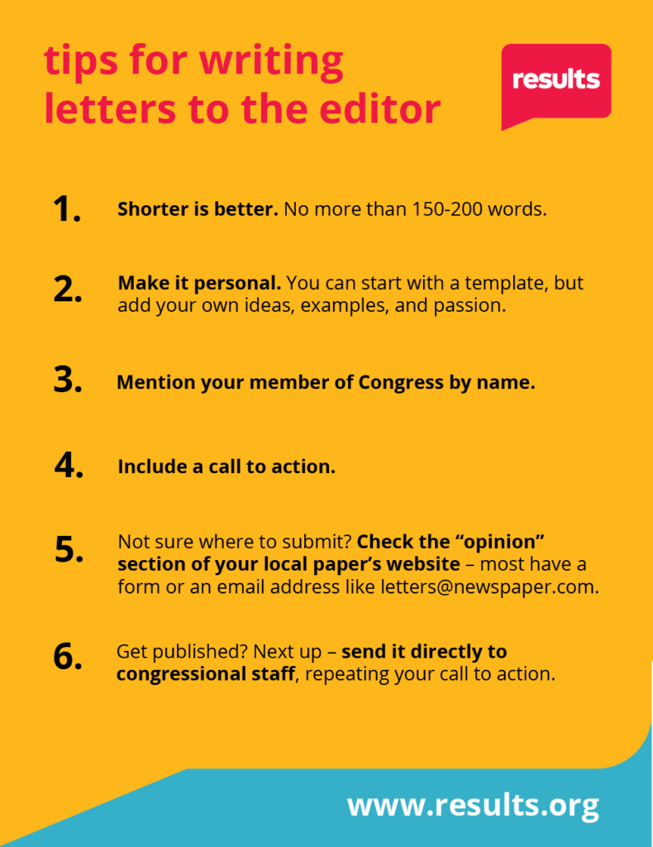
The economic fallout of COVID-19 is huge. Millions of low-wage workers are out of work, can’t pay the rent, or put food on the table. Without help, they could quickly face hunger, eviction, and even homelessness.
I am grateful Congress has passed emergency legislation to help people suffering in this crisis. However, more action is needed. In the next coronavirus response bill, Congress must prioritize housing and hunger by providing no less than $100 billion for emergency rental assistance, passing a national moratorium on evictions, and increasing the maximum SNAP (formerly Food Stamps) benefit by 15 percent.
Looking ahead, Congress should also create a refundable "renters' tax credit" to help low-income Americans pay the rent. With additional resources, they will be better able to weather economic shocks when they come.
I urge our members of Congress to promptly pass measures to help struggling workers and families secure stable housing and keep their families fed during this economic crisis and beyond.

