Use Actions to Engage Advocates on Housing
April brings two important opportunities for you to engage new advocates in RESULTS. First, NY Times columnist Nicholas Kristof will be our guest on the April 4 RESULTS National Webinar (1:00 pm ET). RESULTS is privileged to have this Pulitzer Prize winning journalist speak with us about COVID-19 and its impact on economically marginalized population in the U.S. and around the world.
The second opportunity is lobby meetings during the April congressional recess (April 6-17) to ensure people who are housing-insecure get assistance in this crisis and beyond. Lobby meetings are an excellent way to get someone “hooked on advocacy” with RESULTS. Invite people to join the April 4 webinar online, to attend a local virtual planning meeting afterward to plan your lobby meetings, and then to participate in a virtual lobby meeting with your congressional office in April.
Use this EPIC laser talk as a template for your personal invitation to engage new people in RESULTS.
Engage: I’ve really appreciated learning about your passion for making a difference.
Problem: You now have your chance. With the COVID-19 outbreak, it is critical that advocates tell lawmakers that housing must be a foundational component of our collective response to the virus.
Inform: On April 4, RESULTS hosting our National Webinar with Nicholas Kristof, columnist for the NY Times . Kristof is a fan of RESULTS and has a deep concern for people experiencing poverty. He will speak about the impact of COVID-19 on people experiencing poverty and the importance of grassroots advocacy in this crisis and beyond. Our local RESULTS group normally does these webinars together but with the virus outbreak, we are urging people to join online. After the webinar, our group will do a virtual planning meeting for an upcoming virtual lobby meeting with Representative/Senator _________________’s office to talk about housing.
Call to Action: Would you like to join the Nick Kristof webinar on April 4 at 1 pm ET, take part in our lobby planning, and then join the virtual lobby meeting on _______________(date)?
Tips for personalizing your laser talk.
- Know your audience. Think about the person you are inviting. What about that person makes him/her a good person to invite? Have they taken action? Are they searching for a way to make a difference? Are they passionate about poverty? Incorporate what you know about that person into your Engage statement.
- Share your story. What moved you to get involved with RESULTS? How has your perception of your own personal power changed since getting involved with RESULTS? Share your transformative story as part of your Problem or Inform statement.
- Ask questions. While the Call to Action above is your goal, you don’t have to go there immediately. Get to know the person by asking questions. What do they care about? What would making a difference look like to them? See if there is a way to connect their personal goal to the work of your local RESULTS group, then invite them to the webinar and meetings.
Prioritize Housing in Virus Response
America has been in an affordable housing crisis. Now with COVD-19, that crisis is magnified exponentially. Housing is health care. If people have no place to live or are forced out of their homes due to a loss of income, they are significantly more vulnerable to infection and death. We must look forward by helping American renters secure stable housing over the long term so that when the next crisis comes, we will all be ready.
To supplement lobby meetings in April, write letters to your members of Congress saying that any COVID-19 response must include significant investments to help people secure stable housing.
- Start with “Dear Sen./Rep. ____________”. Tell your name and that you’re a constituent and RESULTS volunteer who believes Congress must take action to help low-income Americans impacted by the COVID-19 outbreak.
- Tell them the economic fallout of the COVID-19 coronavirus is just beginning. Americans who were already struggling to put a roof over the heads are now at even greater risk.
- Housing is health care and our communities are safest when everyone has a place to live. Passing emergency funds to help people experiencing homelessness and those facing eviction must therefore be part of any response plan.
- We must also look ahead. Creating a refundable "renters' tax credit" for low-income renters will help provide them the financial security to be prepared for the next crisis when it comes.
- Urge your members of Congress to quickly pass the emergency and longer-term housing measures needed to help struggling workers and families struggling with homelessness and housing instability during the COVID-19 crisis and beyond.
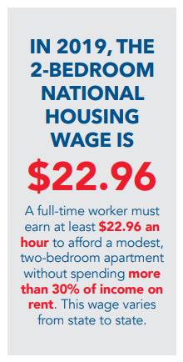
Scan your letter into an e-mail to the housing aide or mail it to the office closest to you.
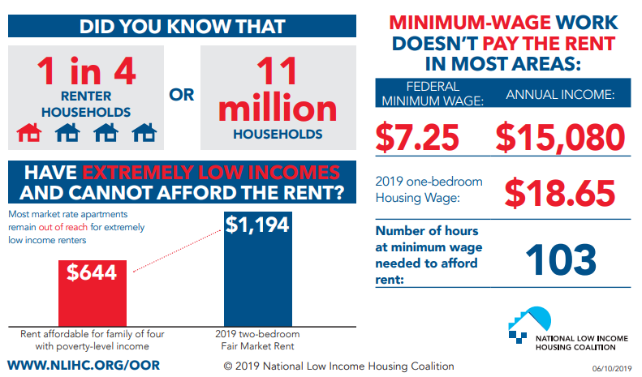
Graphs source: https://reports.nlihc.org/sites/default/files/oor/OOR_2019_Factsheet.pdf

