Discuss the Renters’ Credit with Lawmakers
Take time this month to move our affordable housing campaign forward. Use page one of this action to schedule and plan lobby meetings in February to talk about the renters’ tax credit. Use page two to write letters on the renters’ credit; be sure to invite others to write letters with you.
Why is housing important to you?
Reflect on current and past housing situations in your life. If you have experienced stable and/or unstable housing situations, how has that impacted your life? How do these experiences inform your advocacy on housing? Share your thoughts with members of your group.
Who will schedule your face-to-face meetings and follow up with schedulers?
Congress will be on recess February 17-21, 2020. Request in-person meetings with your representative and both senators to discuss the renters’ credit (meet with aides if you cannot get a face-to-face meeting soon). Use our downloadable meeting request or online template to request meetings during the February recess. Be sure to personalize the request to fit your members of Congress, your group, and the issues you will discuss.
How will you prepare for your meetings?
Review our housing laser talks and housing policy request for talking points and background on the renters’ credit (take a copy of the policy request to leave with them). Research data on your state’s lack of housing and what it costs. When you get a meeting scheduled, contact Meredith Dodson (mdodson@results.org) or Jos Linn (jlinn@results.org) to set up a call to help your prepare.
How will you get lawmakers on the record supporting a renters’ tax credit?
Building support for the renters’ credit starts with education. Meeting with members of Congress this month is your opportunity to introduce them to the renters’ credit, educate them on the need for one, and ask for their support.
“Would you stand up for low-income renters by making a public gesture of support for a renters’ tax credit? For example,…”
The next step is securing their commitment to a renters’ credit. That starts with asking for a public gesture in support of the idea. That could include co-sponsoring one of the current renters’ credit bills in Congress (H.R. 2169/S. 1106 and H.R. 4808/S. 2684), making a speech on the House/Senate floor supporting a renters’ tax credit, publishing an op-ed in support of the idea, making a statement to the media or on their social media platforms in support of the idea.
Note that it may take more than one conversation to secure this support. Ask what information you can provide to help secure their support. Follow up with staff providing research and information in support of the renters’ credit. Keep asking them to take a public stance on the issue until they do it. If you need coaching or other help, please contact RESULTS staff.

Housing for All: Support a Renters’ Tax Credit
The U.S. tax code can be a powerful tool in alleviating poverty. However, there are few housing provisions in the tax code that benefit low-income renters. We could help renters by enacting a renters’ tax credit. This credit would provide a refundable federal tax credit for rental costs above 30 percent of household income (what HUD defines as “affordable”), up to 100% of the area’s Fair Market Rent. By providing renters relief from growing rental costs and, paired with measures to increase the supply of affordable housing, more families could find safe, affordable places to live. Use these talking points or our online template to write letters to Congress about a renters’ credit:
- Start with “Dear Sen./Rep. ____________”. Tell your name and that you’re a constituent and RESULTS volunteer who believes Congress needs to do more to help low-income renters.
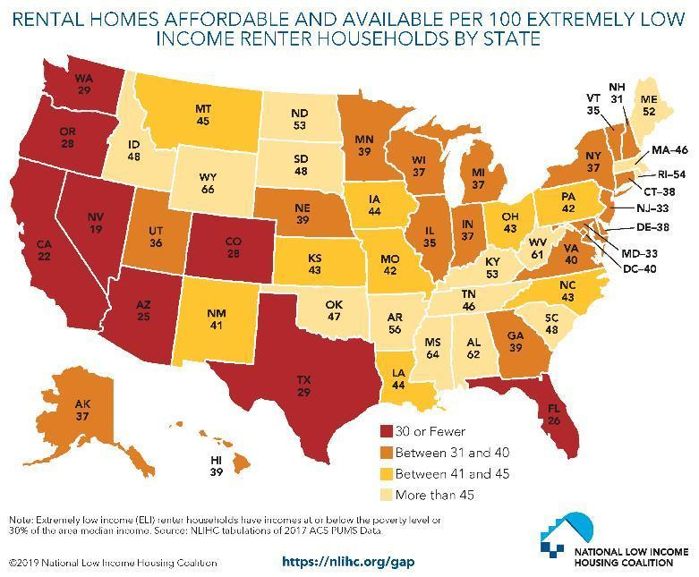
- Tell them America is in a housing crisis. Millions of low-income working families struggle every day just to put a roof over their heads.
- State that, according to Harvard researchers, rents have risen by 61 percent since 1960 but renters' median earnings have gone up 5 percent. Right now, only 37 affordable and available rental homes exist for every 100 extremely low-income renter households (use your state’s number from the graph).
- Explain that we can increasing housing affordability by supporting a "renters’ tax credit" for low- and moderate-income renters. Households would receive a refundable tax credit for rental costs above 30 percent of their household income up to the local fair market rent.
- Urge your members of Congress to speak out publicly in support a refundable renters’ tax credit and urge congressional leadership, including House Ways and Means Committee Leaders Richard Neal and Ranking Member Kevin Brady or Senate (Finance Committee Leaders Chuck Grassley and Ranking Member Ron Wyden, to prioritize renters' credit in any tax legislation.
Once completed, hand-deliver your letters in an upcoming lobby meeting, scan the letter into an e-mail to the housing aide, or mail it to the local office closest to you. Find contact info at: www.results.org/volunteers/action-center/legislator-lookup/.

