2019 RESULTS US Poverty Racial Wealth Inequality Conference Briefing Packet
Section 2: The Creation of Wealth Inequality

Legacies of Wealth Creation
——————————————————————————————————————————
How Did We Get Here? The History Behind Housing Segregation and Racial Wealth Inequality
Researchers (and previous RESULTS conference speakers) Emmanuel Nieves and Dedrick Asante-Muhammad point to the role of federal policies as the historical drivers of racial wealth inequality, arguing that, “the racial wealth divide is the natural byproduct of an endless series of policy choices that have boosted the ability of White Americans to build long-term wealth, while blocking communities of color from doing the same.” Figure 1 depicts some of the major policies dating back to the Civil War era that laid the structural foundation for the racial wealth disparities present today.

Figure 1

New Deal Era Housing Policy
The racial wealth gap of today has its roots in centuries of economic exploitation on the part of wealthy, White colonists. Beginning with the forced removal of Native Americans from their land and then the enslavement of African Americans to work the land for cash crops, the foundation of wealth inequality between Whites and people of color was built before the nation's founding. Nearly a century of Jim Crow segregation maintained the use of legislation and violence to perpetuate inequality.& During this time, federal housing policies of the 1930s New Deal Era profoundly impacted disparities in wealth building opportunities through homeownership and thus economic mobility for White Americans in the 20th century. Concurrently, these policies effectively enabled racial housing segregation through discriminatory practices in homeownership financing under the Federal Housing Administration (FHA) and Department of Veterans Affairs.
Even though racial segregation in housing was outlawed in a 1948 Supreme Court case, the federal government still allowed localities across the country to prevent racial minorities from moving into White neighborhoods. Practices such as blockbusting, redlining, and racialized zoning laws& created deep segregation and blocked households of color from owning their homes and receiving adequate public investment in their neighborhoods. At the same time, many White Americans could buy homes in high opportunity suburbs with support from the federal government in the form of low interest FHA loans. Other policies, like highway projects and disinvestment in public transit in urban centers, disproportionately harmed (and often broke up) communities of color for the benefit of White suburban communities.& These segregationist policies have had decades-long consequences.
The Fair Housing Act of 1968 officially ended discriminatory housing practices. This Act prohibited discrimination in the sale, rental, and financing of dwellings based on race, color, religion, sex, or national origin. It allowed the Department of Housing and Urban Development (HUD) to play an expanded role in requiring local communities across the country to obey the law. This was a significant victory in helping protect people of color from housing discrimination. Although the Fair Housing Act and other civil rights initiatives formally banned racial discrimination in housing, the new policies did not reverse the already existing racial wealth gap – and in fact, segregation and racial wealth inequality have increased rather than decreased at times during our recent history.,,&
The legacy of segregation and systemic racism continues today. One example of this is the differences in home values across neighborhoods. In 2018, researchers at the Brookings Institution found that in majority Black neighborhoods (where 50 percent or more of the population is Black) homes of similar condition were being undervalued by 23 percent when compared to homes in similar quality neighborhoods with virtually no Black residents. This amounts to a devaluation of $48,000 per home or $156 billion in cumulative losses for those Black residents. These findings illustrate the cost of racial bias in housing, regardless of income.
Another way contemporary segregation has manifested itself is through the concentration of poverty. According to the Economic Policy Institute:
- Seven percent of poor Whites lived in high poverty neighborhoods (more than 40 percent of the residents are poor) in 2011, up from four percent in 2000.
- 15 percent of poor Latinos lived in high poverty neighborhoods in 2011, up from 14 percent in 2000
- 23 percent of poor African Americans lived in high poverty neighborhoods in 2011, up from 19 percent in 2000.
Living in neighborhoods with concentrated poverty has shown to reduce home values in those areas. For families in these neighborhoods that can afford to own their home, this means that little wealth can be accrued because of the low home values.& Long-term, this impacts homeowners ability to sell their home at a higher value or leverage homeownership to invest in other wealth building strategies.
The Racial Equity Impact of Policies in Employment, Education and Mass Incarceration
Along with housing segregation, employment discrimination, educational inequities, and the criminal justice system have all contributed to the racial wealth inequities in the US, particularly between Black and White Americans. When first enacted, the Social Security Act of 1935 excluded certain domestic workers and farmers from participating in the program. Because these professions were primarily employed by African Americans, this exclusion had the effect of excluding 65 percent of African American workers from Social Security. The law was not changed to include these workers until 1954, almost two decades later. Similarly, the Fair Labors Standards Act of 1938 which established the forty-hour work week and the federal minimum wage excluded many tip-based professions such as servers and shoe shiners which were predominantly held by African American workers.³⁰
The G.I. bill signified an important time in which the federal government invested in providing affordable education and housing to World War II veterans and their families. This bill is largely credited for the creation of the American middle class. However, because of Jim Crow and other racist policies, veterans of color were not afforded the same opportunity. If an African American or Native American veteran lived in an area in which Jim Crow was prevalent, then the local Veterans’ Administration could deny their benefits or relegate them to lower quality and segregated housing options. In the times in which White families were provided important opportunities for mobility and wealth accumulation, families of color were intentionally, and sometimes violently, excluded from these important federal policies.
Mass incarceration has also contributed to racial wealth inequality through the undermining of families and communities of color. The ‘War on Drugs’ policies, implemented and enforced since the 1970s, created harsher sentences for drug offenses that resulted in a disproportionate share of African American men being incarcerated. The effects of incarceration pose significant barriers to building income and wealth both in the short and long term. Because African Americans are 10 times more likely than Whites to be incarcerated for similar drug offenses, African American families are more at risk of living in poverty when a family member or breadwinner is incarcerated.
More recently, the Great Recession negatively impacted the wealth of millions of families living in the U.S. however, the impact has been particularly hard on families of color. As Dr. Ray said in a recent panel on racial wealth inequality, “when America catches a cold, Black communities catch the flu.” White folks have had a huge head start in generating wealth throughout our nation’s history, while most people of color were only given meaningful opportunities to build wealth 1-2 generations ago. Homeownership represents a larger share of assets for people of color, making them most vulnerable to the downturn in home values from the Great Recession. Additionally, predominately Black neighborhoods were more apt to lose value in their homes. Because of this, many households of color have yet to experience full recovery from the 2008 housing crisis.& Without the comparable wealth that was intentionally denied to them for so long, families of color are much more vulnerable to financial emergencies and have less opportunity to move up the economic ladder.
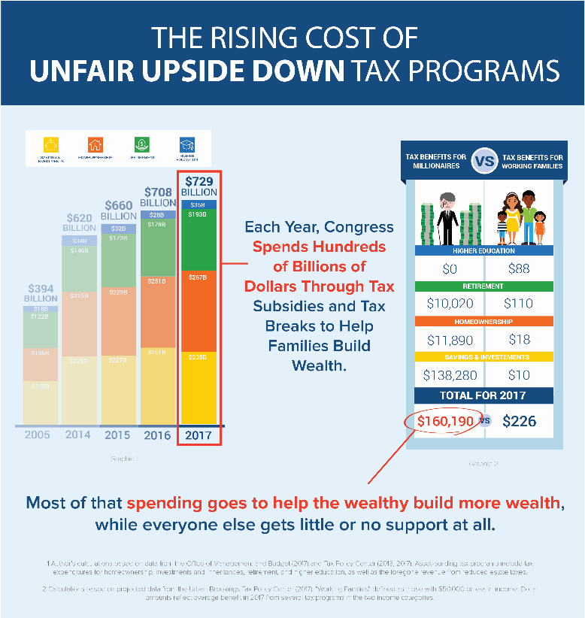
How Tax Policy Exacerbates Racial Wealth Inequality
Wealth inequality and the racial divide are pervasive injustices in this country that has lasted for too long. It is important that we understand how poverty rates and wealth inequality disproportionately affect specific communities – and, if possible, lay the groundwork for policy work to close the racial wealth divide. Tax fairness is not only important in lifting up all families but is particularly critical in supporting families of color to move up the socio-economic ladder. Prior to the passage of major federal tax cuts in 2017, the U.S. tax code already included over half a trillion dollars in tax benefits (see Figure 2) that incentivize households to save and invest. However, lower-income households and households of color are largely excluded from these benefits. As was stated in the first brief, Why is Wealth So Important, the Mortgage Interest Deduction (MID) allows existing homeowners to deduct the interest on their mortgage and other home-related costs, providing tax benefits largely to wealthy, White households. Less than half of African American households own homes and are thus less likely to take advantage of homeownership tax subsidies. Prior to passage of the TCJA, African Americans and Hispanics each made up 13 percent of the nation’s households, while they received six and seven percent respectively of the tax benefits from the mortgage interest deduction. Consequently, the MID serves as one of many examples in which the tax code is structured in an ‘upside-down’ manner where those who have the least to gain benefit the most, while those with the least gain much less.
Figure 2³³

How Wealth is Created Today
——————————————————————————————————————————
The 2017 Tax Cuts and Jobs Act
When done right, tax policy can empower all Americans to save, invest, and build wealth. Unfortunately, the Tax Cuts and Jobs Act (TCJA) passed by Congress in 2017 further exacerbated racial wealth inequality, perpetuated an inequitable, “upside-down” tax code, while also putting investments in anti-poverty policies at risk.,&
The TCJA included the largest one-time reduction in the corporate income tax rate in U.S. history, from 35 percent down to 21 percent. Yet, research from the Congressional Research Service (CRS) found that companies, on average, had a lower than estimated average tax rate of 12.1 percent. While corporations saw massive windfalls from the TCJA, most taxpayers gained little. The CRS noted that individual income taxes fell from 9.6 to 9.2 percent, sharply contrasting the more than 20-point fall of corporate tax rates. As illustrated in Figure 3, most of the individual tax breaks went to the wealthy with incomes over $500,000. The tax code did also limit deductions to $10,000 in state and local property taxes (SALT). SALT deductions allow taxpayers to deduct state and local real estate and personal property taxes, as well as either income taxes or sales tax from their federal income taxes. SALT taxes have historically benefited higher-income households but the TCJA provision limited these deductions, making it a more progressive tax policy change.
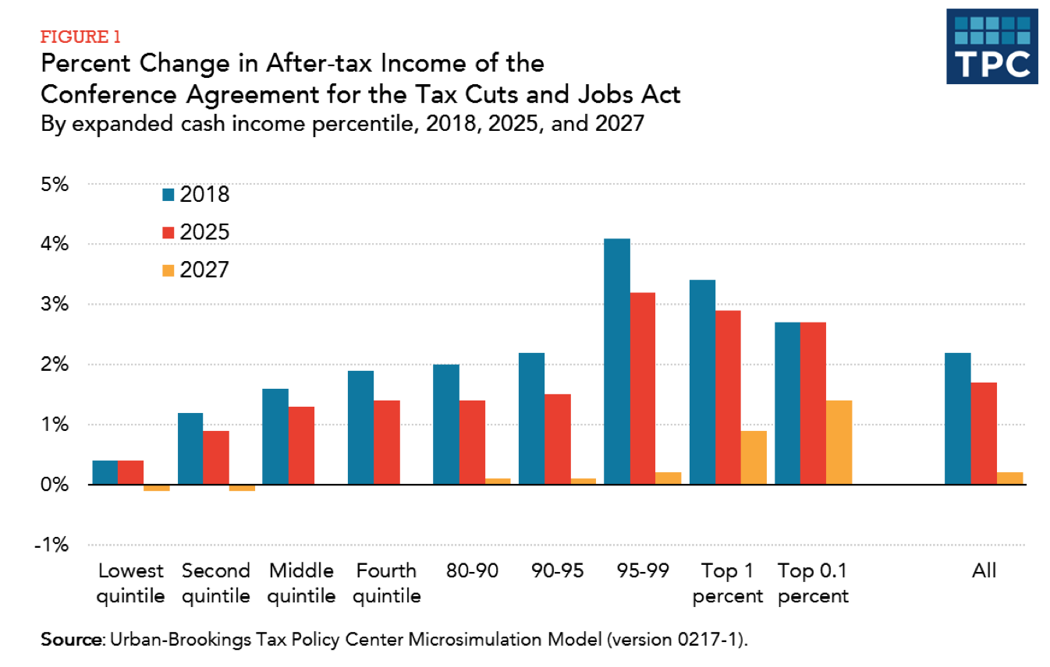
Figure 3⁴⁴

In addition, the individual health insurance mandate under the Affordable Care Act was eliminated this year, potentially forcing health insurance premium increases for millions of Americans. The bill will include short term tax savings for most Americans, but those savings will be eliminated by 2026 as most of the individual tax provisions expire. Currently, only the corporate tax cuts are made permanent.

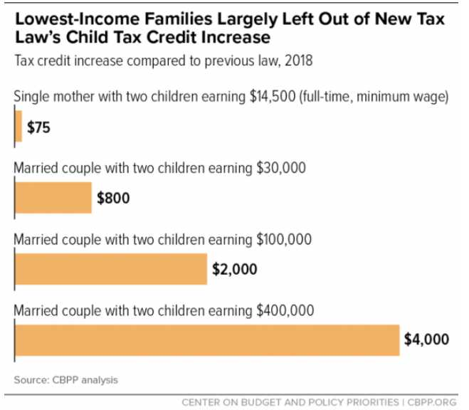
For many years, RESULTS has advocated for increases to the Earned Income Tax Credit (EITC) and Child Tax Credit (CTC), whose benefits are targeted to low-income households. In the TCJA, the Child Tax Credit was increased but the benefits largely go to high-income households (See Figure 4). The credit was doubled to $2,000 per child, but only wealthier families will be able to receive the full benefit. Low-income families can at most get $1,400 per child back as a refund compared to a family earning $400,000, who will get to deduct the full $2,000 credit per child off their taxes. Meanwhile, the TCJA took away eligibility for the CTC for 1 million children in immigrant families and erodes the EITC’s value for low-income families over time.
Figure 4⁴⁵
Finally, estate tax exemptions were doubled, allowing individuals who inherit estates worth up to $11 million to pay no taxes on that inheritance. This change expires in 2025 and is projected to decrease revenue by over $5 billion just in its first year, while benefitting less than 2,000 Americans.& Prior to drastic tax cuts since 2001, the estate tax has generated as much as $24.6 billion in revenue, annually. And, many businesses organized as "pass through" companies will get a 20 percent reduction in their tax rate.

Who it Affects and Who Benefits?
The working and middle class will be affected the most negatively by the tax law – the loss of trillions in revenue means less resources to invest in health care, food assistance, education, and more – and already some policymakers are calling for cuts to anti-poverty programs to deal with the increased deficit. The tax law will benefit wealthy individuals and small businesses (see figure 3 and 5). Forty-three percent of the tax benefits would go to Americans with incomes in the top 5 percent — above $290,000 — while only 19 percent of the benefits would go to Americans with incomes in the bottom 60 percent, or those making less than $81,000. The new law favors people with the highest incomes and has opened vast new opportunities for well-heeled taxpayers to game the system.
How Costly is the TCJA?
Since the TCJA went into effect in 2018 it allowed tax filers to see some of the law’s changes in action. The final bill is estimated to cost $1.46 trillion. Researchers estimate that the US will go into debt in the amount of approximately $1.5 trillion because of the TCJA. Some lawmakers are looking to pay for this debt by cutting essential programs like Medicaid, the Supplemental Nutrition Assistance Program (SNAP), the Child Tax Credit after passing tax legislation that hurt families with low-incomes while providing a boon to the wealthiest.
The TCJA and Racial Wealth Inequality
A 2018 report from Prosperity Now and the Institute for Taxation and Economic Policy lays out how the 2017 tax law will negatively impact racial wealth disparities:
- Eighty percent ($218 billion) of the total $275 billion in tax cuts will go to White households, even though they make up 67 percent of taxpayers.
- The law primarily benefits those who already have wealth rather than creating incentives to build new wealth. Households of color with high incomes still do not see a reward equivalent to their White counterparts because they are less likely than White households to have a majority of their incomes from corporate stocks and investments (Figure 6).
- The richest 1 percent of households (making $1.8 million per year) will receive an average tax cut of about $47,000 while those with the lowest incomes (making $13,000 per year) will receive, on average, $90. Per day, the wealthiest individuals get a larger tax cuts than the poorest.
- In every category White households will receive a larger tax benefit from the TCJA than Black and Latino families. However, Asian households earning less than $23,000 will receive the smallest benefits of any other group within the same earning category, netting just $70 per year in tax benefit.
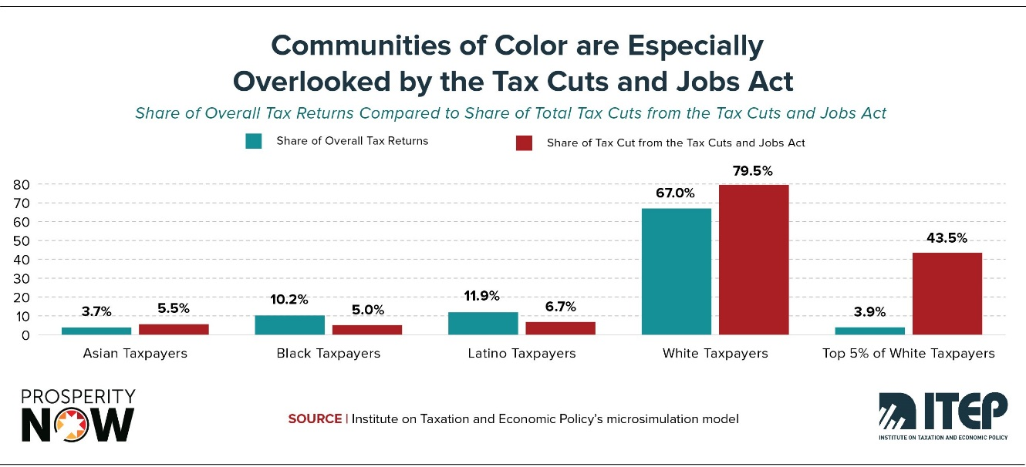
Figure 5
The 2017 tax law poses a significant threat to reducing wealth inequality and undermines the movement to end poverty and reduce racial wealth inequality in the U.S. If we are serious about closing the racial wealth divide, creating tax policy that steers toward opportunity and equity for all Americans is necessary to address these gaping inequalities.
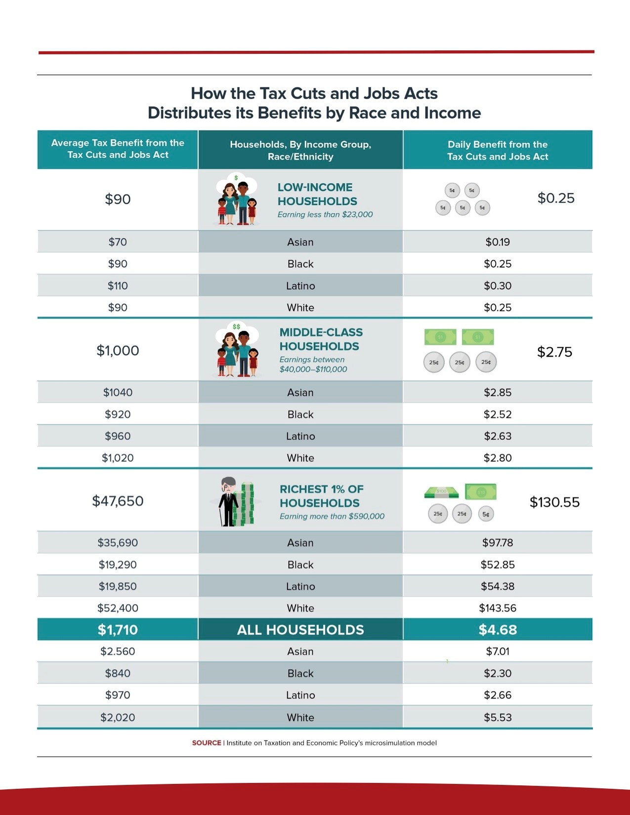
Figure 6
Knowledge Check
Can you name two policies that enabled White Americans to build wealth that largely excluded people of color?
A: Any of these policies provided the support that allowed White families to amass wealth: Land Reversals and Land Seizures, National Housing Act, Fair Housing Administration creation, Social Security Act, Fair Labor Standards Act, G.I. Bill, Urban Renewal Projects, Subprime Mortgage Loan Lending, and the War on Drugs.
True or false the Social Security Act of 1935 applied to all workers in the U.S.?
A: No, this act excluded certain domestic workers and farmers from participating in the program. African Americans mainly held these jobs, which caused the exclusion of 65 percent of African American workers from Social Security. The law was not changed to include these workers until 1954, almost two decades later.
How did the 2017 Tax Code and Jobs Act benefit corporate interests over low- and middle-income families?
The 2017 legislation officially lowered corporate tax rates from 35 to 21 percent. However, corporations reported even steeper reductions, paying an average 12 percent tax rate. On the other hand, individuals only saw a .4 percent tax rate reduction overall. Finally, revisions to the Child Tax Credit benefited families with the highest incomes over those with lower incomes.
What are the effects of the 2017 tax reform on the racial wealth divide?
Since families of color are less likely to hold mass amounts of wealth, changes to the estate tax, corporate tax, and “pass through” business deductions mostly went to White households. Additionally, the projected decreases in revenue from the tax changes will likely decrease the labor force in the public sector, of which African Americans make up a large share putting their employment and communities at risk.

Nieves, E., and Asante-Muhammad, D., “Running in Place: Why the Racial Wealth Divide Keeps Black and Latino Families from Achieving Economic Security.” https://prosperitynow.org/files/resources/Running_in_Place_FINAL_3.2018.pdf. 2018.
Created by Funke Aderonmu, adapted from: Bread for the World Institute, “Racial Wealth Simulation Policy Packet.” http://files.bread.org/institute/simulation/Racial-Wealth-Gap-Policy-Packet.pdf?_ga=2.159261306.1788427538.1530137179-966109393.1526321415. And, “Renewing Inequality: Urban Renewal, Family Displacements and Race 1955-1966.” https://dsl.richmond.edu/panorama/renewal/#view=0/0/1&viz=cartogram. And, Rothstein, Richard, The Color of Law: A Forgotten History of How Our Government Segregated America. https://www.npr.org/books/titles/526656129/the-color-of-law-a-forgotten-history-of-how-our-government-segregated-america
PBS, “Jim Crow Laws.” https://www.pbs.org/wgbh/americanexperience/features/freedom-riders-jim-crow-laws/.
History, “Jim Crow Laws.” https://www.history.com/topics/early-20th-century-us/jim-crow-laws. 2019.
Rothstein, Richard, The Color of Law: A Forgotten History of How Our Government Segregated America. https://www.npr.org/books/titles/526656129/the-color-of-law-a-forgotten-history-of-how-our-government-segregated-america
Justia, “Shelley v. Kraemer” https://supreme.justia.com/cases/federal/us/334/1/case.html
Encyclopedia of Chicago, “Blockbusting” http://www.encyclopedia.chicagohistory.org/pages/147.html
BlackPast.org, “Redlining (1937-).” http://www.blackpast.org/aah/redlining-1937
Washington Post, “‘Snob Zoning’ is Racial Housing Segregation by Another Name.” https://www.washingtonpost.com/news/wonk/wp/2017/09/25/snob-zoning-is-racial-housing-segregation-by-another-name/?utm_term=.6fd380a45e62. 2017.
Investopedia, “Zoning” http://www.investopedia.com/terms/z/zoning.asp
NPR, “A ‘Forgotten History’ of How the US Government Segregated America.” https://www.npr.org/2017/05/03/526655831/a-forgotten-history-of-how-the-u-s-government-segregated-america
NPR, “A ‘Forgotten History’ of How the US Government Segregated America.” https://www.npr.org/2017/05/03/526655831/a-forgotten-history-of-how-the-u-s-government-segregated-america
Miller, Johnny, “Roads to nowhere: how infrastructure built on American inequality.” https://www.theguardian.com/cities/2018/feb/21/roads-nowhere-infrastructure-american-inequality. 2018.
Semuels, Alana, “The Role of Highways in American Poverty.” https://www.theatlantic.com/business/archive/2016/03/role-of-highways-in-american-poverty/474282/. 2016.
U.S. Department of Housing and Urban Development, “The Fair Housing Act” https://portal.hud.gov/hudportal/HUD?src=/program_offices/fair_housing_equal_opp/progdesc/title8
Inequality.org, “Wealth Inequality in the United States.” https://inequality.org/facts/wealth-inequality/.
Reardon, S., Bischoff, K., “Growth in the Residential Segregation of Families by Income, 1970-2009.” https://s4.ad.brown.edu/Projects/Diversity/Data/Report/report111111.pdf. 2011.
Chang, A., “The data proves that school segregation is getting worse.” https://www.vox.com/2018/3/5/17080218/school-segregation-getting-worse-data. 2018.
Litchter, D., Parisi, D., Taquino, M., “Toward a New Macro-Segregation? Decomposing Segregation within and between Metropolitan Cities and Suburbs.” https://journals.sagepub.com/doi/full/10.1177/0003122415588558. 2015.
Brookings Institution, “The Devaluation of Assets in Black Neighborhoods.” https://www.brookings.edu/research/devaluation-of-assets-in-black-neighborhoods/. 2018.
Economic Policy Institute, “Modern Segregation” https://www.epi.org/publication/modern-segregation/
Retsinas, N., Belsky, E., Revisiting Rental Housing: Policies, Programs, and Priorities. http://link.library.mst.edu/portal/Revisiting-rental-housing--policies-programs/cCQC5nEQLHA/.
U.S. Department of Housing and Urban Development, “Understanding Neighborhood Effects of Concentrated Poverty.” https://www.huduser.gov/portal/periodicals/em/winter11/highlight2.html.
Prosperity Now, “The Ever-Growing Gap: Without Change African American and Latino Families Won’t Match White Wealth for Centuries.” https://prosperitynow.org/files/resources/The_Ever_Growing_Gap-CFED_IPS-Final.pdf
History.com, “The G.I. Bill.” https://www.history.com/topics/world-war-ii/gi-bill
Thirteen.org, “The Rise and Fall of Jim Crow.” https://www.thirteen.org/wnet/jimcrow/
Bread for the World Institute, “Racial Wealth Gap Learning Simulation Policy Packet.” http://files.bread.org/institute/simulation/Racial-Wealth-Gap-Policy-Packet.pdf?_ga=2.69274064.1789669477.1529015002-1546765189.1521134376
Kochhar, R. and Fry, R., “Wealth Inequality Has Widened Along Racial, Ethnic Lines Since End of Great Recession.” http://www.pewresearch.org/fact-tank/2014/12/12/racial-wealth-gaps-great-recession/
Brookings Institution, “Racial Wealth Inequality: Social Problems and Solutions.” https://www.brookings.edu/events/racial-wealth-inequality-social-problems-and-solutions/. 2019.
Mellnik, T., Camerson, D., Lu, D., Badger, E., Downs, K., “American’s Great Housing Divide: Are You a Winner or Loser?” Washington Post. https://www.washingtonpost.com/graphics/business/wonk/housing/overview/. 2016.
The Federal Reserve Bank of St. Louis, The Demographics of Wealth 2018 Series: How Education, Race and Birth Year Shape Financial Outcomes. “A Lost Generation? Long-Lasting Wealth Impacts of the Great Recession on Young Families.” https://www.stlouisfed.org/~/media/files/pdfs/hfs/essays/hfs_essay_2_2018.pdf?la=en. 2018.
Schwartz, N., “The Recovery Threw the Middle Class Dream Under a Benz.” https://www.nytimes.com/2018/09/12/business/middle-class-financial-crisis.html. 2018.
Prosperity Now, “Wealth Building for the Wealthy through the Tax Code Continues as Families of Color Fall Farther Behind.” https://prosperitynow.org/blog/wealth-building-wealthy-through-tax-code-continues-families-color-fall-further-behind
RESULTS, “2019 International Conference Resources.” https://results.org/resources/2019-international-conference-resources/.
Investopedia, “Mortgage Interest Deduction.” https://www.investopedia.com/terms/home-mortgage-interest.asp
Institute on Assets and Social Policy, National Low-Income Housing Coalition: “Misdirected Investments: How the Mortgage Interest Deduction Drives Inequality and the Racial Wealth Gap.” https://iasp.brandeis.edu/pdfs/2017/NLIHC-IASP_MID-Report.pdf
Greer, Jeremie, “How the US Tax Code Drives Inequality and What We Can Do to Fix It.” https://iasp.brandeis.edu/pdfs/2017/NLIHC-IASP_MID-Report.pdf
Congressional Research Service, “The Economic Effects of the 2017 Revision: Preliminary Observations.” https://www.everycrsreport.com/files/20190522_R45736_8a1214e903ee2b719e00731791d60f26d75d35f4.pdf. 2019.
Institute for Taxation and Economic Policy, “Congressional Research Service Calls Three Strikes on the Trump Tax Cuts.” 2019.
The Hill, “Trump’s tax law had small effect on economy, wages: Study.” https://thehill.com/policy/finance/445830-tax-law-had-small-effect-on-economy-wages-study. 2019
Long, Heather. Washington Post: “The final GOP tax bill is complete. Here’s what is in it.” https://www.washingtonpost.com/news/wonk/wp/2017/12/15/the-final-gop-tax-bill-is-complete-heres-what-is-in-it/?noredirect=on&utm_term=.bf09ac9e9095
Scott, Dylan, ”The GOP tax law’s lopsided giveaway to corporations, explained in one sentence.” https://www.vox.com/policy-and-politics/2019/5/29/18642928/trump-tax-cuts-and-jobs-act-analysis. 2019.
Tax Policy Center, “Tax Policy Center Briefing Book: The State of State (and Local) Tax Policy. https://www.taxpolicycenter.org/briefing-book/how-does-deduction-state-and-local-taxes-work.
Tax Policy Center, “Distributional Analysis of the Conference Agreement for the Tax Cuts and Jobs Act.” https://www.taxpolicycenter.org/publications/distributional-analysis-conference-agreement-tax-cuts-and-jobs-act/full. 2017.
Marr, C., Duke, B., Huang, C., “New Tax Law Is Fundamentally Flawed and Will Require Basic Restructuring.” https://www.cbpp.org/research/federal-tax/new-tax-law-is-fundamentally-flawed-and-will-require-basic-restructuring. 2018.
Center on Budget and Policy Priorities, “Six Ways the 2017 Tax Law Hurts Low- and Moderate- Income Households.” https://www.cbpp.org/blog/6-ways-the-2017-tax-law-hurts-low-and-moderate-income-households. 2019.
Tax Policy Center, “Tax Policy Center Briefing Book: Key Elements of the U.S. Tax System.” https://www.taxpolicycenter.org/briefing-book/how-many-people-pay-estate-tax.
Tax Policy Center, “Fixing the TCJA: Restoring the Estate Tax’s Exemption Levels.” https://www.taxpolicycenter.org/taxvox/fixing-tcja-restoring-estate-taxs-exemption-levels. 2019.
Ibid.
Long, Heather. Washington Post: “The final GOP tax bill is complete. Here’s what is in it.” https://www.washingtonpost.com/news/wonk/wp/2017/12/15/the-final-gop-tax-bill-is-complete-heres-what-is-in-it/?noredirect=on&utm_term=.bf09ac9e9095
Siddiqui, S., “McConnel blames budget deficit rise on government programs – not Republican tax cuts.” https://www.theguardian.com/us-news/2018/oct/16/mitch-mcconnell-federal-budget-deficit-tax-cuts.2018.
Hanlon, S. and Hendricks, G., “Congress Should Not Give a Second Helping of Tax Cuts to the Rich.” https://www.americanprogress.org/issues/economy/news/2018/06/14/452195/congress-not-give-second-helping-tax-cuts-rich/
Ibid.
Long, Heather. Washington Post: “The final GOP tax bill is complete. Here’s what is in it.” https://www.washingtonpost.com/news/wonk/wp/2017/12/15/the-final-gop-tax-bill-is-complete-heres-what-is-in-it/?noredirect=on&utm_term=.bf09ac9e9095
Prosperity Now and Institute on Taxation and Economic Policy, “Race, Wealth, and Taxes: How the Tax Cuts and Jobs Act Supercharges the Racial Wealth Divide.” https://prosperitynow.org/sites/default/files/resources/ITEP-Prosperity_Now-Race_Wealth_and_Taxes-FULL%20REPORT-FINAL_6.pdf. 2018.
Prosperity Now and Institute on Taxation and Economic Policy, “Race, Wealth, and Taxes: How the Tax Cuts and Jobs Act Supercharges the Racial Wealth Divide.” https://prosperitynow.org/sites/default/files/resources/ITEP-Prosperity_Now-Race_Wealth_and_Taxes-FULL%20REPORT-FINAL_6.pdf. 2018.
Tax Alliance for Economic Mobility, “Principles for Reform: Tax Credits for Low-Income Workers.” https://www.taxallianceforeconomicmobility.org/wp-content/uploads/2019/01/Tax_Alliance_Low-Income-Worker-Credit-Principles_2019-FINAL.pdf. 2019.
Wiehe, M., Nieves, E., Greer, J., Newville, D., “Race, Wealth and Taxes: How the Tax Cuts and Jobs Act Supercharges the Racial Wealth Divide.” https://itep.org/race-wealth-and-taxes-how-the-tax-cuts-and-jobs-act-supercharges-the-racial-wealth-divide/.

