2019 RESULTS US Poverty Racial Wealth Inequality Conference Briefing Packet
Section 1: Why Wealth is So Important

Racial Wealth Inequality

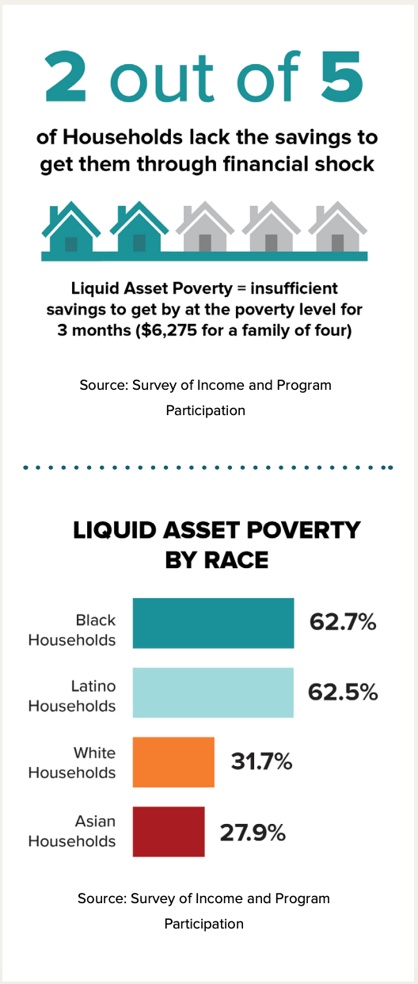
Understanding Wealth
For several years, RESULTS advocates have educated themselves about the importance of policies that address immediate needs and those that help families plan, save, and invest in their future. Savings are an essential part of creating economic security. They are necessary for emergencies, such as unexpected illness or job loss. They are also fundamental for making important investments like education, a home, or a car. However, wealth is not only represented by a savings account. Wealth is the value of all your assets, which include your home, car, and retirement account, minus your debts, such as student loans, credit card debt, and mortgage.
Wealth is the foundation of economic wellbeing for many Americans. In the US, wealth is a key determinant of whether you attend and graduate from college, the kind of neighborhood you live in, and the quality of the schools your child attends, among other things. Wealth can also affect the kind of job you have and how likely you are to own a home.
Looking at wealth and wealth inequality also helps us understand the legacy of structural racism, and why RESULTS Anti-Oppression Values states, “Poverty cannot end as long as oppression exists.”
People experiencing poverty are less likely to have wealth than individuals in other income brackets. Many Americans experience what is called "liquid asset poverty,” meaning they do not have enough cash or easily-converted assets to live at the poverty line for more than three months if they were to lose their source of income. This would include cash, savings and checking accounts, stocks, etc. but would exclude real estate, vehicles, and businesses. According to a 2019 Prosperity Now report, the liquid asset poverty rate in the United States is 40 percent (see figure 1) – with startling disparities by race.
Figure 1⁵
New research released by the Federal Reserve in May 2019 outlines economic well-being in the U.S. Aside from showing that many people are not able to pay their current monthly expenses, the data also show that too many families cannot weather unexpected costs. Black households, regardless of educational attainment, face more financial insecurity than White or Hispanic households. Fifty-eight percent of Black folks with a high school degree or less said they would not be able to pay their monthly bills if confronted with a $400 expense as opposed to only 36 percent of White folks and 48 percent of Hispanics of the same education (see figure 2). With the sheer wealth in the U.S., unexpected expenses of a few hundred dollars should never cause someone to jeopardize the roof over their heads, the food on their table, or their health care.
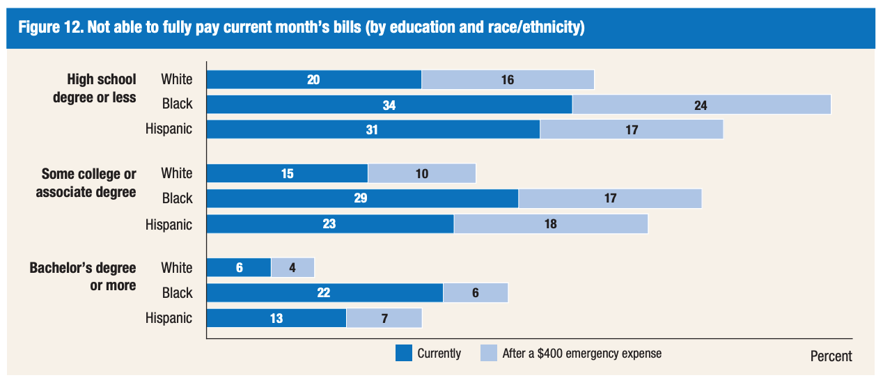
Figure 2⁶
So often, the conversation about inequality focuses on income inequality, which understates the true nature of the gap between the haves and have-nots in society. The United States has the most wealth inequality of any industrialized nation, with 75 percent of the wealth owned by 10 percent of the people (see Figure 3). Moreover, wealth inequality is growing in the United States. After becoming more equal in the mid-20th century, wealth inequality began rising again in the 1970s and is now back to levels not seen since the early 1900s.

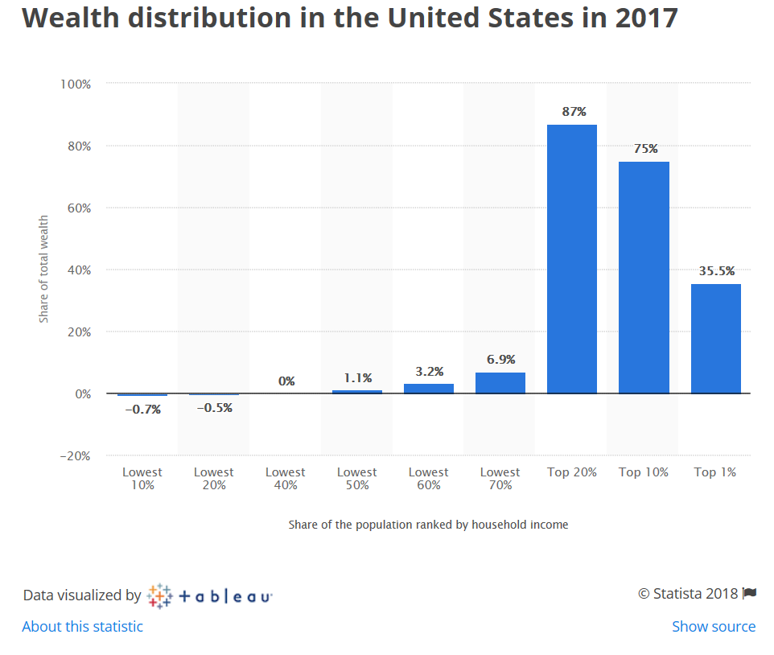
Figure 3

Wealth Inequality and Race in America
Wealth inequality is even more drastic along racial lines. Two separate measures of wealth demonstrate the vast disparities that exist. According to the most recent data available from 2016:
- The median wealth for White families was $171,000 while African American families had $17,409 in median wealth and Hispanic families had $20,920. This translates to White households having more than nine times the wealth of African Americans and more than eight times the wealth of Hispanic families.
- Yet the statistics become grimmer when using calculations of wealth that exclude durable goods, which are items like cars that cannot be converted to cash without losing a substantial amount of their value. Without these durable goods, the median wealth for White families was nearly $147,000, while African American families had $3,557 and Hispanic families had $6,591.&
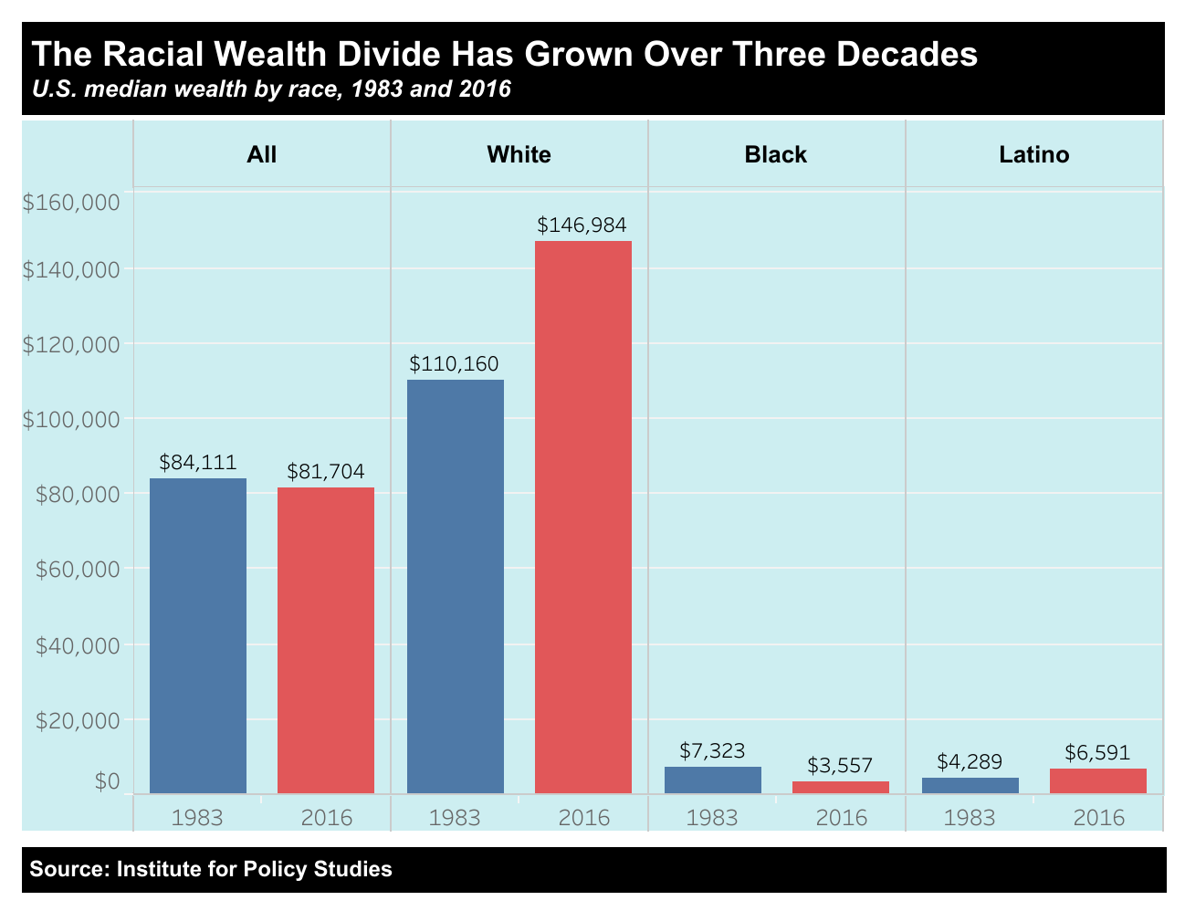
- Put another way, median wealth, without durable goods, for White families was 41 times greater than African American families and 22 times greater than Hispanic family wealth.
Figure 4¹⁰

- Additionally, African-Americans and Hispanics are also more than twice as likely to have no assets as Whites. Which translates to people of color being more likely to have zero or negative net worth (Figure 5).

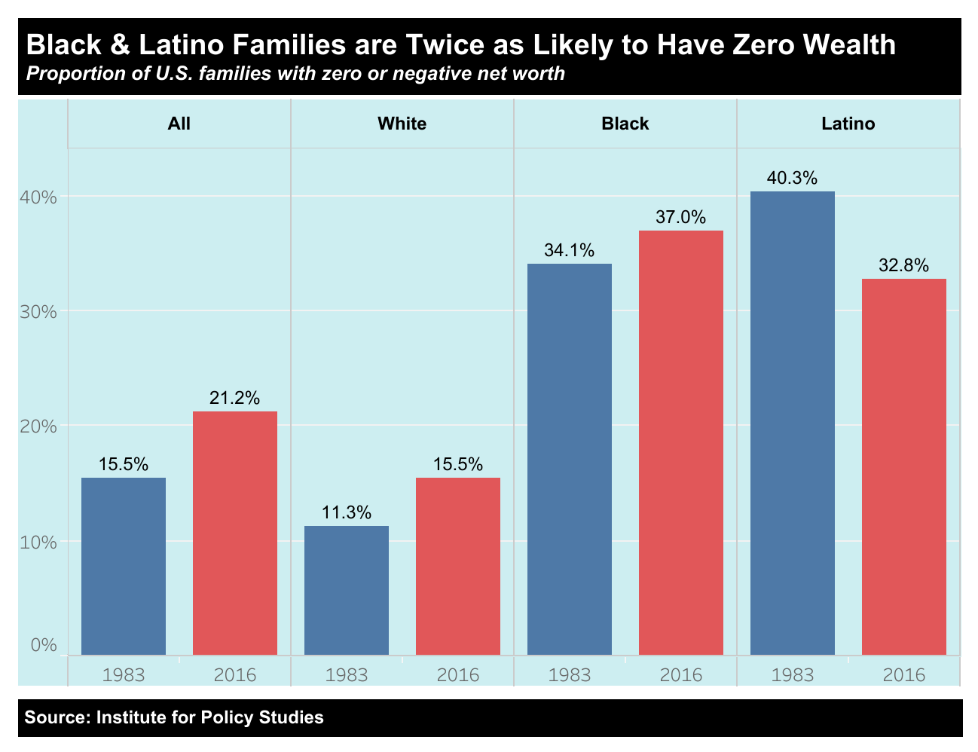
Figure 5¹⁰

There are several factors behind racial wealth inequality. Although family support and inheritances have a small percent impact on the racial wealth gap, they perpetuate wealth inequality through the transfer of resources passed down to the next generation. Over time, wealth that gets passed down accumulates and appreciates in value, thus creating greater inequality between the haves and have-nots.
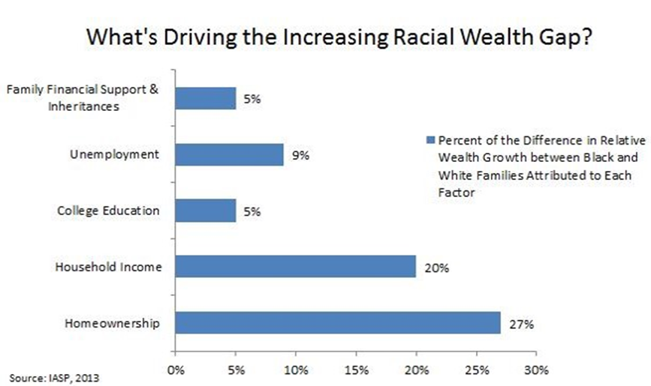

Figure 6
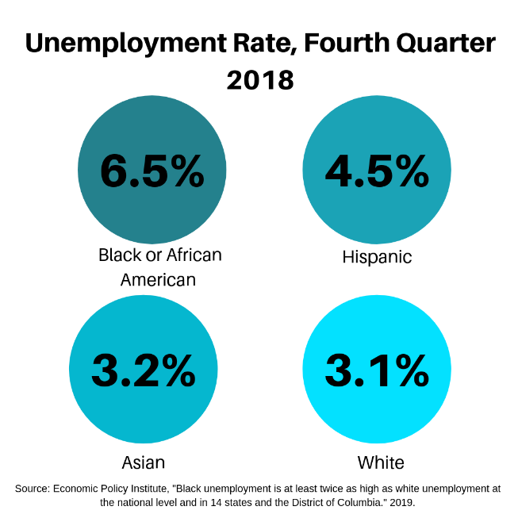
Lack of access to a viable source of income through employment also widens the racial wealth gap. In 2018, the unemployment rate for African American was more than twice the rate for White Americans (see figure 7). While college education remains a path to upward mobility and opportunity for future wealth creation, African Americans and Hispanics are less likely to attend college than their White counterparts. Further, the wealth gap persists even with higher education attainment as the average black college graduate owns less wealth than a White high school dropout.
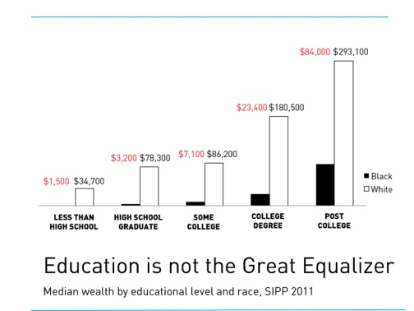
While not entirely attributed to wealth, income still is a necessary component of wealth building. Yet income inequality is highly pervasive along racial lines, with the median income for Whites at $65,845 in 2017 compared with the median income for Hispanics at $49,793 and Blacks at $40,232.
Figure 7
Homeownership is a major factor in the perpetuation of the racial wealth divide. Owning a home is still the primary way most Americans build their personal wealth and when there are great disparities in homeownership, it becomes a large driver in the creation of the wealth gap. According to Brandies University’s Institute on Assets and Social Policy, difference in homeownership accounts for 27 percent of the racial wealth gap, compared to 20 percent for income and five percent for education (see figure 6). In 2017, less than half of African Americans (42 percent) were homeowners while a clear majority of Whites (72 percent) were homeowners. See below for more information on the intersection between housing and race.
Figure 8¹⁸

How Housing Impacts Racial Wealth Inequality
Racial wealth disparities are particularly stark when it comes to housing. In the U.S., housing is foundational to economic wellbeing and is a key determinant of access to opportunity and mobility from poverty. Research shows that housing impacts several aspects of life including your health, the quality of your education, and your future employment prospects. Furthermore, housing – homeownership in particular – is a significant source of wealth for many Americans. “State of the Nation’s Housing” estimated that the median wealth of homeowners was $231,400 compared to the median wealth of renters at $5,000, in 2016. Yet, buying a home is out of reach for many people of color. In 2017, the homeownership rate for Whites was 72 percent compared to 42-60 percent for people of color, with Black households having lowest rates of homeownership at 42 percent. For Black households that do own homes, a greater percentage of their overall wealth comes from homeownership. On average, home equity makes up 56 percent of average assets for Black households as opposed to 38 percent for White households, meaning a home is often the largest single asset for Black families. Yet, research shows that home values for Black households are undervalued by 23 percent in majority-Black neighborhoods. This amounts to $156 billion in losses nationwide.
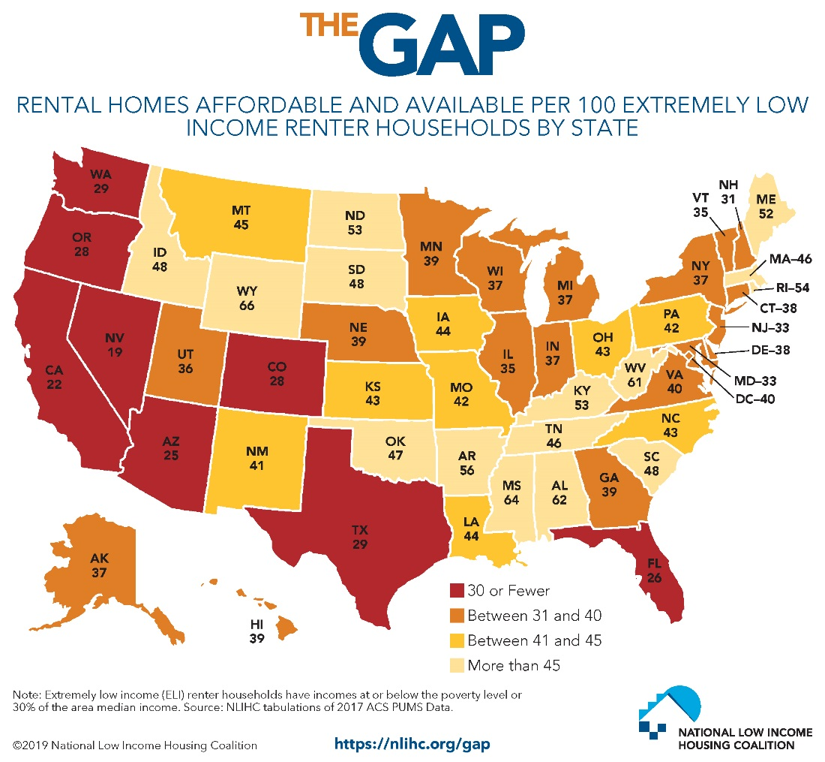
Figure 9

Affordable Housing and its Relationship to Homeownership
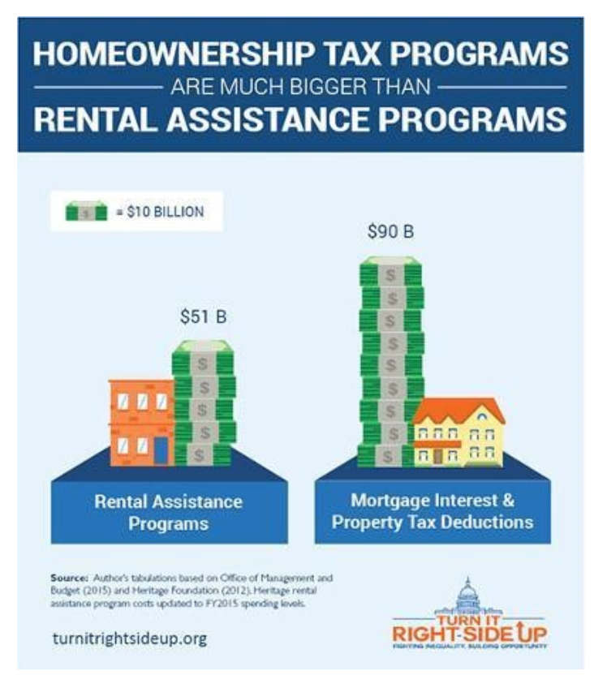
The significant decline in affordable housing nationwide presents another hurdle for families of color seeking to build wealth. According to Harvard researchers, since 1960 renters’ median earnings have gone up 5 percent while rents have risen by 61 percent. The U.S. is facing a shortage of seven million affordable homes for extremely low income renters. The supply of housing units available for less than $800 per month in rent has dropped by 261,000 since 2005 with growth slow to replace those units. Only 10 percent of new apartments in 2016 rented for $800 per month or less.& The resulting shortage leaves only 37 affordable homes available to rent for every 100 extremely low-income renter households, nationwide (see Figure 9). According to a 2018 study by the National Low Income Housing Coalition, there is not a single US state where a worker making the federal minimum wage ($7.25 per hour) can afford a two-bedroom apartment. Instead, a worker would need to make $22.18 on average to afford a ”modest two-bedroom rental home” or work 122 work-week all year at the prevailing minimum wage to afford the modest two bedroom apartment. Households of color are more likely to be renters than homeowners and make up a disproportionate percentage of rental households. For these households, the rising cost of rent and decline in affordable housing leaves less money for savings or other wealth building activities.
Over the past few decades, the federal government invested significantly more in supporting homeowners than it does for renters largely to the benefit of wealthy, White households. Historically, homeowners have been provided with disproportionate funding through the tax code than renters. For example, less than half of African American households own homes and are thus less likely to take advantage of homeownership tax subsidies like the mortgage interest deduction (MID), which allows existing homeowners to deduct the interest on their on their mortgage and other home-related costs. A 2017 study by the Institute on Assets and Social Policy found that while African Americans and Hispanics each make up 13 percent of the nation’s households, they received only six and seven percent respectively of the tax benefits from the mortgage interest deduction. Consequently, the MID serves as one of many examples in which the tax code is structured in an ‘upside-down’ manner where those who have the least to gain benefit the most, while those with the least gain much less. Figure 10 provides context for how our nation has valued homeownership over renting by analyzing 2015 funding levels. The 2017 Tax Cuts and Jobs Act made some changes to these tax provisions for homeowners yet the tax code still uploads racial wealth inequality.
Figure 10
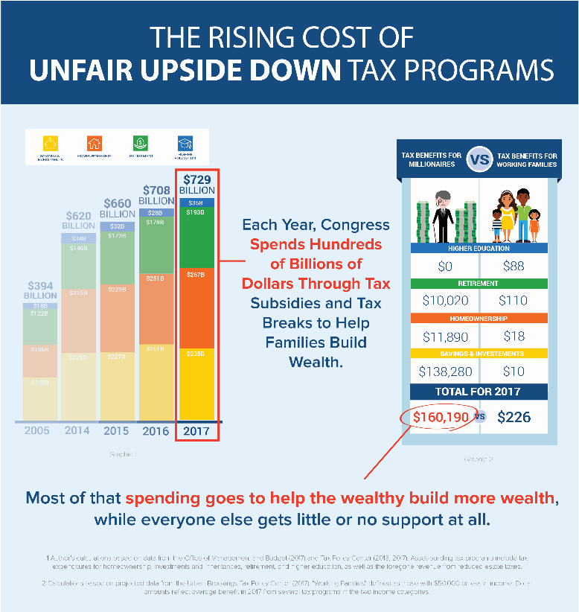
The U.S. tax code is one of the largest government subsidies. Yet, it is rarely recognized as such. In 2015, the top 1 percent of U.S. households received more federal dollars through the tax code than the bottom 80 percent, combined. Tax fairness is not only important in lifting up all families but is particularly critical in supporting families of color to move up the socio-economic ladder. Prior to the passage of major federal tax cuts in 2017, the U.S. tax code already included over half a trillion dollars in tax benefits (see Figure 11) that incentivize households to save and invest. However, lower-income households and households of color are largely excluded from these benefits. See our tax briefing information for more on how the tax code impacts low-income communities and people of color.

Figure 11⁴⁴

Racial Wealth Inequality Today
Communities of color are most impacted by the consistent growth of inequality. Median wealth for Latinx families in 2016 was $6,600 slightly above Black families who had $3,600, a mere two percent of the overall wealth held by White families $147,000 (See figure 4, above). This devastating disparity has grown over the last several generations. Research from the Institute for Assets and Social Policy at Brandeis University found that in 1995 Whites had $7 for every $1 in wealth African Americans had. In 2009, only 20 years later that gap has grown to Whites having $19 for every $1 African Americans have in wealth. Additionally, the Great Recession hit African American and Hispanic families much harder than it hit White families in general. The median net worth of African American households fell from $12,840 in 2005 to $6,081 in 2009. If we exclude home equity, in 2011 African Americans had one $0.06 in wealth for every $1 that Whites had in wealth. That figure was $0.87 for Asians and $0.07 for Hispanics.
These numbers demonstrate ample room for action. As a RESULTS advocate you are uniquely positioned to educate policymakers and the general public, and push for policy changes that will reduce racial wealth inequality.
In additional briefing materials we will cover how the racial wealth gap was created (hint: federal policy played an essential role) and what policy levers can be used to right historical injustices.

Knowledge Check
What is wealth?
A: The accumulation of all assets (e.g. savings, car, home, stocks, bonds, etc.) minus all debts. It is important because it can be used to keep a household afloat during times of financial crisis or help families invest in their future, promoting economic mobility.
What is liquid asset poverty?
A: Liquid asset poverty occurs when, using those assets that are cash or could be converted (i.e. liquidated) quickly — including cash, savings and checking accounts, stocks — a family is able to live at the poverty line for three months if they lost their source of income
What is the ratio of wealth disparities between White households and Black and Latinx households?
A: White households have 10 times more wealth than Black households and six times more wealth than Latinx households, when durable goods (like cars) are taken into account.
What is the rate of homeownership for White households vs. households of color?
A: Seventy-two percent of White households own a home whereas households of color have homeownership rates between 41-60 percent. Black households having lowest rates of homeownership at 41 percent. Homeownership rates for Black households remain nearly as low as 1960 levels, when discrimination was still legal.
How many affordable and available rental homes are there per 100 renters?
A: 37 nationwide, but that number varies by region.
True or False: 1) Tax policy disproportionately benefits homebuyers, who are overwhelming White?
A: 1) True

Gibson-Davis, C. and Percheski, C., The New York Times: “Why the Wealth Gap Hits Families the Hardest.” https://www.nytimes.com/2018/05/18/opinion/wealth-inequality-families-children-elderly.html
RESULTS, “Our Anti-Oppression Values.” https://results.org/our-anti-oppression-values/.
Prosperity Now, “Vulnerability in the Face of Economic Uncertainty.” https://prosperitynow.org/sites/default/files/resources/2019_Scorecard_Key_Findings.pdf. 2019.
Ibid.
Ibid.
Federal Reserve, “Report on the Economic Well-Being of U.S. Households in 2018.” https://www.federalreserve.gov/consumerscommunities/files/2018-report-economic-well-being-us-households-201905.pdf. 2019.
Oxfam International: “Reward Work, Not Wealth.” https://www.oxfamamerica.org/static/media/files/bp-reward-work-not-wealth-220118-en.pdf
Statista, “Wealth distribution in the United States in 2017.” https://www.statista.com/statistics/203961/wealth-distribution-for-the-us/
Urban Institute, “Nine Charts About Wealth Inequality in America.”http://apps.urban.org/features/wealth-inequality-charts/
Inequality.org, “Racial Economic Inequality." https://inequality.org/facts/racial-inequality/#racial-wealth-divide.
Institute for Policy Studies and Inequality.org, “Dreams Deferred: How Enriching the 1% Widens the Racial Wealth Divide.” https://inequality.org/wp-content/uploads/2019/01/IPS_RWD-Report_FINAL-1.15.19.pdf. 2019.
Institute for Policy Studies and Inequality.org, “Dreams Deferred: How Enriching the 1% Widens the Racial Wealth Divide.” https://ips-dc.org/wp-content/uploads/2019/01/IPS_RWD-Report_FINAL-1.15.19.pdf. 2019.
Tippet, R. et al., “Beyond Broke: Why Closing the Racial Wealth is a Priority for National Economic Security.” http://globalpolicysolutions.org/wp-content/uploads/2016/04/Beyond_Broke_FINAL.pdf. 2016.
Darity Jr., W. et al., “What We Get Wrong About Closing the Racial Wealth Gap.” https://socialequity.duke.edu/sites/socialequity.duke.edu/files/site-images/FINAL%20COMPLETE%20REPORT_.pdf
Schapitl, Lexie, Vox: “The Racial Wealth Gap is Where Yesterday’s Injustice Becomes Today’s Inequality. And It’s Growing.” https://www.vox.com/2018/5/23/17377084/racial-wealth-gap-explained-netflix
Shapiro, T., “The Roots of the Widening Racial Wealth Gap: Explaining the Black-White Economic Divide.” https://iasp.brandeis.edu/pdfs/Author/shapiro-thomas-m/racialwealthgapbrief.pdf
Economic Policy Institute, “Black unemployment is at least twice as high as white unemployment at the national level and in 14 states and the District of Columbia.”
Hamilton, D. et. al, “Umbrellas Don’t Make it Rain: Why Studying and Working Hard Isn’t Enough for Black Americans.” http://www.insightcced.org/wp-content/uploads/2015/08/Umbrellas_Dont_Make_It_Rain_Final.pdf
U.S. Census, “Households Income: 2017.” https://www.census.gov/content/dam/Census/library/publications/2018/acs/acsbr17-01.pdf. 2018.
Shapiro, T., “The Roots of the Widening Racial Wealth Gap: Explaining the Black-White Economic Divide.” https://iasp.brandeis.edu/pdfs/Author/shapiro-thomas-m/racialwealthgapbrief.pdf
Currier, E. and Elmi, S., “The Racial Wealth Gap and Today’s American Dream.” http://www.pewtrusts.org/en/research-and-analysis/articles/2018/02/16/the-racial-wealth-gap-and-todays-american-dream
Health Affairs, “Housing and Health: An Overview of the Literature.” https://www.healthaffairs.org/do/10.1377/hpb20180313.396577/full/. 2018.
Opportunity Starts at Home Campaign, “What is Opportunity Starts at Home?” https://www.opportunityhome.org/resources/what-is-opportunity-starts-at-home/.
Harvard Joint Center on Housing Studies, “State of the Nation’s Housing, 2018.” https://www.jchs.harvard.edu/sites/default/files/Harvard_JCHS_State_of_the_Nations_Housing_2018.pdf. 2018.
Prosperity Now, “Scorecard: Homeownership.” https://scorecard.prosperitynow.org/data-by-issue#housing/outcome/homeownership-rate. 2017. The Alliance to End Hunger, “Hunger is a Racial Equity Issue.” https://alliancetoendhunger.org/wp-content/uploads/2017/07/Factsheet_Alliance-To-End-Hunger_HUNGER-IS-A-RACIAL-EQUITY-ISSUE_071917.pdf
Harvard Joint Center on Housing Studies, “State of the Nation’s Housing, 2018.” https://www.jchs.harvard.edu/sites/default/files/Harvard_JCHS_State_of_the_Nations_Housing_2018.pdf. 2018.
Federal Reserve Bank of Cleveland, “What is Behind the Persistence of the Racial Wealth Gap?“ https://www.clevelandfed.org/newsroom-and-events/publications/economic-commentary/2019-economic-commentaries/ec-201903-what-is-behind-the-persistence-of-the-racial-wealth-gap.aspx. 2019.
Brookings Institution, “The Devaluation of Assets in Black Neighborhoods.” https://www.brookings.edu/research/devaluation-of-assets-in-black-neighborhoods/. 2018.
National Low income Housing Coalition, ”The Gap: A Shortage of Affordable Homes.” https://reports.nlihc.org/sites/default/files/gap/Gap-Report_2019.pdf. 2019.
Harvard Joint Center on Housing Studies, “State of the Nation’s Housing, 2018.” https://www.jchs.harvard.edu/sites/default/files/Harvard_JCHS_State_of_the_Nations_Housing_2018.pdf. 2018.
National Low Income Housing Coalition, “The Gap: A Shortage of Affordable Homes.” https://reports.nlihc.org/sites/default/files/gap/Gap-Report_2019.pdf. 2019.
Joint Center for Housing Studies at Harvard University, “State of the Nation’s Housing 2017.” http://www.jchs.harvard.edu/sites/default/files/harvard_jchs_state_of_the_nations_housing_2017_chap1.pdf
Joint Center for Housing Studies at Harvard University, “State of the Nation’s Housing 2018.” https://www.jchs.harvard.edu/sites/default/files/Harvard_JCHS_State_of_the_Nations_Housing_2018.pdf. 2018.
National Low Income Housing Coalition, “The Gap: A Shortage of Affordable Homes.” https://reports.nlihc.org/sites/default/files/gap/Gap-Report_2019.pdf. 2019.
Ibid.
National Low-Income Housing Coalition, “Out of Reach: The High Cost of Housing.” http://nlihc.org/sites/default/files/oor/OOR_2018.pdf
National Low Income Housing Coalition, “The Gap: A Shortage of Affordable Homes.” https://reports.nlihc.org/sites/default/files/gap/Gap-Report_2019.pdf. 2019.
Joint Center for Housing Studies at Harvard University, “America’s Rental Housing 2017.” https://www.jchs.harvard.edu/sites/default/files/harvard_jchs_americas_rental_housing_2017_0.pdf. 2017.
Investopedia, “Mortgage Interest Deduction.” https://www.investopedia.com/terms/home-mortgage-interest.asp
Institute on Assets and Social Policy, National Low-Income Housing Coalition: “Misdirected Investments: How the Mortgage Interest Deduction Drives Inequality and the Racial Wealth Gap.” https://heller.brandeis.edu/iasp/pdfs/racial-wealth-equity/racial-wealth-gap/misdirected-investments.pdf. 2017.
Greer, Jeremie, “How the US Tax Code Drives Inequality and What We Can Do to Fix It.” https://iasp.brandeis.edu/pdfs/2017/NLIHC-IASP_MID-Report.pdf
Prosperity Now, ”How the U.S. Tax Code Drives Inequality — and What We Can Do to Fix It.” https://prosperitynow.org/blog/how-us-tax-code-drives-inequality-and-what-we-can-do-fix-it. 2017.
Ibid.
Prosperity Now, “Wealth Building for the Wealthy through the Tax Code Continues as Families of Color Fall Farther Behind.” https://prosperitynow.org/blog/wealth-building-wealthy-through-tax-code-continues-families-color-fall-further-behind
Kochhar, R. et al., “Wealth Gaps Rise to Record Highs Between Whites, Blacks, Hispanics.” http://www.pewsocialtrends.org/2011/07/26/wealth-gaps-rise-to-record-highs-between-whites-blacks-hispanics/
Tippet, R. et al., “Beyond Broke: Why Closing the Racial Wealth is a Priority for National Economic Security.” http://globalpolicysolutions.org/wp-content/uploads/2016/04/Beyond_Broke_FINAL.pdf
Ibid.

