Wealth allows families to weather unexpected financial storms and invest in their future. Yet, this major tool for socioeconomic mobility has been kept out of reach for families of color due to decades of discriminatory federal policies like redlining, GI bill administration, home mortgage lending, etc.
As a result, there are vast disparities in wealth between white households and households of color. In 2016, white households held $171,000 in wealth whereas Latino households had $20,920 and Black households had $17,409 (Prosperity Now, 2018). This means that white households have more than nine times the wealth of households of color, making them much better equipped for economic security and mobility.
Housing and Wealth
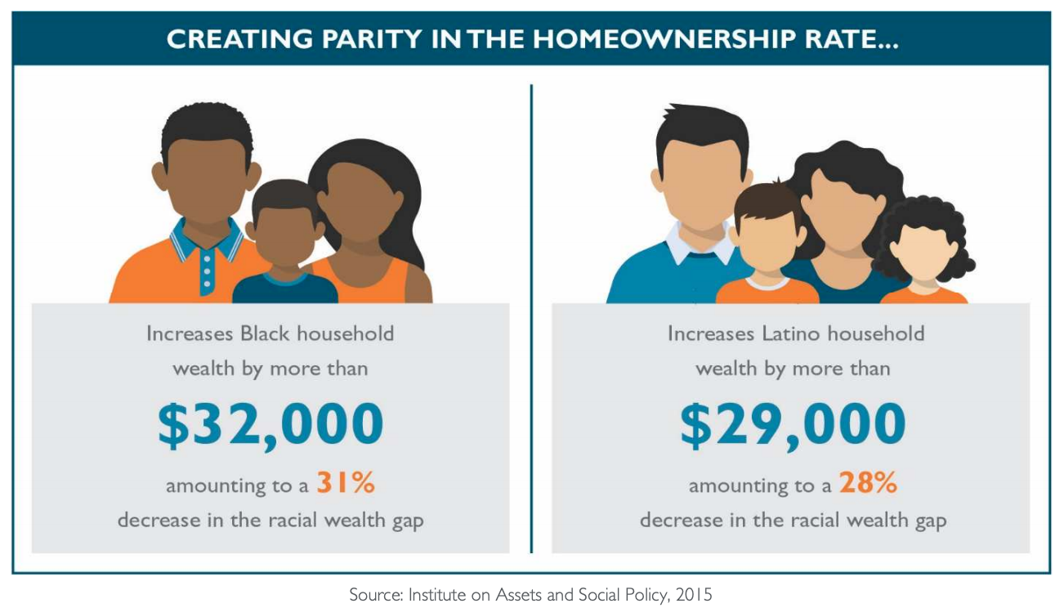
Housing is a major pathway to wealth building (IASP, 2013). Yet, households of color are less likely to own their homes than white households. As the U.S. is amid a housing crisis, where affordable and available rental homes are difficult to secure, this impacts communities of color and low-income households the most. Since 1960 renter’s incomes have gone up by 5 percent while rents have gone up by 61 percent (Harvard Joint Center on Housing Studies, 2015).
Homeownership rates for households of color are nearly unchanged since 1968, when discrimination was still legal (Prosperity Now, 2017). It is estimated that equalizing homeownership rates for people of color and whites can reduce the racial wealth gap by 30 percent.
Policies to Address the Housing Crisis
Federal policy is essential in making positive progress on housing and racial wealth inequality. Here are RESULTS priorities in this area:
- Shift tax priorities to increase support for low- and moderate-income renters via a “Renters Credit”
- Target homeownership policies for first-time homebuyers impacted by segregation to reduce racial wealth inequality
- Increase access to rental assistance via more Housing Choice Vouchers while supporting bipartisan efforts to ban housing discrimination based on income source
- Prioritize increasing affordable housing stock through the Housing Trust Fund
- Address other barriers to affordable housing and racial equity including restrictive zoning, credit scores, and application fees
- Support emergency stabilization funds for families facing eviction
- Create bipartisan proposals to establish an Affordable Housing Task Force
Join us and tell Congress to make affordable housing and homeownership a priority! The affordable housing crisis is a key driver of poverty in the U.S., and your voice can make a huge impact.

