2018 IC US Poverty Background Packet: Housing and Racial Wealth Inequality

Overview: Housing and Racial Wealth Inequality

Understanding Wealth
For several years, RESULTS advocates have educated themselves about the importance of policies that address immediate needs and those that help families plan, save, and invest in their future. Savings are an essential part of creating economic security. They are necessary for emergencies, such as unexpected illness or job loss. They are also fundamental for making important investments like education, a home, or a car. However, wealth is not only represented by a savings account. Wealth is the value of all your assets, which include your home, car, and retirement account, minus your debts, such as student loans, credit card debt, and mortgage.
Wealth is the foundation of economic wellbeing for many Americans. In the US, wealth is a key determinant of whether you attend and graduate from college, the kind of neighborhood you live in, and the quality of the schools your child attends, among other things. Wealth can also affect the kind of job you have and how likely you are to own a home.
People experiencing poverty are less likely to have wealth than individuals in other income brackets. Many Americans experience what is called “asset poverty”. Individuals and families are considered asset poor when they do not have enough assets to live at the poverty line for more than three months if they were to lose their source of income. Currently 1 in 4 – 25.5 percent – of Americans are asset poor. This means that they are one financial crisis away from poverty.

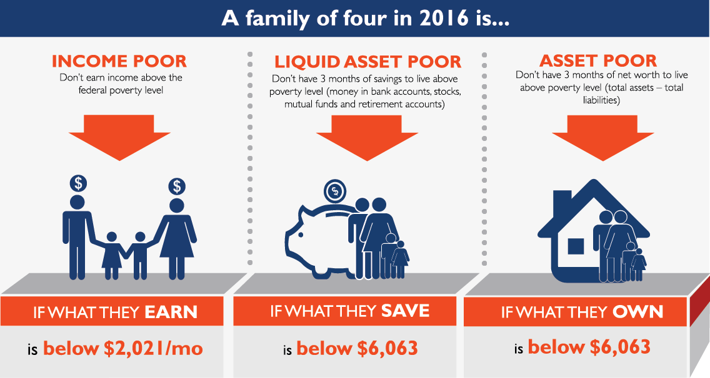
Figure 1

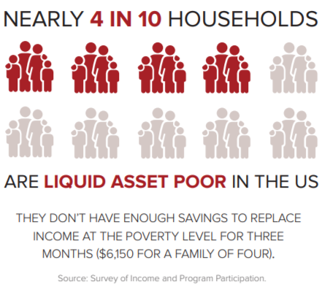
Even more startling is the liquid asset poverty rate in America. It uses the same criteria as asset poverty, but only takes into account those assets that are cash or could be converted (i.e. liquidated) quickly. This would include cash, savings and checking accounts, stocks, etc. but would exclude real estate, vehicles, and businesses. In 2018 the liquid asset poverty rate in the United States is 36.8 percent.
So often, the conversation about inequality focuses on income inequality, which understates the true nature of the gap between the haves and have-nots in society. The United States has the most wealth inequality of any developed nation, with 75 percent of the wealth owned by 10 percent of the people (see Figure 3). Moreover, wealth inequality is growing in the United States. After becoming more equal in the mid-20th century, wealth inequality began rising again in the 1970s and is now back to levels not seen since the early 1900s.
Figure 2 (2018 statistics)

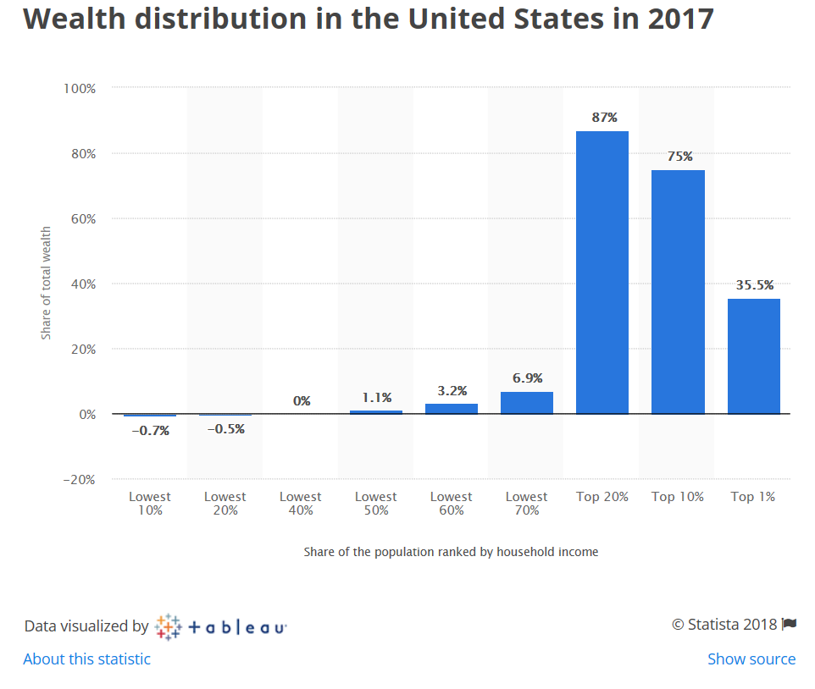
Figure 3

Wealth Inequality and Race in America
Wealth inequality is even more drastic along racial lines. In 2016, the median wealth for white families was $171,000 while African American families had $17,409 in median wealth and Hispanic families had $20,920. Put another way, median wealth for white families was 10 times greater than African American family wealth and eight times greater than Hispanic family wealth. African-Americans and Hispanics are also more than twice as likely to have no assets as whites. People of color are more likely to have zero or negative net worth. For the historical roots of centuries of policies that created the racial wealth divide, see further below.
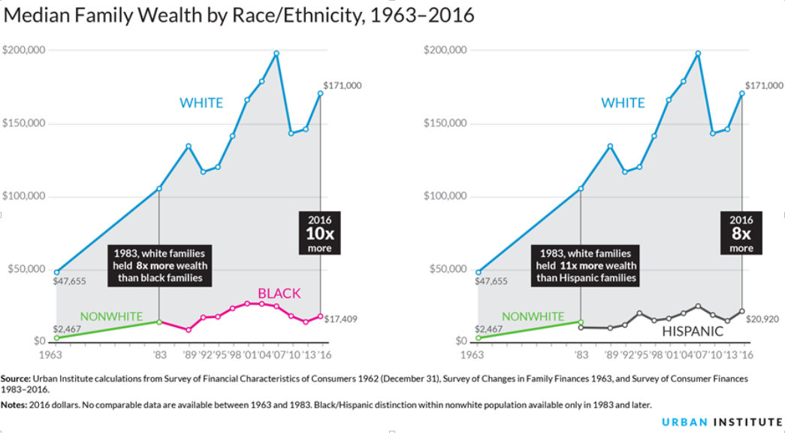
Figure 4 ¹⁰

How Housing Impacts Racial Wealth Inequality
Racial wealth disparities are particularly stark when it comes to housing. In the U.S., housing is foundational to economic wellbeing and is a key determinant of access to opportunity and mobility from poverty. Research shows that housing impacts several aspects of life including your health, the quality of your education, and your future employment prospects. Furthermore, housing – homeownership in particular – is a significant source of wealth for many Americans. The Federal Reserve Bank estimated that the median net worth of homeowners was $195,400 compared to the median net worth of renters at $5,400. Yet, buying a home is out of reach for many people of color. In 2016, the homeownership rate for whites was 71 percent compared to 41-57 percent for people of color. Additionally, for families of color who do own homes, their home values tend to be lower on average than the homes of white families.

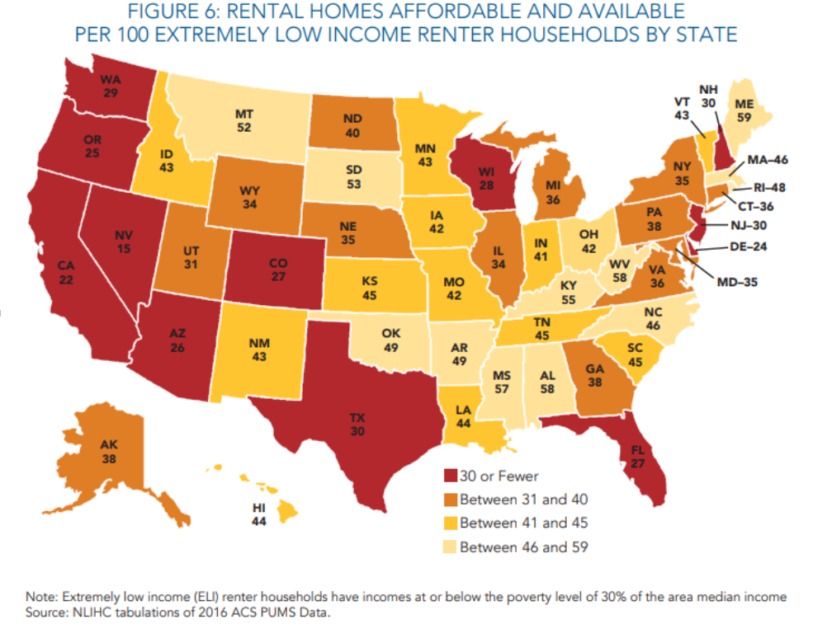
Figure 6 ¹⁵

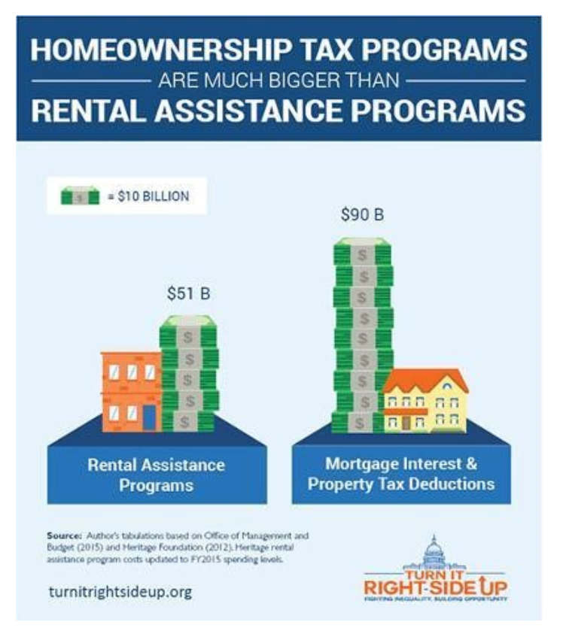
The significant decline in affordable housing nationwide presents another hurdle for families of color seeking to build wealth. The US is facing shortage of more than seven million affordable homes (see Figure 5) and the supply of housing units available for less than $800/month in rent has dropped by 261,000 since 2005. The resulting shortage means that on average nationwide there are only 35 affordable homes available to rent for every 100 extremely low-income renter households.¹⁵ According to a 2018 studying by the National Low Income Housing Coalition, there is not a single US state where a worker making the federal minimum wage ($7.25 per hour) can afford a two-bedroom apartment. Since families of color are more likely than white families to be renters, the rising cost of rent and decline in affordable housing means more income is spent on rent and less money for savings or other wealth building activities. Outside of the housing market, the federal government invests significantly more in supporting homeowners than it does for renters largely to the benefit of wealthy, white households (see Figure 6). The barriers to affordable housing and homeownership pose a significant obstacle for people of color working to build wealth.
Figure 7
How Did We Get Here? The History Behind Housing Segregation and Racial Wealth Inequality
Research points to the role of federal policies as the historical drivers of racial wealth inequality, arguing that, “the racial wealth divide is the natural byproduct of an endless series of policy choices that have boosted the ability of White Americans to build long-term wealth, while blocking communities of color from doing the same.” Figure 8 depicts some of the major policies dating back to the Civil War era that laid the structural foundation for the racial wealth disparities present today.

Figure 8

New Deal Era Housing Policy
The racial wealth gap of today has its roots in centuries of economic exploitation on the part of wealthy, white colonists. Beginning with the forced removal of Native Americans from their land and then the enslavement of African Americans to work the land for cash crops, the foundation of wealth inequality between whites and people of color was built before the nation's founding. In addition, federal housing policies of the 1930s New Deal Era profoundly impacted disparities in wealth building opportunities through homeownership and thus economic mobility for White Americans in the 20th century. Concurrently, these policies effectively enabled racial housing segregation through discriminatory practices in homeownership financing under the Federal Housing Administration (FHA) and Department of Veterans Affairs.
Even though racial segregation in housing was outlawed in a 1948 Supreme Court case, the federal government still allowed localities across the country to prevent racial minorities from moving into white neighborhoods. Practices such as blockbusting, redlining, and racialized zoning laws created deep segregation and blocked households of color from owning their homes and receiving adequate public investment in their neighborhoods. At the same time, many white Americans could buy homes in high opportunity suburbs with support from the federal government in the form of low interest FHA loans. These segregationist policies have had decades-long consequences.
The Fair Housing Act of 1968 officially ended discriminatory housing practices. This Act prohibited discrimination in the sale, rental, and financing of dwellings based on race, color, religion, sex, or national origin. It allowed the Department of Housing and Urban Development to play an expanded role in requiring local communities across the country to obey the law. This was a significant victory in helping protect people of color from housing discrimination. Although the Fair Housing Act and other civil rights initiatives formally banned racial discrimination in housing, the new policies did not reverse the already existing racial wealth gap – and in fact, segregation and racial wealth inequality have increased rather than decreased at times during our recent history.
According to the Economic Policy Institute:
- Seven percent of poor Whites lived in high poverty neighborhoods (more than 40 percent of the residents are poor) in 2011, up from four percent in 2000.
- 15 percent of poor Latinos lived in high poverty neighborhoods in 2011, up from 14 percent in 2000
- 23 percent of poor African Americans lived in high poverty neighborhoods in 2011, up from 19 percent in 2000.
Living in concentrated poverty not only severely decreases a family’s chance to afford their own home, houses decrease in value in high poverty neighborhoods, making it hard to for those who can afford a home to build or maintain wealth.
The Racial Equity Impact of Policies in Employment, Education and Mass Incarceration
Along with housing segregation, employment discrimination, educational inequities, and the criminal justice system have all contributed to the racial wealth inequities in the US, particularly between black and white Americans. When first enacted, the Social Security Act of 1935 excluded certain domestic workers and farmers from participating in the program. Because these professions were primarily employed by African Americans, this exclusion had the effect of excluding 65 percent of African American workers from Social Security. The law was not changed to include these workers until 1954, almost two decades later. Similarly, the Fair Labors Standards Act of 1938 which established the forty-hour work week and the federal minimum wage excluded many tip-based professions such as servers and shoe shiners which were predominantly held by African American workers.³⁰
The G.I. bill signified an important time in which the federal government invested in providing affordable education and housing to World War II veterans and their families. This bill is largely credited for the creation of the American middle class. However, because of Jim Crow and other racist policies, veterans of color were not afforded the same opportunity. If an African American or Native American veteran lived in an area in which Jim Crow was prevalent, then the local Veterans’ Administration could deny their benefits or relegate them to lower quality and segregated housing options. In the times in which white families were provided important opportunities for mobility and wealth accumulation, families of color were intentionally, and sometimes violently, excluded from these important federal policies.
Mass incarceration has also contributed to racial wealth inequality through the undermining of families and communities of color. The ‘War on Drugs’ policies implemented and enforced under the Nixon and Regan Administrations brought about harsher sentences for drug offenses that resulted in a disproportionate share of African American men being incarcerated. The effects of incarceration pose significant costs to building income and wealth both in the short and long term. Because African Americans are 10 times more likely than whites to be incarcerated for similar drug offenses, African American families are more at risk of living in poverty when a family member or breadwinner is incarcerated.
More recently, the Great Recession negatively impacted the wealth of millions of American families; however, the impact has been particularly hard on families of color. White Americans have had a huge head start in generating wealth throughout our nation’s history, while Americans of color were only given meaningful opportunities to build wealth 1-2 generations ago. Without the comparable wealth that was intentionally denied to them for so long, families of color are much more vulnerable to financial emergencies and have less opportunity to move up the economic ladder.
The Racial Wealth Divide Today
Not surprisingly, the discriminatory effects of public policies enacted to support the building of white wealth while excluding people of color have given rise to massive wealth disparities along racial lines today. Further, the racial wealth divide has significantly increased in the last three decades. Research from the Institute for Assets and Social Policy at Brandeis University found that in 1995 Whites had $7 for every $1 in wealth African Americans had. In 2009, only 20 years later that gap has grown to Whites having $19 for every $1 African Americans have in wealth. Additionally, the Great Recession hit African American and Hispanic families much harder than it hit white families in general. The median net worth of African American households fell from $12,840 in 2005 to $6,081 in 2009. If we exclude home equity, in 2011 African Americans had one $0.06 in wealth for every $1 that Whites had in wealth. That figure was $0.87 for Asians and $0.07 for Hispanics.
There are several factors behind the racial wealth divide we see today (see Figure 9).

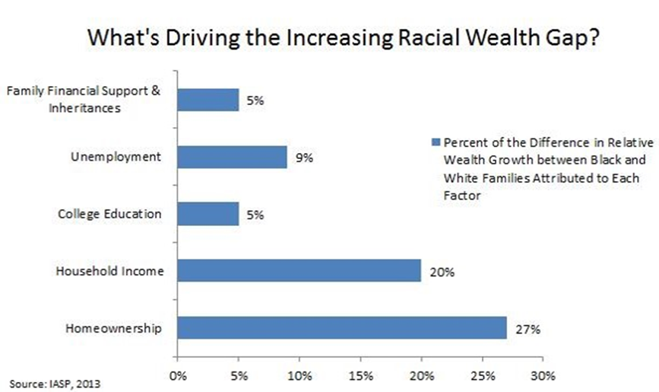

Figure 9 ⁴²

For example, family support and inheritances perpetuate wealth inequality through the transfer of resources passed down to the next generation. Over time, wealth that gets passed down accumulates and appreciates in value, thus creating greater inequality between the haves and have-nots. Lack of access to a viable source of income through employment also widens the racial wealth gap. In 2017, the unemployment rate for African American was more than twice the rate for white Americans. While college education remains a path to upward mobility and opportunity for future wealth creation, African Americans and Hispanics are less likely to attend college than their white counterparts. Further, the wealth gap persists even with higher education attainment as the average black college graduate owns less wealth than a white high school dropout.

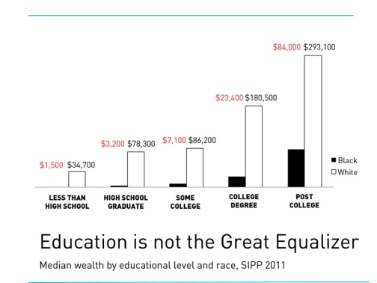
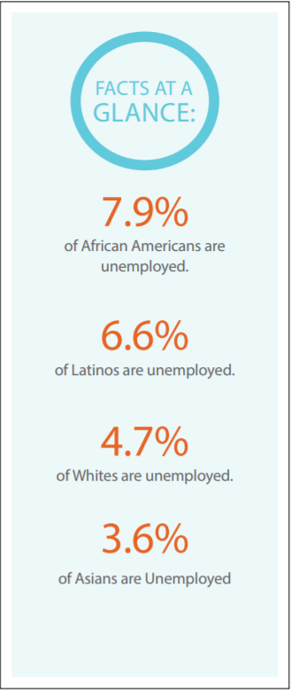
While not entirely attributed to wealth, income still is a necessary component of wealth building. Yet income inequality is highly pervasive along racial lines, with the median income for whites at $65,041 in 2016 compared with the median income for Hispanics at $47,675 and African Americans at $39,490.
Figure 10 ⁴⁰
Homeownership is a major factor in the perpetuation of the racial wealth divide. Owning a home is still the primary way most Americans build their personal wealth and when there are great disparities in homeownership, it becomes a large driver in the creation of the wealth gap. According to Brandies University’s Institute on Assets and Social Policy, difference in homeownership accounts for 27 percent of the racial wealth gap, compared to 20 percent for income and five percent for education. In 2017, less than half of African Americans (42.7 percent) were homeowners while a clear majority of whites (72.7 percent) were homeowners.

Figure 11 ⁴¹

How Tax Policy Exacerbates Racial Wealth Inequality
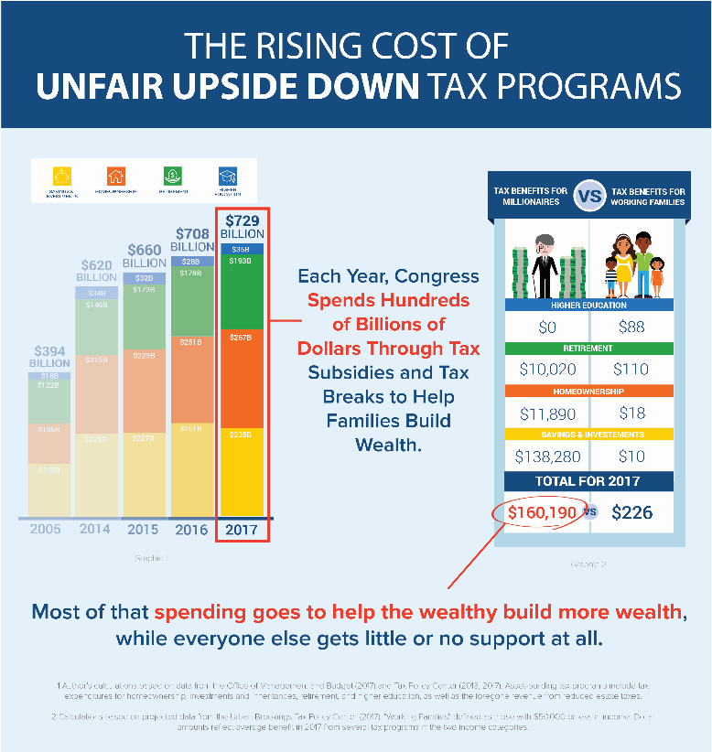
Wealth inequality and the racial divide are pervasive injustices in this country that has lasted for too long. While most of our conversations on Capitol Hill during the RESULTS International Conference will focus other issues, it is important that we understand how poverty rates and wealth inequality disproportionately affect specific communities – and, if possible, lay the groundwork for policy work to close the racial wealth divide. Tax fairness is not only important in lifting up all families but is particularly critical in supporting families of color to move up the socio-economic ladder. Prior to the passage of major federal tax cuts in 2017, the U.S. tax code already included over half a trillion dollars in tax benefits (see Figure 11) that incentivize households to save and invest. However, lower-income households and households of color are largely excluded from these benefits. For example, less than half of African American households own homes and are thus less likely to take advantage of homeownership tax subsidies like the mortgage interest deduction (MID), which allows existing homeowners to deduct the interest on their on their mortgage and other home-related costs. A 2017 study by the Institute on Assets and Social Policy found that while African Americans and Hispanics each make up 13 percent of the nation’s households, they receive only six and seven percent respectively of the tax benefits from the mortgage interest deduction. Consequently, the MID serves as one of many examples in which the tax code is structured in an ‘upside-down’ manner where those who have the least to gain benefit the most, while those with the least gain much less.
Figure 11 ⁴⁴
The 2017 Tax Cuts and Jobs Act
When done right, tax policy can empower all Americans to save, invest, and build wealth. Unfortunately, the new Tax Cuts and Jobs Act (TCJA) passed by Congress in 2017 will likely exacerbate racial wealth inequality and further perpetuate an inequitable, “upside-down” tax code, while also putting investments in anti-poverty policies at risk.
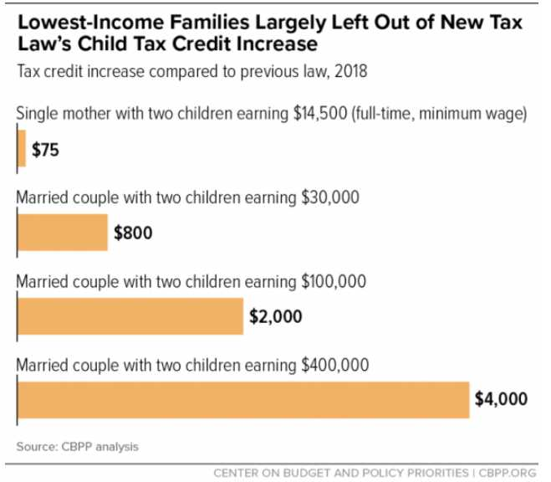
The TCJA represents the largest one-time reduction in the corporate income tax rate in U.S. history, from 35 percent down to 21 percent. The new changes to the tax code under the law also include a larger tax break to the wealthy with incomes over $500,000 and a limit on deductions to $10,000 in state and local property taxes. In addition, the individual health insurance mandate under the Affordable Care Act will be eliminated in 2019 under the new law, potentially forcing health insurance premium increases for millions of Americans. The bill will include short term tax savings for most Americans, but those savings will be eliminated by 2026. Currently, only the corporate tax cuts are made permanent.
Figure 12 ⁵³
For many years, RESULTS has advocated for increases to the Earned Income Tax Credit (EITC) and Child Tax Credit (CTC), whose benefits are targeted to low-income households. In the TCJA, the Child Tax Credit was increased but the benefits largely go to high-income households (See Figure 12). The credit was doubled to $2,000 per child, but only wealthier families will be able to get the full benefit. Low-income families can at most get $1,400 per child back as a refund compared to a family earning $400,000, who will get to deduct the full $2,000 credit per child off their taxes. Sadly, the TCJA made no changes to the EITC.
Finally, the estate tax will only be assessed if a family is inheriting more than $22 million and many businesses organized as "pass through" companies will get a 20 percent reduction in their tax rate.
Who it affects and who benefits?
The working and middle class will be affected the most negatively by the tax law. The tax law will benefit wealthy individuals and small businesses (see Figure 13). Forty-three percent of the tax benefits would go to Americans with incomes in the top 5 percent — above $290,000 — while only 19 percent of the benefits would go to Americans with incomes in the bottom 60 percent, or those making less than $81,000. The new law favors people with the highest incomes and has opened vast new opportunities for well-heeled taxpayers to game the system.
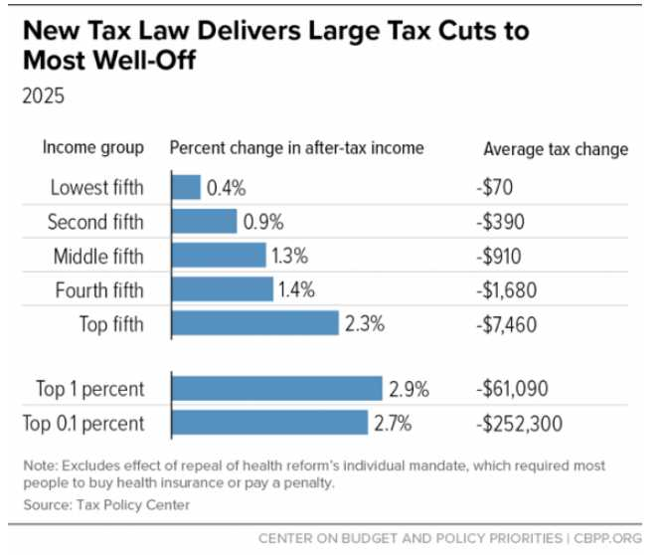
Figure 13

How Costly is the TCJA?
The bill will go into effect in 2018. The final bill is estimated to cost $1.46 trillion. Researchers estimate that the US will go into debt in the amount of approximately $1.5 trillion because of the TCJA.
The TCJA and Racial Wealth Inequality
A 2018 report from the Roosevelt Institute lays out how the 2017 tax law will negatively impact racial wealth disparities primarily in four ways:
- The benefits from the tax law disproportionately accrue to high-income or high-wealth households. Given our nation’s history of exclusion of people of color from economic opportunities, these benefits will largely go to white families leaving families of color behind.
- The law primarily benefits those who already have wealth rather than creating incentives to build new wealth. These benefits will further deepen disparities between existing holders of wealth who are predominantly white, and those who lack wealth who are more likely to be people of color.
- The new limits on state and local deductions will force state and local governments to look for alternate sources of revenue. As a result, state and local governments will likely increase fines and fees which tend to fall disproportionately on people of color.
- The estimated revenue loss from tax cuts enacted by the law will undermine public sector and public services. These cuts will likely decrease the size of public sector labor force of which African Americans make up a large share, putting their employment and communities at risk.
The 2017 tax law poses a significant threat to reducing wealth inequality and will likely undermine the movement to end poverty in the U.S. This summer House Republicans are crafting new tax legislation, a “Tax Cuts 2.0” package, which may make the individual tax breaks permanent and include additional tax policy changes. While the House may take up and pass this bill this year, the Senate is not expected to take up additional tax legislation. If we are serious about closing the racial wealth divide, creating tax policy that steers toward opportunity and equity for all Americans is necessary to address these gaping inequalities.

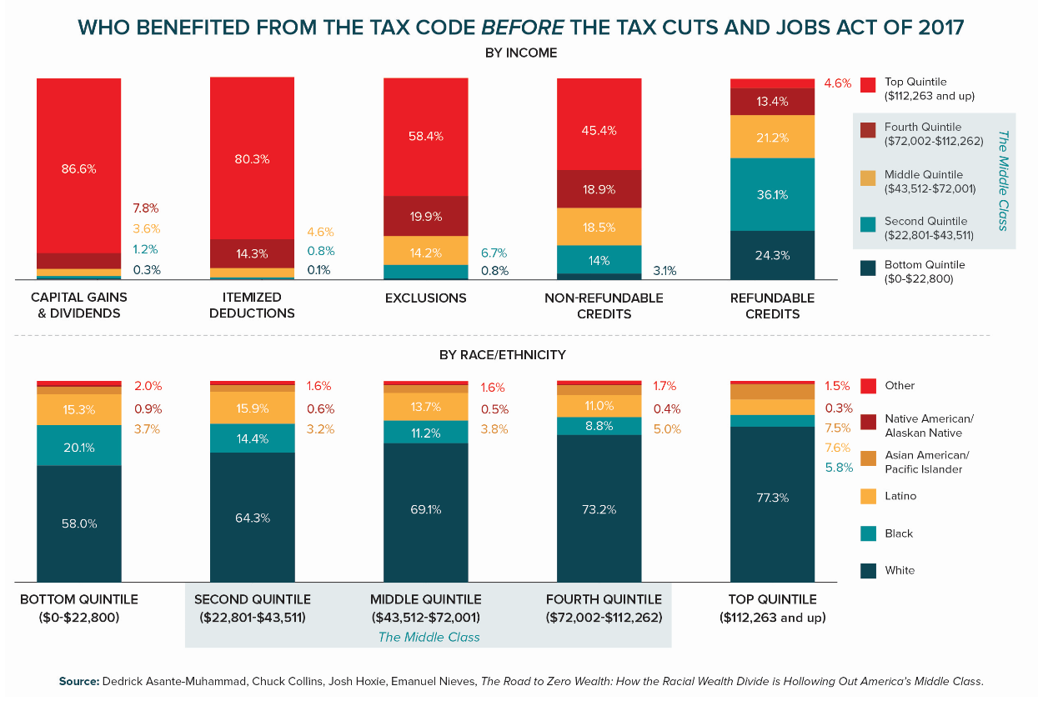
Figure 14

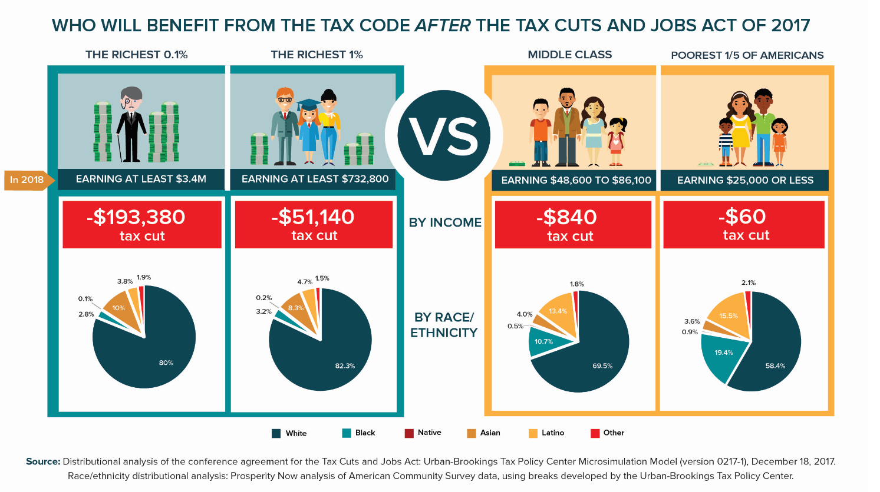
Figure 15

Tax Credits for Working Families
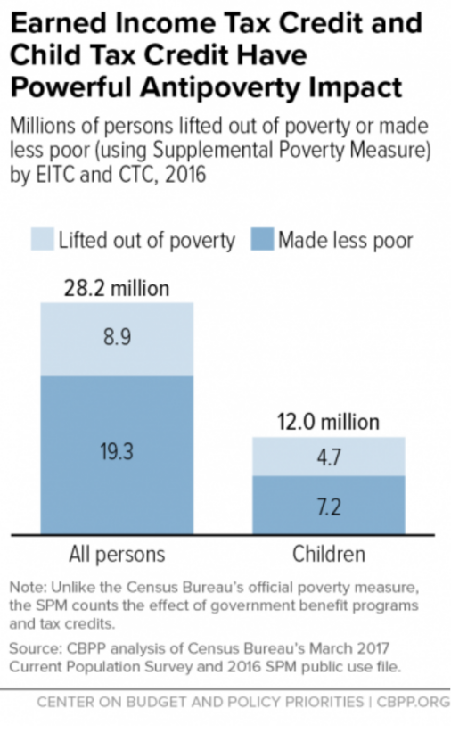
Consequently, tax policy that benefits families in need and people of color as well as other savings policies will help to close the racial wealth gap and decrease poverty rates. The Earned Income Tax Credit (EITC) and low-income portion of the Child Tax Credit (CTC) are particularly beneficial policies for communities of color because these communities experience higher rates of poverty.
The EITC is a refundable federal tax credit available to working individuals and families who work in low-wage jobs. This successful program is designed to “make work pay.” In addition to supplementing low-wage work with additional income, the higher the income a person earns, the higher the EITC they receive. The CTC is a partially refundable federal tax credit designed to help families offset some of the costs of raising children.
While extremely beneficial to families on their own, when the EITC and CTC are combined, they serve as one of the most effective anti-poverty tool available. The Center for Budget and Policy Priorities estimates that in 2016, the EITC and CTC together lifted 8.9 million people and 4.7 million children out of poverty. Only Social Security lifts more people out of poverty each year.

Figure 16 ⁶²
What Will It Take to Address the Racial Wealth Divide?
The racial wealth divide is a complex problem that is largely driven by public policy decisions. However, several faulty ideas or myths exist about the reasons behind the racial wealth divide and how to address it. These myths are primarily rooted in racist stereotypes and false narratives about why people are in poverty. Some of these most widely held notions are listed below.

Most Common Myths About Closing the
Racial Wealth Gap

More educational attainment by African Americans will close the gap ​ | Homeownership disparities alone drive racial wealth gap ​
Buying and banking black will close the gap | Greater financial literacy in the African American community will close the gap​
African American families saving more will close the gap | More entrepreneurship in the black community will close the gap ​
Emulating other “model minorities” will close the gap ​ | Improved “soft skills” and “personal responsibility” will close racial wealth gap
The rise of African American celebrities proves the racial wealth gap is closing | African American family disorganization is a cause of the racial wealth gap
Figure 17

While many of these interventions are desirable paths to achieving economic mobility on an individual and small scale, they are flawed because they put the onus to remedy racial wealth inequality on people of color by changing their behavior, rather than focusing on the structural barriers that play a much more significant role in perpetuating the racial wealth divide. As researchers from the Cook Center for Social Equity point out, “blacks cannot close the racial wealth gap by changing their individual behavior…if the structural sources of major inequality remain unchanged.” To effectively address racial wealth inequality, the federal government must make major policy transformations that target the structural and institutional factors behind the racial wealth gap established through the historical legacy of polices rooted in racism.
There is no single policy that can eliminate the racial wealth divide. Rather it will take a suite of policies and interventions to address the various disparities in income, assets and opportunity that constitute the racial wealth divide (see Figure 18). Ultimately, closing the racial wealth divide will require an assessment of how current federal policies continue to perpetuate racial wealth inequality and enact new polices that ensure households of color receive adequate support to build wealth. While no single public policy can unilaterally close the racial wealth divide on its own, there are several policy proposals that if enacted as part of a broader movement will significantly reduce racial wealth inequality.

Policy​ | IASP Audit: Reduction of Black-White Wealth Gap​
Student Loan Forgiveness for Low-Income Families​ | 7 percent​
Student Loan Forgiveness for Low-Wealth Families​ | 37 percent​
Student Loan Forgiveness for Everyone​ | WORSE​
Equalize Homeownership Rates​ | 31 percent​
Equalize College Graduation Rates​ | 1-3 percent​
End Income Inequality​ | 9-11 percent​
Universal Savings Accounts at birth, with additional deposits​ | 20-80 percent​
Figure 18

Policy Proposals to Eliminate the Racial Wealth Divide
As noted above, most of our conversations with policymakers during the RESULTS International Conference will focus on nutrition programs. But, in some cases our meetings on Capitol Hill offer us an opportunity to educate policymakers and their staff about racial wealth inequality and how housing and tax policy priorities could reduce poverty and reduce the racial wealth divide. We have begun this work to develop a larger frame for our U.S. poverty work and shift grassroots focus to engaging policymakers and candidates this fall on more proactive and visionary policy proposals to reduce poverty. We may build on our work on tax policy by prioritizing efforts to support affordable rental housing and homeownership, given the impact of housing instability on poverty and racial wealth inequality (and how much of housing policy is implemented through the tax code. Some of the policies we are exploring and interested in discussing with policymakers and candidates include:
Wealth Building and Economic Opportunity for People of Color
- Expand EITC to benefit childless adult workers and incentivize families to save a portion of the EITC as emergency savings for later in the year
- Boost the Child Tax Credit for low-income families with young children
- Create Baby Bonds, a universal program that would give every child an initial endowment at birth that would be held in a trust until adulthood. Once in adulthood, the money could be used for education, buying a home or car, or starting a business
- Reinstate the First-time Homebuyers’ Tax Credit to help more low- and moderate-income households become homeowners
- Reform the Mortgage Interest and Real Estate Tax Deductions which provide vastly more benefits to the wealthy with little support for low- and moderate-income households
Rental Assistance and Affordable Housing
- Expand the Low-Income Housing Tax Credit to target extremely low-income (ELI) households defined as living at or below the federal poverty line or at 30 percent of their local area median income (AMI). LIHTC provides tax credits to developers to build affordable housing units for low-income households
- Increase funding for the National Housing Trust Fund which provides block grants to states to construct or rehabilitate affordable housing units for low-income households
- Expand Housing Vouchers to serve more low-income households. Currently, only a quarter of the 19 million eligible households receive housing assistance
- Create Opportunity Vouchers that enable families with children under age 6 to find housing in low poverty or high opportunity neighborhoods
- Establish Federal Emergency Rental Assistance to prevent eviction and homelessness
- Establish a ban on rental discrimination based on source of income, this would target landlords that discriminate against Section 8 housing vouchers
- Establish a Renter’s Credit as a complement to LIHTC that would reduce rents on LIHTC projects and other properties to levels the lowest-income families can afford
Currently, the Trump Administration and members of Congress have put forth several policy proposals that would either threaten or support affordable housing efforts and reducing the racial wealth gap. The most notable of these proposals include:
- The Trump Administration’s FY 19 Budget Proposal: Trump’s proposal would raise rents by 44 percent on four million people receiving rental assistance from the Department of Housing and Development (HUD). The proposal calls for an increase in minimum rents from 30 to 35 percent on households with an adult aged 18 to 65 who doesn’t qualify as disabled as defined by HUD. Further, the proposal would eliminate income deductions that reduce rents for certain households with high out-of-pocket expenses. Currently half of all deductions go to elderly and disabled households, nearly all of which would see rent increases from the change. Trump’s proposal would also eliminate a child care deduction that enables many working parents with rental assistance to afford to work. Lastly, under the proposal, HUD would be granted unlimited authority to impose additional rent increases without congressional approval.
- The Promoting Resident Opportunity through Rent Reform Act of 2018: House Representative Dennis Ross (R-FL) drafted the Promoting Resident Opportunity through Rent Reform Act which implements cuts to rent assistance. Under the Ross bill, households receiving rental assistance would be required to pay 30 percent of their incomes for rent or pay a minimum rent of $75 up from $50, depending on which is higher. The bill also establishes ‘stepped rent’ and ‘tiered rent’ policies that would generate a cliff effect where households see their rent payments increase every two years regardless of their income level. Additionally, the Ross bill would provide state public housing authorities with more flexibility and authority to institute rent increases or shallow benefits policies that could hurt recipients with limited federal oversight from HUD.
- FY 18 Omnibus Funding for the Low-Income Housing Tax Credit: The 2018 omnibus spending bill passed by Congress included provisions for addressing affordable housing shortages. The provisions included in the omnibus drew from portions of the Affordable Housing Credit Improvement Act (S.548) introduced by Sen. Maria Cantwell (D-WA) and Orrin Hatch (R-UT), which calls for increased funding for low income housing development via the Low-Income Housing Tax Credit (LIHTC). A somewhat similar affordable housing credit bill (H.R. 1661) was introduced in the House by Rep. Patrick Tiberi (R-OH-12) and makes several modifications to LIHTC.

Affordable HOUSING Credit Improvement Act 2017
FY 2018 Omnibus SPENDING Bill
50% increase in housing credits over 10 years
Would add an extra 400,000 affordable homes over 10 years

12.5% increase in housing credits over 4 years
Would add an extra 28,400 affordable homes over 10 years*
*However, these new homes will not offset the 235,000 affordable home deficit due to the 2017 tax reform bill

Income- averaging provision included

While the FY 18 Omnibus represents a step in the right direction in increasing support for affordable housing, more funding is needed to address the affordable housing crisis. Additionally, the appropriations for affordable housing in the Omnibus don’t fully offset the damage done by the 2017 tax bill.
- Housing Choice Voucher Mobility Demonstration Act of 2018: On July 10th, 2018, the House passed the Housing Choice Voucher Mobility Demonstration Act (H.R. 5793) with an overwhelming majority. Introduced by Rep. Sean Duffy (R-WI) and Rep. Emanuel Cleaver (D-MO), the proposed bill would enable state public housing authorities (PHAs) to provide housing search assistance and more supportive services to voucher holders who want to move to low-poverty areas as well as increase recruitment of landlords to participate in voucher programs.
The House Appropriations Committee included $50 million in funding for the demonstration in its FY 19 spending bill. This funding would create 2,000 housing vouchers for families with children participating in the voucher program and provide $30 million to state PHAs to provide housing mobility services.
Earlier in May the Senate introduced a similar bill (S. 2945) led by Senators Todd Young (R-IN) and Chris Van Hollen (D-MD) which requires public housing authorities to create a plan for helping low-income families move to higher opportunity/low-poverty areas and authorizes the Department of Housing and Urban Development (HUD) to provide funding for mobility voucher demonstrations.
- Rent Relief Bills: On July 19th, Senator Kamala Harris (D-CA) introduced a rent relief bill (S.3250) that would provide 13.3 million Americans with refundable tax credits to meet the high cost of rent across many of the nation's cities. Harris’ bill would provide tax credits to renters who earn less than $100,000 a year and spend more than 30 percent of their income on rent (which includes utilities). The tax credits would be refundable, meaning taxpayers would receive payments even if their tax liability is $0, and those living in cities like San Francisco with particularly high housing costs could earn up to $125,000 and still receive the credit. Additionally, the size of the benefit increases for poorer families and decreases for families higher up the income distribution. A similar rent relief bill was introduced in the House last year by Rep. Joseph Crowley (D-NY) (H.R. 3670) which Harris’ bill expands on.
- The Credit Access and Inclusion Act of 2018: In June, the House unanimously passed the Credit Access and Inclusion Act (H.R. 435) introduced by Rep. Keith Ellison (D-MN). The bill would encourage increased reporting of alternative payments such as rent and utility bills to the credit bureaus and reduces barriers to having rent payments recorded for tenants who receive housing assistance from HUD. The bill helps equalize access to credit building for people of color and low-income users who are less likely to benefit from traditional credit score measures which typically include data such as mortgage and credit card payments. A similar Senate bill (S. 3040) was introduced by Sen. Tim Scott (R-SC) and Sen. Joe Manchin (D-WV).
Why a credit access and inclusion act?
A person’s credit report and score can impact their financial health and opportunity to make major purchases such as a home or car. Having a low credit score can significantly increase the cost of taking out loans, and negatively impact a person’s employment and rental housing opportunities. People of color and low-income individuals are systematically disadvantaged by the traditional credit scoring system as they are less likely to have mortgage or credit card payments which get factored into credit scores.
Conversely, rent, utility and cellphone payments are not included in traditional credit scores which people of color and those with low-incomes are more likely to make. The racial wealth gap implications of who tends to benefit from credit scores and reporting have led to calls for including alternative data such as rent and utility payments into calculating credit scores.

Gibson-Davis, C. and Percheski, C., The New York Times: “Why the Wealth Gap Hits Families the Hardest.” https://www.nytimes.com/2018/05/18/opinion/wealth-inequality-families-children-elderly.html
Prosperity Now, Assets and Opportunity Scorecard: “Asset Poverty Rate.” http://scorecard.prosperitynow.org/data-by-issue#finance/outcome/asset-poverty-rate
Ibid.
Prosperity Now Scorecard, “Could You Weather a Financial Crisis?” http://scorecard.prosperitynow.org/2016/calculator
Ibid.
Ibid.
Oxfam International: “Reward Work, Not Wealth.” https://www.oxfamamerica.org/static/media/files/bp-reward-work-not-wealth-220118-en.pdf
Statista, “Wealth distribution in the United States in 2017.” https://www.statista.com/statistics/203961/wealth-distribution-for-the-us/
Urban Institute, “Nine Charts About Wealth Inequality in America.” http://apps.urban.org/features/wealth-inequality-charts/
Tippet, R. et al., “Beyond Broke: Why Closing the Racial Wealth is a Priority for National Economic Security.” http://globalpolicysolutions.org/wp-content/uploads/2016/04/Beyond_Broke_FINAL.pdf
Opportunity Starts at Home Campaign, “What is Opportunity Starts at Home?” https://www.opportunityhome.org/resources/what-is-opportunity-starts-at-home/
The Alliance to End Hunger, “Hunger is a Racial Equity Issue.” https://alliancetoendhunger.org/wp-content/uploads/2017/07/Factsheet_Alliance-To-End-Hunger_HUNGER-IS-A-RACIAL-EQUITY-ISSUE_071917.pdf
Darity Jr., W. et al., “What We Get Wrong About Closing the Racial Wealth Gap.” https://socialequity.duke.edu/sites/socialequity.duke.edu/files/site-images/FINAL%20COMPLETE%20REPORT_.pdf
National Low-Income Housing Coalition, “The Gap: A Shortage of Affordable Rental Homes.” http://nlihc.org/gap
Joint Center for Housing Studies at Harvard University, “State of the Nation’s Housing 2017.” http://www.jchs.harvard.edu/sites/default/files/harvard_jchs_state_of_the_nations_housing_2017_chap1.pdf
National Low-Income Housing Coalition, “Out of Reach: The High Cost of Housing.” http://nlihc.org/sites/default/files/oor/OOR_2018.pdf
Nieves, E., and Asante-Muhammad, D., “Running in Place: Why the Racial Wealth Divide Keeps Black and Latino Families from Achieving Economic Security.” https://prosperitynow.org/files/resources/Running_in_Place_FINAL_3.2018.pdf
Bread for the World Institute, “Racial Wealth Simulation Policy Packet.” http://files.bread.org/institute/simulation/Racial-Wealth-Gap-Policy-Packet.pdf?_ga=2.159261306.1788427538.1530137179-966109393.1526321415
“Renewing Inequality: Urban Renewal, Family Displacements and Race 1955-1966.” https://dsl.richmond.edu/panorama/renewal/#view=0/0/1&viz=cartogram
Rothstein, Richard, The Color of Law: A Forgotten History of How Our Government Segregated America. https://www.npr.org/books/titles/526656129/the-color-of-law-a-forgotten-history-of-how-our-government-segregated-america
Rothstein, Richard, The Color of Law: A Forgotten History of How Our Government Segregated America. https://www.npr.org/books/titles/526656129/the-color-of-law-a-forgotten-history-of-how-our-government-segregated-america
Justia, “Shelley v. Kraemer” https://supreme.justia.com/cases/federal/us/334/1/case.html
Encyclopedia of Chicago, “Blockbusting” http://www.encyclopedia.chicagohistory.org/pages/147.html
BlackPast.org, “Redlining (1937-).” http://www.blackpast.org/aah/redlining-1937
Investopedia, “Zoning” http://www.investopedia.com/terms/z/zoning.asp
NPR, “A ‘Forgotten History’ of How the US Government Segregated America.” https://www.npr.org/2017/05/03/526655831/a-forgotten-history-of-how-the-u-s-government-segregated-america
U.S. Department of Housing and Urban Development, “The Fair Housing Act” https://portal.hud.gov/hudportal/HUD?src=/program_offices/fair_housing_equal_opp/progdesc/title8
Economic Policy Institute, “Modern Segregation” https://www.epi.org/publication/modern-segregation/
Prosperity Now, “The Ever-Growing Gap: Without Change African American and Latino Families Won’t Match White Wealth for Centuries.” https://prosperitynow.org/files/resources/The_Ever_Growing_Gap-CFED_IPS-Final.pdf
History.com, “The G.I. Bill.” https://www.history.com/topics/world-war-ii/gi-bill
Thirteen.org, “The Rise and Fall of Jim Crow.” https://www.thirteen.org/wnet/jimcrow/
Bread for the World Institute, “Racial Wealth Gap Learning Simulation Policy Packet.” http://files.bread.org/institute/simulation/Racial-Wealth-Gap-Policy-Packet.pdf?_ga=2.69274064.1789669477.1529015002-1546765189.1521134376
Kochhar, R. and Fry, R., “Wealth Inequality Has Widened Along Racial, Ethnic Lines Since End of Great Recession.” http://www.pewresearch.org/fact-tank/2014/12/12/racial-wealth-gaps-great-recession/
Kochhar, R. et al., “Wealth Gaps Rise to Record Highs Between Whites, Blacks, Hispanics.” http://www.pewsocialtrends.org/2011/07/26/wealth-gaps-rise-to-record-highs-between-whites-blacks-hispanics/
Tippet, R. et al., “Beyond Broke: Why Closing the Racial Wealth is a Priority for National Economic Security.” http://globalpolicysolutions.org/wp-content/uploads/2016/04/Beyond_Broke_FINAL.pdf
Ibid.
Darity Jr., W. et al., “What We Get Wrong About Closing the Racial Wealth Gap.” https://socialequity.duke.edu/sites/socialequity.duke.edu/files/site-images/FINAL%20COMPLETE%20REPORT_.pdf
Schapitl, Lexie, Vox: “The Racial Wealth Gap is Where Yesterday’s Injustice Becomes Today’s Inequality. And It’s Growing.” https://www.vox.com/2018/5/23/17377084/racial-wealth-gap-explained-netflix
Adjeiwaa-Manu, Nana, “Unemployment Data by Race and Ethnicity.” https://globalpolicysolutions.org/wp-content/uploads/2017/07/Unemployment-Data-by-Race.pdf
Hamilton, D. et. al, “Umbrellas Don’t Make it Rain: Why Studying and Working Hard Isn’t Enough for Black Americans.” http://www.insightcced.org/wp-content/uploads/2015/08/Umbrellas_Dont_Make_It_Rain_Final.pdf
Shapiro, T., “The Roots of the Widening Racial Wealth Gap: Explaining the Black-White Economic Divide.” https://iasp.brandeis.edu/pdfs/Author/shapiro-thomas-m/racialwealthgapbrief.pdf
Currier, E. and Elmi, S., “The Racial Wealth Gap and Today’s American Dream.” http://www.pewtrusts.org/en/research-and-analysis/articles/2018/02/16/the-racial-wealth-gap-and-todays-american-dream
Prosperity Now, “Wealth Building for the Wealthy through the Tax Code Continues as Families of Color Fall Farther Behind.” https://prosperitynow.org/blog/wealth-building-wealthy-through-tax-code-continues-families-color-fall-further-behind
Investopedia, “Mortgage Interest Deduction.” https://www.investopedia.com/terms/home-mortgage-interest.asp
Institute on Assets and Social Policy, National Low-Income Housing Coalition: “Misdirected Investments: How the Mortgage Interest Deduction Drives Inequality and the Racial Wealth Gap.” https://iasp.brandeis.edu/pdfs/2017/NLIHC-IASP_MID-Report.pdf
Greer, Jeremie, “How the US Tax Code Drives Inequality and What We Can Do to Fix It.” https://iasp.brandeis.edu/pdfs/2017/NLIHC-IASP_MID-Report.pdf
Long, Heather. Washington Post: “The final GOP tax bill is complete. Here’s what is in it.” https://www.washingtonpost.com/news/wonk/wp/2017/12/15/the-final-gop-tax-bill-is-complete-heres-what-is-in-it/?noredirect=on&utm_term=.bf09ac9e9095
Long, Heather. Washington Post: “The final GOP tax bill is complete. Here’s what is in it.” https://www.washingtonpost.com/news/wonk/wp/2017/12/15/the-final-gop-tax-bill-is-complete-heres-what-is-in-it/?noredirect=on&utm_term=.bf09ac9e9095
Hanlon, S. and Hendricks, G., “Congress Should Not Give a Second Helping of Tax Cuts to the Rich.” https://www.americanprogress.org/issues/economy/news/2018/06/14/452195/congress-not-give-second-helping-tax-cuts-rich/
Ibid.
Marr, C., Duke, B., and Huang, C., “New Tax Law is Fundamentally Flawed and Will Require Basic Restructuring.” https://www.cbpp.org/research/federal-tax/new-tax-law-is-fundamentally-flawed-and-will-require-basic-restructuring
Long, Heather. Washington Post: “The final GOP tax bill is complete. Here’s what is in it.” https://www.washingtonpost.com/news/wonk/wp/2017/12/15/the-final-gop-tax-bill-is-complete-heres-what-is-in-it/?noredirect=on&utm_term=.bf09ac9e9095
Hamilton, D. and Linden, M., “Hidden Rules of Race are Embedded in the New Tax Law.” http://rooseveltinstitute.org/hidden-rules-new-tax-law/
Brown Jr., L. and McCulloch, H., “Building an Equitable Tax Code: A Primer for Advocates.” https://www.policylink.org/sites/default/files/pl_brief_tax_110714_c_0.pdf
Asante-Muhammad, D. et al., “The Road to Zero Wealth: How the Racial Wealth Divide is Hollowing Out America’s Middle Class.” https://ips-dc.org/wp-content/uploads/2017/09/The-Road-to-Zero-Wealth_FINAL.pdf
Newville, D. and Nieves, E., “Wealth Building through the Tax Code Continues for the Wealthy as Families of Color Fall Behind.” https://prosperitynow.org/blog/wealth-building-wealthy-through-tax-code-continues-families-color-fall-further-behind
Center for Budget and Policy Priorities, “Policy Basics: The Earned Income Tax Credit.” https://www.cbpp.org/research/federal-tax/policy-basics-the-earned-income-tax-credit
Darity Jr., W. et al., “What We Get Wrong About Closing the Racial Wealth Gap.” https://socialequity.duke.edu/sites/socialequity.duke.edu/files/site-images/FINAL%20COMPLETE%20REPORT_.pdf
Ibid.
Institute on Assets and Social Policy, “The Racial Wealth Audit.” https://iasp.brandeis.edu/research/RWG/RWA.html
Prosperity Now, “The Ever-Growing Gap: Without Change African American and Latino Families Won’t Match White Wealth for Centuries.” https://prosperitynow.org/files/resources/The_Ever_Growing_Gap-CFED_IPS-Final.pdf
Center on Budget and Policy Priorities, “Policy Basics: The Child Tax Credit.” https://www.cbpp.org/research/federal-tax/policy-basics-the-child-tax-credit
Stein, Jeff, The Washington Post: “How 12 Experts Would End Inequality if They Ran America.” https://www.washingtonpost.com/news/wonk/wp/2018/04/06/how-12-experts-would-end-inequality-if-they-ran-america/?noredirect=on&utm_term=.e09da5773ccc
Chopra, A. et al., “A Down Payment on the Divide: Steps to Ease Racial Inequality in Homeownership.” https://prosperitynow.org/files/resources/a_downpayment_on_the_divide_03-2017.pdf
Ibid
National Low-Income Housing Coalition, “The Gap: A Shortage of Affordable Homes, 2017.” http://nlihc.org/sites/default/files/Gap-Report_2017.pdf
Ibid.
Sard, B. et al., “Helping Young Children Move Out of Poverty by Creating a New Type of Rental Voucher.” https://www.mobilitypartnership.org/helping-young-children-move-out-poverty-creating-new-type-rental-voucher
Ibid
National Low-Income Housing Coalition, “Emergency Rental Assistance Program (ERAP).” http://nlihc.org/rental-programs/catalog/emergency-rental-assistance-program-erap
Affordable Housing Online, “Source of Income Discrimination in Housing.” https://affordablehousingonline.com/source-of-income-antidiscrimination-laws
Fischer, Will, Center on Budget and Policy Priorities: “Renter’s Tax Credit Would Complement Existing Housing Development Credit.” https://www.cbpp.org/blog/renters-tax-credit-would-complement-existing-housing-development-credit
Fischer, Will, Center on Budget and Policy Priorities: “Trump Plan Would Raise Rents on Working Families, Elderly, People with Disabilities.”
Elayne Weiss, National Low Income Housing Coalition: “Proposed Bill Would Significantly Reduce the Effectiveness of the Nation’s Rental Assistance Programs.” http://nlihc.org/sites/default/files/Ross-Rent-Proposal_0418.pdf
Kimura, Donna, “LIHTC Increase Included in Spending Bill.” http://www.housingfinance.com/policy-legislation/lihtc-increase-included-in-spending-bill_o Note: Income-averaging provision allows some housing credit units to be affordable at 80% of area median income (AMI), as long as the development-wide average is 60% AMI or less
Novogradac, Michael, “Final Tax Reform Bill Would Reduce Affordable Rental Housing Production by Nearly 235,000 Homes.” https://www.novoco.com/notes-from-novogradac/final-tax-reform-bill-would-reduce-affordable-rental-housing-production-nearly-235000-homes
Bell, Alison, Center on Budget and Policy Priorities: “House Approval of Housing Voucher Mobility Demonstration is Encouraging.” https://www.cbpp.org/blog/house-approval-of-housing-voucher-mobility-demonstration-is-encouraging
Stein, Jeff, The Washington Post: “Housing for All: Democrats Push for Big Government Response to Soaring Rents.” https://www.washingtonpost.com/amphtml/business/2018/07/19/rents-soar-democrats-push-new-policies-affordable-housing/?noredirect=on&__twitter_impression=true
Chopra, Anju, Prosperity Now: “A Bill for Inclusive Credit Scores Could Narrow the Racial Wealth Gap and Build Financial Security.” https://prosperitynow.org/blog/bill-inclusive-credit-scores-could-narrow-racial-wealth-gap-and-build-financial-security

